Appendix G: Individual MRG Rules
The individual rules in the URGWOM ruleset are discussed separately and are grouped based on policy group. Each section in this appendix is associated with a different MRG policy group. The rules fire in reverse order within URGWOM, so the discussion of the policy groups begins with the last policy group associated with MRG operations, and proceeds to the first.

The discussion for each rule includes a description of the rule including an explanation of the Rule Logic, a list of slots in the model associated with the rule, a log of when and how the rule was last modified, a view of the actual RiverWare rule code, a list of Execution Constraints, and a list of functions referenced in the rule. These items are stored within the ruleset itself and this appendix is generated automatically from that ruleset so that updates to rule documentation can be easily added whenever a rule is updated.

1 SJC Accounts Set Up
Inflows of San Juan-Chama Project water through the Azotea tunnel to Heron Reservoir is tracked in a common pool account called FederalSanJuan in URGWOM. That water is then allocated to the contractors for San Juan-Chama Project water each year. An initial allocation is made on January 1st with an additional allocation made after the runoff if needed to potentially allocate more water to each contractor up to the max allocation for a year and the total firm yield for all contractors. Contractor water can be held in Heron for more than a calendar year if Waivers are in place. Two rules in the policy group handle accounting related to these Waivers, two rules in the policy group are used to make the allocations on January 1 and again on an input follow-up date (e.g. July 1) if necessary, and two rules are related to leases and transfers of water between San Juan-Chama accounts. Inflows of San Juan-Chama Project water through the Azotea tunnel to Heron Reservoir is tracked in a common pool account called FederalSanJuan in URGWOM. That water is then allocated to the contractors for San Juan-Chama Project water each year. An initial allocation is made on January 1st with an additional allocation made after the runoff if needed to potentially allocate more water to each contractor up to the max allocation for a year and the total firm yield for all contractors. Contractor water can be held in Heron for more than a calendar year if Waivers are in place. Two rules in the policy group handle accounting related to these Waivers, two rules in the policy group are used to make the allocations on January 1 and again on an input follow-up date (e.g. July 1) if necessary, and two rules are related to leases and transfers of water between San Juan-Chama accounts.
Rules in the Group:
SetSJCContractorTransfersToSJCEnvironmental
SetAllLeases
SetAdditionalSanJuanContractorAllocationsIfNeeded
SetSanJuanContractorAllocations
SetCommonPoolAllocationsFromContractorWaterNotUsedAndLost
SetCarryoverForContractorWaiverWater
Policy Group Change Log (newest changes at the top):
Date: Who. What

1.1 SetCarryoverForContractorWaiverWater
Rule Purpose:
On the first timestep of every year during a simulation, the Carry Over slot on all the San Juan-Chama storage accounts is set for each contractor to carryover storage into the subsequent year if waivers have been granted for that contractor.
Rule Logic: Execution Constraint logic is at end of explanation.
A FOR DO statement is used to create a list of all the storage accounts for San Juan-Chama contractors at Heron Reservoir as strings which allows for a single assignment statement to then be efficiently used to set the Carry Over account slot for each of those storage accounts at Heron Reservoir. An IF THEN ELSE statement is used to set the Carry Over if waivers are in effect as input to the corresponding column for the contractor in the WaiverGranted table slot in the Waivers data object by year within the simulation. Cochiti Rec Pool water will always carry over. The amount of the Carry Over is set to the storage at the previous timestep (December 31) for the account not to exceed the annual allocation for the contractor. There is no annual allocation limit to Reclamation or Cochiti Rec Pool water that may be carried over. If waivers are not in effect for the contractor, the Carry Over is set to zero.
This rule fires if the current timestep is greater than or equal to the beginning timestep for rulebased simulation as input by the model user to the RulebasedSimulationStartDate scalar slot in the ModelRunTypeTriggers data object and as identified with the user-defined GetStartDate function and if the current timestep is the first of the year.
Comment:
Note that Carry Over slots only have to be set at Heron. Methods are included on the other reservoirs to always carryover storage for storage accounts.
The STRING account set in the outer FOR look doesn't include CohcitiRecPool, but it is still tested within the FOR loop. Probably could simplify this code.
Model slots written by rule:
1. Heron^account.Carry Over where account is all SJC accounts except CochitiRecPool
List of key model objects with slots read by the rule or child functions:
1. ModelRunTypeTriggers
2. Heron
3. Heron.Data
4. Waivers
Log of when and how the rule has been modified (newest changes at the top):
Date: Who. What
2/13/19: Jesse Roach. Added description field and updated notes field.
11/10/17: Jesse Roach. Updated during timestep generalization of MRG rules
Statements
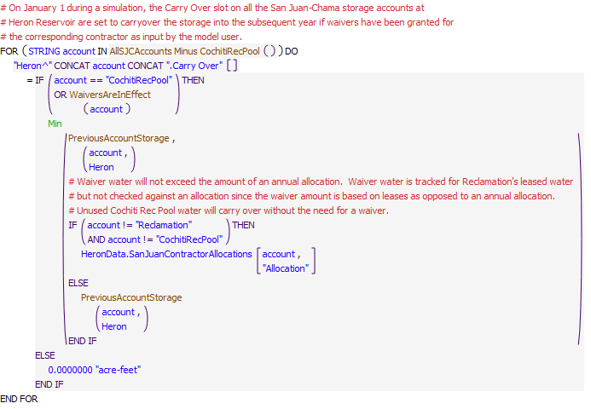
Execution Constraint
Referenced Functions
- WaiversAreInEffect
- AllSJCAccounts Minus CochitiRecPool
- IsFirstTimestepOfYear
- Min
- GetStartDate
- PreviousAccountStorage

1.2 SetCommonPoolAllocationFromContractorWaterNotUsedAndLost
Rule Purpose:
On the first timestep of every year during a simulation, some contractor water may be lost if it is still in Heron. If waivers are not in effect for those contractors, the water is reverted back to the common pool for San Juan-Chama Project water. This rule sets the resulting allocation to the FederalSanJuan storage account at Heron Reservoir on the first timestep of the year.
Rule Logic: Execution Constraint logic is at end of explanation.A FOR DO statement is used to create a list of all the storage accounts for San Juan-Chama contractors at Heron Reservoir as strings. An IF THEN ELSE statement is then used to loop through the accounts and identify the contractors that have not been granted waivers as input to the corresponding column for the contractor in the WaiverGranted table slot in the Waivers data object by year within the simulation and as checked with the WaiversAreInEffect user-defined function. A WITH statement is used within the loop to sum the amount of storage that will revert back to the FederalSanJuan account as then assigned to the Begin Year Allocation slot on the FederalSanJuan storage account at Heron Reservoir.
This rule fires if the current timestep is greater than or equal to the beginning timestep for rulebased simulation as input by the model user to the RulebasedSimulationStartDate scalar slot in the ModelRunTypeTriggers data object and as identified with the user-defined GetStartDate function and if the current timestep is the first of the year.
Comment:
Model slots written by rule:
1. Heron^FederalSanJuan.Begin Year Allocation
List of key model objects with slots read by the rule or child functions:
1. ModelRunTypeTriggers
2. Heron
3. Waivers
Log of when and how the rule has been modified (newest changes at the top):
Date: Who. What
2/13/19: Jesse Roach. Added description field and updated notes field.
11/10/17 Jesse Roach: updated with timestep generalization of MRG rules.
Statements
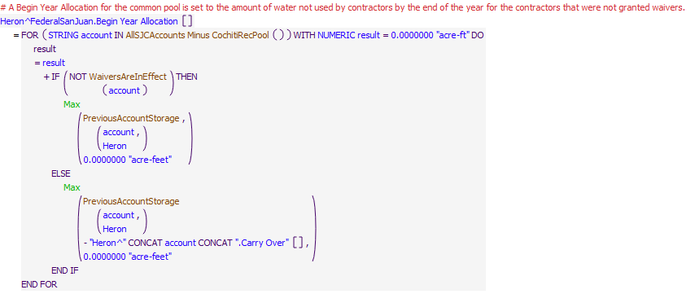
Execution Constraint
Referenced Functions
- WaiversAreInEffect
- AllSJCAccounts Minus CochitiRecPool
- IsFirstTimestepOfYear
- Max
- GetStartDate
- PreviousAccountStorage

1.3 SetSanJuanContractorAllocations
Rule Purpose:
This rule is used to allocate available water in the federal pool at Heron Reservoir to contractors for San Juan-Chama Project water on the first timestep each year. A full allocation may be made to the Cochiti Rec Pool account first depending on policy options. Allocations are then made proportionally, using the remaining supply, to each contractor up to the full annual allocation for the contractor.
Rule Logic: Execution Constraint logic is at end of explanation.The first IF allocates all accounts proportionally if CochitiRecPool can be shorted. The first assignment statement in the ELSE group sets the Begin Year Allocaton slot for the CochitiRecPool storage account at Heron Reservoir to the annual allocation as input to the corresponding row in the SanJuanContractorAllocations table slot in the HeronData data object but not to exceed the available water in the FederalSanJuan account as checked using the predefined Min function. In both IF THEN groups A FOR DO loop is used to create a list of all the other contractors for San Juan-Chama Project water as strings such that the Begin Year Allocation slots for each storage account can be set efficiently. The slots are each set with reference to either the user-defined Compute1JanSanJuanContractorAllocations_ShortCochitiRecPool or the user-defined Compute1JanSanJuanContractorAllocations function. These functions contain an IF THEN ELSE statement for identifying the allocation. If the total storage in the FederalSanJuan account at the previous timestep is greater than the sum of the allocations for all contractors as checked with reference to the predefined SumTableColumn function, the full allocation is made. Otherwise, the allocations are set to annual allocation multiplied by the ratio of the available supply, for all accounts in when Cochiti Rec Pool can be shorted, or minus the full allocation to the Cochiti Rec Pool when it can't, to the appropriate total firm yield.
This rule fires if the current timestep is greater than or equal to the beginning timestep for rulebased simulation as input by the model user to the RulebasedSimulationStartDate scalar slot in the ModelRunTypeTriggers data object and as identified with the user-defined GetStartDate function and if the current timestep is the first of the year and the rule has not fired yet as checked with reference to the predefined HasRuleFiredSuccessfully function.
Comment:
Model slots written by rule:
1. Heron^account.Begin Year Allocation where account is all SJC accounts except Reclamation
List of key model objects with slots read by the rule or child functions:
1. ModelRunTypeTriggers
2. Heron
3. HeronData
Log of when and how the rule has been modified (newest changes at the top):
Date: Who. What
2/13/19: Jesse Roach. Added description field and updated notes field.
11/10/17 Jesse Roach: execution constraint updated with timestep generalization of MRG rules.
Statements
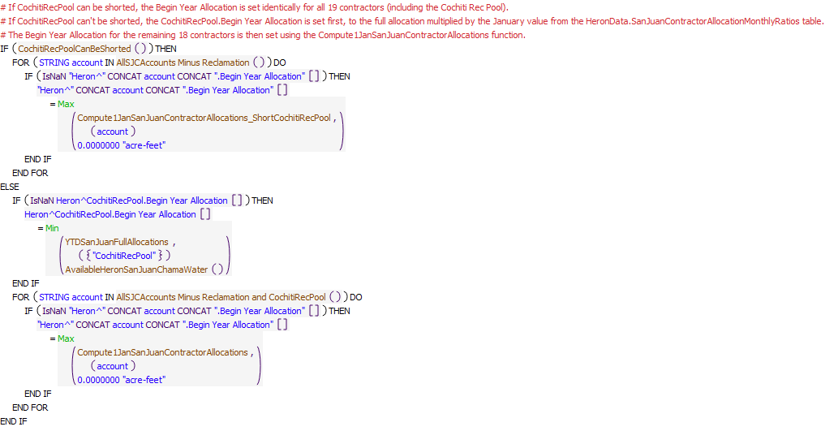
Execution Constraint
Referenced Functions
- CochitiRecPoolCanBeShorted
- Compute1JanSanJuanContractorAllocations_ShortCochitiRecPool
- Compute1JanSanJuanContractorAllocations
- YTDSanJuanFullAllocations
- AvailableHeronSanJuanChamaWater
- IsFirstTimestepOfYear
- Min
- Max
- HasRuleFiredSuccessfully
- AllSJCAccounts Minus Reclamation and CochitiRecPool
- AllSJCAccounts Minus Reclamation
- GetStartDate

1.4 SetAdditionalSanJuanContractorAllocationsIfNeeded
Rule Purpose:
This rule is used to allocate water in the federal pool at Heron Reservoir to contractors for San Juan-Chama Project water at a follow-up date after January 1st if needed to allocate more water up to the annual allocation. Additional allocations would be made if the full allocations for the year could not be made on January 1st due to a limited supply in the common pool for San Juan-Chama Project water at Heron Reservoir. Additional allocations are made on a date input by the model user (e.g. July 1st such that additional water is allocated after the runoff and after the additional inflows for the year from the Azotea tunnel have reach heron Reservoir).
Rule Logic: Rule Logic: Execution Constraint logic is at end of explanation..
The first assignment statement sets the accounting supply to transfer water from the FederalSanJuan account to the Cochiti Rec Pool account to the annual allocation for the CochitiRecPool account as input to the corresponding row in the SanJuanContractorAllocations table slot in the HeronData data object minus the Accrual for the Cochiti Rec Pool account for the year. The assignment is set to not exceed the available water in the FederalSanJuan account as checked using the predefined Min function and not be less than zero as checked with the predefined Max function.
A FOR DO loop is used to create a list of all the other contractors for San Juan-Chama Project water as strings such that each accounting supply for the transfer from the FederalSanJuan account to each contractor storage account can be set efficiently. The slots are each set with reference to the ComputeAdditionalSanJuanContractorAllocations user-defined function. This function references the user-defined 1JanSanJuanAllocations function to sum the allocations made on January 1st for all contractors. If that amount is less than the sum of all annual allocations as computed with the predefined SumTableColumn function and the additional water available in the FederalSanJuan account at the previous timestep is greater than 10 acre-ft, additional allocations are made. Otherwise, the additional allocations are all set to zero.
An internal IF THEN ELSE statement is used to check the sum of allocations made on the first timestep of the year plus the available water in the FederalSanJuan account against the total firm yield as computed with reference to the predefined SumTableColumn function. If enough water is available, the function result is the full allocation minus the Accrual for the contractor at the previous timestep (The Accrual is equal to the Begin Year Allocation with no other inflows to the account for the year). Otherwise, the available water in the FederalSanJuan account is distributed proportionately to each contractor based on the ratio of the annual allocation for the contractor to the total firm yield.
This rule fires if the current timestep is greater than or equal to the beginning timestep for rulebased simulation as input by the model user to the RulebasedSimulationStartDate scalar slot in the ModelRunTypeTriggers data object and as identified with the user-defined GetStartDate function and if the current timestep matches the timestep input to the DateForAdditionalSJCAllocations table slot in the HeronData data object as checked with reference to the DateForAdditionalSJCAllocations user-defined function and the rule has not fired yet as checked with reference to the predefined HasRuleFiredSuccessfully function
Comment:
Model slots written by rule:
1. FederalSanJuanHeronToaccountHeron.Supply where account is all SJC accounts except Reclamation
List of key model objects with slots read by the rule or child functions:
1. ModelRunTypeTriggers
2. Heron
3. HeronData
Log of when and how the rule has been modified (newest changes at the top):
Date: Who. What
2/13/19: Jesse Roach. Added description field and updated notes field.
11/10/17: Jesse Roach. Updated during timestep generalization of MRG rules
Statements
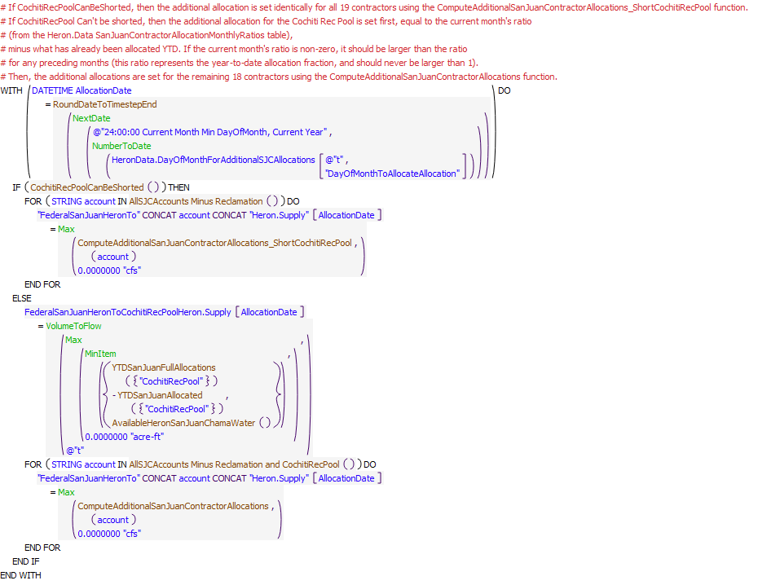
Execution Constraint
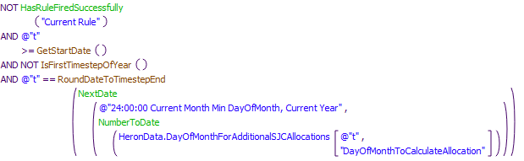
Referenced Functions
- YTDSanJuanAllocated
- CochitiRecPoolCanBeShorted
- YTDSanJuanFullAllocations
- ComputeAdditionalSanJuanContractorAllocations_ShortCochitiRecPool
- ComputeAdditionalSanJuanContractorAllocations
- AvailableHeronSanJuanChamaWater
- RoundDateToTimestepEnd
- IsFirstTimestepOfYear
- MinItem
- Max
- NumberToDate
- NextDate
- VolumeToFlow
- HasRuleFiredSuccessfully
- AllSJCAccounts Minus Reclamation and CochitiRecPool
- AllSJCAccounts Minus Reclamation
- GetStartDate

1.5 SetAllLeases
Rule Purpose:
This rule is used to set all the accounting supplies for transfers from storage accounts for contractors for San Juan-Chama Project water to the Reclamation storage accounts for all leases as input by a model user. Transfer amounts are set to zero for all dates other than the input date for lease transfers to occur.
Rule Logic: Execution Constraint logic is at end of explanation.
A FOR DO loop is used to create a list of the three Rio Chama reservoirs where accounting transfers may occur from Reclamation leases, and an internal FOR DO loop is used to create a list of strings with the potential sources for lease water as San Juan-Chama storage accounts. Accounting supplies for the transfers from the source contractor account to the Reclamation account at each reservoir are set with reference to an IF THEN ELSE statement. If the current timestep matches the date for a transfer to occur as input to the corresponding column in the table slot for the source contractor in the LeaseData data object, the supply is set to the amount input for the current simulation year to the corresponding table slot in the LeaseData data object.
The lease amounts are restricted to not exceed the available water in storage for the source account with reference to the predefined Min function and to not be less than zero using the predefined Max function.
This rule fires if the current timestep is greater than or equal to the beginning timestep for rulebased simulation as input by the model user to the RulebasedSimulationStartDate scalar slot in the ModelRunTypeTriggers data object and as identified with the user-defined GetStartDate function and the rule has not fired yet as checked with reference to the predefined HasRuleFiredSuccessfully function.
Comment:
Model slots written by rule:
1. accountresToReclamationres.Supply where account is all SJC accounts except Reclamation and CochitiRecPool, and res is Heron, ElVado, and Abiquiu
List of key model objects with slots read by the rule or child functions:
1. ModelRunTypeTriggers
2. Heron
3. ElVado
4. Abiquiu
5. LeaseData
Log of when and how the rule has been modified (newest changes at the top):
Date: Who. What
2/13/19: Jesse Roach. Added description field and updated notes field.
11/10/17: Jesse Roach. Updated during timestep generalization of MRG rules
Statements
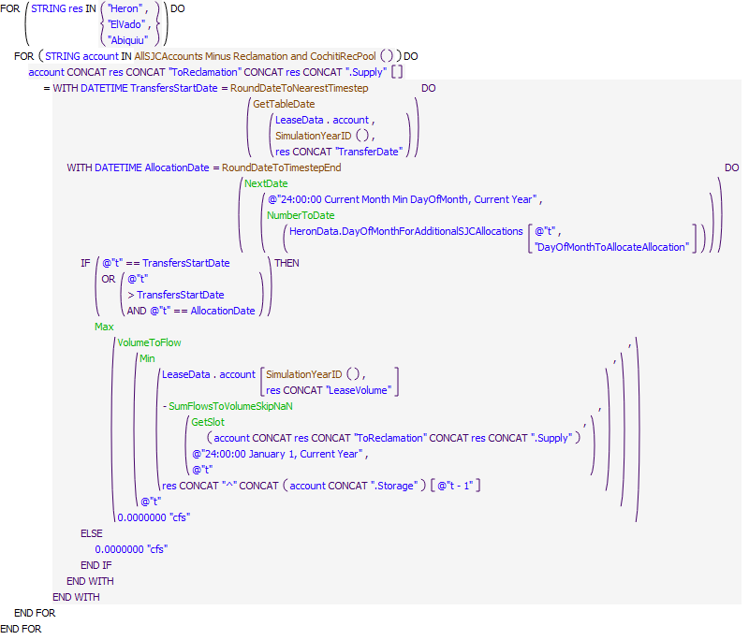
Execution Constraint
Referenced Functions
- GetTableDate
- RoundDateToTimestepEnd
- RoundDateToNearestTimestep
- Min
- Max
- SumFlowsToVolumeSkipNaN
- NumberToDate
- NextDate
- GetSlot
- VolumeToFlow
- HasRuleFiredSuccessfully
- SimulationYearID
- AllSJCAccounts Minus Reclamation and CochitiRecPool
- GetStartDate

1.6 SetSJCcontractorTransfersToSJCEnvironmental
Rule Purpose:
This rule sets transfers for leases of contractor San Juan-Chama Project water to the SJCEnvironmental account in Abiquiu.
Rule Logic: Execution Constraint logic is at end of explanation.
Transfers from the source contactor account to the SJCEnvironmental account at Abiquiu are set based on user input values in the LeaseData data object. Transfers are restricted to the available supply in the source contactor's account.
This rule fires if the current timestep is greater than or equal to the beginning timestep for rulebased simulation as input by the model user to the RulebasedSimulationStartDate scalar slot in the ModelRunTypeTriggers data object and as identified with the user-defined GetStartDate function and If the rule has not fired yet as checked with reference to the predefined HasRuleFiredSuccessfully function.
Model slots written by rule:
1.accountAbiquiuToSJCEnvironmentalAbiquiu.Supply where account is all SJC accounts except Reclamation and CochitiRecPool
List of key model objects with slots read by the rule or child functions:
1.ModelRunTypeTriggers
2.Abiquiu
3.LeaseData
Log of when and how the rule has been modified (newest changes at the top):
Date: Who. What
2/13/19: Jesse Roach. Added description field and updated notes field, and added RoundDateToNearestTimestep function to timestep generalize.
Statements
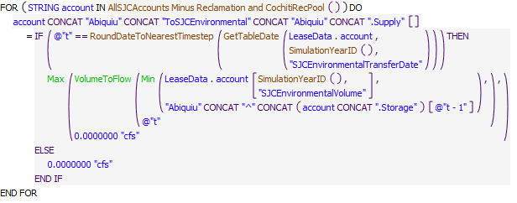
Execution Constraint
Referenced Functions
- GetTableDate
- RoundDateToNearestTimestep
- Min
- Max
- VolumeToFlow
- HasRuleFiredSuccessfully
- SimulationYearID
- AllSJCAccounts Minus Reclamation and CochitiRecPool
- GetStartDate

2 SetBuckmanDiversion
Diversions by the City of Santa Fe and County of Santa Fe at the Buckman Direct Diversion are set with the rules in this policy group. Current coded policy is based on an average diversion rate over time that reflect usage of their allocated San Juan-Chama Project water and allows for diversions of native water too based on any water rights in place for native water. Water diverted and immediately returned as required for their mixing operation at the diversion are included.
Rules in the Group:
SetBuckmanDirectDiversionDemand
SetBuckmanDirectDiversionAccountSupplies
ComputeDeliveriesToBuckmanDirectDiversion
Policy Group Change Log (newest changes at the top):
Date: Who. What

2.1 ComputeDeliveriesToBuckmanDirectDiversion
Rule Purpose:
This rule records deliveries of City of Santa Fe and Santa Fe County water for the Buckman Direct Diversion. These recorded amounts are then referenced when setting the total outflow from Abiquiu Reservoir and for setting the accounting supplies for the final deliveries after the total Abiquiu outflow has been set.
Rule Logic: Execution Constraint logic is at end of explanation.
Two assignment statements are included in this rule that each have the same format. If a value is not input, the series slots in the ComputedDeliveries data object for the delivery of SantaFeCity and SantaFeCounty water are set. If the current timestep is greater than the diversion startup date, the delivery is computed. Otherwise, the value is set to zero. Within the BuckmanSanJuanChamaPortion user-defined function, a diversion amount is determined if the Abiquiu outflow is less than the value in the ThresholdAbiquiuOutflowCutoffSJC slot on the Buckman data object; otherwise, the delivery is zero. The requested delivery is identified as the corresponding average diversion amount for the corresponding water user in the DiversionPortions table slot in the Buckman data object. Within the rule, the delivery is then adjusted in the rule for the San Juan-Chama loss rate from Abiquiu to Otowi and also reduced if needed for the available flow at Abiquiu Reservoir for the corresponding water user.
This rule fires if the current timestep is greater than or equal to the beginning timestep for rulebased simulation as input by the model user to the RulebasedSimulationStartDate scalar slot in the ModelRunTypeTriggers data object and as identified with the user-defined GetStartDate function and the rule has not fired yet as checked with reference to the predefined HasRuleFiredSuccessfully function.
Comment:
Model slots written by rule:
1. ComputedDelivereis.SantaFeCityDeliveryToBuckmanDiversion
List of key model objects with slots read by the rule or child functions:
1. ModelRunTypeTriggers
2. Buckman
3. Abiquiu
Log of when and how the rule has been modified (newest changes at the top):
Date: Who. What
2/13/19: Jesse Roach. Added description field and updated notes field
Statements
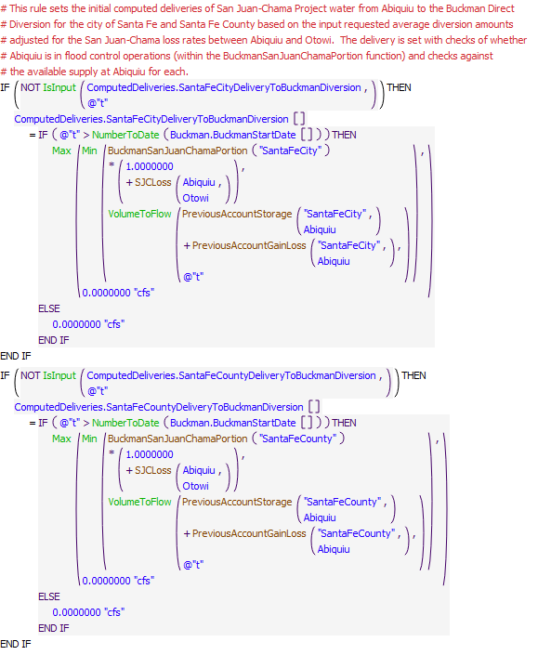
Execution Constraint
Referenced Functions
- BuckmanSanJuanChamaPortion
- Min
- Max
- NumberToDate
- VolumeToFlow
- IsInput
- HasRuleFiredSuccessfully
- SJCLoss
- PreviousAccountGainLoss
- GetStartDate
- PreviousAccountStorage

2.2 SetBuckmanDirectDiversionAccountSupplies
Rule Purpose:
This rule sets the diversion accounting supplies for Santa Fe City and Santa Fe County San Juan-Chama Project water based on the releases from Abiquiu Reservoir .
Rule Logic: Execution Constraint logic is at end of explanation.For a daily timestep run, the previous accounting release at Abiquiu is used to set the current accounting supply at the diversion. At a greater than daily timestep run, they are the same (no lag), with adjustments for the San Juan-Chama loss rates from Abiquiu to Otowi.
This rule fires if the current timestep is greater than or equal to the beginning timestep for rulebased simulation as input by the model user to the RulebasedSimulationStartDate scalar slot in the ModelRunTypeTriggers data object and as identified with the user-defined GetStartDate function.
Comment:
This rule was previously part of the SetBuckmanDirectDiversionDemand rule but pulled out during creation of monthly timestep ruleset.
Model slots written by rule:
1. SantaFeCityAbiquiuToBuckmanBuckmanDiversionToSantaFeCityBuckmanDirectDiversion.Supply
2. SantaFeCountyAbiquiuToBuckmanBuckmanDiversionToSantaFeCountyBuckmanDirectDiversion.Supply
List of key model objects with slots read by the rule or child functions:
1. ModelRunTypeTriggers
2. Abiquiu
3. SanJuanChamaRules
Log of when and how the rule has been modified (newest changes at the top):
Date: Who. What
2/13/19: Jesse Roach. Added description field and updated notes field
11/10/17 Jesse Roach: Old rule SetBuckmanDirectDiversion split into two, including this one during MRG timestep generalization.
Statements
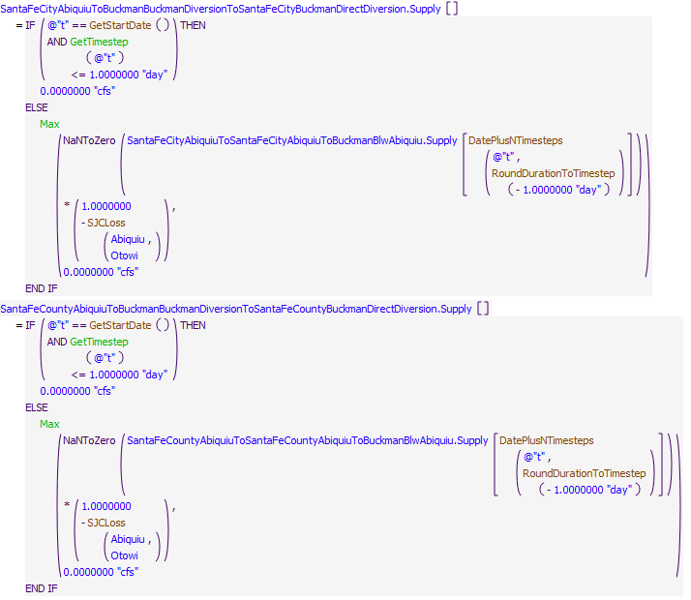
Execution Constraint
Referenced Functions
- DatePlusNTimesteps
- RoundDurationToTimestep
- Max
- GetTimestep
- SJCLoss
- GetStartDate

2.3 SetBuckmanDirectDiversionDemand
Rule Purpose:
This rule sets the diversion and depletion requests, and fraction return flow at Buckman Direct Diversion for both the City of Santa Fe and County of Santa Fe diversions of San Juan-Chama Project water and native Rio Grande water based on the native rights that may be in place. The diversion is set to an amount of San Juan-Chama Project water than can be delivered (or the full request for the City of Santa Fe if an exchange for San Juan-Chama Project water at Elephant Butte is to be modeled), native water used for the mixing operation at the diversion that is immediately returned, and native water based on input water rights with checks for curtailment or cutoff restrictions per the permit. A fractional return is computed for the native water that is diverted for the mixing operation and immediately returned.
Rule Logic: Execution Constraint logic is at end of explanation.
A FOR DO statement is used to set diversions in the future as required for hypothetical simulation in the model runs. Three assignment statements are included in the FOR DO loop. Values for the Diversion Requested and Depletion Requested slots on the BuckmanDirectDiversion water user object are both set to the result from the user-defined ComputeBuckmanDiversion function. A WITH DO statement is used in this function to check the river flow over a number of days such that fluctuations in the modeled river flow do not impact operations with the checks against curtailment and cutoff thresholds. If the current timestep is not the Start Timestep and is greater than or equal to the input startup date, a diversion is computed. Otherwise, the diversion is set to zero. The diversion is computed in separate sections for the San Juan-Chama Project water for the City of Santa Fe, San Juan-Chama Project water for the County of Santa Fe, native water diverted for the mixing operation, and native water diverted set based on the input amount per water rights and with checks against the curtailment and cutoff thresholds.
This rule fires if the current timestep is greater than or equal to the beginning timestep for rulebased simulation as input by the model user to the RulebasedSimulationStartDate scalar slot in the ModelRunTypeTriggers data object and as identified with the user-defined GetStartDate function and the rule has not fired yet as checked with reference to the predefined HasRuleFiredSuccessfully function.
Comment:
This rule was previously part of the SetBuckmanDirectDiversionDemand rule but diversion accounting supplies for Santa Fe City and Santa Fe County San Juan-Chama Project water were split out into the rule SetBuckmanDirectDiversionAccountSupplies during creation of a monthly timestep ruleset.
Model slots written by rule:
1. ComputedDelivereis.SantaFeCityDeliveryToBuckmanDiversion
List of key model objects with slots read by the rule or child functions:
1. ModelRunTypeTriggers
2. Buckman
3. Abiquiu

Log of when and how the rule has been modified (newest changes at the top):
Date: Who. What
2/04/21: Marc Sidlow. Added AND @"t" != @"Finish Timestep" to Execute Rule Only When statement at suggestion of David Neumann (CADSWES) to prevent abort errors at end of model runs.
2/13/19: Jesse Roach. Added description field and updated notes field
2/12/19: Jesse Roach. Fixed Depletion Requested to be equal to Diversion Requested*(1 - fractional return) rather than equal to Diversion Requested as had been set previously.
11/10/17 Jesse Roach: Old rule SetBuckmanDirectDiversion split into two, including this one during MRG timestep generalization.
Statements
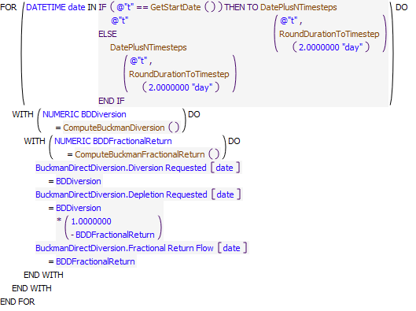
Execution Constraint
Referenced Functions
- DatePlusNTimesteps
- ComputeBuckmanDiversion
- ComputeBuckmanFractionalReturn
- RoundDurationToTimestep
- HasRuleFiredSuccessfully
- GetStartDate

3 Letter Water Deliveries and MRGCD Demand
The rules in the policy group are used to compute letter water delivery amounts for paybacks to MRGCD as transfers at El Vado, deliveries to payback MRGCD by contributing to the MRGCD demand at Cochiti, and deliveries to Elephant Butte to payback the Compact. Rules are also used to identify the MRGCD demand at Abiquiu and El Vado for eventually later identifying the needed release from storage for MRGCD. These rules are all included together because the releases MRGCD demand for identify releases from storage is reduced for any letter water deliveries from Abiquiu already computed that contribute to the demand.
Rules in the Group:
SetElVadoMRGCDDemand
ComputeLetterWaterPaybacksToCompact
ComputeLetterWaterPaybackToMRGCDOutOfAbiquiu
SetAbiquiuMRGCDDemand
ComputeAbiquiuMRGCDDemand
ComputeLetterWaterPaybackToMRGCDatElVado
Policy Group Change Log (newest changes at the top):
Date: Who. What

3.1 ResetMRGCDDemandAtCochitiForHydrologicConditions
Rule Purpose:
This rule allows for the MRGCD demand to be adjusted during a simulation based on hydrologic conditions and is set up to conserve water in storage if the supply has dropped below an input threshold after a threshold date
by changing the demand to zero. The rule checks if the demand was reset to zero at a previous timestep, and if so, the demand will then be maintained at zero for the remainder of the irrigation season.
Rule Logic: Execution Constraint Logic is at end of explanation
An IF statement checks that the timestep is between March 1 and October 31 (inclusive) and the MRGCD.StorageToConserve is less than the threshold volume of 0.1 acre-ft and either the MRGCD Supply is less than the Storage or the demand at Cochiti is less than the threshold flow of 0.1 cfs for this for two future timesteps and if so, then the MRGCD demand (which drives MRGCD releases from storage at El Vado or Abiquiu) at Cochiti is set to zero
This rule fires if the current timestep is greater than or equal to the beginning timestep for rulebased simulation as input by the model user to the RulebasedSimulationStartDate scalar slot in the ModelRunTypeTriggers data object and as identified with the user-defined GetStartDate function and the rule has not fired yet as checked with reference to the predefined HasRuleFiredSuccessfully function.
Comment:
Model slots written by the rule:
1. MRGCD.DemandAtCochiti
List of ket model objects with slods read by the rule or child functions
1. ModelRunTypeTriggers
2. MRGCD.StorageToConserve
3. MRGCDSupply
4. MRGCD.DemandAtCochiti
Log of when and how the rule has been modified (newest changes at the top)
Date: Who: What:
2/13/19: Jesse Roach. Added description field and updated notes field
Statements
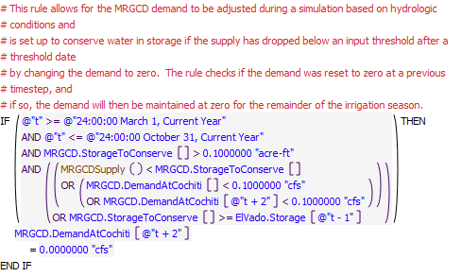
Execution Constraint
Referenced Functions
- MRGCDSupply
- HasRuleFiredSuccessfully
- GetStartDate

3.2 ComputeLetterWaterPaybackToMRGCDatElVado
Rule Purpose:
This rule records computed transfers for contractors to make letter water deliveries to MRGCD as transfers from account storage at El Vado Reservoir to the MRGCD San Juan-Chama account at El Vado. The deliveries are set to zero unless the switch has been set to make paybacks as transfers at El VAdo and the date is on or after the input date to make such a transfer. The recorded value is set to the tracked debt with a check against the available supply for the source contractor.
Rule Logic: Execution Constraint logic is at end of explanation.
A FOR DO loop is used to create a list of the accounts that may have a payback to MRGCD at El Vado pending. The strings allow for all the assignments to then be made with one assignment statement within the loop. If a value is not already input to the corresponding series in the ComputedLetterWater data object, the value is set to the result of the ComputeLetterWaterPaybackToMRGCDasTransferAtElVado function. Within this function, if the value for the current simulation year in the PaybackMRGCDwithTransferAtElVado(1=yes,0=no) column in the table slot for the corresponding account in the LetterWaterDeliveryDate data object is equal to 1 and the date is greater than or equal to the date in the DateToCompleteTransferAtElVado column in the same table slot, a payback amount is computed; otherwise, the value is set to zero. The computed amount is set to mimimum of the payback debt as identified with the predefined GetPaybackDebt function or the the available supply.
This rule fires if the current timestep is greater than or equal to the beginning timestep for rulebased simulation as input by the model user to the RulebasedSimulationStartDate scalar slot in the ModelRunTypeTriggers data object and as identified with the user-defined GetStartDate function and the rule has not fired yet as checked with reference to the predefined HasRuleFiredSuccessfully function.
Comment:
Model slots written by rule:
1. ComputedLetterWater.accountPaybackToMRGCDAtElVado where account is all SJC accounts except Reclamation, CochitiRecPool, and MRGCD
List of key model objects with slots read by the rule or child functions:
1. ModelRunTypeTriggers
2. ComputedLetterWater
3. LetterWaterDeliveryData
4. ElVado
Log of when and how the rule has been modified (newest changes at the top):
Date: Who. What
2/13/19: Jesse Roach. Added description field and updated notes field
Statements
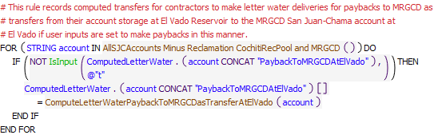
Execution Constraint
Referenced Functions
- ComputeLetterWaterPaybackToMRGCDasTransferAtElVado
- IsInput
- HasRuleFiredSuccessfully
- AllSJCAccounts Minus Reclamation CochitiRecPool and MRGCD
- GetStartDate

3.3 ComputeAbiquiuMRGCDDemand
Rule Purpose:
This rule uses hypothetical simulation to determine the required release from Abiquiu Dam to meet the MRGCD demand at Cochiti Lake. A computed value is determined first and then a final value is set with the SetAbiquiuMRGCDDemand rule. The separate steps are included to potentially allow for some alternate approaches to be used in regards to better matching the needed flow at Abiquiu. The final set value is then referenced later to determine the release needed from El Vado Reservoir and to ultimately set any potential releases from storage to meet the MRGCD demand. If the demand at Cochiti is zero, the demand at Abiquiu is set to zero without a call to hypothetical simulation.
Rule Logic: Execution Constraint logic is at end of explanation.
If the value in the DemandAtCochiti series slot in the MRGCD data object at timestep t+2 is greater than 0.1 cfs, the value for the ComputedMRGCDDemand time series slot in the AbiquiuData data object for the next timestep is set using the user-defined AbiquiuComputedMRGCDDemand function. Otherwise, the slot value is set to 0.0 cfs. The AbiquiuComputedMRGCDDemand function uses the predefined HypTargetSimWithStatus function to determine the required outflow from Abiquiu Dam (or the value for the Gage Inflow time series slot for the BlwAbiquiu stream gage object) to meet a target inflow to Cochiti Lake (or a value for the Outflow time series slot in the OtowiToCochitiLocalInflow reach object) equal to the value for the DemandAtCochiti series slot in the MRGCD data object. The function completes the hypothetical simulation for all the objects in the BelowAbiquiu subbasin and uses the input minimum and maximum outflows from Abiquiu Dam of 0 and 1800 cfs, respectively (the channel capacity below Abiquiu Dam is 1800 cfs) as the bounds for the solution procedure. A tolerance of 2 cfs is allowed for the target flow.
This rule fires if the current timestep is greater than or equal to the beginning timestep for rulebased simulation as input by the model user to the RulebasedSimulationStartDate scalar slot in the ModelRunTypeTriggers data object and as identified with the user-defined GetStartDate function and if the value in the ComputedMRGCDDemand series slot in the AbiquiuData data object is a NaN for the next timestep.
Comment:
Model slots written by rule:
1. AbiquiuData.ComputedMRGCDDemand
List of key model objects with slots read by the rule or child functions:
1. ModelRunTypeTriggers
2. MRGCD
3. All objects in BelowAbiquiu subbasin
Log of when and how the rule has been modified (newest changes at the top):
Date: Who. What
2/13/19: Jesse Roach. Added description field and updated notes field
11/21/2017 Jesse Roach: Updated during MRG timestep generalization
Statements
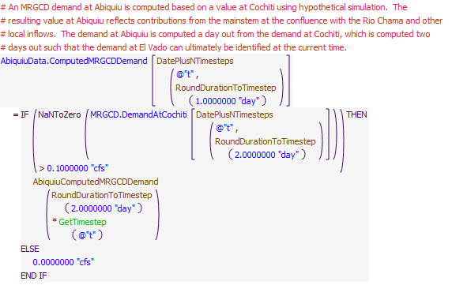
Execution Constraint
Referenced Functions
- DatePlusNTimesteps
- RoundDurationToTimestep
- AbiquiuComputedMRGCDDemand
- GetTimestep
- GetStartDate

3.4 SetAbiquiuMRGCDDemand
Rule Purpose:
This rule sets the MRGCD demand for the next timestep based on the computed demand. This separate rule allows for an adjustment to the computed demand to be implemented to potentially better match the need at Abiquiu Dam. With the adjustment in URGWOM to use a one-day physical lage that matches the one-day accounting lag between Abiquiu and Cochiti, this additional rule may not be needed any more.
Rule Logic: Execution Constraint logic is at end of explanation.
This rule fires if the current timestep is greater than or equal to the beginning timestep for rulebased simulation as input by the model user to the RulebasedSimulationStartDate scalar slot in the ModelRunTypeTriggers data object and as identified with the user-defined GetStartDate function and if the value for the MRGCDDemand in the AbiquiuData data object is a NaN for the next timestep.
The value for the MRGCDDemand slot in the AbiquiuData data object for the next timestep is set to the ComputedMRGCDDemand slot value for the next timestep. For the rulebased simulation start timestep, the value is also set for the current timestep.
This rule fires if the current timestep is greater than or equal to the beginning timestep for rulebased simulation as input by the model user to the RulebasedSimulationStartDate scalar slot in the ModelRunTypeTriggers data object and as identified with the user-defined GetStartDate function AND if the value for the MRGCDDemand in the AbiquiuData data object is a NaN for the next timestep.
Model slots written by rule:
1. AbiquiuData.MRGCDDemand
List of key model objects with slots read by the rule or child functions:
1. ModelRunTypeTriggers
2. AbiquiuData
Log of when and how the rule has been modified (newest changes at the top):
Date: Who. What
2/13/19: Jesse Roach. Added description field and updated notes field
Statements
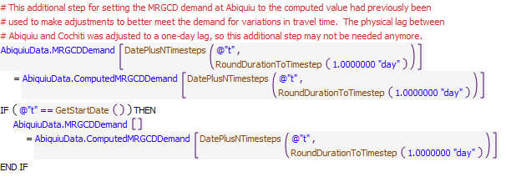
Execution Constraint
Referenced Functions
- DatePlusNTimesteps
- RoundDurationToTimestep
- GetStartDate

3.5 ComputeLetterWaterPaybackToMRGCDOutOfAbiquiu
Rule Purpose:
This rule records computed letter water deliveries set to contribute to meeting the MRGCD demand at Cochiti. The contributions to the demand are split evenly between contractors that need to make deliveries limited to the remaining payback debt for each contractor or the available supply at Abiquiu for the source contractor. If any contractors cannot make their portion of an evenly split delivery, other contractors will delivery more if possible.
Rule Logic: Execution Constraint logic is at end of explanation.
A FOR DO loop is used in the rule to make assignments with reference to the user-defined ComputeLetterWaterPaybacksToMRGCDOutOfAbiquiu function which returns a list of slot names, at index 0, and corresponding resulting deliveries for each, at index 1, in the list. Within the function, an outer WITH DO statement is used to create a list of accounts that may have a letter water payback to MRGCD out of Abiquiu Reservoir. Another WITH DO statement is used to identify the available total payback to MRGCD that could be made at the current timestep as the minimimum of the tracked debt with a check against the available supply for the contractor. A third WITH DO statement is used to create a list of the account names and determined release where the total need to meet the MRGCD demand is split evenly between the number of source contractors restricted for each to the total available payback. A final WITH DO loop is used in the function to create the list of the target slot names for recording the potential letter water delivery and the determined magnitude of the letter water delivery.
This rule fires if the current timestep is greater than or equal to the beginning timestep for rulebased simulation as input by the model user to the RulebasedSimulationStartDate scalar slot in the ModelRunTypeTriggers data object and as identified with the user-defined GetStartDate function and the rule has not fired yet as checked with reference to the predefined HasRuleFiredSuccessfully function.
Comment:
Model slots written by rule:
1. ComputedLetterWater.account where account is all SJC accounts except Reclamation, CochitiRecPool, and MRGCD
List of key model objects with slots read by the rule or child functions:
1. ModelRunTypeTriggers
2. ComputedDeliveries
3. Abiquiu
Log of when and how the rule has been modified (newest changes at the top):
Date: Who. What
2/13/19: Jesse Roach. Added description field and updated notes field
Statements
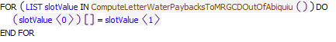
Execution Constraint
Referenced Functions
- ComputeLetterWaterPaybacksToMRGCDOutOfAbiquiu
- HasRuleFiredSuccessfully
- GetStartDate

3.6 ComputeLetterWaterPaybacksToCompact
Rule Purpose:
The letter water deliveries to pay back the Compact are recorded with this rule for each contractor based on the total payback amount for the year for the contractor, the portion to be paid back to the Compact, and the unit delivery schedule for the paybacks to the Compact. Note that deliveries are restricted to the available water in storage at Abiquiu for the contractor, and if water is not available, the payback is NOT adjusted later to make up for the discrepancy, but this should be avoided with water moved from Heron to Abiquiu and made available for the paybacks as needed.
Rule Logic: Execution Constraint logic is at end of explanation.
A FOR DO loop is used in the rule to make assignments for each of the series slots fore each contractor in the ComputedLetterWater data object for contractor letter water deliveries to pay back the Compact. The amounts are set to the value for the current timestep in the UnitDeliveryScheduleForPaybackToCompact periodic slot in the LetterWaterDeliveryData data object multiplied by the value in the RatioToCompact column for the current simulation year in the table slot for the corresponding contractor in the same data object multiplied by the value in the TotalPaybackVolume column in the same table slot. The result is checked against the available supply at Abiquiu for the source contractor.
This rule fires if the current timestep is greater than or equal to the beginning timestep for rulebased simulation as input by the model user to the RulebasedSimulationStartDate scalar slot in the ModelRunTypeTriggers data object and as identified with the user-defined GetStartDate function and the rule has not fired yet as checked with reference to the predefined HasRuleFiredSuccessfully function.
Comment:
The input delivery schedules likely entail moving the water after the irrigation season is over to assure the water is delivered to Elephant Butte Reservoir.
Model slots written by rule:
1. ComputedLetterWater.account where account is all SJC accounts except Reclamation, CochitiRecPool, and MRGCD
List of key model objects with slots read by the rule or child functions:
2. ModelRunTypeTriggers
3. LetterWaterDeliveryData
4. ComputedDeliveries
5. Abiquiu
Log of when and how the rule has been modified (newest changes at the top):
Date: Who. What
2/13/19: Jesse Roach. Added description field and updated notes field
08/24/2018: Marc Sidlow. Changed first item in the MinItem list to calculate a letter water payback based on a result of flow, not volume (the original calculation was returning a flow, but did not consider the conversion of a volume to flow in the result).
Statements
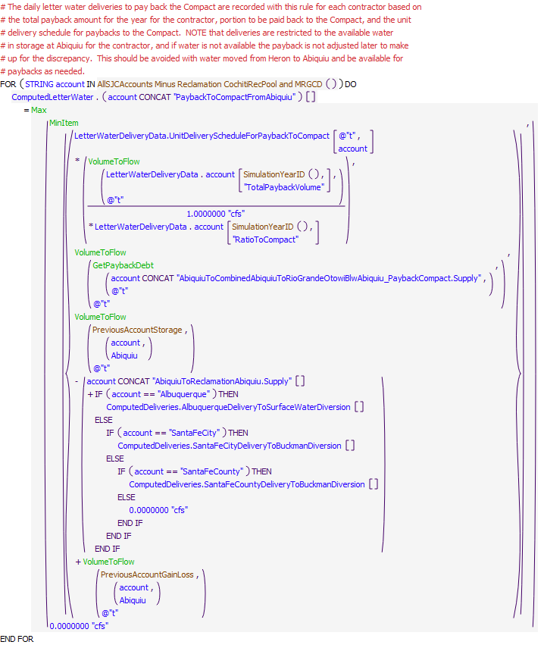
Execution Constraint
Referenced Functions
- MinItem
- Max
- GetPaybackDebt
- VolumeToFlow
- HasRuleFiredSuccessfully
- SimulationYearID
- AllSJCAccounts Minus Reclamation CochitiRecPool and MRGCD
- PreviousAccountGainLoss
- GetStartDate
- PreviousAccountStorage

3.7 SetElVadoMRGCDDemand
Rule Purpose:
The MRGCD demand at El Vado for determining needed releases from storage is computed with this rule. The amount is determined using hypothetical simulation between El Vado and Abiquiu for meeting the MRGCD demand at Abiquiu after subtracting off contributions from any letter water deliveries out of Abiquiu to the MRGCD demand.
Rule Logic: Execution Constraint logic is at end of explanation..
An IF THEN ELSE statement is used to check the result of the GetAbiquiuMRGCDDemand user-defined function which computes the MRGCD demand at Abiquiu as the value in the MRGCDDemand slot in the AbiquiuData data object minus the sum of the recorded letter water deliveries out of Abiquiu to pay back MRGCD in the ComputedLetterWater data object. If that function result is greater than 0.1 cfs, the user-defined ComputeElVadoMRGCDDemand function uses the predefined HypTargetSimWithStatus function to determine the required outflow from El Vado Dam (or the value for the Gage Inflow time series slot for the BlwElVado stream gage object) to meet a target inflow to Abiquiu Reservoir (or a value for the Outflow time series slot in the ElVadoToAbiquiuLocalInflow reach object) equal to the result of the GetAbiquiuMRGCDDemand function for the next timestep. The hypothetical simulation is completed for all the objects in the BelowElVado subbasin and uses the input minimum and maximum outflows from El Vado Dam of 0 and 5000 cfs, respectively, as bounds for the solution procedure. A tolerance of 2 cfs is allowed for the target flow.
This rule fires if the current timestep is greater than or equal to the beginning timestep for rulebased simulation as input by the model user to the RulebasedSimulationStartDate scalar slot in the ModelRunTypeTriggers data object and as identified with the user-defined GetStartDate function and if the value for the MRGCD demand series slot in the ElVadoData data object for the current timestep is a NaN
Comment:
Model slots written by rule:
1. ElVadoData.MRGCDDemand
List of key model objects with slots read by the rule or child functions:
1. ModelRunTypeTriggers
2. AbiquiuData
3. All objects in BelowElVado subbasin
Log of when and how the rule has been modified (newest changes at the top):
Date: Who. What
2/13/19: Jesse Roach. Added description field and updated notes field
11/10/17 Jesse Roach: updated with timestep generalization of MRG rules.
Statements
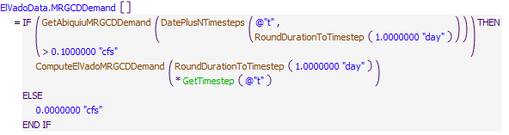
Execution Constraint
Referenced Functions
- DatePlusNTimesteps
- RoundDurationToTimestep
- ComputeElVadoMRGCDDemand
- GetAbiquiuMRGCDDemand
- GetTimestep
- GetStartDate

4 Heron Set UP
The first two rules in this policy group are used to compute the release of native Rio Grande water from Heron Reservoir. Space at Heron Reservoir is designated for San Juan-Chama Project water and the native inflow from Willow Creek is bypassed, but operations actually entail evacuating native water periodically as storage starts to accumulate. This is the realistic approach that is represented in the ruleset as it is not practical for damtenders to bypass the exact inflow every day.
URGWOM is set up to allow surface water diversions to continue for Albuquerque and the city of Santa Fe during flood control operations when their San Juan-Chama Project water cannot be delivered. The rule third rule in this policy group is used to set the deliveries to Elephant Butte to payback any accrued debt or to be delivered for temporary storage when upstream space is not available.
Rules in the Group:
ComputeHeronRGRelease
ComputeHeronRGReleaseFillInDataForElVadoFillingRules
ComputeContractorDeliveriesToElephantButte
Policy Group Change Log (newest changes at the top):
Date: Who. What

4.1 ComputeContractorDeliveriesToElephantButte
Rule Purpose:
This rule records values for Albuquerque and Santa Fe City deliveries to Elephant Butte if there is no space at El Vado or Abiquiu to ultimately avoid losing allocated water at Heron Reservoir or to assure enough water is available for the contractor at Elephant Butte to pay back a debt accrued due to surface water diversions of all native water during flood control operations.
Rule Logic: Execution Constraint logic is at end of explanation.
A FOR DO loop is used to set the corresponding slots for Albuquerque and Santa Fe City in the ComputedDeliveries data object for deliveries to Elephant Butte if values are not input. An internal IF THEN ELSE statement is used to check if the value in the TemporaryStorageAtElephantButteAllowed(1=yes,0=no) column in the DeliverySettings table slot for the corresponding contractor is equal to 1.0. If not, the slot is set to 0.0. If so, the slot is set using the user-defined SJCDeliveryAbiquiuToElephantButte function which sets the delivery to move water at the same determined rate to evacuate water from Heron Reservoir such that it will not be lost or to deliver water to Elephant Butte Reservoir for a pending debt payback.
This rule fires if the current timestep is greater than or equal to the beginning timestep for rulebased simulation as input by the model user to the RulebasedSimulationStartDate scalar slot in the ModelRunTypeTriggers data object and as identified with the user-defined GetStartDate function rule and the rule has not fired yet as checked with reference to the predefined HasRuleFiredSuccessfully function.
Comment:
Model slots written by rule:
1. ComputedDeliveries.Albuquerque.DeliveryAbiquiuToElephantButte
2. ComputedDeliveries.SantaFeCity.DeliveryAbiquiuToElephantButte
List of key model objects with slots read by the rule or child functions:
1. ModelRunTypeTriggers
2. ComputedDeliveries
3. AlbuquerqueDiversions
4. Buckman
5. Waivers
6. ElephantButte
7. Heron
8. ElVado
Log of when and how the rule has been modified (newest changes at the top):
Date: Who. What
2/14/19: Jesse Roach. Added description field and updated notes field
Statements
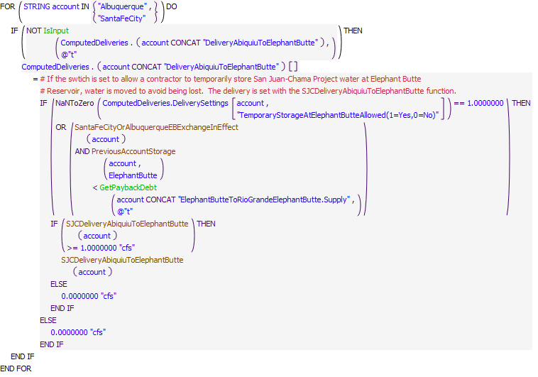
Execution Constraint
Referenced Functions
- SantaFeCityOrAlbuquerqueEBExchangeInEffect
- SJCDeliveryAbiquiuToElephantButte
- GetPaybackDebt
- IsInput
- HasRuleFiredSuccessfully
- GetStartDate
- PreviousAccountStorage

4.2 ComputeHeronRGReleaseFillInDataForElVadoFillingRules
Rule Purpose:
This rule replaces NaN values in HeronData.RGOutflow with zeros right before the simulation start so that a multi-day average calculation caleed by "ElVadoOutFLowForFilling" can return a valid value
Rule Logic: Execution Constraint logic is at end of explanation.
A FOR DO Loop is used to cycle through the dates that occur for some number of days before the Rulesbased Start Date. The number of days is set by the DaysForMovingAverageForSmoothing user defined function. For each of those dates if the outflow of the RioGrande account in Heron is defined (NOT IsNaN), it is assigned to the HeronData.RGOutflow model slot. If is not defined, the model slot is assigned a zero value.
This rule fires if there is no data in HeronData.RGOutflow for the previous timestep and time is within a certain number of time before the simulation start date. That time is the amount of time chosen for flow smoothing for the El Vado filling functions.
Comment:
Fairly complex rules for filling El Vado were implemented around 2014, and it is likely this rule was added as part of that update.
Model slots written by rule:
1. HeronData.RGOutflow
List of key model objects with slots read by the rule or child functions:
1. Heron
2. ModelRunTypeTriggers
3. ElVadoData
Log of when and how the rule has been modified (newest changes at the top):
Date: Who. What
7/15/20: MCB. Added additional notes. See FY2020 Tetra Tech Task 2 tech memo for additional details
2/14/19: Jesse Roach. Added description field and updated notes field
Statements
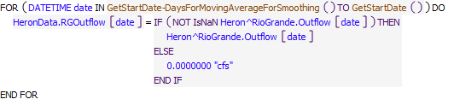
Execution Constraint
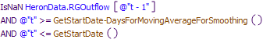
Referenced Functions
- GetStartDate
- GetStartDate-DaysForMovingAverageForSmoothing

4.3 ComputeHeronRGRelease
Rule Purpose:
This rule computes an outflow of Rio Grande water from Heron Dam. The referenced function sets the outflow with three parts. Any unregulated outflow is included, and a separate calculation is included for targeting an end-of-year storage of 350 acre-ft such that the native storage will be zero to start the next calendar year after the end-of-year 350 acre-ft accounting adjustment for impacts of Rio Grande water on evaporation. The third part of the calculation is the primary component that sets the release to evacuate Rio Grande water after a threshold amount of Rio Grande storage has been exceeded to then reduce the storage to a lower storage over an input number of days.
Rule Logic: Execution Constraint logic is at end of explanation.
This rule references the HeronRGOutflow function. The function first includes any unregulated spill that must be included in the Rio Grande outflow as checked with the predefined ElevationToUnregulatedSpill function and set based on the reservoir rating table. Second, if the current timestep is after the date in the DateToBeginEvacuatingWaterTo350ForEndOfYearAdjustment column of the RioGrandeBypassComputationParameters function, a release is determined to evacuate any excess storage over 350 acre-ft by the end of the year such that the end-of-year 350 acre-ft accounting adjustment will return the Rio Grande storage to zero to begin the next year. The primary aspect of the computation includes a check to see if the storage of native water is greater than the value in the ThresholdRGStorageToInitiateBypass column in the RioGrandeBypassComputationParameters table slot or the outflow from Rio Grande storage was greater than zero at the previous timestep and the Rio Grande storage is still greater than the value in the TargetMinimumRGStorage column in the RioGrandeBypassComputationParameters table slot. If those conditions are satisfied, a release is computed. The release is computed to evacuate the difference in the previous storage and the target storage plus the average projected inflow of additional native water over an input number of days. The predefined Floor function is used to restrict releases to only adjust by the increment input to the IncrementalAdjustmentToFlowForEvacuatingWater column in the RioGrandeBypassComputationParameters. The computed release is restricted to not exceed the available Rio Grande water in storage plus the inflow for the current day. The function also contains post-execution constraints to assure the maximum outflow is set as required based on the rating tables.
This rule fires if the value in the RGOutflow series slot in the HeronData data object for the current timestep is a NaN and the current timestep is greater than or equal to the beginning timestep for rulebased simulation as input by the model user to the RulebasedSimulationStartDate scalar slot in the ModelRunTypeTriggers data object and as identified with the user-defined GetStartDate function.
Comment:
Model slots written by rule:
1. HeronData.RGOutflow
List of key model objects with slots read by the rule or child functions:
1. ModelRunTypeTriggers
2. Heron
3. HeronData
4. AzoteaWillow
Log of when and how the rule has been modified (newest changes at the top):
Date: Who. What
2/14/19: Jesse Roach. Added description field and updated notes field
Statements
Execution Constraint
Referenced Functions
- HeronRGOutflow
- GetStartDate

5 Compute PandP Storage & Inflow and Otowi Forecast
The rules in this policy group are used to compute the P&P storage requirement and set the inflow of native water to P&P storage. The approach matches the actual approach used by the BIA and Reclamation with an Otowi forecast computed in URGWOM based on input inflows. The rules allow for P&P water to be stored prior to March 1 if model parameters are set accordingly.
Rules in the Group:
SetInflowToPandPStorage
UnneededPandPTransferredBackToRioGrande
TallyPandPWaterStoredInArticleVII
ResetPandPStorageRequirementToMinIfInputAndHigher
ComputePandPStorageRequirement
ComputeOtowiForecast
Policy Group Change Log (newest changes at the top):
Date: Who. What

5.1 ComputeOtowiForecast
Rule Purpose:
This rule is used to compute a forecasted flow at Otowi for the period from March through July. The Otowi forecast is used later to identify the type of year when setting flow targets and is also referenced as the forecast in the model computation for the P&P storage requirement. Note that an Otowi forecast is determined based on set model inputs.
Rule Logic: Execution Constraint logic is at end of explanation..
If the value in the OtowiForecast time series slot in the PandP data object for December 31 of the current year is not input, an IF THEN ELSE statement is used to see if the finish timestep is before July 31 of the current year, indicating that inflow inputs would not be available in the model run to compute an Otowi forecast volume, and if the forecast for AOP modeling is not a NaN. If those unique conditions are satisfied, probably only for a short-term run, the Otowi forecast directly input for AOP modeling is used. Otherwise, the December 31 OtowiForecast series slot value is set to the computed volume from the user-defined RouteRioGrandeToOtowi function multiplied by a factor or 1.0 or the PercentForecastError (Refer to the ForecastErrorPercent Rule) if the PerrcentForecastError is not a NaN.
The RouteRioGrandeToOtowi function references several other functions in the OtowiForecastFromInputs utility group. All of these functions use the predefined SumFlowsToVolumeSkipNaN function to compute the volume of flow from a particular source that would be expected at Otowi for the period from March 1 through July 31. Each of these functions considers input average percent losses for the forecast period for the appropriate separate designated reaches from the location of the inflow to Otowi. The user-defined AverageForecastPeriodLoss function is used to reference the percent losses, as a function of a reach identifier, which are input to the AverageForecastPeriodLosses table slot in the ForecastData data object.
This rule fires if the current timestep equal to the beginning timestep for rulebased simulation as input by the model user to the RulebasedSimulationStartDate scalar slot in the ModelRunTypeTriggers data object and as identified with the user-defined GetStartDate function or greater than the rulebased simulation start timestep and before May 1 or the first day of a month on or before May 1 of the current year
Comment:
Model slots written by rule:
1. PandP.OtowiForecast
List of key model objects with slots read by the rule or child functions:
1. PandP
2. InputForecastData
3. ModelRunTypeTriggers
4. ForecastData
5. Various flow input locations
Log of when and how the rule has been modified (newest changes at the top):
Date: Who. What
2/14/19: Jesse Roach. Added description field and updated notes field
11/10/17 JR: updated during timestep generalization of MRG rules.
Statements
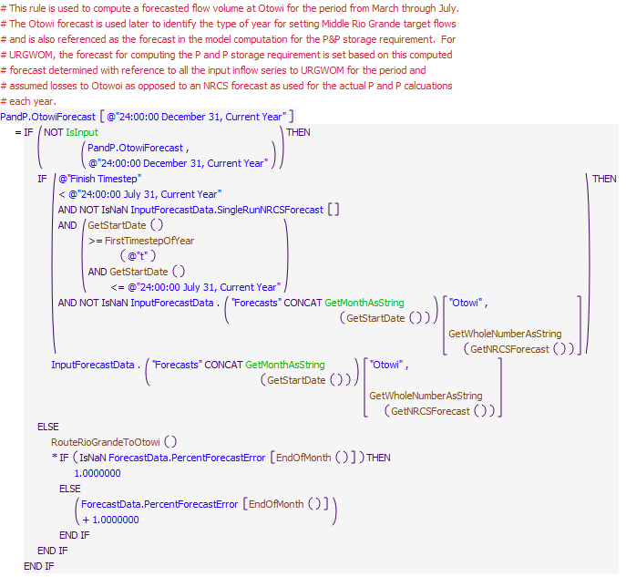
Execution Constraint
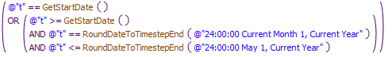
Referenced Functions
- EndOfMonth
- RoundDateToTimestepEnd
- FirstTimestepOfYear
- RouteRioGrandeToOtowi
- GetMonthAsString
- IsInput
- GetWholeNumberAsString
- GetStartDate
- GetNRCSForecast

5.2 ComputePandPStorageRequirement
Rule Purpose:
This rule computes a P&P storage requirement at El Vado Reservoir on March 1, April 1, May 1, and also on the rulebased simulation start timestep if it is after March 1. The storage requirement is calculated based on the procedures actually used by the BIA in coordination with Reclamation as the amount of water that would be needed to meet the P&P Demand in the Middle Valley during the irrigation season with consideration for natural flows from the mainstem. Note that the resulting calculated storage requirement may be reset if the model user has also input a minimum storage requirement.
Rule Logic: Execution Constraint logic is at end of explanation.
The CalculatedStorageRequirement series slot in the PandP data object for the current timestep is set with two IF THEN ELSE statements. If the current timestep is prior to March 1st or after October 31st, the value is set to 0 acre-ft. If the current timestep is March 1, April 1, May 1, or the start timestep and after March 1, the storage requirement is set to a sum of the monthly needs for the remainder of the year plus the dead storage at El Vado Reservoir. The dead storage is determined using the user-defined DeadStorage function based on the highest reservoir stage with zero outflow in the Max Release table for the ElVado storage reservoir object which is converted to a storage using the predefined ElevationToStorage function. On other dates between March 1 and October 31, the storage requirement at the current timestep is set the storage requirement at the previous timestep. The user-defined ComputeMonthlyIndianStorageReq function is used to create a list of the monthly Indian storage requirements that are summed with the user-defined SumList function. The ComputeMonthlyIndianStorageReq function computes the requirement as the maximum of zero or the value in the MonthlyDemandsForStorageRequirementCalc table slot for the corresponding month minus the result from the ElVadoUsableFlow function all divided by the value in the ElVadoToOtowiEfficiencyForStorageRequirementCalc table slot in the PandP data object. The ElVadoUsableFlow function multiplies the result from the user-defined ComputeSupplyAtOtowi function by the corresponding input value in the UsableFlowFactor table slot in the PandP data object referenced using the user-defined LookupUsableFlowFactor function.
This rule fires if the current timestep is greater than or equal to the beginning timestep for rulebased simulation as input by the model user to the RulebasedSimulationStartDate scalar slot in the ModelRunTypeTriggers data object and as identified with the user-defined GetStartDate function and the rule has not fired yet as checked with reference to the predefined HasRuleFiredSuccessfully function.
Comment:
Model slots written by rule:
1. PandP.CalculatedStorageRequirement
List of key model objects with slots read by the rule or child functions:
1. ModelRunTypeTriggers
2. PandP
Log of when and how the rule has been modified (newest changes at the top):
Date: Who. What
2/14/19: Jesse Roach. Added description field and updated notes field.
11/10/17 JR: updated during timestep generalization of MRG rules.
Statements
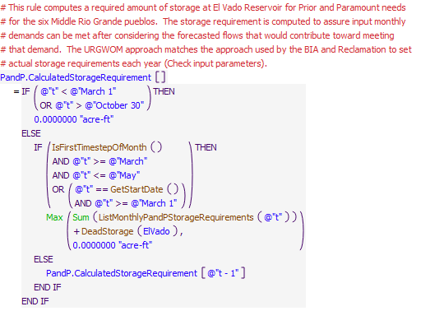
Execution Constraint
Referenced Functions
- DeadStorage
- IsFirstTimestepOfMonth
- ListMonthlyPandPStorageRequirements
- Max
- Sum
- HasRuleFiredSuccessfully
- GetStartDate

5.3 ResetPandPStorageRequirementToMinIfInputAndHigher
Rule Purpose:
URGWOM is set up such that a model user can override a computed P&P storage requirement to assure the storage requirement is greater than or equal to a user input minimum. This flexibility is particularly valuable for AOP modeling where a exact storage requirement may already be known that should be used as a minimum as an override to a potentially lower computed value computed in URGWOM. The separate final storage requirement is recorded and then used for setting P&P storage.
Rule Logic: Execution Constraint logic is at end of explanation.
The FinalStorageRequirement series slot in the PandP data object for the current timestep is set to the maximum of the CalculatedStorageRequirement series slot value or the value in the InputMinPandPStorageRequirement scalar slot in the PandP data object as checked with the predefined Max function. An outer IF THEN ELSE statement is used to check if the date is before March 1 or after October 30 when the storage requirement is set to zero.
This rule fires if the current timestep is greater than or equal to the beginning timestep for rulebased simulation as input by the model user to the RulebasedSimulationStartDate scalar slot in the ModelRunTypeTriggers data object and as identified with the user-defined GetStartDate function and the rule has not fired yet as checked with reference to the predefined HasRuleFiredSuccessfully function.
Model slots written by rule:
1. PandP.FinalStorageRequirement
List of key model objects with slots read by the rule or child functions:
1. ModelRunTypeTriggers
2. PandP
Log of when and how the rule has been modified (newest changes at the top):
Date: Who. What
2/14/19: Jesse Roach. Added description field and updated notes field
Statements
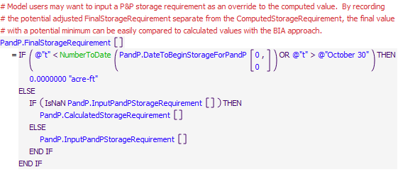
Execution Constraint
Referenced Functions
- NumberToDate
- HasRuleFiredSuccessfully
- GetStartDate

5.4 TallyPandPWaterStoredInArticleVII
Rule Purpose:
This rule records a tally of the P&P water stored while Article VII is in effect. This tally is then referenced when determining whether unused P&P water each year should be evacuated from El Vado Reservoir or transferred to Rio Grande storage at El Vado. The tally adds water stored while Article VII was in effect, subtracts water then evacuated at the end of the year that was stored while Article VII was in effect, and subtracts releases in excess of the amount needed to meet the P&P demand between May and October, which is water not needed and being evacuated as water stored while Article VII was in effect.
Rule Logic: Execution Constraint logic is at end of explanation.
The value in the SumPandPWaterStoredWhileInArticleVII series slot for the current timestep is set with an IF THEN ELSE statement. If the current timestep is January 1 or the start timestep and a value is not input, the previous value is set to the previous storage in the PandP account if the ArticleVII switch value is 1.0 or 0 if not. If a previous value for the tally is input, that value is used.
For subsequent timesteps, the tally is set to the previous value in the SumPandPWaterStoredWhileInArticleVII plus the inflow, as the value of the transfer supply converted to a volume, at the previous timestep if the ArticleVII switch is 1.0 minus the any release from the PandP account out of El Vado Reservoir, based on the corresponding supply, if the date is between the dates to evacuate PandP water at the end of the year, and minus any release made between May and October that is above the release needed to meet the PandP demand at Otowi (i.e. this excess releases is P&P water not needed and being evacuated as water stored while Article VII was in effect).
This rule fires if the rule has not fired yet as checked with reference to the predefined HasRuleFiredSuccessfully function.
Comment:
Model slots written by rule:
1. PandP.SumPandPWaterStoredInArticleVII
List of key model objects with slots read by the rule or child functions:
1. PandP
2. RioGrandeCompact
Log of when and how the rule has been modified (newest changes at the top):
Date: Who. What
2/14/19: Jesse Roach. Added description field and updated notes field
Statements
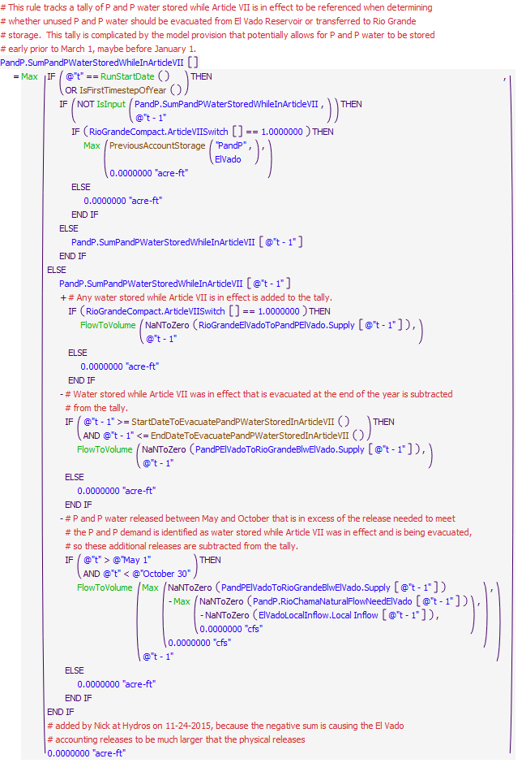
Execution Constraint
Referenced Functions
- IsFirstTimestepOfYear
- EndDateToEvacuatePandPWaterStoredInArticleVII
- StartDateToEvacuatePandPWaterStoredInArticleVII
- Max
- RunStartDate
- FlowToVolume
- IsInput
- HasRuleFiredSuccessfully
- PreviousAccountStorage

5.5 UnneededPandPTransferredBackToRioGrande
Rule Purpose:
This rule sets the transfer of unused P&P water to the Rio Grande account at El Vado Reservoir. Note that any water stored while Article VII was in effect will be evacuated before excess water stored while Article VII was not in effect is transferred to the Rio Grande account. Water may be transferred to the Rio Grande account at the end of the year or during the irrigation season if the P&P storage exceeds the final storage requirement.
Rule Logic: Execution Constraint logic is at end of explanation.
This rule calls the function PandPTransferToRioGrande which checks if the current timestep is after the date in the EvacuationStartDate column of the ParametersToEvacuatePandPWaterStoredInArticleVII table slot in the PandP data object, and the value in the SumPandPWaterStoredWhileInArticleVII series slot is less than 0.01 acre-ft, the accounting supply for the transfer from the PandP account to the Rio Grande account is set to the previous storage in the PandP account at El Vado Reservoir. If the current timestep is between May 1 and October 30 and the tally of water stored while Article VII is in effect is less than 0.01 acre-ft and the value for the Accrual to the PandP account plus water potentially stored early is greater than the storage requirement, and the previous PandP account storage is greater than the storage requirement, the accounting supply is set to the previous storage minus the storage requirement. The latter check allows for water to be moved out of the PandP account if the storage requirement on May 1 decreases from an earlier computed requirement. If those conditions are not satisfied, the accounting supply is set to 0.0 cfs.
This rule fires if the current timestep is greater than or equal to the beginning timestep for rulebased simulation as input by the model user to the RulebasedSimulationStartDate scalar slot in the ModelRunTypeTriggers data object and as identified with the user-defined GetStartDate function and the slot which it writes is not a number in the current timestep.
Comment:
Model slots written by rule:
1. PandPElVadoToRioGrandeElVado.Supply
List of key model objects with slots read by the rule or child functions:
1. ModelRunTypeTriggers
2. PandP
3. ElVado
Log of when and how the rule has been modified (newest changes at the top):
Date: Who. What
2/15/19: Jesse Roach. Added description field and updated notes field
Statements
Execution Constraint
Referenced Functions
- PandPTransferToRioGrande
- GetStartDate

5.6 SetInflowToPandPStorage
Rule Purpose:
This rule sets the transfer from Rio Grande storage to P&P storage at El Vado Reservoir for storing inflows for meeting the P&P storage requirement regardless of whether Article VII of the Compact is in effect. Daily inflows are stored as needed up until the storage requirement is met with available inflows above the minimum El Vado release and above the amount needed for the total Middle Rio Grande irrigation demand. Note that the referenced storage requirement allows for water to be stored up to the minimum possible requirement prior to March 1 if parameters are set accordingly in the model.
Rule Logic: Execution Constraint logic is at end of explanation..
The accounting supply for the transfer of water from the RioGrande account account to the PandP account at El Vado for the current timestep is set using the user-defined InflowToPandPStorage function. The function computes the value as the minimum of the current Rio Grande inflow minus the maximum of the MRGCDDemand slot value in the ElVadoData data object or the minimum Rio Grande outflow identified with the user-defined MinRGOutflow function. If the Rio Grande storage is negative, the available flow for storage is reduced to allow for the Rio Grande account to return to zero storage. The inflow is also restricted to the result from the user-defined ComputePandPStorageSpace function.
The ComputePandPStorageSpace function computes the space with an IF THEN ELSE statement. If the current timestep is prior to March 1 and after the date in the DateToBeginStorageForPandP table slot in the PandP data object as checked with the user-defined StoreEarlyForPandP function, the space is computed as a computed minimum storage requirement, evaluated with the user-defined MinimumPandPStorageRequirement function, minus the storage in the PandP account at the previous timestep plus the cumulative of the Gain Loss values for the account since storage began. When storage is not beginning early, the space is computed as the value in the FinalStorageRequirement slot in the PandP data object for the current timestep minus the previous Accrual to the account minus any water stored early during the previous calendar year as determined with the user-defined PandPWaterStoredEarlyAtEndOfPreviousCalendarYear.
This rule fires if the current timestep is greater than or equal to the beginning timestep for rulebased simulation as input by the model user to the RulebasedSimulationStartDate scalar slot in the ModelRunTypeTriggers data object and as identified with the user-defined GetStartDate function and if the value for the accounting supply to transfer water from the RioGrande account account to the PandP account at El Vado for the current timestep is a NaN
Comment:
Model slots written by rule:
1. RioGrandeElVadoToPandPElVado.Supply
List of key model objects with slots read by the rule or child functions:
1. ModelRunTypeTriggers
2. PandP
3. ElVado
Log of when and how the rule has been modified (newest changes at the top):
Date: Who. What
2/15/19: Jesse Roach. Added description field and updated notes field
Statements
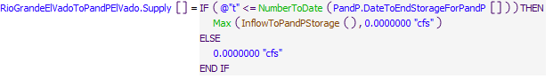
Execution Constraint
Referenced Functions
- InflowToPandPStorage
- Max
- NumberToDate
- GetStartDate

6 ComputeCallForPandPRelease
The rules in this policy group incrementally complete the computations for ultimately computing the call for releases from P&P storage at El Vado Reservoir. The rules are configured to record the steps in the computation such that the incremental calculations can be reviewed from any model run. The call effectively represents the amount of additional water that needs to be released from El Vado Dam to meet a daily demand schedule after considering inflows from the mainstem and native flows above El Vado Reservoir.
Rules in the Group:
ComputeCallForPandPReleaseElVado
RioChamaNaturalFlowNeedForPandPElVado
RioChamaNaturalFlowNeedForPandPOtowi
ComputeFlowFromMainstemForPandPCallCalc
Policy Group Change Log (newest changes at the top):
Date: Who. What

6.1 ComputeFlowFromMainstemForPandPCallCalc
Rule Purpose:
This rule records a value for the flow from the mainstem realized at Otowi for identifying the potential additional water needed to meet the daily P&P irrigation demand at Otowi.
Rule Logic: Execution Constraint logic is at end of explanation.
The value for the NaturalFlowFromMainstemForCallCalc in the PandP data object for the current timestep is set the minimum of the Gage Outflow on the Embudo stream gage object at the previous timestep adjusted based on the Variable GainLoss Coef values for the previous timestep on the EmbudoToConfluence and ConfluenceToOtowi reach objects or the Gage Outflow on the Otowi stream gage object at the previous timestep. That resulting flow is then adjusted based on the appropriate value in the UsableFlowFactorsForCallCalc table slot it the PandP data object. Note that for the model run start timestep, flows are not available to complete the calculation, so the flow at Embudo is used for this first timestep to start the simulation.
This rule fires if the value for the NaturalFlowFromMainstemForCallCalc in the PandP data object for the current timestep is a NaN.
Comment:
Model slots written by rule:
1. PandP.NaturalFlowFromMainstemForCallCalc
List of key model objects with slots read by the rule or child functions:
1. Embudo
2. EmbudoToConfluence
3. Otowi
4. PandP
Log of when and how the rule has been modified (newest changes at the top):
Date: Who. What
2/15/19: Jesse Roach. Added description field and updated notes field
Statements
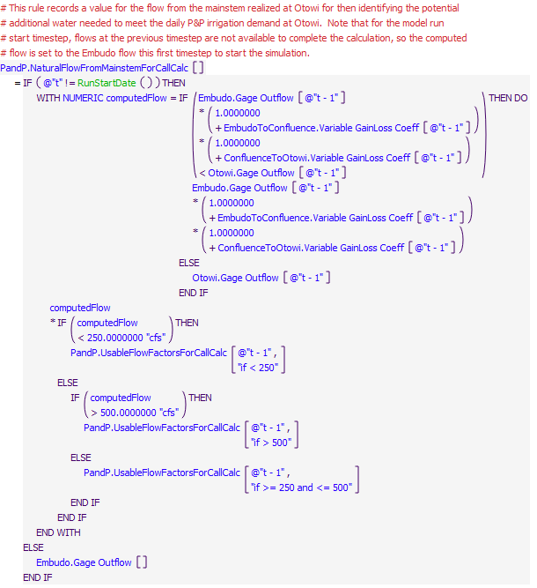
Execution Constraint
Referenced Functions
- RunStartDate

6.2 RioChamaNaturalFlowNeedForPandPOtowi
Rule Description:
This rule records a value for the flow needed from the Rio Chama in addition to the flow provided from the mainstem as needed to meet the daily P&P irrigation demand at Otowi.
Rule Logic: Execution Constraint logic is at end of explanation.
The value for the RioChamaNaturalFlowNeedOtowi in the PandP data object for the next timestep is set with an IF THEN ELSE statement. If the current timestep is between March 1 and November 15 as checked with the user-defined PandPIrrigationSeason function, the next timestep is less than or equal to the Finish Timestep, and the value in the DailyDemandForCallCalc series slot for the next timestep is greater than the value in the NaturalFlowFromMainstemForCallCalc series slot in the PandP data object for the current timestep, a computation is completed. Otherwise, the value is set to 0.0 cfs. The calculation is set as the quantity of the DailyDemandForCallCalc slot value at the next timestep minus the NaturalFlowFromMainstemForCallCalc series slot value for the current timestep multiplied by the appropriate value from the UsableFlowFactorsForCallCalc table slot in the PandP data object as identified with IF THEN ELSE statements.
This rule fires if the value for the RioChamaNaturalFlowNeedOtowi in the PandP data object for the next timestep is a NaN,
Comment:
This rule has not been timestep generalized. It doesn't crash, but likely not accurate at a monthly timestep.
Model slots written by rule:
1. PandP.RioChamaNaturalFlowNeedOtowi
List of key model objects with slots read by the rule or child functions:
1. PandP
2. ElVado
Log of when and how the rule has been modified (newest changes at the top):
Date: Who. What
2/15/19: Jesse Roach. Added description field and updated notes field
Statements
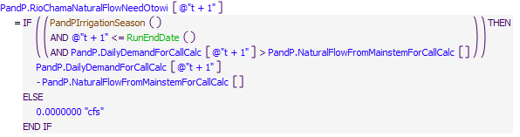
Execution Constraint
Referenced Functions
- PandPIrrigationSeason
- RunEndDate

6.3 RioChamaNaturalFlowNeedForPandPElVado
Rule Purpose:
This rule records a value for the flow needed at El Vado in addition to the flow provided from the mainstem as needed to meet the daily P&P irrigation demand at Otowi. Model loss coefficients for the reaches between El Vado and Otowi from the previous timestep are used to identify the flow needed at El Vado from the flow needed at Otowi.
Rule Logic: Execution Constraint logic is at end of explanation.
The value for the RioChamaNaturalFlowNeedElVado in the PandP data object for the current timestep is set to the value in the RioChamaNaturalFlowNeedOtowi series slot for the next timestep divided by the delivery efficiency from the confluence to Otowi computed as 1.0 plus the previous Variable GainLoss Coef slot value in the ConfluenceToOtowi reach object divided by the delivery efficiency from Abiquiu Dam to Chamita computed as 1.0 plus the previous Variable GainLoss Coef slot value in the BlwAbiquiuToChamita reach object divided by the delivery efficiency from the El Vado Dam to Abiquiu Reservoir computed as 1.0 plus the previous Variable GainLoss Coef slot value in the BlwElVadoToAbvAbiquiu reach object. At the start timestep, the result is set to 0.0 cfs to get the simulation started.
If the value for the RioChamaNaturalFlowNeedElVado in the PandP data object for the next timestep is a NaN, the rule fires.
Comment:
This rule has not been timestep generalized. It doesn't crash, but likely not accurate at a monthly timestep.
Model slots written by rule:
1. PandP.RioChamaNaturalFlowNeedElVado
List of key model objects with slots read by the rule or child functions:
1. ModelRunTypeTriggers
2. PandP
3. ConfluenceToOtowi
4. BlwAbiquiuToChamita
5. BelowElVadoToAbvAbiquiu
Log of when and how the rule has been modified (newest changes at the top):
Date: Who. What
2/15/19: Jesse Roach. Added description field and updated notes field
Statements
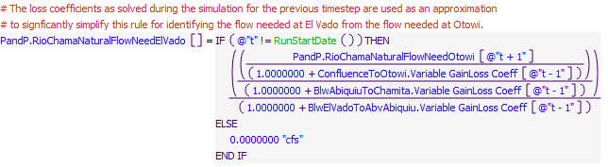
Execution Constraint
Referenced Functions
- RunStartDate

6.4 ComputeCallForPandPReleaseElVado
Rule Purpose:
This rule sets a call for releases of P&P water from storage. The primary purpose of the rule is to set the release as needed to meet the P&P demand at Otowi, but releases are also set to evacuate unused P&P storage that was stored while Article VII was in effect.
Rule Logic: Execution Constraint logic is at end of explanation.
If the current timestep is after the date in the EvacuationStartDate column of the ParametersToEvacuatePandPWaterStoredInArticleVII table slot in the PandP data object and before the date in the EvacuationEndDate column, a release is set to the maximum of the rate to evacuate all the water over the evacuation period or the input value in the TypicalMinimumReleaseRate column of the ParametersToEvacuatePandPWaterStoredInArticleVII table slot in the PandP data object. The release is restricted to not exceed the value in the SumPandPWaterStoredWhileInArticleVII series slot in the PandP data object.
Otherwise, if the current timestep is between May 1 and October 30 and the tally of water stored while Article VII is in effect is greater than 0 acre-ft and the value for the Accrual to the PandP account plus water potentially stored early is greater than the storage requirement, and the previous PandP account storage is greater than the storage requirement, the release is set to value in the TypicalMinimumReleaseRate column of the ParametersToEvacuatePandPWaterStoredInArticleVII table slot in the PandP data object not to exceed the amount of water in the PandP storage account. Else, the release is set to the difference in the value in the RioChamaNaturalFlowNeedElVado series slot minus the value in the Local Inflow series slot in the ElVadoLocalInflow reach object nto to exceed the available storage in the PandP storage account.
This rule fires if the current timestep is greater than or equal to the beginning timestep for rulebased simulation as input by the model user to the RulebasedSimulationStartDate scalar slot in the ModelRunTypeTriggers data object and as identified with the user-defined GetStartDate function and if the value for the PandPReleaseFromElVado series slot in the ComputedDeliveries data object for the next timestep is a NaN.
Comment:
Model slots written by rule:
1. ComputedDeliveries.PandPReleaseFromElVado
List of key model objects with slots read by the rule or child functions:
1. ModelRunTypeTriggers
2. PandP
3. ElVado
4. ComputedDeliveries
Log of when and how the rule has been modified (newest changes at the top):
Date: Who. What
2/15/19: Jesse Roach. Added description field and updated notes field
Statements
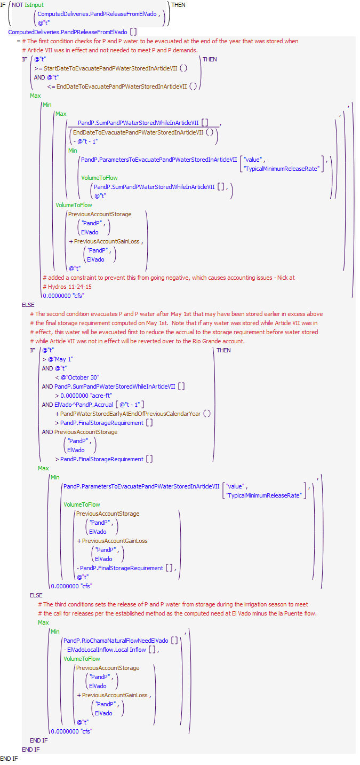
Execution Constraint
Referenced Functions
- EndDateToEvacuatePandPWaterStoredInArticleVII
- PandPWaterStoredEarlyAtEndOfPreviousCalendarYear
- StartDateToEvacuatePandPWaterStoredInArticleVII
- Min
- Max
- VolumeToFlow
- IsInput
- PreviousAccountGainLoss
- GetStartDate
- PreviousAccountStorage

7 El Vado Article VII Accounting
The rules in this policy group are used to move water in the Rio Grande account into a different account when Article VII goes into effect, and to set the accounting supplies for transferring Rio Grande water to Emergency Drought water accounts contingent on availability of tracked allocations for storage. Inflows above the amount needed for P&P storage and the amount needed to meet the MRGCD demand are stored in these accounts when Article VII is in effect and storage allocations are available. Storage of Emergency Drought water is split between MRGCD and ESA based on the available space for each.
Rules in the Group:
SetInflowToEmergencyDroughtWaterAccounts
SetInflowToMRGCDoutofArticleVII
Policy Group Change Log (newest changes at the top):
Date: Who. What

7.1 SetInflowToMRGCDoutofArticleVII
Rule Purpose:
If Article VII goes into effect, and MRGCD water stored outside of Article VII is being tracked, any water stored in the RioGrande account on El Vado is moved in the MRGCDoutofArticleVII account on El Vado.
Rule Logic: Execution Constraint logic is at end of explanation.
An IF THEN ELSE loop is used to move storage in El Vado from the Rio Grande account to the MRGCDoutofArticleVII account if Article VII is in effect but wasnt in effect in the previous timestep, and if MRGCDoutofArticleVII accounting is being used. Otherwise, the supply is set to zero.
This rule fires if the current timestep is greater than or equal to the beginning timestep for rulebased simulation as input by the model user to the RulebasedSimulationStartDate scalar slot in the ModelRunTypeTriggers data object and as identified with the user-defined GetStartDate function, and if the value for the RioGrandeElVadoToMRGCDoutofArticleVIIElVado Supply is NaN in the current timestep.
Comment:
Model slots written by rule:
1. RioGrandeElVadoToMRGCDoutofArticleVIIElVado.Supply
List of key model objects with slots read by the rule or child functions:
1. ModelRunTypeTriggers
2. RioGrandeCompact
3. ElVado
Log of when and how the rule has been modified (newest changes at the top):
Date: Who. What
2/15/19: Jesse Roach. Added description field and updated notes field
Statements
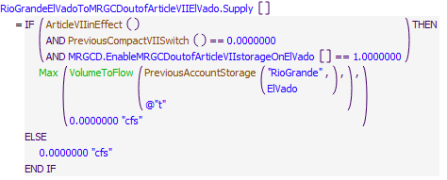
Execution Constraint
Referenced Functions
- PreviousCompactVIISwitch
- ArticleVIIinEffect
- Max
- VolumeToFlow
- GetStartDate
- PreviousAccountStorage

7.2 SetInflowToEmergencyDroughtWaterAccounts
Rule Purpose:
This rule computes the transfer of native Rio Grande inflows to Emergency Drought water storage for MRGCD and ESA. Available inflows not needed for P&P storage and also above the amount needed for meeting the MRGCD demand are stored as Emergency Drought water when Article VII is in effect. Storage of available inflows are split between Emergency Drought water storage for MRGCD and ESA based on the ratio of the available space for the individual use to the total space for both MRGCD and ESA Emergency Drought water where the space reflects the remaining unfilled allocation for storage of Emergency Drought water.
Rule Logic: Execution Constraint logic is at end of explanation.
A WITH DO loop is used to define the inflow to El Vado Reservoir potentially available for Emergency Drought Water storage using the InflowAvailableForStorageAsEmergencyDroughtWaterAtElVado function. The flow available for storage is computed as the estimated Rio Grande inflow minus any required
inflow to P&P storage and minus the amount needed to meet the MRGCD Demand at El Vado. The RioGrandeElVadoToMRGCDDroughtElVado.Supply and RioGrandeElVadoToSupplementalESA.Supply slots to transfer native inflows to Emergency Drought Water storage are set with this rule. The rule contains an IF THEN ELSE statement to identify whether Article VII is in effect, there is space for Emergency Drought water storage for the corresponding Emergency Drought Water account, and the current timestep is in the user defined season for filling Emergency Drought Water storage. If those conditions are not satisfied, the inflow to Emergency Drought Water storage for the account is set to 0.0 cfs. Otherwise, the calculation is set to the minimum of the computed available inflow for Emergency Drought Water storage multiplied by the ratio of the available space for the account to the total available space for both ESA and MRGCD Emergency Drought Water storage and the value derived in the ComputeUserSpaceForEmergencyDroughtWater function (the relinquished Emergency Drought Water allocation minus the previous Emergency Drought water account storage plus gains and losses and the maximum of the value in the Min function and 0.0 cfs.
This rule fires if the current timestep is greater than or equal to the beginning timestep for rulebased simulation as input by the model user to the RulebasedSimulationStartDate scalar slot in the ModelRunTypeTriggers data object and as identified with the user-defined GetStartDate function and the rule has not fired yet as checked with reference to the predefined HasRuleFiredSuccessfully function.
Comment:
Model slots written by rule:
1. RioGrandeElVadoToMRGCDDroughtElVado.Supply
2. RioGrandeElVadoToSupplementalESAElVado.Supply
List of key model objects with slots read by the rule or child functions:
1. ModelRunTypeTriggers
2. RioGrandeCompact
3. ElVado
4. ElVadoData
Log of when and how the rule has been modified (newest changes at the top):
Date: Who. What
2/15/19: Jesse Roach. Added description field and updated notes field
Statements
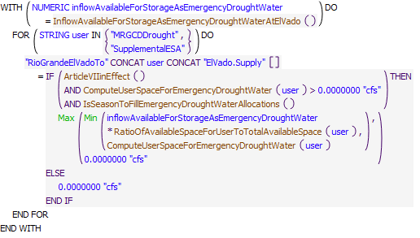
Execution Constraint
Referenced Functions
- ArticleVIIinEffect
- IsSeasonToFillEmergencyDroughtWaterAllocations
- ComputeUserSpaceForEmergencyDroughtWater
- InflowAvailableForStorageAsEmergencyDroughtWaterAtElVado
- RatioOfAvailableSpaceForUserToTotalAvailableSpace
- Min
- Max
- HasRuleFiredSuccessfully
- GetStartDate

8 Set MiddleValleyTargets CochitiDeviationsTargets
The rules in this policy group are used to set Middle Rio Grande target flows per the 2003 Biological Opinion for ESA operations. Rules are used to set targets based on a lookup table, and the targets may then be reset to include step downs in targets to represent the use of supplemental water for discretionary operations or to higher targets at Central for Cochiti deviations.
Rules in the Group:
EndTargetsForOverbankOrRecruitment
ResetCentralTargetForCochitiDeviations and SetConservationSpaceAtCochiti
RecordPeakInflowAndDateForDeviationsRules
ResetIsletaSanAcaciaSanMarcialTargetsForStepDown
MinCentralFlowTarget
MinIsletaSanAcaciaSanMarcialFlowTargets
SetMinTargetsAtStart
Hydrology Year Type
Policy Group Change Log (newest changes at the top):
Date: Who. What

8.1 Hydrology Year Type
Rule Purpose:
This rule is used to set a trigger for the current timestep to 1, 2, or 3 to identify whether the year is classified as Dry, Normal, or Wet, respectively. The result is used later when downstream target flows are determined. These year classifications are established as needed for defining flow targets per the 2003 Biological Opinion. Note that the year classification is checked at the first timestep of each month through May 1st, and the year classification as of May 1st is maintained for the remainder of the calendar year. If Article VII is in effect or the Otowi forecast is less than 80 percent of average, the year is classified as dry. If the forecast is greater than 120 percent of average, the year is classified as wet.
Rule Logic: Execution Constraint logic is at end of explanation.
The HydrologyYearType time series slot in the MiddleValleyTargets data object is set using IF THEN ELSE statements. If the current timestep is the Start Timestep or the first day of a month on or before May 1, the following criteria are checked for potentially adjusting the hydrology year type. Otherwise, the same established year classification from the previous timestep is maintained. If the stipulations in Article VII of the Compact apply, the value is set to 1.0 to identify that it is a Dry year. Otherwise, the OtowiForecast for the current year computed with the ComputeOtowiForecast Rule is checked against the input AverageOtowiForecast in the PandP data object multiplied by the corresponding forecast factor entered in the ForecastFactorsForHydYearType table slot in the MiddleValleyTargets data object. If the forecast is less than or equal to the average forecast times the Dry forecast factor, the value for the HydrologyYearType slot is set to 1.0 to identify that it is a Dry year. If the Otowi forecast is greater than the average forecast times the Wet forecast factor, the value is set to 3.0 to identify that it is a Wet year. If none of the preceding criteria applies, the value is set to 2.0 to identify that is a Normal year.
This rule fires if the current timestep is greater than or equal to the beginning timestep for rulebased simulation as input by the model user to the RulebasedSimulationStartDate scalar slot in the ModelRunTypeTriggers data object and the value for the HydrologyYearType series slot in the MiddleValleyTargets data object is a NaN for the current timestep.
Model slots written by rule:
1. MiddleValleyTargets.HydrologyYearType
List of key model objects with slots read by the rule or child functions:
1. ModelRunTypeTriggers
2. RioGrandeCompact
3. PandP
Log of when and how the rule has been modified (newest changes at the top):
Date: Who. What
2/18/19: Jesse Roach. Added description field and updated notes field
Statements
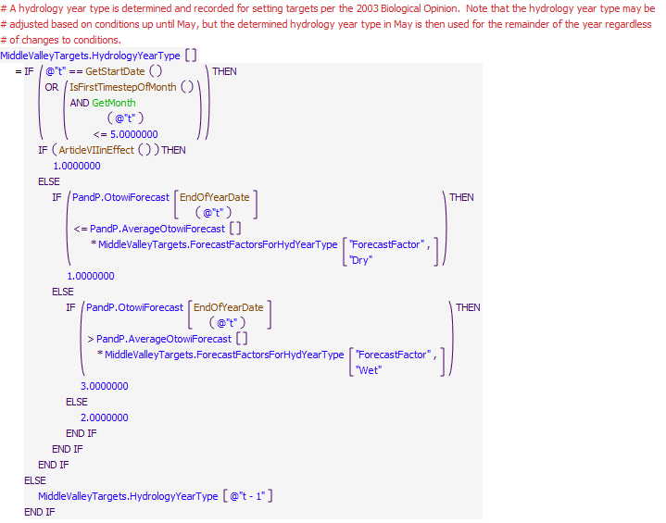
Execution Constraint
Referenced Functions
- ArticleVIIinEffect
- EndOfYearDate
- IsFirstTimestepOfMonth
- GetMonth
- GetStartDate

8.2 SetMinTargetsAtStart
Rule Purpose:
This rule is used to set a trigger for the current timestep to 1, 2, or 3 to identify whether the year is classified as Dry, Normal, or Wet, respectively. The result is used later when downstream target flows are determined. These year classifications are established as needed for defining flow targets per the 2003 Biological Opinion. Note that the year classification is checked at the first timestep of each month through May 1st, and the year classification as of May 1st is maintained for the remainder of the calendar year. If Article VII is in effect or the Otowi forecast is less than 80 percent of average, the year is classified as dry. If the forecast is greater than 120 percent of average, the year is classified as wet.
Rule Logic: Execution Constraint logic is at end of explanation.
The HydrologyYearType time series slot in the MiddleValleyTargets data object is set using IF THEN ELSE statements. If the current timestep is the Start Timestep or the first day of a month on or before May 1, the following criteria are checked for potentially adjusting the hydrology year type. Otherwise, the same established year classification from the previous timestep is maintained. If the stipulations in Article VII of the Compact apply, the value is set to 1.0 to identify that it is a Dry year. Otherwise, the OtowiForecast for the current year computed with the ComputeOtowiForecast Rule is checked against the input AverageOtowiForecast in the PandP data object multiplied by the corresponding forecast factor entered in the ForecastFactorsForHydYearType table slot in the MiddleValleyTargets data object. If the forecast is less than or equal to the average forecast times the Dry forecast factor, the value for the HydrologyYearType slot is set to 1.0 to identify that it is a Dry year. If the Otowi forecast is greater than the average forecast times the Wet forecast factor, the value is set to 3.0 to identify that it is a Wet year. If none of the preceding criteria applies, the value is set to 2.0 to identify that is a Normal year.
This rule fires if the current timestep is greater than or equal to the beginning timestep for rulebased simulation as input by the model user to the RulebasedSimulationStartDate scalar slot in the ModelRunTypeTriggers data object and the value for the HydrologyYearType series slot in the MiddleValleyTargets data object is a NaN for the current timestep.
Model slots written by rule:
1. MiddleValleyTargets.HydrologyYearType
List of key model objects with slots read by the rule or child functions:
1. ModelRunTypeTriggers
2. RioGrandeCompact
3. PandP
Log of when and how the rule has been modified (newest changes at the top):
Date: Who. What
2/18/19: Jesse Roach. Added description field and updated notes field
Statements
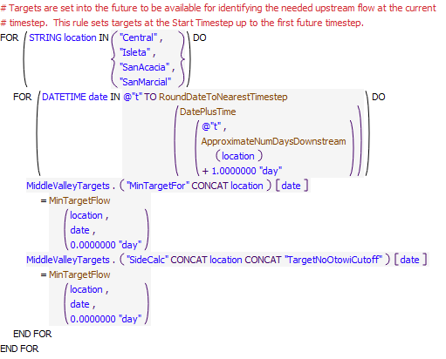
Execution Constraint
Referenced Functions
- DatePlusTime
- RoundDateToNearestTimestep
- MinTargetFlow
- ApproximateNumDaysDownstream
- HasRuleFiredSuccessfully
- GetStartDate

8.3 MinIsletaSanAcaciaSanMarcialFlowTargets
Rule Purpose:
This rule is used to set the downstream flow targets at Isleta, San Acacia, and San Marcial based on the hydrology year type and with consideration for the input adjustment factor. (The target for Central is set separately to prevent priority conflicts with the potential alternate policy for resetting Central targets for recruitment or overbank flows as a result of Cochiti deviations.) Targets are actually set into the future based on the travel time from Abiquiu Dam to the target location. Targets are set to zero after the year-to-date Otowi flow volume has exceeded the input threshold volume for conserving supplemental leased San Juan-Chama Project water and if there is no Emergency Drought water available (i.e. there is no storage in the SupplementalESA account at El Vado Reservoir). Policy for this proposed action of conserving supplemental leased San Juan-Chama Project in wetter years may be turned off by inputting a very high threshold Otowi flow volume.
Rule Logic: Execution Constraint logic is at end of explanation.
A FOR DO loop is used to record the downstream flow targets for the timestep equal to the current timestep plus one timestep (the approximate travel time from Abiquiu Dam to Cochiti) plus the travel time from Cochiti to the target location for the following three time series slots in the MiddleValleyTargets data object: MinTargetForIsleta, MinTargetForSanAcacia, and MinTargetForSanMarcial. If the year-to-date modeled flow volume in the Gage Outflow series slot for the Otowi stream gage object is less than the input value in the ThresholdOtowiVolumeHoldLeaseWater scalar slot in the MiddleValleyTargets data object or the storage in the SupplementalESA account at El Vado Reservoir at the previous timestep is greater than zero, the target is determined with reference to the user-defined MinTargetFlow function as a function of the date, hydrology year type, and target flow adjustment factor. The target flows for each location, based on date and hydrology year type, are input to the MinTargetFlows periodic slot in the MiddleValleyTargets data object, and the target flow adjustment factor for each target location and each month is input to the MinTargetFlowsSafetyFactor periodic slot in the MiddleValleyTargets data object. If the condition is not satisfied, the target is set to zero.
An outer IF THEN ELSE statement is included such that the year-to-date Otowi flow volume is not checked if the current timestep is the Start Timestep or January 1. An additional assignment statement is also included to record what the targets would be if the values were not reset to zero after the year-to-date Otowi flow volume exceeds the threshold volume. These assignments are made to three series slots for the target locations that end with TargetNoOtowiCutoff in the MiddleValleyTargets data object.
This rule executes if the value in the MinTargetForSanMarcial series slot in the Middle Valley Demands data object is a NaN for the timestep equal to t+1 plus the result from the user-defined ApproximateNumDaysDownstream function for San Marcial.
Model slots written by rule:
1. MiddleValleyTargets.MinTargetForLOCATION where LOCATION is Isleta, SanAcacia, and SanMarcial
2. MiddleValleyTargets.SideCalcLOCATIONTargetNoOtowiCutoff where LOCATION is Isleta, SanAcacia, and SanMarcial
List of key model objects with slots read by the rule or child functions:
1. MiddleValleyTargets
2. Otowi
3. ElVado
Log of when and how the rule has been modified (newest changes at the top):
Date: Who. What
2/18/19: Jesse Roach. Added description field and updated notes field
11/10/17 JR: updated during timestep generalization of MRG rules.
Statements
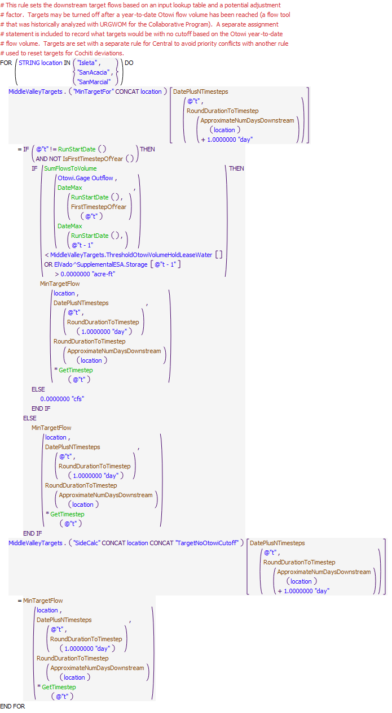
Execution Constraint
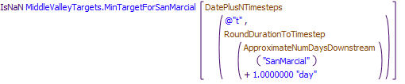
Referenced Functions
- DatePlusNTimesteps
- RoundDurationToTimestep
- FirstTimestepOfYear
- IsFirstTimestepOfYear
- MinTargetFlow
- ApproximateNumDaysDownstream
- SumFlowsToVolume
- GetTimestep
- RunStartDate
- DateMax

8.4 MinCentralFlowTarget
Rule Purpose:
This rule is used to set the downstream flow target at Central based on the hydrology year type and with consideration for the input adjustment factor. (The target for Central is set separately to prevent conflicts with the potential alternate policy for resetting Central targets for recruitment or overbank flows as a result of Cochiti deviations.) The target is set into the future at a daily timestep based on the travel time from Abiquiu Dam to Central. The target may be set to zero after the year-to-date Otowi flow volume has exceeded the input threshold volume for conserving supplemental leased San Juan-Chama Project water and if there is no Emergency Drought water available (i.e. there is no storage in the SupplementalESA account at El Vado Reservoir). Policy for this proposed action of conserving supplemental leased San Juan-Chama Project in wetter years may be turned off by inputting a very high threshold Otowi flow volume. Note that the rule for resetting the Central targets for Cochiti deviations is higher priority and targets will be subsequently be changed for deviations if deviations are implemented.
Rule Logic: Execution Constraint logic is at end of explanation.
The downstream flow target for the MinTargetForCentral time series slot in the MiddleValleyTargets data object is set for the timestep equal to the current timestep plus one timestep (the approximate travel time from Abiquiu Dam to Cochiti) plus the travel time from Cochiti to Central. If the year-to-date modeled flow volume in the Gage Outflow series slot for the Otowi stream gage object is less than the input value in the ThresholdOtowiVolumeHoldLeaseWater scalar slot in the MiddleValleyTargets data object or the storage in the SupplementalESA account at El Vado Reservoir at the previous timestep is greater than zero, the target is determined with reference to the user-defined MinTargetFlow function as a function of the date, hydrology year type, and target flow adjustment factor. The target flow, based on the date and hydrology year type, is input to the MinTargetFlows periodic slot in the MiddleValleyTargets data object, and the target flow adjustment factor for each target location and each month is input to the MinTargetFlowsSafetyFactor periodic slot in the MiddleValleyTargets data object. If the condition is not satisfied, the target is set to zero.
An outer IF THEN ELSE statement is included such that the year-to-date Otowi flow volume is not checked if the current timestep is the Start Timestep or January 1. An additional assignment statement is also included to record what the targets would be if the values were not reset to zero after the year-to-date Otowi flow volume exceeds the threshold volume. This assignment is made to the SideCalcCentralTargetNoOtowiCutoff series slot in the MiddleValleyTargets data object.A target flow at Central is set with a separate rule such that priority conflicts do not cause problems with setting targets for other locations when the Central target may be set higher for Cochiti Deviations. The Central target is first set here with reference to a lookup table for the time of year and hydrology year type. The Central target may be set to zero if a model user input threshold high Otowi year-to-date flow volume has been exceeded and Reclamation leased water should be conserved for the next year.
This rule executes if the value in the MinTargetForCentral series slot in the MiddleValleyTargets data object is a NaN for the timestep equal to t+1 plus the result from the user-defined ApproximateNumDaysDownstream function for Central.
Model slots written by rule:
1. MiddleValleyTargets.MinTargetForCentral
2. MiddleValleyTargets.SideCalcCentralTargetNoOtowiCutoff
List of key model objects with slots read by the rule or child functions:
1. MiddleValleyTargets
2. Otowi
3. ElVado
Log of when and how the rule has been modified (newest changes at the top):
Date: Who. What
2/18/19: Jesse Roach. Added description field and updated notes field
11/10/17 JR: updated during timestep generalization of MRG rules.
Statements
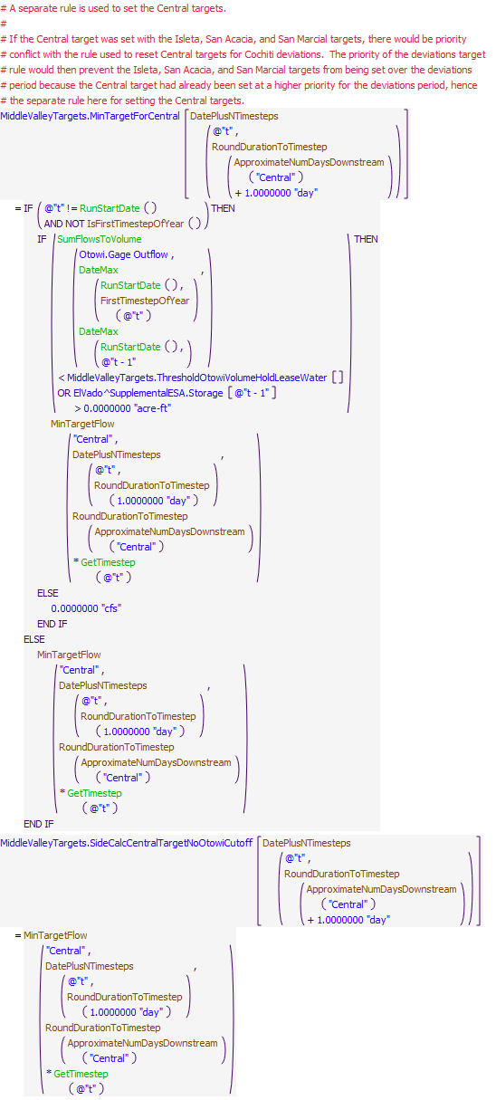
Execution Constraint
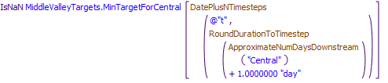
Referenced Functions
- DatePlusNTimesteps
- RoundDurationToTimestep
- FirstTimestepOfYear
- IsFirstTimestepOfYear
- MinTargetFlow
- ApproximateNumDaysDownstream
- SumFlowsToVolume
- GetTimestep
- RunStartDate
- DateMax

8.5 ResetIsletaSanAcaciaSanMarcialTargetsForStepDown
Rule Purpose:
Targets may be reset in URGWOM for discretionary operations as conducted under the Biological Opinion (Service, 2003) which entail using supplemental water to manage the recession after the runoff and control the rate of drying after river rewetting for minnow salvage. Policy for representing discretionary operations entails implementing a longer step down in targets at the end of the runoff and shorter step downs in targets thereafter following each river rewetting event. Note that a step down in targets as needed after the continuous flow requirement if the runoff ends before the continuous flow requirement is over would be represented separately and would need to be included in the input target table.
This rule resets the targets for a 30-day step down to manage recession at the first occurrence of river drying. The definition of drying and the shape of the step down in targets are set based on input threshold flows and target values. Any input adjustment factor is applied to the computed step down in targets. Targets are not set for discretionary operations if the threshold year-to-date Otowi flow volume for conserving leased San Juan-Chama Project water has been exceeded and there is no Emergency Drought water.
Rule Logic: Execution Constraint logic is at end of explanation.
A FOR DO loop is used to reset the downstream flow targets for the timestep equal to the current timestep plus one timestep (the approximate travel time from Abiquiu Dam to Cochiti) plus the travel time from Cochiti to the target location for the following three time series slots in the MiddleValleyTargets data object: MinTargerForIsleta, MinTargetForSanAcacia, and MinTargetForSanMarcial. If the year-to-date modeled flow volume in the Gage Outflow series slot for the Otowi stream gage object is less than the input value in the ThresholdOtowiVolumeHoldLeaseWater scalar slot in the MiddleValleyTargets data object or the storage in the SupplementalESA account at El Vado Reservoir at the previous timestep is greater than zero, the target is computed using the user-defined ComptueTargetInStepDown function based on the input values for the final target in the step down, initial target in the step down, number of steps, and duration of the step down. The adjustment factor is then applied to the computed target. If the condition is not satisfied, the target is set to the original table value with reference to the user-defined MinTargetFlow function.
An outer IF THEN ELSE statement is included such that the year-to-date Otowi flow volume is not checked if the current timestep is the Start Timestep or January 1. An additional assignment statement is also included using similar logic except without the check against the year-to-date Otowi flow volume to record what the targets would be if the values were not reset to zero after the year-to-date Otowi flow volume exceeds the threshold volume. These assignments are made to three time series slots for the target locations that end with TargetNoOtowiCutoff in the MiddleValleyTargets data object. Also, another assignment statement is included to set the value in the StepDownImplementedCounter series slot in the MiddleValleyTargets data object to track the number of timesteps since the step down was implemented as needed for computing the target during the step down period.
This rule fires if the rule has not fired successfully for the current timestep as determined with reference to the predefined HasRuleFiredSuccessfully function and a switch is set to implement the operation based on an input value greater than zero in the TriggerImplementStepDownInTargets scalar slot in the MiddleValleyTargets data object and river drying has initiated as checked with the user-defined TimeToStartStepDownInTargets function or an initiated step down in targets needs to continue as checked with the TimeToContinueStepDownInTargets function.
Model slots written by rule:
1. MiddleValleyTargets.MinTargetForLOCATION where LOCATION is Isleta, SanAcacia, and SanMarcial
2. MiddleValleyTargets.SideCalcLOCATIONTargetNoOtowiCutoff where LOCATION is Isleta, SanAcacia, and SanMarcial
List of key model objects with slots read by the rule or child functions:
1. MiddleValleyTargets
2. Otowi
3. ElVado
Log of when and how the rule has been modified (newest changes at the top):
Date: Who. What
2/18/19: Jesse Roach. Added description field and updated notes field
Statements
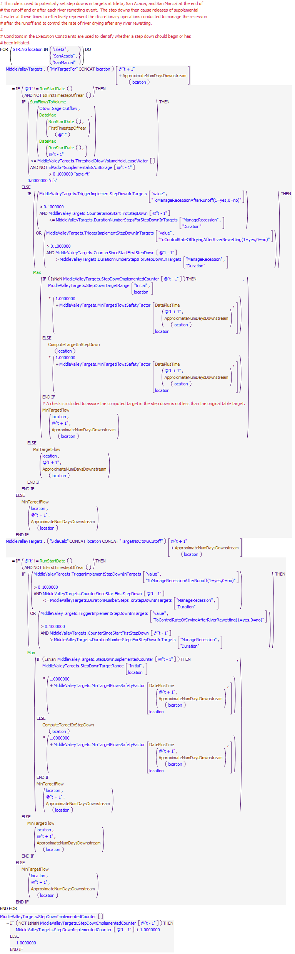
Execution Constraint
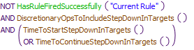
Referenced Functions
- DatePlusTime
- FirstTimestepOfYear
- IsFirstTimestepOfYear
- MinTargetFlow
- ApproximateNumDaysDownstream
- ComputeTargetInStepDown
- TimeToStartStepDownInTargets
- DiscretionaryOpsToIncludeStepDownInTargets
- TimeToContinueStepDownInTargets
- SumFlowsToVolume
- Max
- RunStartDate
- DateMax
- HasRuleFiredSuccessfully

8.6 RecordPeakInflowAndDateForDeviationsRules
Rule Description:
This rule records a date and magnitude for the estimated peak inflow to Cochiti Lake. The values are then referenced later when setting operations for Cochiti deviations to target storage before the peak with releases of temporary storage then made to augment the peak flow for better providing recruitment or overbank flows in the Middle Rio Grande for ESA interests.
Rule Logic: Execution Constraint logic is at end of explanation..
Two assignment statements are included in this rule that each contain an IF THEN statement to make assignments if values are not input as checked with the predefined IsInput function. Values for the EstimatedPeakInflow and EstimatedPeakInflowDate annual timestep slots are set to the two resulting values from using the user-defined CochitiMaxInflowAndDateList function which creates a two item list with the magnitude of the flow and the date for the maximum inflow between two input dates. A WITH DO loop is used in the CochitiMaxInflowAndDate function to create a list of estimated flows for each date between the the two input dates defined with the user-defined RecruitmentOrOverbankSeasonStartDate and RecruitmentOrOverbankSeasonEndDate functions. Future inflows are estimated based on input inflows to the model and are computed with consideration for the restriction to flows past Abiquiu to the channel capacity below Abiquiu Dam. A final list is created with the maximum flow and corresponding date.
This rule executes if the current timetep is equal to the date before the beginning of the Cochiti deviations period as identified with the RecruitmentOrOverbankSeasonStartDate function or the start timestep is later in the year as checked with the predefined DateMax function or on the rulebased simulation start timestep if later. The estimated date and magnitude of the Cochiti peak inflow is recorded once a year
Model slots written by rule:
1. CochitiDeviations.EstimatedPeakInflow
List of key model objects with slots read by the rule or child functions:
1. CochitiDeviations
2. AbiquiuData
3. ForecastData
4. Various model inflows
Log of when and how the rule has been modified (newest changes at the top):
Date: Who. What
2/18/19: Jesse Roach. Added description field and updated notes field
11/17/17 JR: Added execution constraint so that rule doesn't fire at monthly timestep
Statements
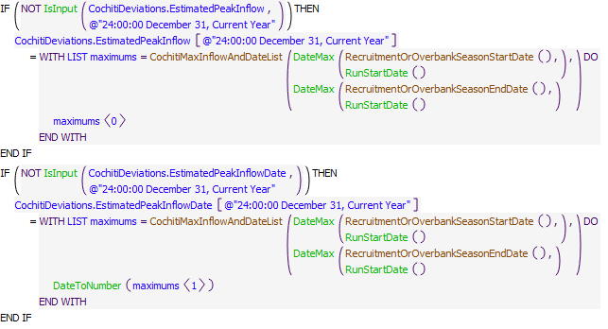
Execution Constraint
Referenced Functions
- RecruitmentOrOverbankSeasonEndDate
- RecruitmentOrOverbankSeasonStartDate
- CochitiMaxInflowAndDateList
- GetTimestep
- RunStartDate
- DateMax
- DateToNumber
- IsInput
- GetStartDate

8.7 ResetCentralTargetForCochitiDeviations and SetConservationSpaceAtCochiti
Rule Purpose:
This rule is used to reset the downstream flow targets at Central to provide either a recruitment hydrograph or an overbank hydrograph if Cochiti deviations are implemented. The targets for the entire hydrograph are set on the determined date, or input date, to begin storage at Cochiti Lake for deviations. The computed date is based on an input number of days prior to the estimated date of the peak inflow to Cochiti. The available conservation space at Cochiti is also then set for the corresponding operation based on a lookup table if a value was not input. If deviations are not being modeled, the amount of conservation space is set to a separate input amount which may likely be zero. Deviations are not implemented if the current timestep is after the last year that deviations are implemented as input. The rule also includes assignments to a trigger slot to record which operation was conducted.
Rule Logic: Execution Constraint logic is at end of explanation.
The rule contains an IF THEN ELSE statement to check whether conditions are satisfied to reset targets for recruitment or for overbank flows. Two assignment statements are included after conditions are checked to reset Central targets for the corresponding operation and to set an amount of conservation space available at Cochiti Lake for deviations operations.
The following conditons are checked first. If the Otowi forecast is within the range for conducting deviations to provide overbank flows as checked with the user-defined IsOverbankForecastRange function and the projected peak inflow to Cochiti is within the range for conducting deviations to provide overbank flows as input to the EnvironmentalMinMaxPeakFlows table slot in the CochitiDeviations data object or the Otowi forecast is within the range for conducting deviations to provide recruitment flows but the projected peak inflow to Cochiti is within the range for conducting deviations to provide overbank flows as input to the EnvironmentalMinMaxPeakFlows table slot, operations are set to provide overbank flows. If the Otowi forecast is within the range for conducting deviations to provide recruitment flows as checked with the user-defined IsRecruitmentForecastRange function and the projected peak inflow to Cochiti is within the range for conducting deviations to provide recruitment flows as input to the EnvironmentalMinMaxPeakFlows table slot in the CochitiDeviations data object or the Otowi forecast is within the range for conducting deviations to provide overbank flows but the projected peak inflow to Cochiti is less than the minimum for conducting deviations to provide overbank flows as input to the EnvironmentalMinMaxPeakFlows table slot, operations are conducted to provide recruitment flows.
For each condition, A FOR DO loop is then used to set the MinTargetForCentral series slot in the MiddleValleyTargets data object for the list of dates and corresponding targets for the operation as created with the user-defined EnvironmentalMinRelease function. The EnvironmentalMinRelease function identifies the list of targets to provide flows for the corresponding operation, overbank or recruitment, from the EnvironmentalTargets table slot in the MiddleValleyTargets data object.
Another IF THEN ELSE statement is used for each condition to set the value for the ComputedRGConservationSpaceAvailable annual time series slot in the CochitiDeviations data object if a value was not input. The allowable conservation space is set using the predefined TableLookup function with reference to the Otowi forecast as a percent of average and referencing the column for the corresponding operation, overbank or recruitment, in the RGConservationSpaceTable in the CochitiDeviations data object. If conditions for deviations are not satisfied, the slot value is set to the input value to the FullTimeRGConservationSpaceAvailableNotRelevantToDeviations table slot in the CochitiDeviations data object.
A trigger is also set for each condition to the ModeledDeviationsIndicator1forRecrutimentOr2forOverbank slot to record which operations was modeled.
This rule fires if the rule has not fired successfully yet as checked with reference to the user-defined HasRuleFiredSuccessfully function, the current timestep is greater than or equal to the beginning timestep for rulebased simulation as input by the model user to the RulebasedSimulationStartDate scalar slot in the ModelRunTypeTriggers data object, the value in the ModelDeviations(1=yes,0=no) column of the ModelUserControlTrigger table slot in the CochitiDeviations data object equals 1.0, and the current timestep is before the date input to the LastYearCochitiDeviationsAuthorized table slot. In addition to those conditions, a check is included to check if the switch is set to use an input date for Cochiti deviations as checked with the UsePresetDayForCochitiDeviationsStorage function. If so, the current timestep is checked to see if it is equal to the value in the PresetDayForCochitiDeviationsStorage table slot in the CochitiDeviations data object; otherwise, the current timestep is checked to see if it is equal to the value in the EstimatedPeakInflowDate annual timestep slot offset by the value in the DaysOfCochitiDeviationsStorageBeforePeak scalar slot.
Model slots written by rule:
1. MiddleValleyTargets.MinTargetForCentral
2. MiddleValleyTargets.SideCalcCentralTargetNoOtowiCutoff
List of key model objects with slots read by the rule or child functions:
1. ModelRunTypeTriggers
2. CochitiDeviations
3. MiddleValleyTargets
Log of when and how the rule has been modified (newest changes at the top):
Date: Who. What
2/18/19: Jesse Roach. Added description field and updated notes field
Statements
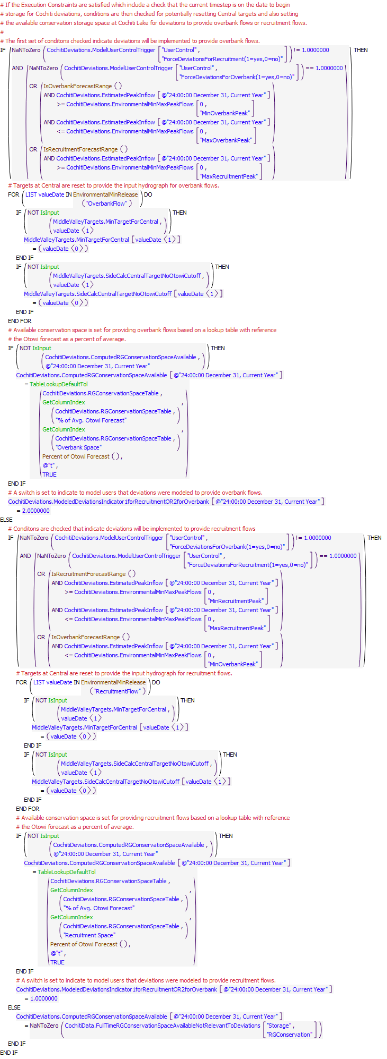
Execution Constraint
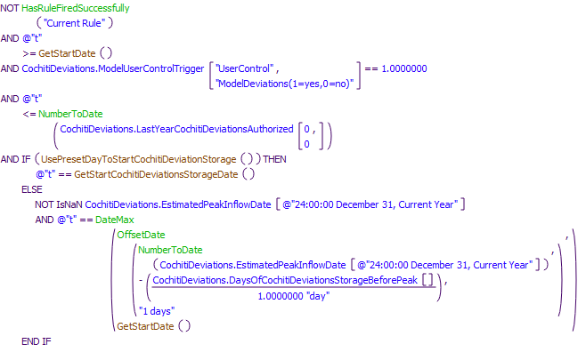
Referenced Functions
- GetStartCochitiDeviationsStorageDate
- UsePresetDayToStartCochitiDeviationStorage
- IsRecruitmentForecastRange
- EnvironmentalMinRelease
- IsOverbankForecastRange
- Percent of Otowi Forecast
- NumberToDate
- DateMax
- OffsetDate
- GetColumnIndex
- TableLookupDefaultTol
- IsInput
- HasRuleFiredSuccessfully
- GetStartDate

8.8 EndTargetsForOverbankOrRecruitment
Rule Purpose:
This rule is used to reset targets at Central set for Cochiti deviations back to the original table targets if conservation storage at Cochiti Lake drops below a threshold low volume. This adjustment is required to prevent supplemental leased San Juan-Chama Project water or Emergency Drought water from being used to provide recruitment or overbank flows after conservation storage is no longer available from Cochiti deviations.
Rule Logic: Execution Constraint logic is at end of explanation.
A FOR DO loop is used to record the downstream flow target for the MinTargetForCentral time series slot in the MiddleValleyTargets data object for the timestep equal to the current timestep plus one timestep (the approximate travel time from Abiquiu Dam to Cochiti) plus the travel time from Cochiti to Central. If the year-to-date modeled flow volume in the Gage Outflow series slot for the Otowi stream gage object is less than the input value in the ThresholdOtowiVolumeHoldLeaseWater scalar slot in the MiddleValleyTargets data object or the storage in the SupplementalESA account at El Vado Reservoir at the previous timestep is greater than zero, the target is determined with reference to the user-defined MinTargetFlow function as a function of the date, hydrology year type, and target flow adjustment factor. The target flow, based on the date and hydrology year type, is input to the MinTargetFlows periodic slot in the MiddleValleyTargets data object, and the target flow adjustment factor for each target location and each month is input to the MinTargetFlowsSafetyFactor periodic slot in the MiddleValleyTargets data object. If the condition is not satisfied, the target is set to zero.
This rule fires if a value has been set in the MinTargetForCentral series slot in the MiddleValleyTargets data object for the timestep equal to the current timestep plus one timestep (the approximate travel time from Abiquiu Dam to Cochiti) plus the travel time from Cochiti to Central and that value is greater than the value set with reference to the original target table and the storage in the RioGrandeConservation account at Cochiti Lake at the previous timestep is less than the input value in the LowStorageToEndDeviationsTargets scalar slot in the CochitiDeviations data object.
Model slots written by rule:
1. MiddleValleyTargets.MinTargetForCentral
2. MiddleValleyTargets.SideCalcCentralTargetNoOtowiCutoff
List of key model objects with slots read by the rule or child functions:
1. CochitiDeviations
2. MiddleValleyTargets
3. CochitiData
Log of when and how the rule has been modified (newest changes at the top):
Date: Who. What
2/18/19: Jesse Roach. Added description field and updated notes field
11/17/17 JR: Added execution constraint so that rule doesn't fire at monthly timestep
Statements
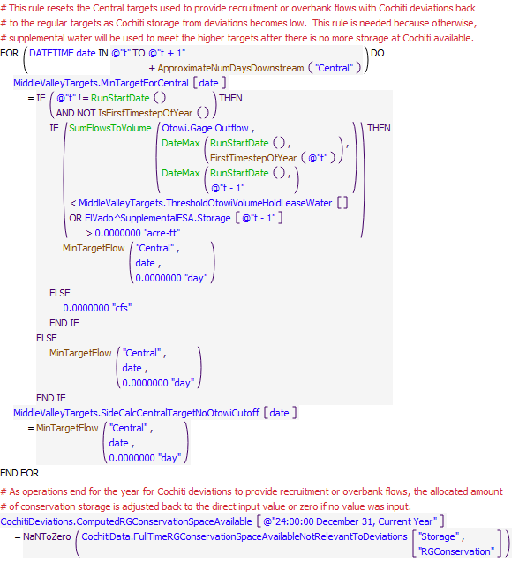
Execution Constraint
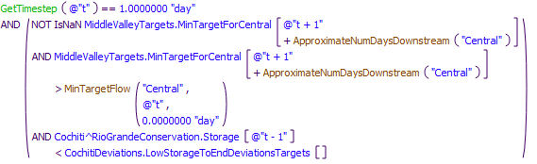
Referenced Functions
- FirstTimestepOfYear
- IsFirstTimestepOfYear
- MinTargetFlow
- ApproximateNumDaysDownstream
- SumFlowsToVolume
- GetTimestep
- RunStartDate
- DateMax

9 EstimatedCochitiInflowAvailableForMiddleValleyDemands
The rules in this policy group are used to develop an estimated inflow to Cochiti Lake available for Middle Rio Grande demands. The calculation is completed in separate steps with the results recorded to series slots that allows for model users to compare the estimates to the resulting modeled flows for each step. The inflow to Cochiti is then used to reset MRGCD diversions if needed for that flow to prevent supplemental water for targets from being diverted.
Rules in the Group:
EstimateCochitiInflowAvailableForMiddleValleyDemands
EstimateAbiquiuRGInflow
EstimateElVadoRGOutflow
Policy Group Change Log (newest changes at the top):
Date: Who. What

9.1 EstimateElVadoRGOutflow
Rule Purpose:
This rule estimates the outflow from El Vado Dam that will be available for meeting the MRGCD demand plus any additional inflows that are bypassed if Article VII is in effect. The computation includes bypassed inflows, any release of P&P water, and any release from available storage to meet the MRGCD demand.
Rule Logic: Execution Constraint logic is at end of explanation.
The value for the EstimatedElVadoRGOutflow series slot in the MRGCD data object for the current timestep is set to the result of the ComputeEstimateElVadoRGOutflow function. That function computes an initial potential outflow as the MRGCD demand at El Vado restricted if needed to the available bypassed inflow plus available water in storage released to meet the demand. Bypassed inflows are set to the value for the Local Inflow series slot on the ElVadoLocalInflow reach object for the current timestep minus the three accounting supplies for transferring inflow to the PandP, MRGCDDrought, and SupplementalESA accounts. Water available in storage to also contribute to meet the demand is equal to the previous storage in the Rio Grande account plus all pending transfers to the MRGCD San Juan-Chama account at the current timestep plus any water transferred from the PandP account back to the RioGrande account plus all Emergency Drought water in storage for MRGCD. Any pending release from the PandP account is also included.
If Article VII is in effect as checked with the user-defined ArticleVIIInEffect function, the resulting initial potential outflow for meeting the MRGCD demand is increased to include all bypassed inflows and any release form PandP storage.
This rule fires if the current timestep is greater than or equal to the beginning timestep for rulebased simulation as input by the model user to the RulebasedSimulationStartDate scalar slot in the ModelRunTypeTriggers data object and the rule has not fired yet as checked with reference to the predefined HasRuleFiredSuccessfully function.
Model slots written by rule:
1. MRGCD.EstimatedElVadoRGOutflow
List of key model objects with slots read by the rule or child functions:
1. ModelRunTypeTriggers
2. ElVadoData
3. HeronData
4. RioGrandeCompact
5. ComputedDeliveries
Log of when and how the rule has been modified (newest changes at the top):
Date: Who. What
2/18/19: Jesse Roach. Added description field and updated notes field
Statements
Execution Constraint
Referenced Functions
- ComputeEstimatedElVadoRGOutflow
- HasRuleFiredSuccessfully
- GetStartDate

9.2 EstimateAbiquiuRGInflow
Rule Purpose:
This rule estimates the inflow to Abiquiu Reservoir based on the estimated outflow from El Vado Dam.
Rule Logic: Execution Constraint logic is at end of explanation.
The value for the EstimatedAbiquiuRGInflow series slot for the next timestep is set using the user-defined RouteElVadoRGOutflowToAbiquiu function which references the predefined HypSim function to complete hypothetical simulation for the reach from El Vado to Abiquiu with an upstream flow equal to the value in the EstimatedElVadoRGOutflow series slot in the MRGCD data object set by the previous rule.
This rule fires if the current timestep is greater than or equal to the beginning timestep for rulebased simulation as input by the model user to the RulebasedSimulationStartDate scalar slot in the ModelRunTypeTriggers data object and the rule has not fired yet as checked with reference to the predefined HasRuleFiredSuccessfully function.
Model slots written by rule:
1. MRGCD.EstimatedAbiquiuRGInflow
List of key model objects with slots read by the rule or child functions:
1. ModelRunTypeTriggers
2. MRGCD
3. Objects in "BelowElVado" subbasin
Log of when and how the rule has been modified (newest changes at the top):
Date: Who. What
2/18/19: Jesse Roach. Added description field and updated notes field11/10/17 JR: updated during timestep generalization of MRG rules.
Statements
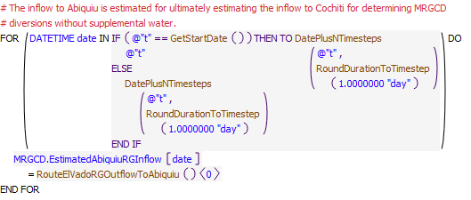
Execution Constraint
Referenced Functions
- DatePlusNTimesteps
- RoundDurationToTimestep
- RouteElVadoRGOutflowToAbiquiu
- HasRuleFiredSuccessfully
- GetStartDate

9.3 EstimateCochitiInflowAvailableForMiddleValleyDemands
Rule Purpose:
This rule estimates an inflow to Cochiti Lake available to meet the Middle Valley demands based on the estimated inflow to Abiquiu for the MRGCD demand plus any releases of San Juan-Chama Project water from storage at Abiquiu for the Buckman Direct Diversion, the Albuquerque diversion, as additional water released from storage for the MRGCD demand, or as letter water deliveries to payback MRGCD (Letter water to pay back the Compact is not included with amount available for Middle Valley demands).
Rule Logic: Execution Constraint logic is at end of explanation.
The value for the EstimatedCochitiInflowAvailableForMiddleValley series slot in the MRGCD data object for the next timestep is set to the result of the RouteAbiquiuFlowToCochitiForMiddleValleyDemands function which references the predefined HypSim function to complete hypothetical simulation for the reach from El Vado to Abiquiu with an upstream flow equal to the result of the EstimatedAbiquiuOutflowForMiddleValleyDemands function. That function for estimating the Abiquiu outflow computes an initial potential outflow as the value in the EstimatedAbiquiuRGInflow series slot for the current timestep plus the values in the SantaFeCityDeliveryToBuckmanDiversion and SantaFeCountyDeliveryToBuckmanDiversion series slots in the ComputedDeliveries data object plus a sum of any pending letter water deliveries released from storage at Abiquiu Reservoir to pay back MRGCD. That initial outflow is then adjusted if needed to include additional releases from storage to meet the MRGCD demand if needed with a check of the initial computed outflow against the MRGCDDemand series slot in the AbiquiuData data object. The value for any release from storage for the Albuquerque diversion in the AlbuquerqueDeliveryToSurfaceWaterDiversion series slot in the ComputedDeliveries data object is also included after checking the MRGCD demand since these diversions are not included in the MRGCD demand.
This rule fires if the current timestep is greater than or equal to the beginning timestep for rulebased simulation as input by the model user to the RulebasedSimulationStartDate scalar slot in the ModelRunTypeTriggers data object and the rule has not fired yet as checked with reference to the predefined HasRuleFiredSuccessfully function.
Model slots written by rule:
1. MRGCD.EstimatedCochitiInflowAvailableForMiddleValley
List of key model objects with slots read by the rule or child functions:
1. ModelRunTypeTriggers
2. MRGCD
3. ComputedDeliveries
4. ComputedLetterWater
5. AbiquiuData
6. Objects in "BelowAbiquiu" subbasin
Log of when and how the rule has been modified (newest changes at the top):
Date: Who. What
2/18/19: Jesse Roach. Added description field and updated notes field11/10/17 JR: updated during timestep generalization of MRG rules.
11/10/17 JR: updated during timestep generalization of MRG rules.
Statements
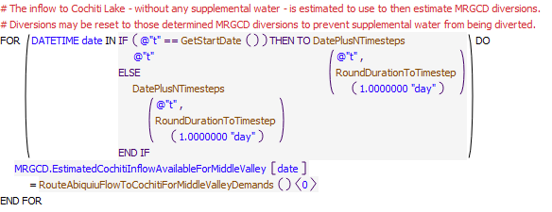
Execution Constraint
Referenced Functions
- DatePlusNTimesteps
- RoundDurationToTimestep
- RouteAbiquiuFlowToCochitiForMiddleValleyDemands
- HasRuleFiredSuccessfully
- GetStartDate

10 SetMiddleValleyOperations
These rules set the operations of the LFCC pumps along with the flows through the Atrisco siphon and the returns at the Central wasteway. Diversions at Angostura may be increased during shortage operations such that the limited supply of water is delivered to the Belen Division as efficiently as possible. Diversions may also be reset lower if necessary to prevent supplemental water for targets from being diverted when there is a shortage. Potential shorted diversions are set separately as the policy at each diversion is dependent on whether there are any target flows below the diversion.
Rules in the Group:
ResetSanAcaciaToPreventDiversionOfSuppWater
ResetIsletaToPreventDiversionOfSuppWater
ResetAngosturaToPreventDiversionOfSuppWater
ResetCochitiDivToPreventDiversionOfSuppWater
ResetAngosturaDiversionForShortageOps
MRGCDWastewayCalcs
LFCCPumpingRequested
SanAcaciaSocorroMainCanalDiversionRequest
Policy Group Change Log (newest changes at the top):
Date: Who. What

10.1 SanAcaciaSocorroMainCanalDiversionRequest
Rule Purpose:
This rule sets the diversion requested to the Socorro Main Canal at the San Acacia diversion based on an input diversion schedule minus the contributions from the Unit 7 drain in the MRGCD system. Flows from the Unit 7 drain contribute toward meeting the need at the Socorro main canal, and diversions from the river are curtailed accordingly. The diversion requested values for San Acacia are set separately from the Cochiti, Angostura, and Isleta diversions due to the unique dependency at San Acacia on the Unit 7 through flow.
Rule Logic: Execution Constraint logic is at end of explanation.
An IF THEN ELSE statement is used to set the diversion requested value for multiple timesteps as needed at the Start Timestep, and then ultimately if a value is not input, the value for the Diversion Requested series slot is set for the CanalDiv water user on the SanAcaciaDiversions aggregate diversion site object for the current timestep plus one day (i.e. the approximate travel time from Abiquiu Dam to Cochiti Lake) plus the travel time from Cochiti Dam to San Marcial as input to the ApproxNoOfDaysDS table slot in the MiddleValleyTargets data object. (The assignment is set into the future as needed for the hypothetical simulation to estimate flows needed for targets.) The diversion is set to the result of the user-defined GetMRGCDDiversionRequested function minus the value in the Total Outflow series slot for the previous timestep in the DrainUnit7Return aggregate distribution canal object. The associated value for the Depletion Requested series slot for the CanalDiv water user on the SanAcaciaDiversions aggregate diversion site object is set to zero.
This rule fires if the current timestep is greater than or equal to the beginning timestep for rulebased simulation as input by the model user to the RulebasedSimulationStartDate scalar slot in the ModelRunTypeTriggers data object and the rule has not fired yet as checked with reference to the predefined HasRuleFiredSuccessfully function.
Model slots written by rule:
1. SanAcaciaDiversions:CanalDiv.Diversion Requested
2. SanAcaciaDiversions:CanalDiv.Depletion Requested
List of key model objects with slots read by the rule or child functions:
1. ModelRunTypeTriggers
2. MRGCD
3. DrainUnit7Return
Log of when and how the rule has been modified (newest changes at the top):
Date: Who. What
2/18/19: Jesse Roach. Added description field and updated notes field
11/10/17 JR: updated during timestep generalization of MRG rules.
Statements
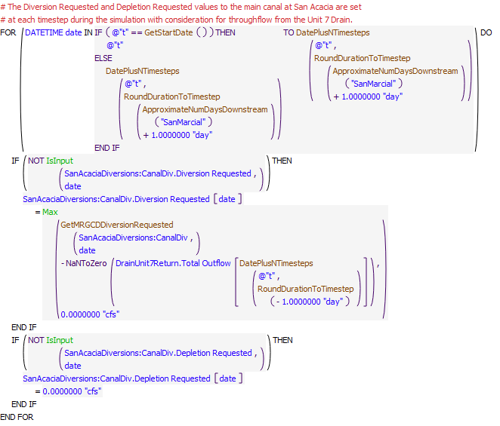
Execution Constraint
Referenced Functions
- DatePlusNTimesteps
- RoundDurationToTimestep
- ApproximateNumDaysDownstream
- GetMRGCDDiversionRequested
- Max
- IsInput
- HasRuleFiredSuccessfully
- GetStartDate

10.2 LFCCPumpingRequested
Rule Purpose:
This rule sets the pumping rates from the LFCC at the Neil Cupp, North Boundary of the Bosque del Apache National Wildlife Refuge, and South Boundary sites. Policy is coded for pumping water from the LFCC to the river to manage recession after the runoff or to prevent river drying. Water that seeps into the LFCC is pumped to the river where pumping begins based on input river flow triggers. After pumping has initiated at a site, pumping will continue for a minimum of one week and until a threshold flow at San Acacia has been exceeded. Pumping will cease for the year at each site after the specific dates input for each site.
Rule Logic: Execution Constraint logic is at end of explanation.
Two FOR DO loops are used to set the value for the Diversion Request series slots for the Neil Cupp, North Boundary, and South Boundary diversion objects from the current timestep through the current timestep plus one day (i.e. the approximate travel time from Abiquiu Dam to Cochiti Lake) plus the travel time from Cochiti Dam to San Marcial as input to the ApproxNoOfDaysDS table slot in the MiddleValleyTargets data object. (The assignment is set into the future as needed for the hypothetical simulation to estimate flows needed for targets.)
The user-defined LFCCPumping function is referenced for setting the Diversion Request values to represent the pumping at each site. A series of IF THEN ELSE statements are included to check the conditions for setting the diversion. If the current timestep is after the Start Timestep and switches have been set by the model user to set a pumping rate for the corresponding site and the current date is before the input date to shutdown pumping for that site for the year as input to the DateToShutDownForYear table slot in the LFCCPumpingTriggers data object and as checked with the user-defined BeforeDateToShutDownLFCCPumpsForYear function, a pumping rate is set. Otherwise, the pumping rate is set to zero.
If the hydrology year type as checked with the user-defined HydrologyYearType function (reference the discussion for the Hydrology Year Type rule) is Dry and the flow at San Acacia is less than the input trigger flow to start pumping at that site as input to the Dry table slot in the LFCCPumpingTriggers data object, the function result is set to the value for the PumpingRate for that site in that same table slot. A similar check is then completed if the hydrology year type is Normal. If the hydrology year type is Wet and the current timestep is within the winter target season for wet targets as checked with the user-defined IsWetSanMarcialWinterTargetSeason function and the flow at San Acacia is less than the input trigger to start pumping at that site for wet years, the function result is set to value for the WinterPumpingRate in the Wet table slot in the LFCCPumping triggers data object. Alternatively, if the hydrology year type is Wet and the current timestep is NOT within the winter target season for wet targets and the flow at San Acacia is less than the input trigger to start pumping at that site for wet years, the function result is set to value for the SummerPumpingRate in the Wet table slot in the LFCCPumping triggers data object.
If pumping occurred at the previous timestep for the site as checked with the user-defined LFCCPumpingOnPreviousDay function and pumping has not continued for at least a week as checked with NOT LFCCPumpingForAtLeastAWeek function or the flow at San Acacia has not exceeded the trigger flow within the past week to shutdown pumping as checked with the SATriggerForLFCCPumpingShutdownExceededAWeek function, the function result is set to the previous pumping rate (i.e. the previous set pumping rate is maintained).
This rule fires if the current timestep is greater than or equal to the beginning timestep for rulebased simulation as input by the model user to the RulebasedSimulationStartDate scalar slot in the ModelRunTypeTriggers data object and the rule has not fired yet as checked with reference to the predefined HasRuleFiredSuccessfully function.
Model slots written by rule:
1. NeilCupp.Diversion Request
2. NorthBoundary.Diversion Request
3. SouthBoundary.Diversion Request
List of key model objects with slots read by the rule or child functions:
1. LFCCPumpingTriggers
2. MiddleValleyTargets
3. SanAcaciaFloodway
Log of when and how the rule has been modified (newest changes at the top):
Date: Who. What
2/18/19: Jesse Roach. Added description field and updated notes field
11/10/17 JR: updated during timestep generalization of MRG rules.
Statements
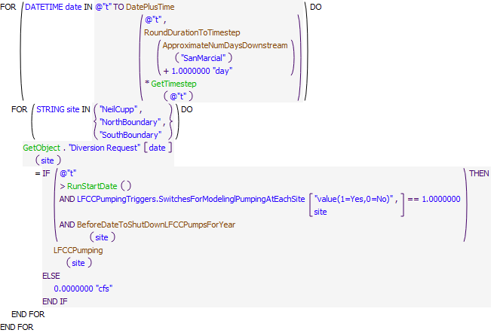
Execution Constraint
Referenced Functions
- DatePlusTime
- RoundDurationToTimestep
- ApproximateNumDaysDownstream
- LFCCPumping
- BeforeDateToShutDownLFCCPumpsForYear
- GetTimestep
- RunStartDate
- GetObject
- HasRuleFiredSuccessfully
- GetStartDate

10.3 MRGCDWastewayCalcs
Rule Purpose:
This rule sets the MRGCD returns to the river through key wasteways and flows through siphons as represented in the URGWOM layout. Flows through some wasteway objects in URGWOM are simply set with the RiverWare method to use a percentage of the available flow, but some returns or siphon flows are set with this rule based on general policy as identified by the URGWOM Tech Team. Note that it may be important for the policy implemented with this rule to match the policy used for the Middle Valley calibration. Flows through the Central Wasteway and Atrisco siphon are set along with returns at the Peralta wasteways, the return from Atrisco Drain outfall, and the flow through the Corrales siphon.
Rule Logic: Execution Constraint logic is at end of explanation.
A FOR DO loop is used to set the Diversion Request on the objects for each wasteway or siphon for the current timestep plus one day (i.e. the approximate travel time from Abiquiu Dam to Cochiti Lake) plus the travel time from Cochiti Dam to San Marcial as input to the ApproxNoOfDaysDS table slot in the MiddleValleyTargets data object. (The assignment is set into the future as needed for the hypothetical simulation to estimate flows needed for targets.)
The Diversion Request slot value is set on the CentralWasteway and AtriscoSyphon objects with IF THEN ELSE statements. During the irrigation season (March 1 October 31), the flow through the Central wasteway is set to the flow at that location in the MRGCD system, represented by the Outflow value from the AngosturaEastSideAgDepletionsCanal object, minus 180 cfs. During the non-irrigation season, all flow in the system is returned through the wasteway. During the irrigation season, the flow diverted through the Atrisco siphon is set to 120 cfs if the Outflow value from the CentralEastSideLag reach object is greater than or equal to 180 cfs. Alternatively, the flow through the siphon is set to the flow in the system * 0.67 during the irrigation season. During the non-irrigation season, no flow is diverted through the Atrisco siphon. An IF THEN ELSE statement is used to set the Diversion Request slot on the CorralesSyphon object to an input typical value during the irrigation season or zero in the non-irrigation season. An IF THEN ELSE statement is used to set the Diversion Request for the IsletaToBernardoArea3WasteWayDiversion object to return the available flow while maintain a target flow MRGCDs system for the San Juan Main Canal during the irrigation season. All flow is returned at the object during the non-irrigation season. An IF THEN ELSE statement is used to set the Diversion Request slot on the AtriscoDrainOutfall object to return available flow while maintaining a target throughflow to the Belen Diversion in the irrigation season and returning all flow in the non-irrigation season.
This rule fires if the current timestep is greater than or equal to the beginning timestep for rulebased simulation as input by the model user to the RulebasedSimulationStartDate scalar slot in the ModelRunTypeTriggers data object and the rule has not fired yet as checked with reference to the predefined HasRuleFiredSuccessfully function.
Model slots written by rule:
1. CentralWasteway.Diversion Request
2. AtriscoSyphon.Diversion Request
3. IsletaToBernardoArea3WasteWayDiversion.Diversion Request
4. BypassToBelen.Diversion Request
5. CorralesSyphon.Diversion Request
List of key model objects with slots read by the rule or child functions:
1. MiddleValleyTargets
2. Central
3. PeraltaWastewaysCalc
4. CorralesSiphonCall
Log of when and how the rule has been modified (newest changes at the top):
Date: Who. What
2/18/19: Jesse Roach. Added description field and updated notes field
7/6/18 Jesse Roach: updated extensively during planning runs due to buggy behavior.
11/10/17 Jesse Roach: updated during timestep generalization of MRG rules.
Statements
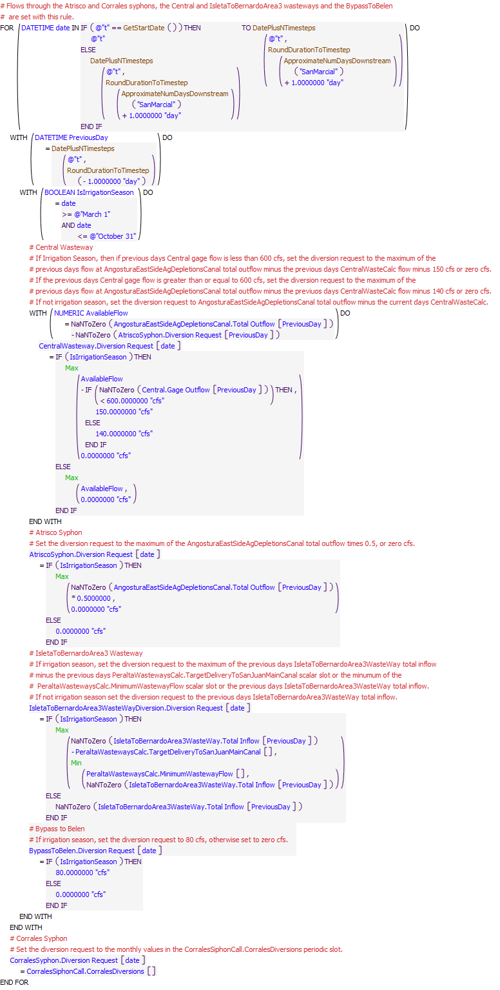
Execution Constraint
Referenced Functions
- DatePlusNTimesteps
- RoundDurationToTimestep
- ApproximateNumDaysDownstream
- Min
- Max
- HasRuleFiredSuccessfully
- GetStartDate

10.4 ResetAngosturaDiversionForShortageOps
Rule Purpose:
This rule increases the requested diversion values for the Angostura diversion when MRGCD is in a shortage situation (i.e. no water in storage and the inflow to Cochiti is less than the MRGCD demand) and operations are being conducted to assure delivery of P&P water to the six Middle Valley pueblos. In actual operations, diversions are also increased so MRGCD can then use the limited supply as efficiently as possible. Flows to the Central wasteway and Atrisco siphon are also reset accordingly to zero and 120 cfs, respectively, for shortage operations within this rule.
Rule Logic: Execution Constraint logic is at end of explanation.
Two assignment statements are included to reset the Diversion Requested values for the current timestep plus one timestep (the approximate travel time from Abiquiu Dam to Cochiti) plus the travel time from Cochiti to San Marcial. Values are reset for the AlbMainCanal and AtriscoFeeder water users on the AngosturaDiversions aggregate diversion site object to the maximum canal capacities as input to the MaxCapacityAtAngosturaAlbMainCanal and MaxCapacityAtAngosturaAtriscoFeeder scalar slots on the MRGCD data object. Flows to the Central wasteway (CentralWasteway.Diversion Request) and the Atrisco siphon (AtriscoSyphon.Diversion Request) are also reset in this rule to 0.0 cfs and 120 cfs, respectively for shortage operations to effectively represent deliverying 120 cfs through the Atrisco siphon during such opeartions and all remaining flow down the Albuquerque drain with any excess to be delivered as efficiently as possible to the Belen Division.
This rule fires if the rule has not fired successfully for the current timestep as determined with reference to the predefined HasRuleFiredSuccessfully function and if the current timestep is greater than or equal to the beginning timestep for rulebased simulation as input by the model user to the RulebasedSimulationStartDate scalar slot in the ModelRunTypeTriggers data object and if the user-defined TimeToIncreaseAngosturaDiversions function is evaluated as TRUE. That latter function checks to see if the value in the TriggerIncreaseAngosturaDiversionsForPandPOps table slot in the MRGCD data object is 1 (i.e. a switch has been set by the model user to implement operations to increase Angostura diversions when MRGCD is in a shortage situation) and if the current timestep is greater than or equal to March 1st and less than or equal to October 31st (i.e. the diversion is being reset only within the irrigation season) and the MRGCD supply as computed with the user-defined MRGCDSupply function is less than the value for the DemandAtCochiti series slot in the MRGCD data object and the inflow to Cochiti is less than the MRGCD demand plus a buffer amount input to the MRGCDData.CochitiInflowBuffer scalar slot.
Model slots written by rule:
1. BlwSanFelipeDiversions:AlbMainCanal.Diversion Requested
2. BlwSanFelipeDiversions:AtriscoFeeder.Diversion Requested
3. CentralWasteway.Diversion Request
4. AtriscoSyphon.Diversion Request
List of key model objects with slots read by the rule or child functions:
1. MiddleValleyTargets
2. MRGCD
Log of when and how the rule has been modified (newest changes at the top):
Date: Who. What
11/8/22: Lucas Barrett. Updated rule so that the diversion requested from AlbMainCanal and AtriscoFeeder did not go over 300 cfs (per MRGCD).
2/18/19: Jesse Roach. Added description field and updated notes field
11/10/17 JR: updated during timestep generalization of MRG rules.
Statements
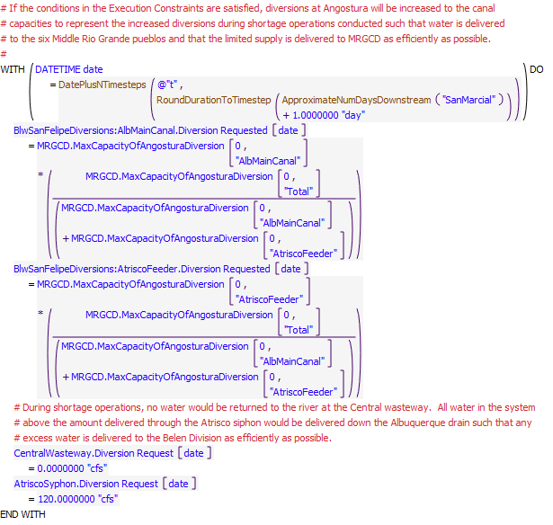
Execution Constraint
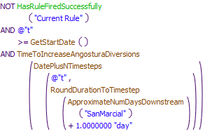
Referenced Functions
- DatePlusNTimesteps
- RoundDurationToTimestep
- ApproximateNumDaysDownstream
- TimeToIncreaseAngosturaDiversions
- HasRuleFiredSuccessfully
- GetStartDate

11 SetAlbuquerqueDiversion
Diversions by Albuquerque are set with the rules in the policy group. The rules include a check for a preemptive cutoff where Albuquerque would switch to groundwater before curtailment and cutoff restrictions under the permit go into effect, flood control operations at Abiquiu Dam prevent the delivery of San Juan-Chama Project water, or high flows out of Cochiti Dam prevent safe operation of the diversion structure. Note that the model user can set switches in the model to allow for diversions of all native water to occur while Abiquiu is in flood control operations with a debt tracked to be paid back later with San Juan-Chama Project water, and another switch is included that would allow for all San Juan-Chama Project water to be diverted when native flows are too low such that full diversions can continue.
Rules in the Group:
SetMinBypassAtAngosturaForAlbuquerqueSJC
ComputeAbiquiuSJCDeliveriesToAlbuquerqueDiversion
SetAlbuquerqueDiversion
RecordAlbuquerqueRGDiversion
RecordAlbuquerqueSJCDiversion
ComputeAlbuquerqueRGDiversionPerPermit
SetPreemptiveAlbuquerqueCutoffSwitch
Policy Group Change Log (newest changes at the top):
Date: Who. What
11/10/17 JR: In order to take advantage of calculations done estimating available flow at Cochiti for Middle Valley Demands at the same timestep (instead of relying on lags as is possible with a daily model), the SetDebts LetterWater PastAlbLoanToMRGCD EBExchange Policy Group and the SetAlbuquerqueDiversion policy groups were moved together and placed between the ComputeUpstreamFlowNeededForTargets and the SetMiddleValleyOperations policy groups). These changes allowed values calculated in the EstimatedCochitiInflowAvailableForMiddleValleyDemands Policy Group to be utilized in the SetAlbuquerqueDiversion policy group. This move had no impact on daily timestep runs.

11.1 SetPreemptiveAlbuquerqueCutoffSwitch
Rule Purpose:
Policy for operating the Albuquerque surface water diversion is expected to entail a complete shutdown before criteria per the permit would result in curtailments or cutoff to diversions. This rule sets a switch to identify whether conditions are satisfied for a preemptive cutoff of Albuquerque surface water diversions (Albuquerque would switch to groundwater to meet their demand). Preemptive cutoff criteria include a low river flow at which Albuquerque would shutdown before the permit criteria result in a curtailment to diversions, a high Cochiti outflow at which operating the diversion would be unsafe and impractical, and an Abiquiu high outflow at which Abiquiu operations are being conducted for flood control operations and Albuquerques San Juan-Chama Project water would not be released. Note that policy is included in URGWOM to potentially allow diversions to continue when Abiquiu is in flood control operations with a follow-up exchange modeled at Elephant Butte for Albuquerque to subsequently payback the Rio Grande account for diversions when Albuquerque San Juan-Chama Project water could not be delivered from Abiquiu Reservoir. Also, URGWOM is set up to potentially allow all San Juan-Chama Project water to be diverted when curtailment or cutoff restrictions would be in place for native water under the permit. Separate switches are included for the model user to potentially implement such policy in which case a preemptive cutoff may be avoided.
Rule Logic: Execution Constraint logic is at end of explanation.
An IF THEN statement is used to check if the switch has been directly input. If not, the value for the PreemptiveCutoffSwitch series slot for the current timestep in the AlbuquerqueDiversions data object is set to 1.0 if the criteria in the PreemptiveCutoffAlbuquerqueDiversion function are satisfied. Otherwise, the value is set to 0.0.
The PreemptiveCutoffAlbuquerqueDiversion function includes a check to see if the value in the TriggerUseAllSJCIfNeeded table slot in the AlbuquerqueDiversions data object is NOT equal to 1.0 and if the Gage Outflow on the Central stream gage object at the previous timestep is less than the input value for the ThresholdCentralFlowForAlbPreemptiveCutoff scalar slot or the value of the TriggerModelElephantButteExchange table slot in the AlbuquerqueDiversions data object is equal to 1.0 and the Outflow from the Abiquiu level power reservoir object is greater than or equal to the input value in the ThresholdHighAbiquiuOutflowForAlbPreemptiveCutoff scalar slot or the Outflow from the Cochiti object is greater than the input to the ThresholdHighCochitiOutflowForAlbPreemptiveCutoff scalar slot on the AlbuquerqueDiversions data object.
This rule fires if the rule has not fired yet as checked with reference to the predefined HasRuleFiredSuccessfully function.
Model slots written by rule:
1. AlbuquerqueDiversions.PreemptiveCutoffSwitch
List of key model objects with slots read by the rule or child functions:
1. AlbuquerqueDiversions
2. MRGCD
3. Central
4. Abiquiu
5. Cochiti
Log of when and how the rule has been modified (newest changes at the top):
Date: Who. What
2/18/19: Jesse Roach. Added description field and updated notes field
11/10/17 JR: Preemptive cutoff doesn't have any meaning at a monthly timestep, so execution logic added to PreemptiveCutoffAlbuquerqueDiversion function so that that function returns false for greater than daily timestep.
Statements
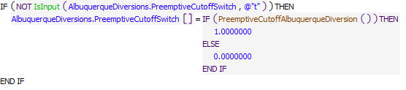
Execution Constraint
Referenced Functions
- PreemptiveCutoffAlbuquerqueDiversion
- IsInput
- HasRuleFiredSuccessfully

11.2 ComputeAlbuquerqueRGDiversionPerPermit
Rule Purpose:
This rule records a Albuquerque diversion amount for native Rio Grande water based on the permit that reflects any potential curtailment or cutoff to diversions as a function of river flows. This value reflects the native portion of the total diversion.
Rule Logic: Execution Constraint logic is at end of explanation.
The value for the ComputedCurtailedOrCutoffRGDiversion series slot in the AlbuquerqueDiversions data object for the current timestep is set based on the flow of native Rio Grande water in the river as checked over a number of days to prevent fluctuations in modeled flow from affecting operations. If the river flow is less than the value in the StartCurtailment column of the AlbuquerqueCurtailmentRanges table slot in the AlbuquerqueDiversions data object and greater than the value in the Cutoff column of the AlbuquerqueCurtailmentRanges table slot, the value is set to the Albuquerque demand for San Juan-Chama Project water minus the difference in the StartCurtailment value and the RioGrande flow at AlamedaBridge. Elseif the flow is less than the value in the Cutoff column of the AlbuquerqueCurtailmentRanges table slot, the Rio Grande diversion value is set to zero. Otherwise, the value is set to match the AlbuquerqueSJCDemand.
This rule fires if the current timestep is greater than or equal to the beginning timestep for rulebased simulation as input by the model user to the RulebasedSimulationStartDate scalar slot in the ModelRunTypeTriggers data object and as identified with the user-defined GetStartDate function and the rule has not fired yet as checked with reference to the predefined HasRuleFiredSuccessfully function.
Model slots written by rule:
1. AlbuquerqueDiversions.ComputedCurtailedOrCutoffRGDiversion
List of key model objects with slots read by the rule or child functions:
1. ModelRunTypeTriggers
2. AlbuquerqueDiversions
Log of when and how the rule has been modified (newest changes at the top):
Date: Who. What
2/18/19: Jesse Roach. Added description field and updated notes field
11/10/17 JR: generalized to different timesteps by pulling out code that defines riverFlow to a timestep specific function called RGFlowAtAlamedaForCurtailmentCalc. Simplified check for RunStartDate in the rule by pulling that into the RGFlowAtAlamedaForCurtailmentCalc underlying function.
Statements
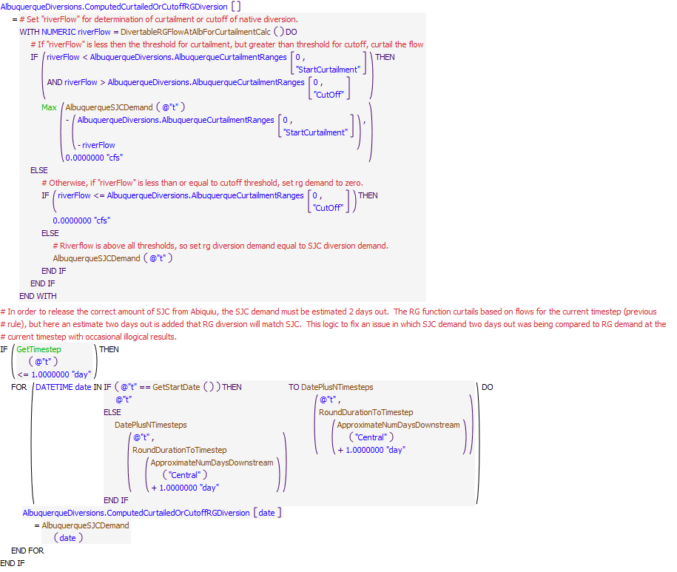
Execution Constraint
Referenced Functions
- DatePlusNTimesteps
- DivertableRGFlowAtAlbForCurtailmentCalc
- AlbuquerqueSJCDemand
- RoundDurationToTimestep
- ApproximateNumDaysDownstream
- Max
- GetTimestep
- HasRuleFiredSuccessfully
- GetStartDate

11.3 RecordAlbuquerqueSJCDiversion
Rule Purpose:
The San Juan-Chama Project water portion of the Albuquerque diversion is recorded with this rule. The amount is generally set to a standard demand (e.g. 65 cfs) that is equal to the native water diversion, but may be set to zero if the preemptive cutoff switch has been set or Abiquiu is in flood control operations where San Juan-Chama Project water cannot be delivered to the diversion. The rule includes checks to assure Albuquerque San Juan-Chama Project water is available to deliver to meet the computed demand. The native portion is allowed in return for the 50 percent return flow credit for downstream wastewater treatmant plant returns.
Rule Logic: Execution Constraint logic is at end of explanation.
The value for the AlbuquerqueSJCdiversion series slot in the AlbuquerqueDiversions data object is set with reference to three IF THEN ELSE statements. The diversion is set to zero if it is before the startup date for the diversion, the preemptive cutoff switch at the current timestep is equal to 1, or the preemptive cutoff switch has been 1 for the last two weeks as checked with reference to the user-defined PreemptiveCutoffAlbuquerqueDiversionsWithinLastTwoWeeks function. If the value in the TriggerModelElephantButteExchange table slot in the AlbuquerqueDiversions data object is equal to 1.0 and the Abiquiu outflow is greater than the value in the ThresholdHighAbiquiuOutflowforAlbPreemptiveCutoff slot, the San Juan-Chama diversion is set to zero. A WITH DO statement is used to record the amount of San Juan-Chama Project water available for diversion. If the value in the TriggerUseAllSJCIfNeeded table slot in the AlbuquerqueDiversions data object is equal to 1.0, the San Juan-Chama diversion is set to twice the demand computed with reference to the user-defined AlbuquerqueSJCDemand function minus the value in the ComputedCurtailedOrCutoffRGDiversion slot. Otherwise the diversion is set to the demand. The final assignment is set with a check against the available water that is also adjusted for the San Juan-Chama loss rates from Abiquiu to the surface water diversion.
This rule fires if the current timestep is greater than or equal to the beginning timestep for rulebased simulation as input by the model user to the RulebasedSimulationStartDate scalar slot in the ModelRunTypeTriggers data object and as identified with the user-defined GetStartDate function and the rule has not fired yet as checked with reference to the predefined HasRuleFiredSuccessfully function.
Model slots written by rule:
1. AlbuquerqueDiversions.AlbuquerqueSJCDiversion
List of key model objects with slots read by the rule or child functions:
1. AlbuquerqueDiversions
2. MiddleValleyTargets
3. Abiquiu
4. SanJuanChamaRules
Log of when and how the rule has been modified (newest changes at the top):
Date: Who. What
2/18/19: Jesse Roach. Added description field and updated notes field
4/17/2018 JR: Modified while working some of the kinks out of Albuquerque diversion behavior.
11/10/17 JR: Updated during MRG timestep generalization
Statements
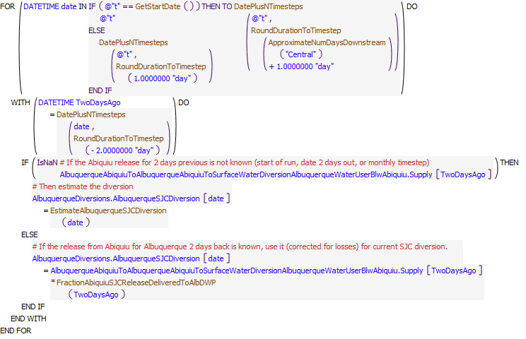
Execution Constraint
Referenced Functions
- DatePlusNTimesteps
- EstimateAlbuquerqueSJCDiversion
- FractionAbiquiuSJCReleaseDeliveredToAlbDWP
- RoundDurationToTimestep
- ApproximateNumDaysDownstream
- HasRuleFiredSuccessfully
- GetStartDate

11.4 RecordAlbuquerqueRGDiversion
Rule Purpose:
This rule sets an initial value for the native Rio Grande water to be diverted at the Albuquerque surface water diversion. The amount is generally set to half the diversion as allowed for the return flow credit. If the preemptive cutoff switch has been set, the Rio Grande diversion is set to zero. The amount will be set to the total diversion, or twice the typical San Juan-Chama Project diversion, if the model user has set a switch to allow for all native diversion during Abiquiu flood control operations with a debt to be paid back later.
Rule Logic: Execution Constraint logic is at end of explanation.
The value for the AlbuquerqueRGDiversion series slot in the AlbuquerqueDiversions data object is set with reference to IF THEN ELSE statements. The diversion is set to zero if it is before the startup date for the diversion, the preemptive cutoff switch at the current timestep is equal to 1, or the preemptive cutoff switch has been 1 for the last two weeks as checked with reference to the user-defined PreemptiveCutoffAlbuquerqueDiversionsWithinLastTwoWeeks function. If the value in the ComputedCurtailedOrCutoffRGDiversion series slot for the current timestep is less than the Albuquerque demand, the AlbuquerqueRGDiversion slot value is set to the ComputedCurtailedOrCutoffRGDiversion series slot value. If the value in the TriggerModelElephantButteExchange table slot in the AlbuquerqueDiversions data object is equal to 1.0 and it is not the start timestep, the value is set to twice the demand for San Juan-Chama Project water as determined with reference to the user-defined AlbuquerqueSJCDemand function minus the accounting supply slot value for the delivery of San Juan-Chama Project water from Abiquiu at the previous timestep adjusted for San Juan-Chama Losses to the diversion. Otherwise the slot is set the Albuqueque demand with the result restricted to not exceed the available supply for Albuquerque at Abiquiu Reservoir.
This rule fires if the current timestep is greater than or equal to the beginning timestep for rulebased simulation as input by the model user to the RulebasedSimulationStartDate scalar slot in the ModelRunTypeTriggers data object and as identified with the user-defined GetStartDate function and the rule has not fired yet as checked with reference to the predefined HasRuleFiredSuccessfully function.
Model slots written by rule:
1. AlbuquerqueDiversions.AlbuquerqueRGDiversion
List of key model objects with slots read by the rule or child functions:
1. AlbuquerqueDiversions
2. MiddleValleyTargets
3. Abiquiu
4. ElephantButte
5. SanJuanChamaRules
Log of when and how the rule has been modified (newest changes at the top):
Date: Who. What
2/18/19: Jesse Roach. Added description field and updated notes field
11/10/17 JR: Updated during MRG timestep generalization
Statements
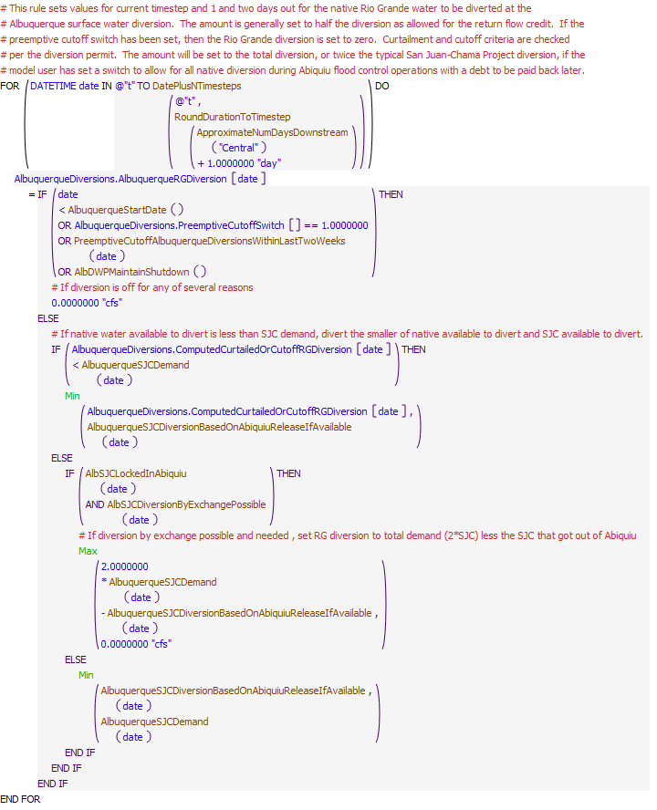
Execution Constraint
Referenced Functions
- DatePlusNTimesteps
- AlbDWPMaintainShutdown
- AlbSJCDiversionByExchangePossible
- AlbSJCLockedInAbiquiu
- AlbuquerqueStartDate
- AlbuquerqueSJCDiversionBasedOnAbiquiuReleaseIfAvailable
- AlbuquerqueSJCDemand
- PreemptiveCutoffAlbuquerqueDiversionsWithinLastTwoWeeks
- RoundDurationToTimestep
- ApproximateNumDaysDownstream
- Min
- Max
- HasRuleFiredSuccessfully
- GetStartDate

11.5 SetAlbuquerqueDiversion
Rule Purpose:
This rule sets the total Albuquerque diversion as the sum of the initial computed diversion of native Rio Grande water and the final amount of San Juan-Chama Project water delivered to the diversion. The diversion is set for the next day in daily timestep runs such that a value will be in place as needed for hypothetical simulation to solve through the Middle Rio Grande portion of the model.
Rule Logic: Execution Constraint logic is at end of explanation.
A FOR DO loop is used to make assignments for the current timestep and the next timetep. The value for the Diversion Requested series slot on the AlbuquerqueWaterUser water user object is set to the sum of the accounting supply slot value at the previous timestep for the delivery of San Juan-Chama Project water from Abiquiu adjusted for San Juan-Chama Losses to the diversion and the AlbuquerqueRGDiversion slot value on the AlbuquerqueDiversions data object for the current timestep. The Depletion Requested slot is set in the same manner where a value is required for rulebased simulations.The total requested diversion at the Albuquerque diversion is set to the amount of San Juan-Chama Project water ultimately delivered to the diversion minus losses plus the final amount of native Rio Grande water to be diverted. The requested depletion must also be set in RiverWare. The diversion is set one timestep into the future as needed for hypothetical simulations completed to determine the amount of water needed for targets.
This rule fires if the current timestep is greater than or equal to the beginning timestep for rulebased simulation as input by the model user to the RulebasedSimulationStartDate scalar slot in the ModelRunTypeTriggers data object and as identified with the user-defined GetStartDate function and the rule has not fired yet as checked with reference to the predefined HasRuleFiredSuccessfully function.
Model slots written by rule:
1. AlbuquerqueWaterUser.Diversion Requested
2. AlbuquerqueWaterUser.Depletion Requested
List of key model objects with slots read by the rule or child functions:
1. AlbuquerqueDiversions
2. MiddleValleyTargets
Log of when and how the rule has been modified (newest changes at the top):
Date: Who. What
2/18/19: Jesse Roach. Added description field and updated notes field
11/10/17 JR: Updated during MRG timestep generalization
Statements
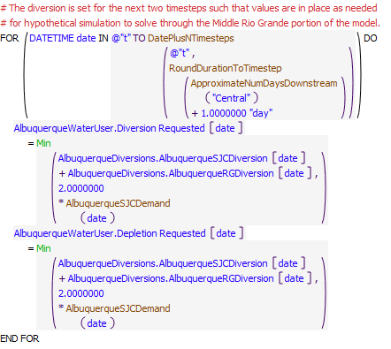
Execution Constraint
Referenced Functions
- DatePlusNTimesteps
- AlbuquerqueSJCDemand
- RoundDurationToTimestep
- ApproximateNumDaysDownstream
- Min
- HasRuleFiredSuccessfully
- GetStartDate

11.6 ComputeAbiquiuSJCDeliveriesToAlbuquerqueDiversion
Rule Purpose:
This rule sets an initial computed delivery of San Juan-Chama Project water from Abiquiu Reservoir to the Albuquerque surface water diversion to be referenced when setting the total Abiquiu outflow and for setting the accounting supply for the delivery. In daily timestep runs the diversion supply is also set in this rule based on the delivery made at the previous timestep, which can be done here due to the modeled 1-day lag between Abiquiu and the surface water diversion. For monthly timestep runs, this supply is estimated at the current timestep.
Rule Logic: Execution Constraint logic is at end of explanation.
If a value was not input, the AlbuquerqueDeliveryToSurfaceWater diversion slot on the ComputedDeliveries data object is set to the value in the AlbuquerqueSJCDiversion slot on the AlbuquerqueDiversions data object adjusted for the San Juan-Chama loss rates between Abiquiu and the diversion.
The diversion accounting supply to the water user object is also set with reference to the separate accounting supply set at the previous timestep for the delivery to the diversion and as adjusted for the San Juan-Chama loss rates to the diversion. Diversions are not set at the start timestep since information is not available in the model to set the diversion.A delivery of Albuquerque San Juan-Chama Project water from Abiquiu Reservoir to the surface water diversion is recorded with this rule based on the final determined amount of San Juan-Chama Project water to be diverted and with consideration for San Juan-Chama loss rates between Abiquiu Dam and the diversion. The recorded delivery is then referenced when setting the total outflow from Abiquiu Reservoir and for setting a final accounting supply for the delivery. A diversion supply at the Albuquerque diversion is also set in this rule based either on the final delivery made at the previous timestep for daily timestep model runs, or an estimate of the SJC releases at the current timestep for monthly timestep runs.
This rule fires if the current timestep is greater than or equal to the beginning timestep for rulebased simulation as input by the model user to the RulebasedSimulationStartDate scalar slot in the ModelRunTypeTriggers data object and as identified with the user-defined GetStartDate function and the rule has not fired yet as checked with reference to the predefined HasRuleFiredSuccessfully function.
Model slots written by rule:
1. ComputedDeliveries.AlbuquerqueDeliveryToSurfaceWaterDiversion
List of key model objects with slots read by the rule or child functions:
1. AlbuquerqueDiversions
2. MiddleValleyTargets
3. Abiquiu
4. Central
5. SanJuanChamaRules
Log of when and how the rule has been modified (newest changes at the top):
Date: Who. What
2/18/19: Jesse Roach. Added description field and updated notes field
11/10/17 JR: Updated during MRG timestep generalization
Statements
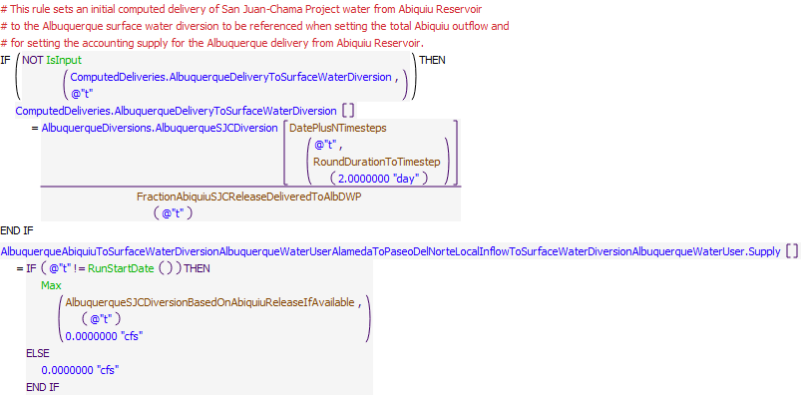
Execution Constraint
Referenced Functions
- DatePlusNTimesteps
- AlbuquerqueSJCDiversionBasedOnAbiquiuReleaseIfAvailable
- FractionAbiquiuSJCReleaseDeliveredToAlbDWP
- RoundDurationToTimestep
- Max
- RunStartDate
- IsInput
- HasRuleFiredSuccessfully
- GetStartDate

11.7 SetMinBypassAtAngosturaForAlbuquerqueSJC
Rule Purpose:
This rule sets a minimum bypass at the Angostura diversion to assure any San Juan-Chama Project water for the Albuquerque diversion does not get diverted at Angostura.
Rule Logic: Execution Constraint logic is at end of explanation.
A FOR DO statement is used to make the assignment into the future as required to allow for hypothetical simulation to solve. The value for the Minimum Diversion Bypass on the BlwSanFelipeDiversionsReach reach object is set to the accounting supply slot value at the previous timestep for the delivery of San Juan-Chama Project water from Abiquiu adjusted for San Juan-Chama Losses to the diversion.
This rule fires if the current timestep is greater than or equal to the beginning timestep for rulebased simulation as input by the model user to the RulebasedSimulationStartDate scalar slot in the ModelRunTypeTriggers data object and as identified with the user-defined GetStartDate function and the rule has not fired yet as checked with reference to the predefined HasRuleFiredSuccessfully function.
Model slots written by rule:
1. SanFelipeToCentralSeepageArea1.Minimum Diversion Bypass
List of key model objects with slots read by the rule or child functions:
1. MiddleValleyTargets
2. SanJuanChamaRules
Log of when and how the rule has been modified (newest changes at the top):
Date: Who. What
2/18/19: Jesse Roach. Added description field and updated notes field
11/10/17 JR: Updated during MRG timestep generalization
Statements
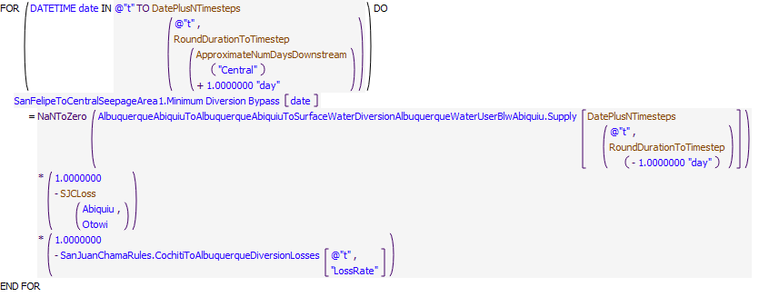
Execution Constraint
Referenced Functions
- DatePlusNTimesteps
- RoundDurationToTimestep
- ApproximateNumDaysDownstream
- HasRuleFiredSuccessfully
- SJCLoss
- GetStartDate

12 SetDebts LetterWater PastAlbLoanToMRGCD EBExchange
URGWOM is set up to allow surface water diversions to continue for Albuquerque and the city of Santa Fe during flood control operations when their San Juan-Chama Project water cannot be delivered. A debt is tracked for each during these times to be paid back later with a transfer at Elephant Butte Reservoir.
Contractors for San Juan-Chama Project water may cause depletions in the basin due to groundwater pumping or some other water use and then pay back the river for the impacts with deliveries of San Juan-Chama Project water from storage. Debts caused by groundwater pumping or such other water uses are not modeled in URGWOM and thus must be input by the model user. The inputs also include a split for the amount of the payback that should go to MRGCD and the portion that should be paid back to the Compact deliveries. The payback to MRGCD may occur as a transfer to the MRGCD San Juan-Chama account at El Vado Reservoir or a release to contribute to meeting the MRGCD irrigation demand. The pay back to the Compact is set as a delivery in the winter to Elephant Butte Reservoir after irrigation diversions have ceased.
This policy group also contains a rule to allow for model users to set up an MRGCD debt to payback ABCWUA for a past loan. The debt is tracked in RiverWare until paid back with the delivery from MRGCD?s San Juan-Chama account at El Vado Reservoir to the Albuquerque account at Abiquiu Reservoir.
Rules in the Group:
SetLetterWaterPaybackDebts
SetDebtForPastAlbuquerqueLoanToMRGCD
SetDebtForDiversionsWhenSJCLockedInAbiquiu
Policy Group Change Log (newest changes at the top):
Date: Who. What
11/10/17 JR: In order to take advantage of calculations done estimating available flow at Cochiti for Middle Valley Demands at the same timestep (instead of relying on lags as is possible with a daily model), the SetDebts LetterWater PastAlbLoanToMRGCD EBExchange Policy Group and the SetAlbuquerqueDiversion policy groups were moved together and placed between the ComputeUpstreamFlowNeededForTargets and the SetMiddleValleyOperations policy groups). These changes allowed values calculated in the EstimatedCochitiInflowAvailableForMiddleValleyDemands Policy Group to be utilized in the SetAlbuquerqueDiversion policy group. This move had no impact on daily timestep runs.

12.1 SetDebtForDiversionsWhenSJCLockedInAbiquiu
Rule Purpose:
This rule sets the exchange borrow supply for the debts incurred by the Albuquerque or the City of Santa Fe as a result of diverting water at their surface water diversions while Abiquiu Dam is in flood control operations and San Juan-Chama Project water is not being delivered. The debt for Albuquerque is set to half the Rio Grande diversion due to the return flow credit for the other half of the diversion. The Santa Fe debt is set to the amount taken that would have otherwise been San Juan-Chama Project water.
Rule Logic: Execution Constraint logic is at end of explanation..
Two assignment statements are included in this rule. The first assignment statement sets the borrow supply for the Albuquerque debt equal to half the resulting Rio Grande diversion if the value in the TriggerModelElephantButteExchange table slot is equal to 1 and the value in the Outflow slot on the Abiquiu reservoir level power object at the previous timestep is greater than or equal to the value in the ThresholdHighAbiquiuOutflowForAlbPreemptiveCutoff table slot in the AlbuquerqueDiversions data object. Otherwise, that borrow supply is set to zero. The second assignment statement sets the borrow supply for the City of Santa Fe debt to the amount of San Juan-Chama Project water that would have otherwise been diverted minus any potential delivery of San Juan-Chama Project water, which should be zero during flood ops, if the value in the TriggerModelElephantButteExchangesSantaFeCity table slot in the Buckman data object is equal to 1 and the previous Abiuiu outflow is greater than the value in the ThresholdAbiquiuOutflowCutoffSJC slot in the Buckman data object.
This rule fires if the current timestep is greater than or equal to the beginning timestep for rulebased simulation as input by the model user to the RulebasedSimulationStartDate scalar slot in the ModelRunTypeTriggers data object and as identified with the user-defined GetStartDate function and the rule has not fired yet as checked with reference to the predefined HasRuleFiredSuccessfully function
Model slots written by rule:
1. AlbuquerquePaybackToRioGrandeForDiversionDuringFloodOps+Input Borrow+.Supply
2. SantaFeCityPaybackToRioGrandeForDiversionDuringFloodOps+Input Borrow+.Supply
List of key model objects with slots read by the rule or child functions:
1. ModelRunTypeTriggers
2. AlbuquerqueDiversions
3. ElephantButte
4. Abiquiu
5. SanJuanChamaRules
Log of when and how the rule has been modified (newest changes at the top):
Date: Who. What
2/19/19: Jesse Roach. Added description field and updated notes field
Statements
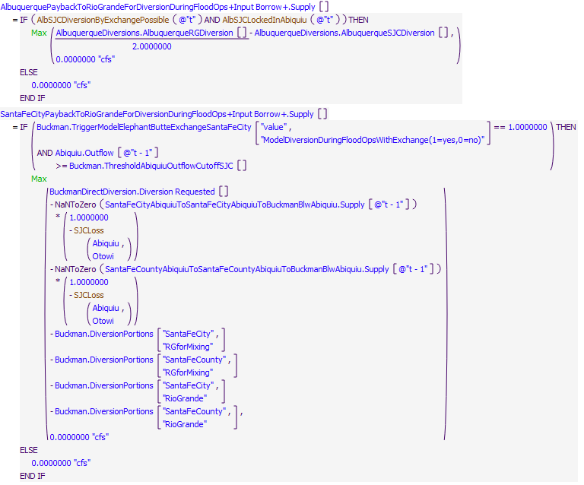
Execution Constraint
Referenced Functions
- AlbSJCDiversionByExchangePossible
- AlbSJCLockedInAbiquiu
- Max
- HasRuleFiredSuccessfully
- SJCLoss
- GetStartDate

12.2 SetDebtForPastAlbuquerqueLoanToMRGCD
Rule Purpose:
Albuquerque historically loaned their San Juan-Chama Project water to MRGCD and the pending payback may be modeled based on an input schedule for the payback. This rule sets the exchange Borrow slot for any input debt from a past loan by Albuquerque to MRGCD. The debt is then tracked and paid back as MRGCD makes deliveries of their San Juan-Chama Project water at El Vado Reservoir to the Albuquerque account at Abiquiu Reservoir.
Rule Logic: Execution Constraint logic is at end of explanation.
The Borrow slot on the MRGCDPaybackToAlbuquerqueEX exchange is set to the input amount in the VolumeForPayback column in the for current year of simulation in the PaybackScheduleForPastAlbuquerqueLoanToMRGCD table slot.
This rule fires if the current timestep equal to the beginning timestep for rulebased simulation as input by the model user to the RulebasedSimulationStartDate scalar slot in the ModelRunTypeTriggers data object and as identified with the user-defined GetStartDate function or greater than the rulebased simulation start timestep and equal to January 1 and the rule has not fired yet as checked with reference to the predefined HasRuleFiredSuccessfully function.
Model slots written by rule:
1. MRGCDPaybackToAlbuquerqueEX.Borrow
2. SantaFeCityPaybackToRioGrandeForDiversionDuringFloodOps+Input Borrow+.Supply
List of key model objects with slots read by the rule or child functions:
1. ModelRunTypeTriggers
2. ComputedDeliveries
Log of when and how the rule has been modified (newest changes at the top):
Date: Who. What
2/19/19: Jesse Roach. Added description field and updated notes field
Statements
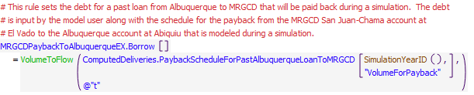
Execution Constraint
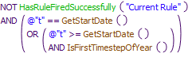
Referenced Functions
- IsFirstTimestepOfYear
- VolumeToFlow
- HasRuleFiredSuccessfully
- SimulationYearID
- GetStartDate

12.3 SetLetterWaterPaybackDebts
Rule Purpose:
Contractors for San Juan-Chama Project water may cause depletions in the basin and a payback for the depletions is modeled in URGWOM as deliveries of their San Juan-Chama Project water to payback MRGCD and the Compact for the depletions. These modeled deliveries reflect actual deliveries made when the State sends letters to Reclamation requesting the deliveries of the contractor's San Juan-Chama Project water, hence letter water deliveries. The volume of the payback for each contractor for each simulation year is input by the model user along with the portion to be paid back to MRGCD versus the Compact. The payback to MRGCD can be modeled as a transfer to the MRGCD account at El Vado Reservoir or a release from the source contractors account at Abiquiu toward meeting the MRGCD demand at Cochiti as needed. Three separate exchanges are set up for each contractor to track the debt separately for the three potential payback options. This rule sets the debts for each contractor for each of the potential three payback options.
Rule Logic: Execution Constraint logic is at end of explanation. A FOR DO Loop creates a list of all of the San Juan Contractors, excluding Reclamation, MRGCD and the Cochiti Rec Pool. Then for each contractor required annual delivery amount for so called "Letter Water" is set as one of the three different possible debts. A debt for any water to be repaid to the Compact by releases from Abiquiu is set first. Next, any water to be repaid to the MRGCD is set, but becase this debt can be repaid in two different locations depending on user input, an IF statement checks if the payback to MRGCD is to be a transfer at El Vado Reservoir or a release from Abiquiu and sets the flow accordingly.
This rule is set up to execute at the beginning of each calendar year during the rule based portion of the model run. Specifically, this rule fires if it has not fired yet as checked with reference to the predefined HasRuleFiredSuccessfully functiononce per timestep. AND the timestep is EITHER equal to the beginning timestep for rulebased simulation as input by the model user to the RulebasedSimulationStartDate scalar slot in the ModelRunTypeTriggers data object and as identified with the user-defined GetStartDate function OR after the GetStartDate and is the first timestep of the year
Model slots written by rule:
1. LetterWaterPaybackToCompactOutOfAbiquiuFrom_ACCOUNT_EX.Borrow where _ACCOUNT_ is all SJC accounts except Reclamation, CochitiRecPool, and MRGCD
List of key model objects with slots read by the rule or child functions:
1. ModelRunTypeTriggers
2. LetterWaterDeliveryData
Log of when and how the rule has been modified (newest changes at the top):
Date: Who. What
2/19/19: Jesse Roach. Added description field and updated notes field
Statements
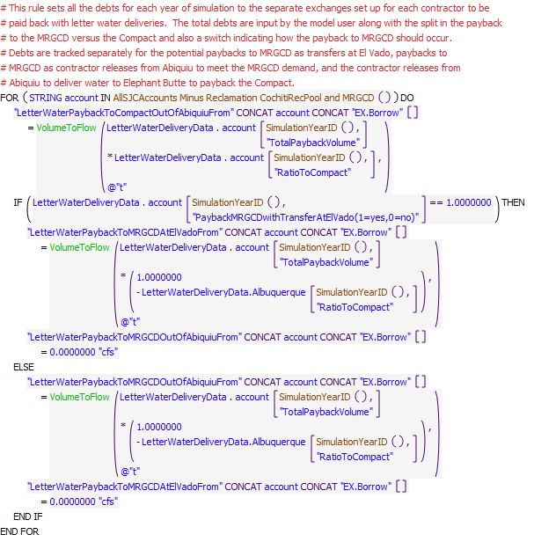
Execution Constraint
Referenced Functions
- IsFirstTimestepOfYear
- VolumeToFlow
- HasRuleFiredSuccessfully
- SimulationYearID
- AllSJCAccounts Minus Reclamation CochitiRecPool and MRGCD
- GetStartDate

13 ComputeUpstreamFlowNeededForTargets
The rules in this policy group are used to determine the flow needed at Cochiti for the Middle Rio Grande target flows and ultimately the amount of supplemental water needed from Abiquiu and El Vado Reservoirs. A need for Emergency Drought water from El Vado is estimated and a final needed release is determined such that releases are not adjusted every day to better reflect actual operations.
Rules in the Group:
ComputeSupplementalESARelease
SetNeededEmergencyDroughtWaterReleaseFromElVadoForTargets
ComputeEmergencyDroughtWaterNeededFromElVadoForTargets
ComputeTotalFlowNeededAtAbiquiuForAllMiddleValleyTargets
ComputeMinCochitiReleaseForAllMiddleValleyTargets
ComputeMinCochitiReleaseForSanMarcialTarget
ComputeMinCochitiReleaseForSanAcaciaTarget
ComputeMinCochitiReleaseForIsletaTarget
ComputeMinCochitiReleaseForCentralTarget
AlternateCalcOfMinCochitiReleases

Policy Group Change Log (newest changes at the top):
Date: Who. What
2/19/2019: Jesse Roach. Moved ComputeSupplementalESARelease to this group

13.1 AlternateCalcOfMinCochitiReleases
Rule Purpose:
This rule was set up as an alternative to the use of hypothetical simulation in RiverWare for identifying the flow needed at Cochiti for the Middle Valley targets. In addition to efficiency improvements, this alternate approach may prove valuable as a simplified means for determining the flow needed for targets that is more similar to the way actual operations are conducted and thereby potentially more easily explained to stakeholders in the basin. This approach is used if a switch is set by the model user to use the alternate approach.
Rule Logic: Execution Constraint logic is at end of explanation.
This rule uses functions to estimate evaporation, seepage, diversions, and returns, and Jemez inflows to the river based on future dates if the data is available, or averages of the previous 3 days otherwise.
This rule fires if the current timestep is greater than or equal to the beginning timestep for rulebased simulation as input by the model user to the RulebasedSimulationStartDate scalar slot in the ModelRunTypeTriggers data object and the rule has not fired yet as checked with reference to the predefined HasRuleFiredSuccessfully function and the value in the TriggerUseAlternateApproachToEstimateFlowNeededAtCochitiForTargets table slot in the MiddleValleyTargets data object is equal to 1.0, and there is available supplemental water in storage.
Model slots written by rule:
1. MiddleValleyTargets.MinReleaseForLOCATION where LOCATION is Central, Isleta, SanAcacia, and SanMarcial
List of key model objects with slots read by the rule or child functions:
1. ModelRunTypeTriggers
2. MiddleValleyTargets
3. Many model objects in Middle Valley
Log of when and how the rule has been modified (newest changes at the top):
Date: Who. What
2/19/19: Jesse Roach. Added description field and updated notes field
2/9/2018 JR: Additional timestep generalization.
Statements
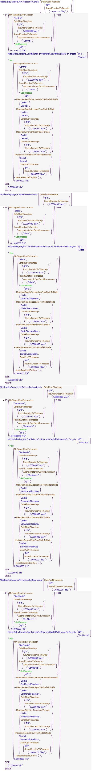
Execution Constraint
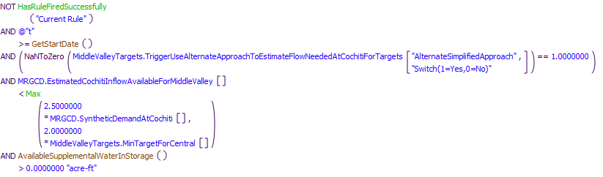
Referenced Functions
- DatePlusNTimesteps
- RoundDurationToTimestep
- ApproximateNumDaysDownstream
- MinTargetFlowForLocation
- MainstemReachSeepageFromNodeToNode
- MainstemReturnFlowFromNodeToNode
- MainstemReachEvaporationFromNodeToNode
- JemezPredictedOutflow
- MainstemDiversionFromNodeToNode
- AvailableSupplementalWaterInStorage
- Max
- GetTimestep
- HasRuleFiredSuccessfully
- GetStartDate

13.2 ComputeMinCochitiReleaseForCentralTarget
Rule Purpose:
This rule uses hypothetical simulation to determine the minimum total outflow from Cochiti Dam needed to meet the determined target flow at Central. The value for the next timestep is computed as needed to eventually determine the flow needed at Abiquiu at the current timestep. Inflows to Jemez Reservoir are assumed to be bypassed at Jemez Canyon Dam.
Rule Logic: Execution Constraint logic is at end of explanation.
The function completes the hypothetical simulation for all the objects in the BlwCochitiToCentralTarget subbasin and uses the minimum outflow and maximum outflow from Cochiti Dam as the bounds for the solution procedure as input to the MinRelease periodic slot and ReservoirData table slot, respectively, in the CochitiData data object and referenced with the user-defined MinOutflow and MaxOutflow functions, respectively. A tolerance of 0.25 cfs is allowed for the target flow. The inflow from the Rio Jemez is set to the inflow to Jemez Reservoir with the user-defined JemezInflowInputs function.
This rule fires if the current timestep is greater than or equal to the beginning timestep for rulebased simulation as input by the model user to the RulebasedSimulationStartDate scalar slot in the ModelRunTypeTriggers data object, the rule has not fired yet as checked with reference to the predefined HasRuleFiredSuccessfully function, the value in the TriggerUseAlternateApproachToEstimateFlowNeededAtCochitiForTargets table slot in the MiddleValleyTargets data object is equal to 1.0, and the recorded value to the MinTargetForCentral series slot in the MiddleValleyTargets data object is greater than zero for the timestep equal to the next timestep plus the number of timesteps for the release to reach Central from Cochiti Dam. The travel time is set based on the travel time input to the ApproxNoOfDaysDS table slot in the MiddleValleyTargets data object and referenced with the user-defined ApproximateNumDaysDownstream function. The execution constraints also check that the sum of the storage in the Reclamation account at Heron, the Reclamation and Supplemental ESA accounts at El Vado, the Reclamation and Rio Grande Conservation accounts at Abiquiu and the Rio Grande Conservation accounts at Cochiti and Jemez is greater than zero. Also, the EstimatedCochitiInflowAvailableForMiddleValley series slot value for the current timestep is checked to assure it is less than 2.5 times the value in the SyntheticDemandAtCochiti periodic slot in the MRGCD data object for the current timestep or 2.0 times the value for the MinTargetForCentral time series slot in the MiddleValleyTargets data object for the current timestep. (The latter two checks are included to minimize the amount of hypothetical simulation started with this rule.)
The value for the MinReleaseForCentral time series slot in the MiddleValleyDemands data object for the next timestep is set using the user-defined ReleaseToMeetMinFlowAtCentral function which uses the predefined HypTargetSimWithStatus function to determine the required outflow from Cochiti (or the value for the Inflow time series slot for the BlwCochitiDiversionsReach reach object) to meet a target flow at Central (or the Gage Outflow time series slot in the Central stream gage object) at the timestep equal to the next timestep plus the number of timesteps for the release to reach Central from Cochiti Dam. The next timestep and travel time are set as function arguments within the rule where the travel time is input to the ApproxNoOfDaysDS table slot in the MiddleValleyTargets data object and referenced with the user-defined ApproximateNumDaysDownstream function.
Model slots written by rule:
1. MiddleValleyTargets.MinReleaseForCentral
List of key model objects with slots read by the rule or child functions:
1. ModelRunTypeTriggers
2. MiddleValleyTargets
3. Heron
4. ElVado
5. Abiquiu
6. Cochiti
7. Jemez
8. MRGCD
9. Middle Valley Objects called by HypSim
Log of when and how the rule has been modified (newest changes at the top):
Date: Who. What
2/19/19: Jesse Roach. Added description field and updated notes field
11/10/17 JR: updated during MRG timestep generalization.
Statements
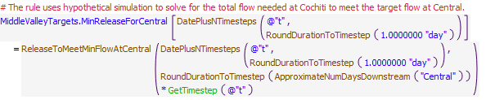
Execution Constraint
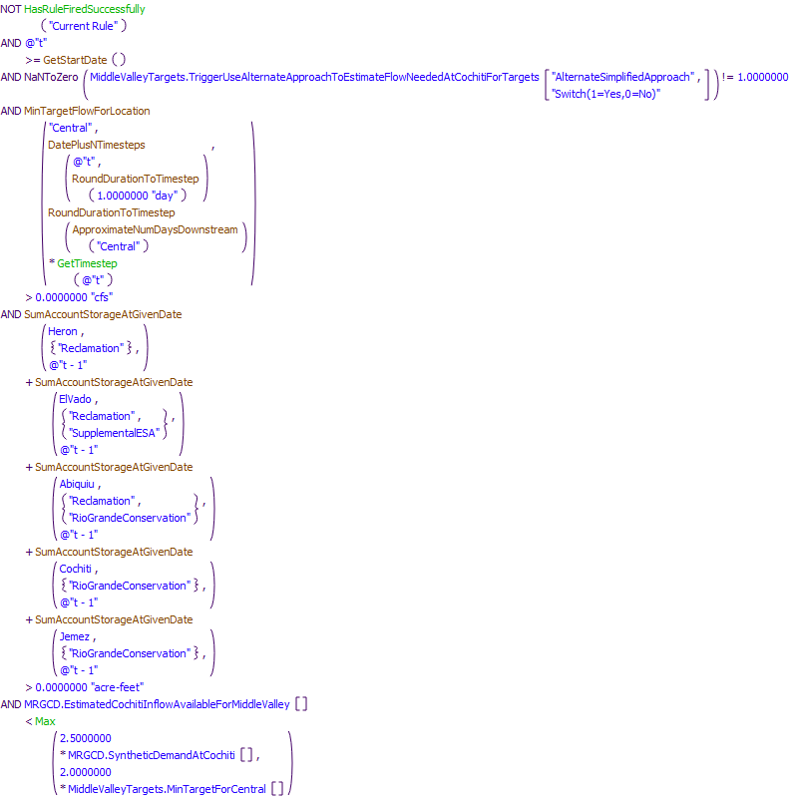
Referenced Functions
- DatePlusNTimesteps
- RoundDurationToTimestep
- ApproximateNumDaysDownstream
- ReleaseToMeetMinFlowAtCentral
- MinTargetFlowForLocation
- Max
- GetTimestep
- HasRuleFiredSuccessfully
- GetStartDate
- SumAccountStorageAtGivenDate

13.3 ComputeMinCochitiReleaseForIsletaTarget
Rule Purpose:
This rule determines the minimum total outflow from Cochiti Dam needed to meet the determined target flow at Isleta.
Rule Logic: Execution Constraint logic is at end of explanation.
This rule is analagous to the ComputeMinCochitiReleaseForCentralTarget rule except the minimum release is being determined for the target flow at Isleta. See the explanation for that rule for details.
This rule fires if the current timestep is greater than or equal to the beginning timestep for rulebased simulation as input by the model user to the RulebasedSimulationStartDate scalar slot in the ModelRunTypeTriggers data object, the rule has not fired yet as checked with reference to the predefined HasRuleFiredSuccessfully function, the value in the TriggerUseAlternateApproachToEstimateFlowNeededAtCochitiForTargets table slot in the MiddleValleyTargets data object is equal to 1.0, and the recorded value to the MinTargetForCentral series slot in the MiddleValleyTargets data object is greater than zero for the timestep equal to the next timestep plus the number of timesteps for the release to reach Central from Cochiti Dam. The travel time is set based on the travel time input to the ApproxNoOfDaysDS table slot in the MiddleValleyTargets data object and referenced with the user-defined ApproximateNumDaysDownstream function. The execution constraints also check that the sum of the storage in the Reclamation account at Heron, the Reclamation and Supplemental ESA accounts at El Vado, the Reclamation and Rio Grande Conservation accounts at Abiquiu and the Rio Grande Conservation accounts at Cochiti and Jemez is greater than zero. Also, the EstimatedCochitiInflowAvailableForMiddleValley series slot value for the current timestep is checked to assure it is less than 2.5 times the value in the SyntheticDemandAtCochiti periodic slot in the MRGCD data object for the current timestep or 2.0 times the value for the MinTargetForCentral time series slot in the MiddleValleyTargets data object for the current timestep. (The latter two checks are included to minimize the amount of hypothetical simulation started with this rule.)
Model slots written by rule:
1. MiddleValleyTargets.MinReleaseForIsleta
List of key model objects with slots read by the rule or child functions:
1. ModelRunTypeTriggers
2. MiddleValleyTargets
3. Heron
4. ElVado
5. Abiquiu
6. Cochiti
7. Jemez
8. MRGCD
Middle Valley Objects called by HypSim
Log of when and how the rule has been modified (newest changes at the top):
Date: Who. What
2/19/19: Jesse Roach. Added description field and updated notes field
11/10/17 JR: updated during MRG timestep generalization.
Statements
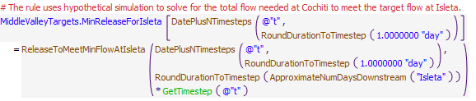
Execution Constraint
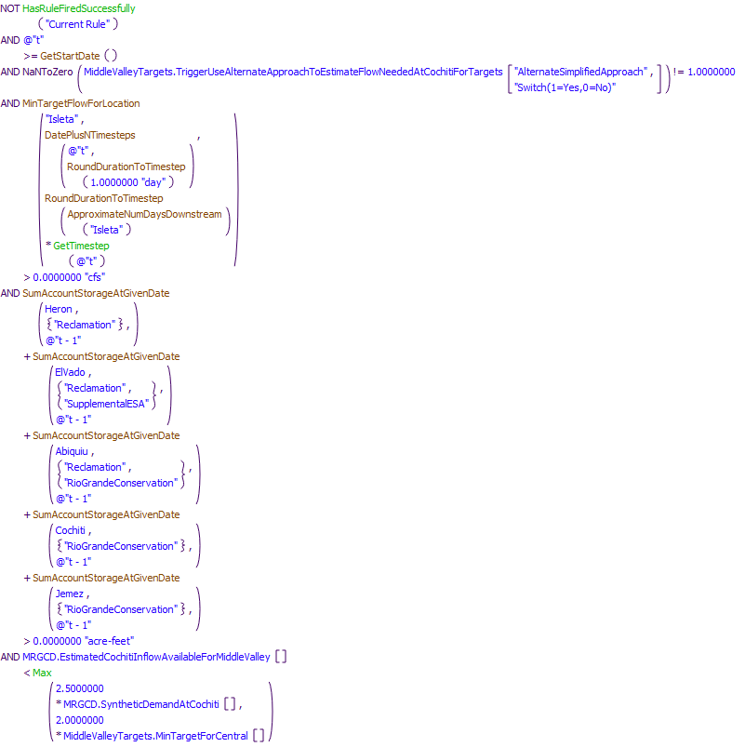
Referenced Functions
- DatePlusNTimesteps
- RoundDurationToTimestep
- ApproximateNumDaysDownstream
- MinTargetFlowForLocation
- ReleaseToMeetMinFlowAtIsleta
- Max
- GetTimestep
- HasRuleFiredSuccessfully
- GetStartDate
- SumAccountStorageAtGivenDate

13.4 ComputeMinCochitiReleaseForSanAcaciaTarget
Rule Purpose:
This rule determines the minimum total outflow from Cochiti Dam needed to meet the determined target flow at San Acacia.
Rule Logic: Execution Constraint logic is at end of explanation.
This rule is analagous to the ComputeMinCochitiReleaseForCentralTarget rule except the minimum release is being determined for the target flow at San Acacia. See the explanation for that rule for details.
This rule fires if the current timestep is greater than or equal to the beginning timestep for rulebased simulation as input by the model user to the RulebasedSimulationStartDate scalar slot in the ModelRunTypeTriggers data object, the rule has not fired yet as checked with reference to the predefined HasRuleFiredSuccessfully function, the value in the TriggerUseAlternateApproachToEstimateFlowNeededAtCochitiForTargets table slot in the MiddleValleyTargets data object is equal to 1.0, and the recorded value to the MinTargetForCentral series slot in the MiddleValleyTargets data object is greater than zero for the timestep equal to the next timestep plus the number of timesteps for the release to reach Central from Cochiti Dam. The travel time is set based on the travel time input to the ApproxNoOfDaysDS table slot in the MiddleValleyTargets data object and referenced with the user-defined ApproximateNumDaysDownstream function. The execution constraints also check that the sum of the storage in the Reclamation account at Heron, the Reclamation and Supplemental ESA accounts at El Vado, the Reclamation and Rio Grande Conservation accounts at Abiquiu and the Rio Grande Conservation accounts at Cochiti and Jemez is greater than zero. Also, the EstimatedCochitiInflowAvailableForMiddleValley series slot value for the current timestep is checked to assure it is less than 2.5 times the value in the SyntheticDemandAtCochiti periodic slot in the MRGCD data object for the current timestep or 2.0 times the value for the MinTargetForCentral time series slot in the MiddleValleyTargets data object for the current timestep. (The latter two checks are included to minimize the amount of hypothetical simulation started with this rule.)
Model slots written by rule:
1. MiddleValleyTargets.MinReleaseForIsleta
List of key model objects with slots read by the rule or child functions:
1. ModelRunTypeTriggers
2. MiddleValleyTargets
3. Heron
4. ElVado
5. Abiquiu
6. Cochiti
7. Jemez
8. MRGCD
9. Middle Valley Objects called by HypSim
Log of when and how the rule has been modified (newest changes at the top):
Date: Who. What
2/19/19: Jesse Roach. Added description field and updated notes field
11/10/17 JR: updated during MRG timestep generalization.
Statements
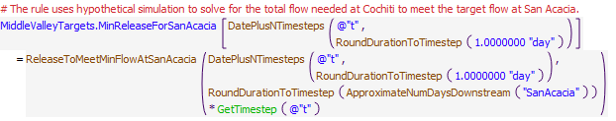
Execution Constraint
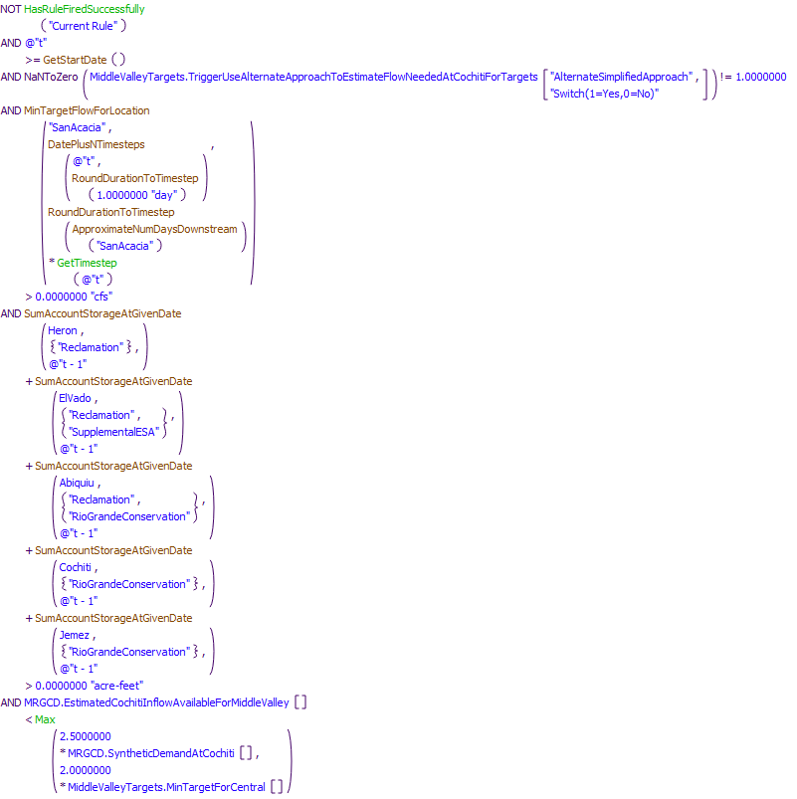
Referenced Functions
- DatePlusNTimesteps
- RoundDurationToTimestep
- ApproximateNumDaysDownstream
- MinTargetFlowForLocation
- ReleaseToMeetMinFlowAtSanAcacia
- Max
- GetTimestep
- HasRuleFiredSuccessfully
- GetStartDate
- SumAccountStorageAtGivenDate

13.5 ComputeMinCochitiReleaseForSanMarcialTarget
Rule Purpose:
This rule determines the minimum total outflow from Cochiti Dam needed to meet the determined target flow at San Marcial.
Rule Logic: Execution Constraint logic is at end of explanation.
This rule is analagous to the ComputeMinCochitiReleaseForCentralTarget rule except the minimum release is being determined for the target flow at San Marcial. See the explanation for that rule for details.
This rule fires if the current timestep is greater than or equal to the beginning timestep for rulebased simulation as input by the model user to the RulebasedSimulationStartDate scalar slot in the ModelRunTypeTriggers data object, the rule has not fired yet as checked with reference to the predefined HasRuleFiredSuccessfully function, the value in the TriggerUseAlternateApproachToEstimateFlowNeededAtCochitiForTargets table slot in the MiddleValleyTargets data object is equal to 1.0, and the recorded value to the MinTargetForCentral series slot in the MiddleValleyTargets data object is greater than zero for the timestep equal to the next timestep plus the number of timesteps for the release to reach Central from Cochiti Dam. The travel time is set based on the travel time input to the ApproxNoOfDaysDS table slot in the MiddleValleyTargets data object and referenced with the user-defined ApproximateNumDaysDownstream function. The execution constraints also check that the sum of the storage in the Reclamation account at Heron, the Reclamation and Supplemental ESA accounts at El Vado, the Reclamation and Rio Grande Conservation accounts at Abiquiu and the Rio Grande Conservation accounts at Cochiti and Jemez is greater than zero. Also, the EstimatedCochitiInflowAvailableForMiddleValley series slot value for the current timestep is checked to assure it is less than 2.5 times the value in the SyntheticDemandAtCochiti periodic slot in the MRGCD data object for the current timestep or 2.0 times the value for the MinTargetForCentral time series slot in the MiddleValleyTargets data object for the current timestep. (The latter two checks are included to minimize the amount of hypothetical simulation started with this rule.)
Model slots written by rule:
1. MiddleValleyTargets.MinReleaseForSanMarcial
List of key model objects with slots read by the rule or child functions:
1. ModelRunTypeTriggers
2. MiddleValleyTargets
3. Heron
4. ElVado
5. Abiquiu
6. Cochiti
7. Jemez
Log of when and how the rule has been modified (newest changes at the top):
Date: Who. What
2/19/19: Jesse Roach. Added description field and updated notes field
11/10/17 JR: updated during MRG timestep generalization.
Statements
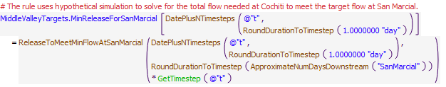
Execution Constraint
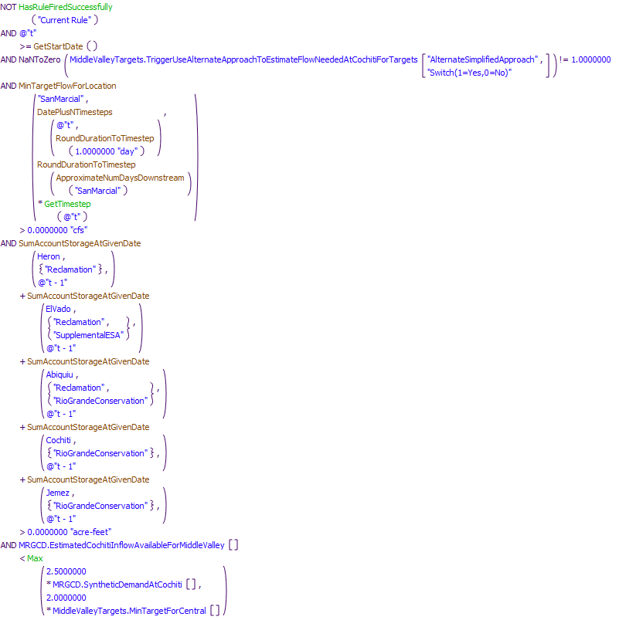
Referenced Functions
- DatePlusNTimesteps
- RoundDurationToTimestep
- ApproximateNumDaysDownstream
- MinTargetFlowForLocation
- ReleaseToMeetMinFlowAtSanMarcial
- Max
- GetTimestep
- HasRuleFiredSuccessfully
- GetStartDate
- SumAccountStorageAtGivenDate

13.6 ComputeMinCochitiReleaseForAllMiddleValleyTargets
Rule Purpose:
This rule determines the maximum value from the four computed minimum releases from Cochiti Dam needed to meet the target flows at Central, Isleta, San Acacia, and San Marcial. The resulting maximum total flow needed for targets in the Middle Valley is then referenced later to identify the amount of supplemental water needed from Abiquiu Reservoir (or Cochiti Deviations). Values are set for the next day in daily runs and the current timestep in monthly runs. Indicators are also set to identify which targets are critical and driving the release of supplemental water.
Rule Logic: Execution Constraint logic is at end of explanation.
If a value is not input as checked with the predefined IsInput function, the MinReleaseNeededAtCochiti time series slot in the MiddleValleyTargets data object for the next timestep is set using the user-defined ComputeCochitiMinimumFlow function. The ComputeCochitiMinimumFlow function uses the predefined MaxItem function to determine the maximum value from the minimum releases to meet the target flows at Central, Isleta, San Acacia, and San Marcial. A second assignment statement is used to set the same slot value for the current timestep if it is the current timestep equals the start timestep.
This rule also includes four separate assignment statements that record values of 1 or 0 to the CentralDrivingTargetIndicator, IsletaDrivingTargetIndicator, SanAcaciaDrivingTargetIndicator, and SanMarcialDrivingTargetIndicator series slots in the MiddleValleyTargets data object. If the value for the minimum release for the corresponding target is greater than 0.1 cfs and the difference in the final mimimum release from Cochiti for all targets and the minimum release for the corresponding target is less than 0.1 cfs (i.e. the values are the same) and supplemental water was released, the corresponding slot value is set to 1.0 to indicate that the corresponding target is critical and driving the release of supplemental water for the current timestep. Otherwise, the slot value is set to 0.
This rule fires if the current timestep is greater than or equal to the beginning timestep for rulebased simulation as input by the model user to the RulebasedSimulationStartDate scalar slot in the ModelRunTypeTriggers data object and the rule has not fired yet as checked with reference to the predefined HasRuleFiredSuccessfully function.
Model slots written by rule:
1. MiddleValleyTargets.MinReleaseNeededAtCochiti
2. MiddleValleyTargets.LOCATIONDrivingTargetIndicator where LOCATION is Central, Isleta, SanAcacia, and SanMarcial
List of key model objects with slots read by the rule or child functions:
1. ModelRunTypeTriggers
2. MiddleValleyTargets
Log of when and how the rule has been modified (newest changes at the top):
Date: Who. What
2/19/19: Jesse Roach. Added description field and updated notes field
11/10/17 JR: updated during MRG timestep generalization.
Statements
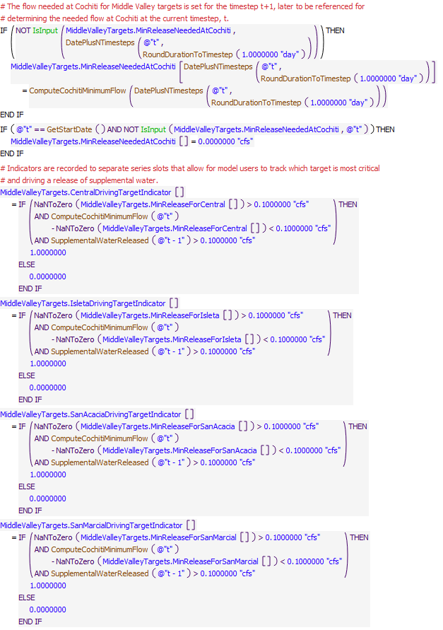
Execution Constraint
Referenced Functions
- DatePlusNTimesteps
- ComputeCochitiMinimumFlow
- RoundDurationToTimestep
- SupplementalWaterReleased
- IsInput
- HasRuleFiredSuccessfully
- GetStartDate

13.7 ComputeTotalFlowNeededAtAbiquiuForAllMiddleValleyTargets
Rule Purpose:
This rule uses hypothetical simulation to determine the total release from Abiquiu Dam required to meet the computed minimum flow needed at Cochiti Lake for all the Middle Valley targets. The flow needed at Abiquiu is set to zero if the flow needed at Cochiti is not greater than zero, there is no supplemental water available in storage, or the estimated inflow to Cochiti Lake is high.
Rule Logic: Execution Constraint logic is at end of explanation.
An IF THEN ELSE statement is used to see if the value for the MinReleaseNeededAtCochiti in the MiddleValleyTargets data object is greater than zero, and if the sum of the storage in the Reclamation account at Heron, the Reclamation and Supplemental ESA accounts at El Vado, the Reclamation and Rio Grande Conservation accounts at Abiquiu and the Rio Grande Conservation account at Cochiti is greater than zero, and if the value for the EstimatedCochitiInflowAvailableForMiddleValley series slot in the MRGCD data object is less than 2.5 times the value in the SyntheticDemandAtCochiti time series slot in the MRGCD data object for the current timestep or 2.0 times the value for the MinTargetForCentral time series slot in the MiddleValleyTargets data object for the current timestep. If so, the
TotalFlowNeededAtAbiquiuForTargets time series slot in the AbiquiuData data object for the current timestep is set with the user-defined AbiquiuMinFlowsDemand function. Otherwise the assignment is set to 0.0 cfs.
The AbiquiuMinFlowsDemand function uses the predefined HypTargetSimWithStatus function to determine the required outflow from Abiquiu Dam (or the value for the Gage Inflow time series slot for the BlwAbiquiu stream gage object) to meet a target inflow to Cochiti Lake (or a value for the Outflow time series slot in the OtowiToCochitiLocalInflow reach object) equal to the value for the MinReleaseNeededAtCochiti time series slot in the MiddleValleyTargets data object for the next timestep. The function completes the hypothetical simulation for all the objects in the BelowAbiquiu subbasin and uses the input minimum and maximum outflows from Abiquiu Dam of 0 and 1800 cfs, respectively (the channel capacity below Abiquiu Dam is 1800 cfs) as bounds for the solution. A tolerance of 5 cfs is allowed for the target flow. If the flow needed at Cochiti is zero, there is no supplemental water, or the inflows to Cochiti Lake are high, the flow needed at Abiquiu is simply set to zero to reduce the calls to the computationally intensive hypothetical simulation and improve the efficiency of URGWOM runs.
This rule fires If the current timestep is greater than or equal to the beginning timestep for rulebased simulation as input by the model user to the RulebasedSimulationStartDate scalar slot in the ModelRunTypeTriggers data object and the value for the TotalFlowNeededAtAbiquiuForTargets time series slot in the MiddleValleyTargets data object for the current timestep is a NaN.
Model slots written by rule:
1. MiddleValleyTargets.TotalFlowNeededAtAbiquiuForTargets
List of key model objects with slots read by the rule or child functions:
1. ModelRunTypeTriggers
2. MiddleValleyTargets
3. ComputedDeliveries
4. MRGCD
5. Heron
6. ElVado
7. Abiquiu
8. Cochiti
Log of when and how the rule has been modified (newest changes at the top):
Date: Who. What
2/19/19: Jesse Roach. Added description field and updated notes field
11/10/17 JR: updated during MRG timestep generalization.
Statements
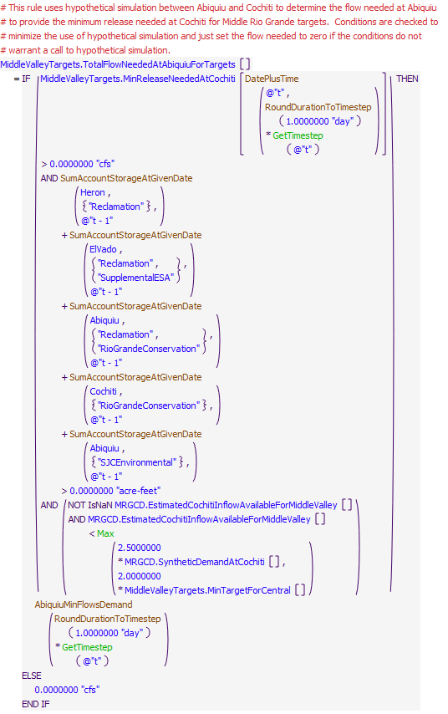
Execution Constraint
Referenced Functions
- DatePlusTime
- RoundDurationToTimestep
- AbiquiuMinFlowsDemand
- Max
- GetTimestep
- GetStartDate
- SumAccountStorageAtGivenDate

13.8 ComputeEmergencyDroughtWaterNeededFromElVadoForTargets
Rule Purpose:
The amount of Emergency Drought water needed from El Vado for targets must be estimated before the Rio Grande bypass at Abiquiu is known. This rule is used to estimate the amount of Emergency Drought water needed as the total release needed for targets minus the estimated Rio Grande inflow and minus San Juan-Chama Project deliveries to the Buckman Direct Diversion, the Albuquerque diversion, deliveries to Elephant Butte, letter water deliveries to payback the Compact, letter water deliveries to payback MRGCD, and releases from MRGCD storage at Abiquiu. The calculation is complicated by the potential conservation storage at Abiquiu that may be modeled. The amount needed at Abiquiu is adjusted by the last loss coefficient betwen El Vado and Abiquiu to estimate the amount needed at El Vado.
Rule Logic: Execution Constraint logic is at end of explanation.
The value for the NeededEmergencyDroughtWaterFromElVado series slot in the MiddleValleyTargets data object is set with this rule as the result for the user-defined EmergencyDroughtWaterForTargetsNeededAtAbiquiu function adjusted with reference to the Variable Gain Loss slot value in the BlwElVadoToAbvAbiquiu reach object for the previous timestep. The function computes the need at Abiquiu using an initial value equal to the TotalFlowNeededAtAbiquiuForTargets series slot minus the values in the AlbuquerqueDeliveryToSurfaceWaterDiversion, SantaFeCityDeliveryToBuckmanDiversion, SantaFeCountyDeliveryToBuckmanDiversion, AlbuquerqueDeliveryAbiquiuToElephantButte, and SantaFeCityAbiquiuToElephantButte slots in the ComputedDeliveries data object minus the value in the EstimateAbiquiuRGInflow series slot in the MRGCD data object for the current timestep. The flow needed is also reduced by the letter water deliveries to payback MRGCD, letter water deliveries to payback the Compact, any release of available MRGCD San Juan-Chama water at Abiquiu to meet the MRGCD demand.
If the previous storage in the RioGrandeConservation account at Abiquiu is greater than that initial demand and the current timestep is between the dates to release conservation storage from Abiquiu referenced with the user-defined GetStartAbiquiuRGConsReleaseDate and GetEndAbiquiuRGConsReleaseDate functions or the previous storage in the RioGrandeConservation account at Jemez is greater than the initial demand and the current timestep is between the dates to release conservation storage from Jemez referenced with the user-defined GetStartJemezRGConsReleaseDate and GetEndJemezRGConsReleaseDate functions, the function result is set to 0.0. Otherwise, the function result is the initial demand.
This rule fires if the current timestep is greater than or equal to the beginning timestep for rulebased simulation as input by the model user to the RulebasedSimulationStartDate scalar slot in the ModelRunTypeTriggers data object and the rule has not fired successfully for the current timestep as determined with reference to the predefined HasRuleFiredSuccessfully function.
Model slots written by rule:
1. MiddleValleyTargets.NeededEmergencyDroughtWaterFromElVado
List of key model objects with slots read by the rule or child functions:
1. ModelRunTypeTriggers
2. MiddleValleyTargets
3. ComputedDeliveries
4. MRGCD
5. Abiquiu
6. Cochiti
7. Jemez
Log of when and how the rule has been modified (newest changes at the top):
Date: Who. What
2/19/19: Jesse Roach. Added description field and updated notes field
11/10/17 JR: updated during MRG timestep generalization.
Statements
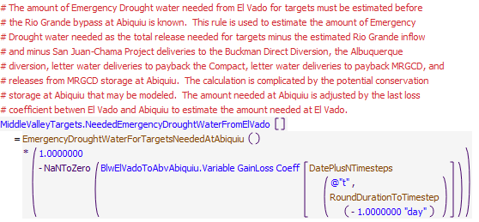
Execution Constraint
Referenced Functions
- DatePlusNTimesteps
- RoundDurationToTimestep
- EmergencyDroughtWaterForTargetsNeededAtAbiquiu
- HasRuleFiredSuccessfully
- GetStartDate

13.9 SetNeededEmergencyDroughtWaterReleaseFromElVadoForTargets
Rule Purpose:
This rule sets a final value for the needed minimum release of Emergency Drought water from El Vado for targets with reference to the computed need. The actual release is not adjusted unless a specific threshold change in the need is exceeded and the release of supplemental water is not adjusted until after an input minimum of days since the last adjustment. The calculations are included to better represent actual operations that do not entail adjusting the release each day by a few cfs in attempt to exactly meet a target flow.
Rule Logic: Execution Constraint logic is at end of explanation.
An IF THEN ELSE statemeint is included to first check if the current timestep is the start timestep for rulebased simulation. If so, the value for the NeededEmergencyDroughtWaterReleaseFromElVado time series slot in the MiddleValleyTargets data object for the current timestep is set to the value in the NeededEmergencyDroughtWaterFromElVado time series slot for the current timestep rounded to the nearest 10 cfs. A separate assignment is included to reset a counter for the number of days since an adjustment was made to the release of supplemental water.
Otherwise, another IF THEN ELSE statement is included to check if the previous counter value in the CountSinceEmergencyDroughtWaterReleaseAdjusted time series slot is greater than or equal to the value in the MinDaysBeforeSupplementalWaterReleaseAdjusted scalar slot in the MiddleValeyTargets data object and the average demand over that period minus the previous value for the NeededEmergencyDroughtWaterReleaseFromElVado time series slot exceeds the value for the ChangeBeforeSupplementalWaterReleaseAdjusted scalar slot in the MiddleValleyTargets data object or the previous value in the CountSinceEmergencyDroughtWaterReleaseAdjusted time series slot in the MiddleValleyTargets data object is greater than or equal to the value in the MaxDaysWithNoSupplementalWaterReleaseAdjustment scalar slot. If the condition is satisfied, the value for the NeededEmergencyDroughtWaterReleaseFromElVado slot is set to the average of the NeededEmergencyDroughtWaterFromElVado slot values since the last adjustment was made. Otherwise, the previous value for the NeededEmergencyDroughtWaterReleaseFromElVado slot is maintained. A counter is also set if the value in the NeededEmergencyDroughtWaterReleaseFromElVado slot is adjusted.
This rule fires if the current timestep is greater than or equal to the beginning timestep for rulebased simulation as input by the model user to the RulebasedSimulationStartDate scalar slot in the ModelRunTypeTriggers data object and the value for the NeededEmergencyDroughtWaterReleaseFromElVado time series slot in the MiddleValleyTargets data object for the current timestep is a NaN.
Model slots written by rule:
1. MiddleValleyTargets.NeededEmergencyDroughtWaterReleaseFromElVado
List of key model objects with slots read by the rule or child functions:
1. ModelRunTypeTriggers
2. MiddleValleyTargets
Log of when and how the rule has been modified (newest changes at the top):
Date: Who. What
2/19/19: Jesse Roach. Added description field and updated notes field
11/10/17 JR: updated with timestep generalization of MRG rules.
Statements
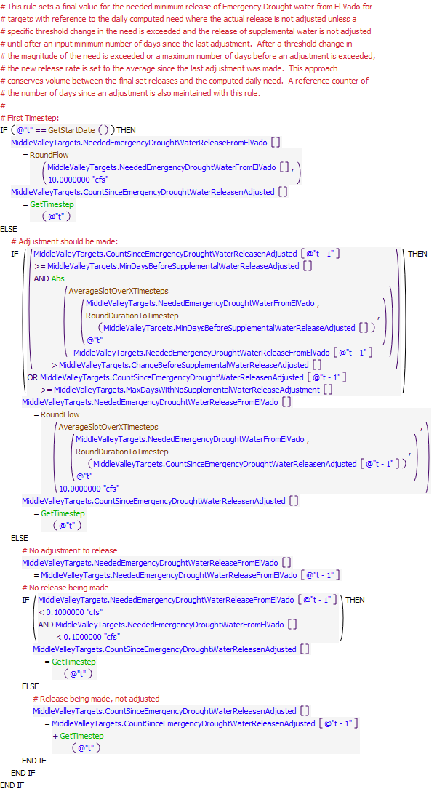
Execution Constraint
Referenced Functions
- RoundDurationToTimestep
- RoundFlow
- Abs
- GetTimestep
- AverageSlotOverXTimesteps
- GetStartDate

13.10 ComputeSupplementalESARelease
Rule Purpose:
This rule computes a daily release of Emergency Drought water from El Vado Reservoir for ESA needs as the determined need restricted to not exceed the input daily maximum, the maximum release volume for a year, or the available Emergency Drought water supply for ESA at El Vado Reservoir.
Rule Logic: Execution Constraint logic is at end of explanation.
If a value is not input as checked with reference to the predefined IsInput function, the value for the SupplementalESAReleaseFromElVadoForTargets time series slot in the ComputedDeliveries data object for the current timestep is set to the result of the SupplementalESAReleaseFromElVado function. This function uses a WITH DO loop to sum the year-to-date releases with reference to the SupplementalESAElVadoToRioGrandeBlwElVado supply slot values from January 1 to the previous timestep. An IF THEN ELSE statement is used to identify if the current timestep is within the input dates for releases as checked with the user-defined ESAReleaseSeason function. If not, the function result is 0.0 cfs. Otherwise, the release is computed with reference to the user-defined MinList function to the minimum of the
value in the NeededEmergencyDroughtWaterReleaseFromElVado series slot in the MiddleValleyTargets data object for the current timestep or the available storage at the previous timestep in the SupplementalESA account at El Vado with any transfer to the account at the current timestep or the value in the MaxESARelease table slot in the RelinquishedCreditsEmergencyDroughtWater data object or the difference in the value in the MaxSupplementalESAAnnualRelease row of the RelinquishedNMCreditAllocations table slot in the RelinquishedCreditsEmergencyDroughtWater data object and the sum of the year-to-date releases.
This rule fires if the current timestep is greater than or equal to the beginning timestep for rulebased simulation as input by the model user to the RulebasedSimulationStartDate scalar slot in the ModelRunTypeTriggers data object and if the value for the SupplementalESAReleaseFromElVadoForTargets time series slot in the ComputedDeliveries data object for the current timestep is a NaN.
Model slots written by rule:
1. ComputedDeliveries.SupplementalESAReleaseFromElVadoForTargets
List of key model objects with slots read by the rule or child functions:
1. ComputedDeliveries
2. MiddleValleyTargets
3. ElVado
4. RelinquishedCreditsEmergencyDroughtWater
Log of when and how the rule has been modified (newest changes at the top):
Date: Who. What
2/19/19: Jesse Roach. Added description field and updated notes field
Statements
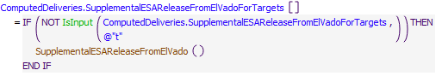
Execution Constraint
Referenced Functions
- SupplementalESAReleaseFromElVado
- IsInput
- GetStartDate

14 Release of Emergency Drought Water & MRGCD out of Article VII water
The rules in this policy group are used to compute releases of Emergency Drought water or MRGCD water stored out of Article VII as contributions to meeting the MRGCD demand and deliveries to meet target flows in the Middle Rio Grande with checks against the available supply and checks against input limited annual release volumes.
Rules in the Group:
ComputeMRGCDoutofArticleVIIRelease
ComputeMRGCDDroughtRelease
ComputeSupplementalESARelease
Policy Group Change Log (newest changes at the top):
Date: Who. What
2/19/2019: Jesse Roach. Moved ComputeMRGCDoutofArticleVIIRelease into the group and renamed.

14.1 ComputeMRGCDDroughtRelease
Rule Purpose:
This rule computes a daily release of Emergency Drought water from El Vado Reservoir for MRGCD to meet the remaining need for the MRGCD demand above native inflows that are bypassed at El Vado and any release of P&P water. Emergency Drought water is used before Rio Grande project water in storage and before MRGCD's San Juan-Chama Project water.
Rule Logic: Execution Constraint logic is at end of explanation.
If a value is not input as checked with reference to the predefined IsInput function, the value for the MRGCDDroughtReleaseFromElVado time series slot in the ComputedDeliveries data object for the current timestep is set to the result of the MRGCDDroughtReleaseFromElVado function. This function uses a WITH DO loop to sum the year-to-date releases with reference to the MRGCDDroughtElVadoToRioGrandeBlwElVado supply slot values from January 1 to the previous timestep. The result is set with reference to the predefined MinItem function to the MRGCD demand at El Vado minus the P&P releases determined with the ElVadoMRGCDDemand function minus the current Rio Grande inflow available to bypass computed as the Rio Grande inflow minus the transfers into the MRGCDDrought, SupplementalESA, and PandP accounts. If the Rio Grande storage is negative, the inflow is also adjusted to allow for the Rio Grande storage to return to zero. The MinItem function also checkes the available storage at the previous timestep in the MRGCDDrought account at El Vado with any transfer to the account at the current timestep and the difference in the value in the MaxMRGCDDroughtAnnualRelease row of the RelinquishedNMCreditAllocations table slot in the RelinquishedCreditsEmergencyDroughtWater data object and the sum of the year-to-date releases.
This rule fires if the current timestep is greater than or equal to the beginning timestep for rulebased simulation as input by the model user to the RulebasedSimulationStartDate scalar slot in the ModelRunTypeTriggers data object and the MRGCDDroughtReleaseFromElVado time series slot in the ComputedDeliveries data object for the current timestep is a NaN.
Model slots written by rule:
1. ComputedDeliveries.MRGCDDroughtReleaseFromElVado
List of key model objects with slots read by the rule or child functions:
1. ModelRunTypeTriggers
2. ComputedDeliveries
3. MiddleValleyTargets
4. ElVado
5. ElVadoData
6. RelinquishedCreditsEmergencyDroughtWater
Log of when and how the rule has been modified (newest changes at the top):
Date: Who. What
2/19/19: Jesse Roach. Added description field and updated notes field
Statements
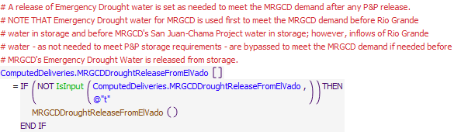
Execution Constraint
Referenced Functions
- MRGCDDroughtReleaseFromElVado
- IsInput
- GetStartDate

14.2 ComputeMRGCDoutofArticleVIIRelease
Rule Purpose:
The rule computes releases of RG water stored out of Article VII for MRGCD as the MRGCD demand at El Vado minus any native inflows to El Vado available to bypass. The final set release of RG water stored out of Article VII for MRGCD includes checks against the available supply in the MRGCDoutofArticleVII account at El Vado.
Rule Logic: Execution Constraint logic is at end of explanation.
If the ComputedDeliveries.MRGCDoutofArticleVIIReleaseFromElVado slot is not input and the MRGCDoutofArticleVIIstorageOnElVado account is enabled the function MRGCDoutofArticleVIIReleaseFromElVado is called. Otherwise the release is set to zero. The MRGCDoutofArticleVIIReleaseFromElVado takes the smaller of available and needed release. The needed release is the MRGCD demand at El Vado less inflows to El Vado, and MRGCD Drought Releases.
This rule fires if the current timestep is greater than or equal to the beginning timestep for rulebased simulation as input by the model user to the RulebasedSimulationStartDate scalar slot in the ModelRunTypeTriggers data object and the MRGCDoutofArticleVIIReleaseFromElVado time series slot in the ComputedDeliveries data object for the current timestep is a NaN.
Model slots written by rule:
1. ComputedDeliveries.MRGCDoutofArticleVIIReleaseFromElVado
List of key model objects with slots read by the rule or child functions:
1. ModelRunTypeTriggers
2. ElVado
3. ElVadoData
4. ComputedDeliveries
5. Heron
Log of when and how the rule has been modified (newest changes at the top):
Date: Who. What
2/19/19: Jesse Roach. Added description field and updated notes field
Statements
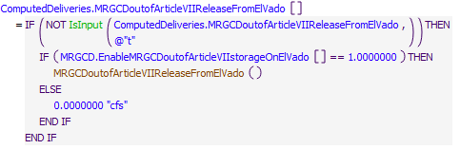
Execution Constraint
Referenced Functions
- MRGCDoutofArticleVIIReleaseFromElVado
- IsInput
- GetStartDate

15 EstimateElVadoRGRelease
The rules in the policy group compute Rio Grande releases from El Vado for compact debit as well as for filling El Vado Reservoir if Article VII is not in effect. If Article VII is in effect, inflows are bypassed. An estimated magnitude and date for the peak inflow to El Vado Reservoir are recorded to help with filling rules. The magnitude and date of the peak are referenced for policy for fillingNative water will also be released from storage as available and as needed to meet the MRGCD demand with consideration for contributions from P&P releases and deliveries of MRGCD Emergency Drought water.
Rules in the Group:
EstimateElVadoRGRelease
ComputeElVadoOutflowForFilling
ComputeSupplementalESAReleaseRecordEstimatedElVadoPeakInflowAndDate
ComputeCompactDebitReleaseFromElVado
Policy Group Change Log (newest changes at the top):
Date: Who. What

15.1 ComputeCompactDebitReleaseFromElVado
Rule Purpose:
This rule empties the compact debit account in El Vado.
Rule Logic: Execution Constraint logic is at end of explanation.
If a value has not been input by the user, the account is emptied starting on a user-input StartDay, and continues until the user-input EndDay as specified in the "RioGrandeCompact.CompactDebitReleaseSchedule" slot, if there is any CompactDebit account water in El Vado, and the RioGrandeCompact.EnableCompactDebitStorageOnElVado switch is set at 1.0. Water is emptied from this account at a constant rate based on the release schedule dates. On the final day of releases, all of the remaining water is emptied out of the account (the constant rate doesn't take into account minor fluctuations in gain-loss values on the account). If any one of the Boolean tests are FALSE, then the value is set to 0 cfs.
This rule fires if the current timestep is greater than or equal to the beginning timestep for rulebased simulation as input by the model user to the RulebasedSimulationStartDate scalar slot in the ModelRunTypeTriggers data object and the CompactDebitReleaseFromElVado time series slot in the ComputedDeliveries data object for the current timestep is a NaN.
Model slots written by rule:
1. ComputedDeliveries.CompactDebitReleaseFromElVado
List of key model objects with slots read by the rule or child functions:
1. ModelRunTypeTriggers
2. ComputedDeliveries
3. RioGrandeCompact
4. ElVado
Log of when and how the rule has been modified (newest changes at the top):
Date: Who. What
2/19/19: Jesse Roach. Added description field and updated notes field
Statements
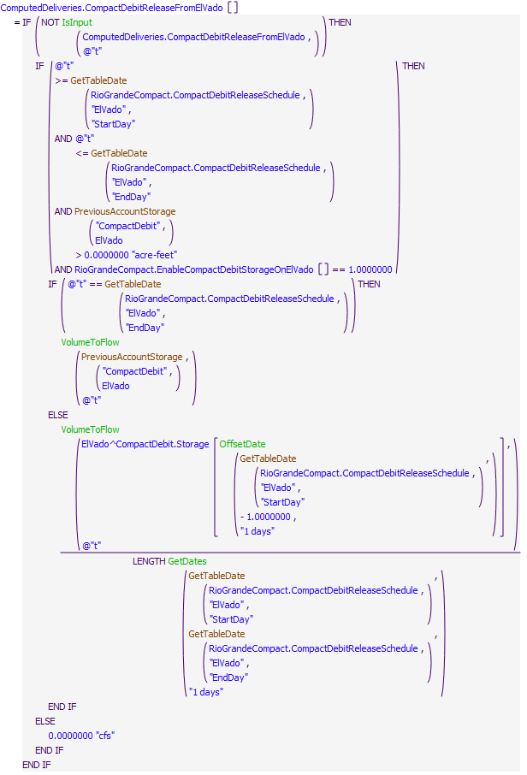
Execution Constraint
Referenced Functions
- GetTableDate
- OffsetDate
- GetDates
- VolumeToFlow
- IsInput
- GetStartDate
- PreviousAccountStorage

15.2 RecordEstimatedElVadoPeakInflowAndDate
Rule Purpose:
This rule records a date and magnitude for the estimated peak inflow to El Vado Reservoir for each year in a model run. The values are then referenced later when setting the release of native water from El Vado Reservoir during filling if Article VII of the Compact is not in effect.
Rule Logic: Execution Constraint logic is at end of explanation.
This rule executes if the current timetep is equal to March 1 or the rule based simulation start timestep if that rulebased simulation timestep is after March 1.
Two assignment statements are included in this rule. Values for the EstimatedPeakInflow and EstimatedPeakInflowDate slots for December 31 of the current year are set to the two resulting values from using the user-defined ElVadoMaxInflowAndDateList function which creates a two item list with the magnitude of the peak inflow and the date for the maximum inflow between March 1 and July 31. A WITH DO loop is used in the ElVadoMaxInflowAndDateList function to create a list of estimated flows for each date between the the two input dates of March 1 and July 31. Future inflows are estimated based on input inflows to AzoteaWillow confluence object and the Local Inflow slot of the ElVadoLocalInflow reach object. A final list is created with the maximum flow and corresponding date.
This rule fires if the timestamp is at or after the beginning timestep for rulebased simulation as input by the model user to the RulebasedSimulationStartDate scalar slot in the ModelRunTypeTriggers data object and as identified with the user-defined GetStartDate function AND either EstimatedPeakInflowDate OR EstimatedPeakFlow are undefined
Model slots written by rule:
1. ElVadoData.EstimatedPeakInflowDate
2. ElVadoData.EstimatedPeakInflow
List of key model objects with slots read by the rule or child functions:
1. ModelRunTypeTriggers
2. AzoteaWillow
3. ElVadoLocalInflow
Log of when and how the rule has been modified (newest changes at the top):
Date: Who. What
2/19/19: Jesse Roach. Added description field and updated notes field
11/10/17 JR: updated during timestep generalization of MRG rules.
Statements
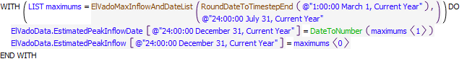
Execution Constraint
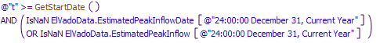
Referenced Functions
- ElVadoMaxInflowAndDateList
- RoundDateToTimestepEnd
- DateToNumber
- GetStartDate

15.3 ComputeElVadoOutflowForFilling
Rule Purpose:
The rule is used to set releases in order to completely fill El Vado if possible during spring runoff.
Rule Logic: Execution Constraint logic is at end of explanation.
The rule calls the function ElVadoOutflowForFilling which replicates an approach developed for filling El Vado Reservoir by filling up to a level prior to the peak that leaves buffer space between the pool elevation and the top of the fill pool. After the peak, the reservoir will completely fill as possible. Several parameters and factors were refined for this algorithm using a spreadsheet to fully test the approach with historical data.
This rule fires if the current timestep is greater than or equal to the beginning timestep for rulebased simulation as input by the model user to the RulebasedSimulationStartDate scalar slot in the ModelRunTypeTriggers data object and the OutflowForFilling time series slot in the ElVadoData data object for the current timestep is a NaN.
Model slots written by rule:
1. ElVadoData.OutflowForFilling
List of key model objects with slots read by the rule or child functions:
1. ModelRunTypeTriggers
2. ElVadoData
3. ElVado
Log of when and how the rule has been modified (newest changes at the top):
Date: Who. What
2/19/19: Jesse Roach. Added description field and updated notes field
Statements
Execution Constraint
Referenced Functions
- ElVadoOutflowForFilling
- GetStartDate

15.4 EstimateElVadoRGRelease
Rule Purpose:
This rule computes a daily release of Rio Grande water from El Vado Reservoir. If Article VII is in effect, inflows are bypassed as not needed for P&P storage and storage to meet Emergency Drought Water allocations for MRGCD and ESA. Inflows will also be stored if needed to offset a negative storage. If Article VII is not in effect, the outflow is set to the computed amount for filling. The outflow from the Rio Grande account is checked to assure the MRGCD demand is met with releases from available storage if needed and against the Minimum Rio Grande outflow for ultimately assuring Rio Chama acequia diversions demands are met. The total outflow of native water includes any computed release of P&P water or Emergency Drought water for MRGCD or ESA.
Rule Logic: Execution Constraint logic is at end of explanation.
The value for the RGOutflow series slot in the ElVadoData data object for the current timestep is set using the ElVadoRGRelease function. The predefined MaxItem function is first used to identify the maximum of 1) the release of native water set as a function of Article VII status, 2) the release needed to meet the MRGCD demand, and 3) the minimum Rio Grande outflow. 1) An IF THEN ELSE statement is used to check the user-defined ArticleVIIinEffect function. If Article VII is in effect, the bypassed inflow is set to the result from the CurrentRGInflow function minus the accounting supplies for transfers to the MRGCDDrought, SupplementalESA, and PandP accounts. The bypassed inflow is also adjusted if the previous Rio Grande storage is negative to allow for the Rio Grande storage to return to zero. If Article VII is not in effect, the release is set to the result of the user-defined ElVadoOutflowForFilling function (That function mimics a calibrated procedure developed by Warren Sharp that was tested extensively by Warren in an Excel file (20100608_PotentialElVadoOps2010.xls) and was refined to serve as a guide for how El Vado Reservoir could be filled to best assure the reservoir is filled with available inflows while minimizing the chance that the downstream channel capacity is exceeded). 2) The release needed to meet the MRGCD demand is set to the value in the MRGCDDemand series slot in the ElVadoData data object for the current timestep minus the value in the PandPReleaseFromElVado series slot in the ComputedDeliveries data object as checked with the user-defined ElVadoMRGCDDemand function minus the value in the MRGCDDroughtReleaseFromElVado series slot in the ComputedDeliveries data object for the current timestep checked against the previous storage in the RioGrande account at ElVado using the predefined Min function. 3) The minimum Rio Grande outflow from El Vado is checked with the MinRGOutflow function. Values in the PandPReleaseFromElVado, MRGCDroughtReleaseFromElVado, and SupplementalESAReleaseFromElVadoForTargets series slots in the ComputedDeliveries data object are then added to compute the total Rio Grande outflow.
This rule fires if the current timestep is greater than or equal to the beginning timestep for rulebased simulation as input by the model user to the RulebasedSimulationStartDate scalar slot in the ModelRunTypeTriggers data object and if the value for the RGOutflow series slot in the ElVadoData data object for the current timestep is a NaN.
Model slots written by rule:
1. ElVadoData.RGOutflow
List of key model objects with slots read by the rule or child functions:
1. ModelRunTypeTriggers
2. ElVadoData
3. ElVado
4. Heron
5. RioGrandeCompact
6. ElVadoLocalInflow
Log of when and how the rule has been modified (newest changes at the top):
Date: Who. What
2/19/19: Jesse Roach. Added description field and updated notes field
Statements
Execution Constraint
Referenced Functions
- ElVadoRGRelease
- GetStartDate

16 Heron San Juan Chama Release
The rules in this policy group are used to compute deliveries of San Juan-Chama Project water from Heron Reservoir to El Vado Reservoir, Abiquiu Reservoir, or the Cochiti Recreation Pool within reservoir and legal constraints. Deliveries to Abiquiu may be scheduled to provide rafting releases below El Vado Dam.
Rules in the Group:
HeronSJReleaseRestrictions
ComputeHeronSJRelease
ComputeHeronSJCDeliveriesToElVado
ComputeHeronSJCDeliveriesToAbiquiu
RecordPotentialRaftingReleases
RecordComputedRaftingSchedule
Policy Group Change Log (newest changes at the top):
Date: Who. What
2/26/2019: Jesse Roach. Moved HeronSJReleaseRestrictions rule out of the Heron group at priority 133 and into this group at priority 136.

16.1 RecordComputedRaftingSchedule
Rule Purpose:
If a specific rafting schedule has not been input by the model users, this rule records a typical schedule for rafting releases below El Vado Dam based on input values in a periodic slot and with reference to user set dates for a rafting season.
Rule Logic: Execution Constraint logic is at end of explanation.
An IF THEN statement is used to check to see if the ComputedRaftingSchedule series slot in the ElVadoData data object for the current timestep is not input. If not, an IF THEN ELSE statement is then used to see if the current timestep is within the rafting season dates set in the RaftingSeasonDates table slot in the El Vado Data data object as referenced with the user-defined RaftingSeasonStartDate and RaftingSeasonEndDate functions. If so, the ComputedRaftingSchedule series slot value for the current timestep is set to the value in the RaftingSchedule periodic slot in the same data object. Otherwise, the rafting schedule slot value is set to zero.
This rule fires if the current timestep is greater than or equal to the beginning timestep for rulebased simulation as input by the model user to the RulebasedSimulationStartDate scalar slot in the ModelRunTypeTriggers data object and the rule has not fired successfully for the current timestep as determined with reference to the predefined HasRuleFiredSuccessfully function.
Model slots written by rule:
1. ElVadoData.ComputedRaftingSchedule
List of key model objects with slots read by the rule or child functions:
1. ModelRunTypeTriggers
2. ElVadoData
Log of when and how the rule has been modified (newest changes at the top):
Date: Who. What
2/25/19: Jesse Roach. Added description field and updated notes field
Statements
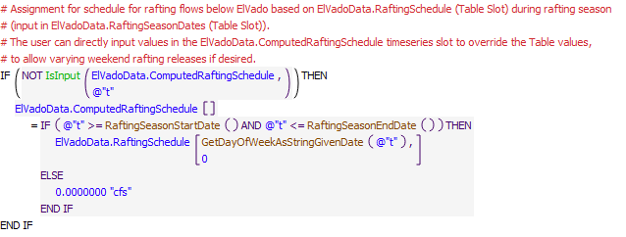
Execution Constraint
Referenced Functions
- RaftingSeasonEndDate
- RaftingSeasonStartDate
- GetDayOfWeekAsStringGivenDate
- IsInput
- HasRuleFiredSuccessfully
- GetStartDate

16.2 RecordPotentialRaftingReleases
Rule Purpose:
This rule records a potential delivery from Heron Reservoir to Abiquiu Reservoir for individual contractors to provide rafting flows below El Vado Dam. The determined delivery may be set when the final computed delivery is set with consideration for other factors.
Rule Logic: Execution Constraint logic is at end of explanation.
A FOR DO loop is used to set the potential rafting release slot value for each contractor in the ComputedDeliveries data object for the current timestep based on the list of slot names, at index 0, and determined releases, at index 1, identified with the user-defined PotentialRaftingReleasesFromHeron function.
Within the function, an outer WITH DO loop is used to create a list of accounts that move water to provide a rafting release. An inner WITH DO statement is used to identify the available water at Heron for delivery at the current timestep for each contractor as the minimum of the previous storage for the account minus water to be retained at Heron as waiver water for the account determined with the user-defined CurrentYearAllocatiounToBeRetainedAsWaiverWater function minus the amount of contractor water to be retained for a pending lease to Reclamation identified with the user-defined HeronStorageToBeLeased function checked against the available supply for the contractor. Final releases are set to split the delivery between all accounts to meet the target rafting flow computed with the RequestedRaftingRelease function.
This rule fires if the current timestep is greater than or equal to the beginning timestep for rulebased simulation as input by the model user to the RulebasedSimulationStartDate scalar slot in the ModelRunTypeTriggers data object and the rule has not fired successfully for the current timestep as determined with reference to the predefined HasRuleFiredSuccessfully function.
Model slots written by rule:
1. ComputedDeliveries.ACCOUNT where ACCOUNT is SJC contractor
List of key model objects with slots read by the rule or child functions: ModelRunTypeTriggers
ComputedDeliveries
Log of when and how the rule has been modified (newest changes at the top):
Date: Who. What
2/25/19: Jesse Roach. Added description field and updated notes field
Statements
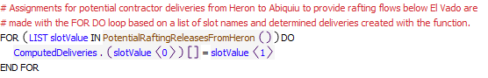
Execution Constraint
Referenced Functions
- PotentialRaftingReleasesFromHeron
- HasRuleFiredSuccessfully
- GetStartDate

16.3 ComputeHeronSJCDeliveryToCochitiRecPool
Rule Purpose:
This rule computes a delivery of Cochiti Rec Pool water from Heron to Cochiti Lake. Deliveries may be set under multiple conditions to assure an input minimum storage is maintained or water is moved out of Heron by the end of the year, as a rafting release, or over a typical delivery period restricted to not exeed the target content at Cochiti Lake. Note that the target content at Cochiti Lake may be set by the model user to an input Cochiti surface area or an input storage with different results due to the impacts of modeled sedimentation at Cochiti Lake.
Rule Logic: Execution Constraint logic is at end of explanation.
If the value for the CochitiRecPoolDeliveryHeronToCochiti series slot in the ComputedDeliveries data object for the current timestep is not input as checked with the predefined IsInput function, a value is computed with the user-defined SJCDeliveryFromHeronToCochitiRecPool function. Within the function IF THEN ELSE statements are used to check conditions for computing an outflow. If the previous storage in the CochitiRecPool account at Cochiti is less than the value in the MinDownstreamStorageTriggerImmediateDelivery column and CochitiRecPool row of the DeliverySetting table slot in the ComputedDeliveries data object, a release is computed as the rate input to the TypicalDeliveryFromHeron column of the same table slot restricted if needed to the previous CochitiRecPool account storage at Heron. Otherwise, if the total amount of water to be moved out of Heron Reservoir as computed with the user-defined TotalWaterToBeMovedOutOfHeron function is greater than 0 acre-ft and the current timestep is greater than or equal to the offset date equal to December 31st minus the value in the DaysBeforeTargetDateToStartMovingWater column and CochitiRecPool row of the DeliverySettings table slot and less than or equal to December 31st, a release is computed with the TypicalSJCDeliveryFromHeron function. That function sets the computed release to the maximum of the input value in the TypicalDeliveryFromHeron column or the average delivery to evacuate the TotalWaterToBeMovedOutOfHeron over the number days to move water before Decmeber 31st. Otherwise, if the value in the RaftingReleaseTrigger(1=Raft,0=NoRaft) column and CochitiRecPool row of the DeliverySettings table slot equals 1.0 and the current timestep is prior to the end of the rafting season identified with the user-defined RaftingSeasonEndDate function, the release is set to the value in the PotentialCochitiRecPoolRaftingRelease series slot in the ComputedDeliveries data object. Otherwise, if the current timestep is between the dates in the TypicalDeliveryStartDate and TypicalDeliveryEndDate columns for the CochitiRecPool row in the DeliverySettings table slot, the release is computed with the TypicalSJCDeliveryFromHeron function over the period within those two dates.
The predefined Min function is used to restrict the determined release to the amount of water needed at Cochiti with reference to the storage in the CochitiRecPool account at Cochiti at the previous timestep. If the value for the SwitchForCochitiRecPoolTargetContent scalar slot is equal to 1.0, the Cochiti storage associated with the value in the AuthorizedSurfaceAcres column of the PoolLevels table slot in the CochitiData data object is targeted; otherwise, the storage input to the Content of Permanent Pool column of the Permanent Sediment Content table is targeted.
This rule fires if the value for the CochitiRecPoolDeliveryHeronToCochiti series slot in the ComputedDeliveries data object for the current timestep is a NaN and if the current timestep is greater than or equal to the beginning timestep for rulebased simulation as input by the model user to the RulebasedSimulationStartDate scalar slot in the ModelRunTypeTriggers data object.
Model slots written by rule:
1. ComputedDeliveries.CochitiRecPoolDeliveryHeronToCochiti
List of key model objects with slots read by the rule or child functions:
1. ModelRunTypeTriggers
2. ComputedDeliveries
3. Cochiti
Log of when and how the rule has been modified (newest changes at the top):
Date: Who. What
2/25/19: Jesse Roach. Added description field and updated notes field
Statements
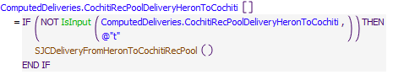
Execution Constraint
Referenced Functions
- SJCDeliveryFromHeronToCochitiRecPool
- IsInput
- GetStartDate

16.4 ComputeHeronSJCDeliveriesToAbiquiu
Contractor water may be moved from Heron to Abiquiu Reservoir within a user input period with consideration for a user input minimum release rate over that period. Releases may also be immediately made if the storage for the contractor at Abiquiu Reservoir drops below a low user input threshold. The water may also be moved at an alternate schedule to augment flows for rafting below El Vado Dam if the user has input a switch to implement this operation. Available contractor water at Heron will also be evacuated by the waiver date or by the end of the year if needed to avoid being lost. The final release rate is determined with consideration for the space at Abiquiu Lake.
Rule Logic: Execution Constraint logic is at end of explanation.
A FOR DO loop is used to set computed deliveries from Heron to Abiquiu for each contractor to slots in the ComputedDeliveries data object. If the corresponding slot value for the current timestep is not input as checked with the predefined IsInput function, and the available space at Abiquiu for the contractor as checked with the user-defined AvailableAccountStorage function is greater than a percentage of the maximum storage or a delivery has already begun indicated by the previous value for the assignment slot greater than 0.0 cfs or the previous account storage is less than the value in the MinDownstreamStorageTriggerImmediateDelivery column for the account in the DeliverySetting table slot in the ComputedDeliveries data object, a delivery is computed with the user-defined SJCDeliveryFromHeronToAbiquiu function.
Within the function, separate WITH DO loops are used to define different potential releases that may be made. If the previous storage for the corresponding account at Abiquiu is less than the value in the MinDownstreamStorageTriggerImmediateDelivery column for the account in the DeliverySettings table slot, a release rate is computed as the rate input to the TypicalDeliveryFromHeron column of the same table slot restricted if needed to the previous account storage at Heron. If the total amount of water to be moved out of Heron Reservoir by the waiver date as computed with the user-defined WaiverWaterToBeMovedOutOfHeron function is greater than 0 acre-ft and the current timestep is greater than or equal to the offset date equal to waiver date as referenced with the user-defined WaiverDate function minus the value in the DaysBeforeTargetDateToStartMovingWater column for the corresponding account in the DeliverySettings table slot and less than or equal to waiver date, a waiver release rate is computed with the TypicalSJCDeliveryFromHeron function. That function sets the computed release to the maximum of the input value in the TypicalDeliveryFromHeron column or the average delivery to evacuate the WaiverWaterToBeMovedOutOfHeron over the number days to move water before the waiver date. If the total amount of water to be moved out of Heron Reservoir as computed with the user-defined TotalWaterToBeMovedOutOfHeron function is greater than 0 acre-ft and the current timestep is greater than or equal to the offset date equal to December 31st minus the value in the DaysBeforeTargetDateToStartMovingWater column for the corresponding account in the DeliverySettings table slot and less than or equal to December 31st, an end-of-year release is computed with the TypicalSJCDeliveryFromHeron function. If the current timestep is between the dates in the TypicalDeliveryStartDate and TypicalDeliveryEndDate columns for the corresponding account in the DeliverySettings table slot, the typical release rate is computed with the TypicalSJCDeliveryFromHeron function over the period within those two dates. The final determined release rate for the account is set to the maximum of the potential release rates and includes a check against the potential rafting release. Note that the maximum of all the potential release rates may be zero.
The predefined Min function is used to restrict the determined release to the available space at Abiquiu for the contractor determined with the user-defined AvailableAccountStorage function.
This rule fires if the current timestep is greater than or equal to the beginning timestep for rulebased simulation as input by the model user to the RulebasedSimulationStartDate scalar slot in the ModelRunTypeTriggers data object and the rule has not fired successfully for the current timestep as determined with reference to the predefined HasRuleFiredSuccessfully function.
Model slots written by rule:
1. ComputedDeliveries.ACCOUNTDeliveryHeronToAbiquiu where ACCOUNT is all SJC accounts except CochitiRecPool and MRGCD
List of key model objects with slots read by the rule or child functions:
1. ModelRunTypeTriggers
2. ComputedDeliveries
3. Heron
4. Abiquiu
Log of when and how the rule has been modified (newest changes at the top):
Date: Who. What
2/25/19: Jesse Roach. Added description field and updated notes field
Statements
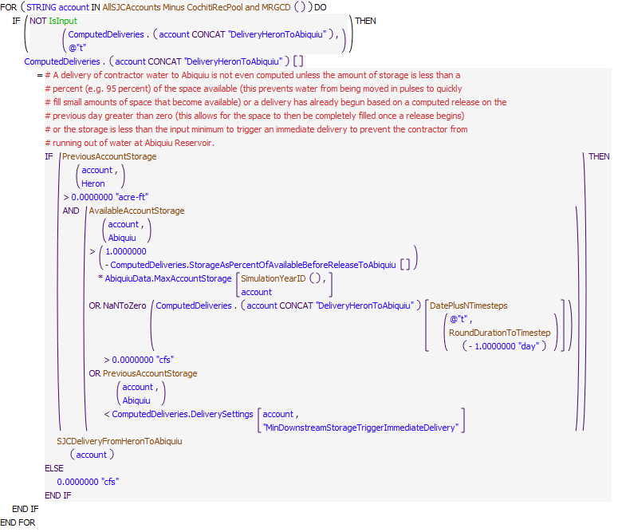
Execution Constraint
Referenced Functions
- DatePlusNTimesteps
- AvailableAccountStorage
- SJCDeliveryFromHeronToAbiquiu
- AllSJCAccounts Minus CochitiRecPool and MRGCD
- RoundDurationToTimestep
- IsInput
- HasRuleFiredSuccessfully
- SimulationYearID
- GetStartDate
- PreviousAccountStorage

16.5 ComputeHeronSJCDeliveriesToElVado
Rule Purpose:
Deliveries of contractor San Juan-Chama Project water from Heron Reservoir to El Vado Reservoir are set with this rule. MRGCD water is moved to fill available space, and other contractor water may be temporarily stored at El Vado if allowed based on model user inputs. Water for other contractors is moved as space is available at El Vado Reservoir and up to an estimated amount that can be evacuated before the next runoff.
Rule Logic: Execution Constraint logic is at end of explanation.
A FOR DO loop is used to set computed deliveries from Heron to El Vado Reservoir for each contractor to slots in the ComputedDeliveries data object. If the corresponding slot value for the current timestep is not input as checked with the predefined IsInput function, a delivery is computed with the user-defined SJCDeliveryFromHeronToElVado function.
Within the function, the delivery is computed in separate steps. If the account is MRGCD, a delivery for MRGCD is computed using the user-defined MRGCDDeliveryToElVado function that sets the MRGCD delivery to move water over an input period or to maintain a minimum account storage at El Vado if needed and as possible. If the account is not Reclamation, a needed delivery to assure water is available at El Vado for a pending lease to Reclamation or letter water transfer to MRTGCD is added as computed with the WaterNeededForPendingLeaseToReclamationAndOrLetterWaterTransferToMRGCD atElVado function. The computation includes additional water moved to avoid being lost at Heron Reservoir. For contractors other than MRGCD, the amount moved is restricted to an estimated amount that can be evacuated from El Vado before the next runoff as computed within the ProjectedElVadoTempStorageThatCanBeEvacuated function. The resulting computed delivery is restricted to the available account storage at Heron Reservoir at the previous timestep or the available space at El Vado after computed as all space while assuring space is available for MRGCD.
This rule fires if the current timestep is greater than or equal to the beginning timestep for rulebased simulation as input by the model user to the RulebasedSimulationStartDate scalar slot in the ModelRunTypeTriggers data object and the rule has not fired successfully for the current timestep as determined with reference to the predefined HasRuleFiredSuccessfully function.
Model slots written by rule:
1. ComputedDeliveries.ACCOUNTDeliveryHeronToElVado where ACCOUNT is all SJC accounts except CochitiRecPool
List of key model objects with slots read by the rule or child functions:
1. ModelRunTypeTriggers
2. ComputedDeliveries
3. Heron
4. ElVado
Log of when and how the rule has been modified (newest changes at the top):
Date: Who. What
2/25/19: Jesse Roach. Added description field and updated notes field
Statements
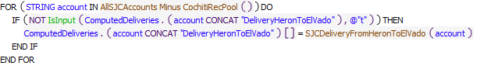
Execution Constraint
Referenced Functions
- SJCDeliveryFromHeronToElVado
- AllSJCAccounts Minus CochitiRecPool
- IsInput
- HasRuleFiredSuccessfully
- GetStartDate

16.6 ComputeHeronSJRelease
Rule Purpose:
A total release of San Juan-Chama Project water from Heron Reservoir is computed as a summation of the individual deliveries for each San Juan-Chama contractor.
Rule Logic: Execution Constraint logic is at end of explanation.
The value for the SJOutflow series slot in the HeronData data object for the current timestep is computed as an addition of all the computed individual deliveries in the series slots in the ComputedDeliveries data object. The predefined Max function is used to assure the release is enough to provide the value in the MinRelease periodic slot in the HeronData data object and the predefined Min function is used to restrict the total release to an input value to the MaximumSJOutflow periodic slot in the HeronData data object.
This rule fires if the current timestep is greater than or equal to the beginning timestep for rulebased simulation as input by the model user to the RulebasedSimulationStartDate scalar slot in the ModelRunTypeTriggers data object and the rule has not fired successfully for the current timestep as determined with reference to the predefined HasRuleFiredSuccessfully function.
Model slots written by rule:
1. HeronData.SJOutflow
List of key model objects with slots read by the rule or child functions:
1. ModelRunTypeTriggers
2. ComputedDeliveries
3. HeronData
4. ElVadoData
Log of when and how the rule has been modified (newest changes at the top):
Date: Who. What
2/26/19: Jesse Roach. Call to RGOutflow(ElVado) was changed to RGOutflow(Heron). This was a bug, but never would have been noticed because HeronData.MinRelease is zero at all times.
2/25/19: Jesse Roach. Added description field and updated notes field
Statements
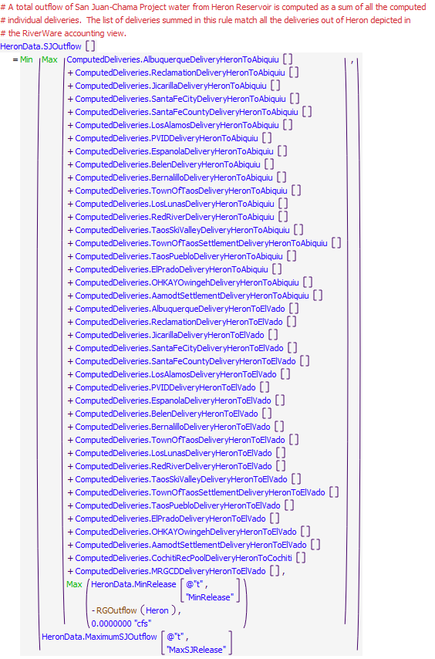
Execution Constraint
Referenced Functions
- RGOutflow
- Min
- Max
- HasRuleFiredSuccessfully
- GetStartDate

16.7 HeronSJReleaseRestrictions
Rule Purpose:
This rule checks to see if Heron Reservoir has full ice coverage or if it must spill. If so, the release of San Juan-Chama Project water is reset to 0.0 cfs. The ice coverage is computed as part of the CurrentSurfaceAreaPanAndIce evaporation method.
Rule Logic: Execution Constraint logic is at end of explanation.
This rule contains an IF THEN statement to set the value of the SJOutflow time series slot in the HeronData data object for the current timestep to 0.0 cfs if the result from either the user-defined HeronHasFullIceCover or HeronMustSpill functions is TRUE. The former function checks to see if the input value in the Surface Ice Coverage time series slot in the Heron storage reservoir object for the current timestep is greater than or equal to the value in the IceCoverageThreshold table slot in the HeronData data object. The latter function first computes the storage of water above the maximum pool elevation as the value for the Storage time series slot in the Heron storage reservoir object for the previous timestep minus the maximum storage that corresponds to the MaxElevation input in the ReservoirData table slot in the HeronData data object. If that value plus the value in the Inflow time series slot in the Heron storage reservoir object minus the value in the Inflow1 time series slot in the AzoteaWillow confluence object is greater than the maximum outflow as determined using the predefined GetMaxOutflowGivenHW function, the result for the function is TRUE.
This rule fires if the current timestep is greater than or equal to the beginning timestep for rulebased simulation as input by the model user to the RulebasedSimulationStartDate scalar slot in the ModelRunTypeTriggers data object and the rule has not fired successfully for the current timestep as determined with reference to the predefined HasRuleFiredSuccessfully function.
Comment:
Colored purple because ice cover constraint is likely a physical reservoir limitation. The spilling constraint is likely flood control related as Heron would only be spilling due to native inflows.
Model slots written by rule:
1. HeronData.SJOutflow
List of key model objects with slots read by the rule or child functions:
1. ModelRunTypeTriggers
2. HeronData
3. Heron
Log of when and how the rule has been modified (newest changes at the top):
Date: Who. What
2/25/19: Jesse Roach. Added description field and updated notes field
Statements
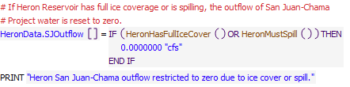
Execution Constraint
Referenced Functions
- HeronMustSpill
- HeronHasFullIceCover
- HasRuleFiredSuccessfully
- GetStartDate

17 San Juan Diversions
The rules in this policy group are used for setting the San Juan diversions with consideration for the available flow in the tributaries to the San Juan River, all diversion and tunnel capacities, and legal constraints for the Project diversions. Diversions result in modeled flows into Heron Reservoir via the Azotea tunnel. The diversions are computed at this location in priority such that the space in Heron Reservoir can be assessed.
Rules in the Group:
San Juan Diversions
ComputeAnnualSJDiversion
Policy Group Change Log (newest changes at the top):
Date: Who. What

17.1 ComputeAnnualSJDiversion
Rule Purpose:
On the first timestep of each year, this rule sums the annual diversion of San Juan water over the previous year. The values are then referenced when implementing 10-year restrictions on San Juan-Chama Project diversions.
Rule Logic: Execution Constraint logic is at end of explanation.
The value for the AnnualDiversion time series slot in the SanJuanChamaDiversions data object for the previous timestep is set to the summation of the values in the Total time series slot in the SanJuanChamaDiversions data object for the January 1 of the previous year, or the start timestep if it is later, through the previous timestep. The predefined SumSlotOverTime function is used to complete the summation and the predefined FlowToVolume function is used to convert the flows to a volume.
This rule fires if the current timestep is the first timestep of the year, and not the Start Timestep and the value for the AnnualDiversion annual time series slot in the SanJuanChamaDiversions data object for December 31 of the previous year is a NaN,.
Model slots written by rule:
1. SanJuanChamaDiversions.AnnualDiversion
List of key model objects with slots read by the rule or child functions:
1. AzoteaOutlet
Log of when and how the rule has been modified (newest changes at the top):
Date: Who. What
2/25/19: Jesse Roach. Added description field and updated notes field
Statements
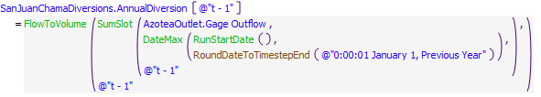
Execution Constraint
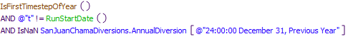
Referenced Functions
- RoundDateToTimestepEnd
- IsFirstTimestepOfYear
- SumSlot
- RunStartDate
- DateMax
- FlowToVolume

17.2 San Juan Diversions
Rule Purpose:
The San Juan Diversions at the Blanco, Little Oso, and Oso diversions are determined with this rule. If an input maintenance switch is checked for a diversion, an input diversion will be referenced for the corresponding diversion. Diversions will be limited if necessary based on the annual limit, limited diversion for a decade, or the available space at Heron Reservoir. If the Project diversion is limited, separate calculations are used to determine the diversions. Otherwise, the diversions are set to the input diversion capacity. These rules capture detailed aspects of diversion and tunnel capacities that may ultimately affect the total Project diversion volume to Heron Reservoir via the Azotea tunnel.
Rule Logic: Execution Constraint logic is at end of explanation.
A FOR DO loop is used to set the Diversion Request values for the current timestep for all the diversions in the San Juan Diversions subbasin. An exterior IF THEN ELSE statement is used to identify whether the maintenance switch is on for the diversion as identified with the user-defined IsMaintenanceSwitchOn function. If so, the Diversion Request is set to the input value in the MaintenanceFlow table slot for the data object for the corresponding diversion. An interior IF THEN ELSE statement is used to identify whether the diversion is limited based on the annual diversion limit, decade diversion limit, or the space in Heron Reservoir using the user-defined DiversionIsLimited function in the SanJuanDiversions utility group. If not, the Diversion Request is set to the input value in the Max Diversion table slot for the corresponding diversion. If so, the limited remaining diversion for the year, decade, or based on the available space in Heron Reservoir is converted to a flow rate for one timestep and compared to the value in the SmallDivThreshold table slot in the SanJuanChamaRule data object. If the threshold is not exceeded, the Diversion Request is set with the user-defined SmallDivCalc function in the SanJuanDiversions utility group. Otherwise, the value is set using the user-defined LargeDivCalc function in the SanJuanDiversions utility group.
This rule also includes two additional assignment statements to set the values in the Diversion Request time series slots in the OsoTunnelInlet and AzoteaTunnelInlet diversion objects to the value in the Max Diversion table slot for the corresponding diversion as referenced using the user-defined Capacity function in the SanJuanDiversions utility group.
This rule fires if the current timestep is greater than or equal to the beginning timestep for rulebased simulation as input by the model user to the RulebasedSimulationStartDate scalar slot in the ModelRunTypeTriggers data object and the rule has not fired successfully for the current timestep as determined with reference to the predefined HasRuleFiredSuccessfully function.
Model slots written by rule:
1. BlancoDiversion.Diversion Request
2. LittleOsoDiversion.Diversion Request
3. OsoDiversion.Diversion Request
4. OsoTunnelInlet.Diversion Request
5. AzoteaTunnelInlet.Diversion Request
List of key model objects with slots read by the rule or child functions:
1. ModelRunTypeTriggers
2. SanJuanChamaRules
3. SanJuanChamaDiversions
4. Heron
Log of when and how the rule has been modified (newest changes at the top):
Date: Who. What
2/25/19: Jesse Roach. Added description field and updated notes field
Statements
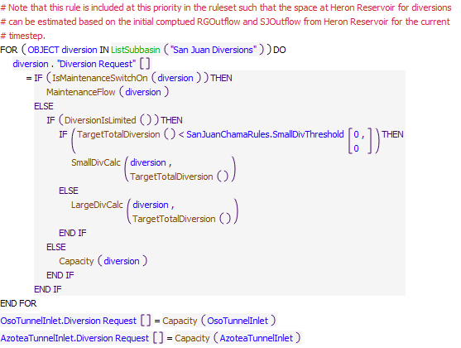
Execution Constraint
Referenced Functions
- IsMaintenanceSwitchOn
- MaintenanceFlow
- Capacity
- LargeDivCalc
- DiversionIsLimited
- TargetTotalDiversion
- SmallDivCalc
- ListSubbasin
- HasRuleFiredSuccessfully
- GetStartDate

18 Heron
The rules in this policy group are used to ultimately determine the total outflow from Heron Dam and include checks against the reservoir outlet works contraints, and the maximum daily pool elevation change of one foot.
Rules in the Group:
HeronCheckDeltaStorage
HeronOutflow
HeronSJReleaseRestrictions
Policy Group Change Log (newest changes at the top):
Date: Who. What
2/26/2019: Jesse Roach. Moved HeronSJReleaseRestrictions rule out of this group at priority 133 and into the Heron San Juan Chama Release group at priority 136.

18.1 HeronOutflow
Rule Purpose:
Unless a total outflow for Heron Dam has been input for the current timestep, the value is set to the sum of the separate initial computed values for the release of native Rio Grande water and the release of San Juan-Chama Project water if the resulting total release is physically legitimate with consideration for the outlet works. If not, the release is reset to reflect the restriction of the Heron Dam outlet works.
Rule Logic: Execution Constraint logic is at end of explanation.
This rule contains an IF THEN ELSE statement to see if the value in the TotalOutflowDirectlyInputToOverrideRules time series slot in the HeronData data object for the current timestep as referenced using the user-defined TotalOutflow function is a NaN. If not, the value for the Outflow time series slot in the Heron storage reservoir object for the current timestep is set to that TotalOutflowDirectlyInputToOverrideRules value. Otherwise, the Outflow is set to the sum of the RGOutflow and SJOutflow for Heron Dam checked with the user-defined CheckThisResPhysicalConstraints function
This rule fires if the current timestep is greater than or equal to the beginning timestep for rulebased simulation as input by the model user to the RulebasedSimulationStartDate scalar slot in the ModelRunTypeTriggers data object and if the value for the Outflow time series slot in the Heron storage reservoir object for the current timestep is a NaN.
Model slots written by rule:
1. Heron.Outflow
List of key model objects with slots read by the rule or child functions:
1. ModelRunTypeTriggers
2. HeronData
3. Heron
Log of when and how the rule has been modified (newest changes at the top):
Date: Who. What
2/25/19: Jesse Roach. Added description field and updated notes field
Statements
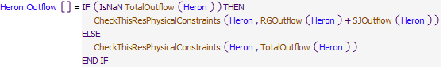
Execution Constraint
Referenced Functions
- CheckThisResPhysicalConstraints
- TotalOutflow
- RGOutflow
- SJOutflow
- GetStartDate

18.2 HeronCheckDeltaStorage
Rule Logic: Execution Constraint logic is at end of explanation.
This rule references the user-defined HeronLimitDeltaStorage function to compute the outflow corresponding to a decrease in the pool elevation equal to the input value in the maxDeltaPoolElev table slot in the HeronData data object. The predefined ElevationToStorage and VolumeToFlow functions are referenced in this function. The value in the Outflow time series slot in the Heron storage reservoir object is then set to the result after it is checked with the user-defined CheckThisResPhysicalConstraints function. This rule also includes a PRINT statement to print a comment to the Diagnostics Output window that the change in storage was limited and PRINT statements are activiated in the Diagnostics Manager.
This rule fires if the current timestep is greater than or equal to the beginning timestep for rulebased simulation as input by the model user to the RulebasedSimulationStartDate scalar slot in the ModelRunTypeTriggers data object and if the change in the pool elevation as determined with the user-defined ComputeDeltaPoolElevWOAbs function is greater than the value input to the maxDeltaPoolElev table slot in the HeronData data object and if the value in either the RGOutflow or the SJOutflow time series slot in the HeronData data object for the current timestep is greater than zero.
Model slots written by rule:
1. Heron.Outflow
List of key model objects with slots read by the rule or child functions:
1. ModelRunTypeTriggers
2. HeronData
3. Heron
Log of when and how the rule has been modified (newest changes at the top):
Date: Who. What
2/25/19: Jesse Roach. Added description field and updated notes field
Statements
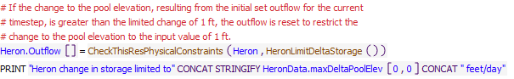
Execution Constraint
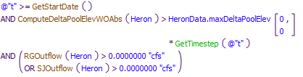
Referenced Functions
- CheckThisResPhysicalConstraints
- ComputeDeltaPoolElevWOAbs
- HeronLimitDeltaStorage
- RGOutflow
- GetTimestep
- SJOutflow
- GetStartDate

19 Heron Accounts
The two rules in this policy group which fire first are used to set the accounting supply for the final determined outflow of Rio Grande water from Heron Reservoir, and assure that supply got set. If the supply does not get set, a simulation will stop and allows the model user to identify the problem from that location in the simulation (The problem may not be directly related to the computation of the Rio Grande outflow).
The next two rules in this policy group are used to set all the accounting supplies for deliveries of San Juan-Chama Project water from Heron Reservoir. Supplies are all set to the intial computed values for the deliveries unless some operational constraint resulted in the total outflow from not being fully met. For deliveries through the single combined passthrough account, additional supplies are set to move the water back out of the downstream combined passthrough account to the corresponding contractor?s storage account. The rules that set accounting supplies for San Juan Chama Project water do not necessarily fire in reverse priority number as listed. The order that they fire in is controlled by user input in the periodic table ReleaseTypePriority on the HeronData object. The function RuleIsInPriority controls the order of fireing for these rules. It does this by checking to see if all rules that are higher in priority than the current rule have already fired.
The next two rules in this policy group are used to track the balances of contractor waiver water in storage at Heron Reservoir. Waiver balances are zeroed out the day after the waiver date with any remaining waiver water in storage transferred to the FederalSanJuan account at Heron. Waiver balances are updated throughout the year for any leases of waiver water to Reclamation and for waiver water moved to El Vado or Abiquiu Reservoir.
The final rule in this policy group transfers 350 AF of native water to the SJC Federal pool in Heron at the end of each year to offset losses of SJC water.

Rules in the Group:
HeronRioGrandeEvaporationAdjustment
UpdateContractorWaiverBalances
ZeroWaivers
SetTransfersAtElVadoForDeliveriesViaCombinedAccount
SetHeronSJCAccountingSupplies
CheckHeronRGOutflow
SetHeronRGAccount
Policy Group Change Log (newest changes at the top):
Date: Who. What

19.1 SetHeronRGAccount
Rule Purpose:
This rule sets the supply for the release from Rio Grande account at Heron Reservoir based on the determined outflow. If the Rio Grande outflow is greater than the Heron outflow, the supply is set to the Heron outflow. If the Heron outflow is greater than the sum of the Rio Grande and San Juan outflow, the reconciled release is set to the Heron outflow minus the San Juan outflow, or the minimum Rio Grande outflow if it is higher. Otherwise, the supply is set to the Rio Grande outflow.
Rule Logic: Execution Constraint logic is at end of explanation.
The value for the RioGrandeHeronToRioGrandeHeronSeepage supply slot for the current timnestep is set with this rule to the result from the user-defined ReconcileRGOutflow function. For Heron, this ReconcileRGOutflow function includes an IF THEN ELSE statement to see if the value for the RGOutflow time series slot in the HeronData data object for the current timestep as referenced using the user-defined RGOutflow function is greater than the value in the Outflow time series slot in the Heron storage reservoir object. If so, the function result is set to that Outflow for the Heron storage reservoir object. Otherwise, a second IF THEN ELSE statement is used to see if the value for that Outflow is greater than the sum of the values in the RGOutflow and SJOutflow time series slots in the HeronData data object. If so, the function result is set to the maximum of either the minimum Rio Grande outflow (0.0 cfs for Heron Dam) or the difference between the value in the Outflow time series slot in the Heron storage reservoir object and the value in the SJOutflow time series slot in the HeronData data Object. If not, the function result is set to the value in the RGOutflow time series slot in the HeronData data object for the current timestep.
This rule fires if the current timestep is greater than or equal to the beginning timestep for rulebased simulation as input by the model user to the RulebasedSimulationStartDate scalar slot in the ModelRunTypeTriggers data object and if the value for the RioGrandeHeronToRioGrandeHeronSeepage supply slot for the current timnestep is a NaN.
Model slots written by rule:
1. RioGrandeHeronToRioGrandeHeronSeepage.Supply
List of key model objects with slots read by the rule or child functions:
1. ModelRunTypeTriggers
2. HeronData
3. Heron
Log of when and how the rule has been modified (newest changes at the top):
Date: Who. What
2/25/19: Jesse Roach. Added description field and updated notes field
Statements
Execution Constraint
Referenced Functions
- ReconcileRGOutflow
- GetStartDate

19.2 CheckHeronRGOutflow
Rule Purpose:
This rule aborts the simulation if the supply for the release of Rio Grande water from the account at Heron Reservoir was not set. This rule helps with debugging because a simulation will stop if the Rio Grande supply was not set and the problem and any missing input can be identified by backtracking in the calculations from the point in the simulation that the run aborted. NOTE THAT the problem is likely not directly related to the computation of the Rio Grande outflow but most likely some earlier aspect of the rules solution. This rule just forces the run to go ahead and stop, so the problem can be fixed.
Rule Logic: Execution Constraint logic is at end of explanation.
If the value for the RioGrandeHeronToRioGrandeHeronSeepage supply slot for the current timestep is a NaN, the STOP_RUN command is used to stop the simulation, and the PRINT statement is used to print a comment to the Diagnostics Output window that the run stopped because the account slot value was not set.
This rule fires if the current timestep is greater than or equal to the beginning timestep for rulebased simulation as input by the model user to the RulebasedSimulationStartDate scalar slot in the ModelRunTypeTriggers data object.
Model slots written by rule:
1. ModelRunTypeTriggers
List of key model supplies read by the rule or child functions:
1. RioGrandeHeronToRioGrandeHeronSeepage.Supply
Log of when and how the rule has been modified (newest changes at the top):
Date: Who. What
2/25/19: Jesse Roach. Added description field and updated notes field
Statements
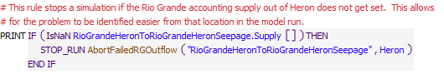
Execution Constraint
Referenced Functions
- AbortFailedRGOutflow
- GetStartDate

19.3 SetHeronSJCAccountingSupplies
Rule Purpose:
This rule sets all the accounting supplies for deliveries of San Juan-Chama Project water from Heron Reservoir.
Rule Logic: Execution Constraint logic is at end of explanation.
An IF THEN statement is used first in the rule to identify if the final reconciled outflow of San Juan-Chama Project water determined with the user-defined ReconcileSJOutflow function is less than the previous determined outflow. If so, Print statements are used to print statements to the Diagnostics Output window that the full initial computed outflow could not be met, if Print statements are enable in the Diagnostics Manager. A FOR DO statement is then used in the rule to set all the accounting supplies from a list of all supply slot names, at index 0, and the final determined deliveries, at index 1, as created with the user-defined HeronPrioritizedSJCSuppliesAndValuesReconciliationCheck function. That function contains a list of all the accounting supplies from Heron Reservoir for deliveries of San Juan-Chama Project water and a corresponding list of all the initial computed deliveries recorded to the ComputedDeliveries data object. A WHILE DO loop is then used in the function to loop through each supply in the order listed and set the deliveries while checking the cumulative release set within the function with each final determined delivery against the final total outflow of San Juan-Chama Project water. If the final total outflow of San Juan-Chama Project water, which is an input to the function, is less than the sum of the intial computed deliveries, deliveries included at the bottom of the listed supplies will be shorted in order from bottom up as needed. Deliveries may not be made for lower priority deliveries if some operational constraint restricted San Juan-Chama outflows from Heron, but this is very rare in the simulations.
This rule fires if the current timestep is greater than or equal to the beginning timestep for rulebased simulation as input by the model user to the RulebasedSimulationStartDate scalar slot in the ModelRunTypeTriggers data object and if the rule has not fired yet as determined with a reference to the predefined HasRuleFiredSuccessfully function.
Model slots written by rule:
40 SJC Supplies from Heron to HeronSeepage
List of key model objects with slots read by the rule or child functions:
1. ModelRunTypeTriggers
2. ComputedDeliveries
Log of when and how the rule has been modified (newest changes at the top):
Date: Who. What
2/25/19: Jesse Roach. Added description field and updated notes field
Statements
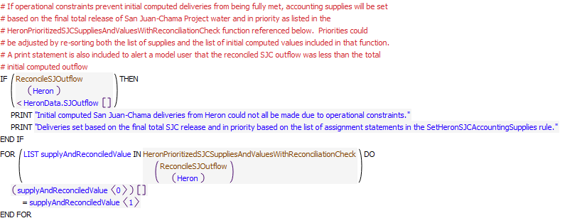
Execution Constraint
Referenced Functions
- HeronPrioritizedSJCSuppliesAndValuesWithReconciliationCheck
- HasRuleFiredSuccessfully
- ReconcileSJOutflow
- GetStartDate

19.4 SetTransfersAtElVadoForDeliveriesViaCombinedAccount
Rule Purpose:
URGWOM is set up to move water for contractors for San Juan-Chama Project water (other than MRGCD, Reclamation, Albuquerque, Cochiti Rec Pool, Santa Fe City, and Santa Fe County) in a single chain of passthrough accounts. This configuration allows for fewer accounts and fewer slots to be used in URGWOM to reduce the model size and reduce memory requirements. Also, all these other contractors only use their allocated water for leases to Reclamation or for letter water deliveries. When their water is moved through the single thread of passthrough accounts, the water is moved back to storage accounts for each contractor at the downstream reservoirs (El Vado and Abiquiu). This rule is used to transfer their water back to storage accounts for the contractors at El Vado for the contractor's water moved from Heron to El Vado.
Rule Logic: Execution Constraint logic is at end of explanation.
Twelve assignment statements are included in this rule to set the accounting supplies for transfers from the Combined storage accout at El Vado to contractor storage accounts at El Vado based on any delivery from Heron to El Vado for the corresponding contractor as moved in the combined passthrough accounts to El Vado. The assignments are simple one-to-one assignments since there is no San Juan-Chama loss or lag between Heron and El Vado.
This rule fires if the current timestep is greater than or equal to the beginning timestep for rulebased simulation as input by the model user to the RulebasedSimulationStartDate scalar slot in the ModelRunTypeTriggers data object and if the rule has not fired yet as determined with a reference to the predefined HasRuleFiredSuccessfully function.
Model slots written by rule:
15 SJC Supplies from the Combined account to specific SJC accounts in ElVado
List of key model objects with slots read by the rule or child functions:
1. ModelRunTypeTriggers
2. Supplies from Heron SJC accounts to combined seepage
Log of when and how the rule has been modified (newest changes at the top):
Date: Who. What
2/25/19: Jesse Roach. Added description field and updated notes field
Statements
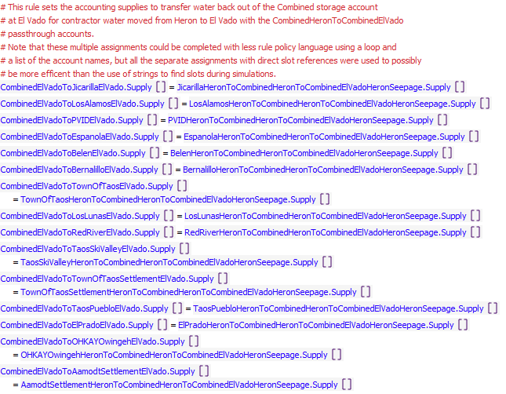
Execution Constraint
Referenced Functions
- HasRuleFiredSuccessfully
- GetStartDate

19.5 ZeroWaivers
Rule Purpose:
On the first timestep after the input waiver date (e.g. September 30th), accounting supplies are set to transfer remaining contractor waiver water still in storage at Heron Reservoir to the common pool for San Juan-Chama Project water. The separate tracked waiver balances for each contractor are also reset to zero.
Rule Logic: Execution Constraint logic is at end of explanation.
A FOR DO loop is used to make two assignments for each of the strings in the list of contractors for San Juan-Chama Project water. The accounting supply for the transfer of San Juan-Chama project water for each contractor to the FederalSanJuan account at Heron Reservoir is set to the minimum of the value for the contractor waiver balance tracked in corresponding series slots in the Waivers data object and as referenced with the user-defined PreviousWaiverBalance function or the previous account storage for the contractor. The value for the waiver balance series slot for the contractor is also set to 0.0 acre-ft.
This rule fires if the current timestep is greater than or equal to the beginning timestep for rulebased simulation as input by the model user to the RulebasedSimulationStartDate scalar slot in the ModelRunTypeTriggers data object and if the current timestep is equal to the date input to the WaiverDate table slot in the Waivers data object plus one day.
Model slots written by rule:
1. ACCOUNTHeronToFederalSanJuanHeron.Supply
List of key model objects with slots read by the rule or child functions:
1. ModelRunTypeTriggers
2. Heron
3. Waivers
Log of when and how the rule has been modified (newest changes at the top):
Date: Who. What
2/25/19: Jesse Roach. Added description field and updated notes field
11/10/17 JR: updated with timestep generalization of MRG rules.
Statements
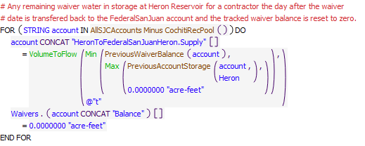
Execution Constraint
Referenced Functions
- PreviousWaiverBalance
- WaiverDate
- AllSJCAccounts Minus CochitiRecPool
- RoundDateToTimestepEnd
- Min
- Max
- GetTimestep
- VolumeToFlow
- GetStartDate
- PreviousAccountStorage

19.6 UpdateContractorWaiverBalances
Rule Purpose:
The waiver balance for each contractor is tracked as the previous waiver balance minus any waiver water leased to Reclamation and minus any water moved to El Vado or Abiquiu. A Reclamation balance is also tracked that is increased with leases. A waiver balance is also tracked that reflects leased waiver water, which must be moved out of Heron before the waiver date.
Rule Logic: Execution Constraint logic is at end of explanation.
A FOR DO loop is used to set the waiver balance slot for each contractor for San Juan-Chama Project water in the Waivers data object. IF THEN ELSE statements are used to check three conditions for setting the waiver balance slot. 1) If the current timestep is January 1 and waivers are in effect for the contractor as checked with the user-defined WaiversAreInEffect function, the waiver balance slot is set to the previous account storage at Heron. Throughout the rest of the year, 2) for all accounts other than the Reclamation account, the waiver balance is set to the previous waiver balance minus any waiver water leased to Reclamation as checked with reference to the corresponding accounting supply and minus any water moved to El Vado or Abiquiu also as checked with reference to the corresponding account supply for the account. 3) For Reclamation, the waiver balance is set to the previous balance PLUS any waiver water leased to Reclamation minus any delivery of Reclamation water to El Vado or Abiquiu as checked with reference to the corresponding accounting supply.
This rule fires if the current timestep is greater than or equal to the beginning timestep for rulebased simulation as input by the model user to the RulebasedSimulationStartDate scalar slot in the ModelRunTypeTriggers data object and if the rule has not fired yet as determined with a reference to the predefined HasRuleFiredSuccessfully function and if the current timestep is NOT equal to the date input to the WaiverDate table slot in the Waivers data object plus one day.
Model slots written by rule:
1. Waivers.ACCOUNTBalance where ACCOUNT is all SJC accounts except CochitiRecPool
List of key model objects with slots read by the rule or child functions:
1. ModelRunTypeTriggers
2. Heron
3. Waivers
Log of when and how the rule has been modified (newest changes at the top):
Date: Who. What
2/26/19: Jesse Roach. Added description field and updated notes field
11/10/17 JR: updated with timestep generalization of MRG rules.
Statements
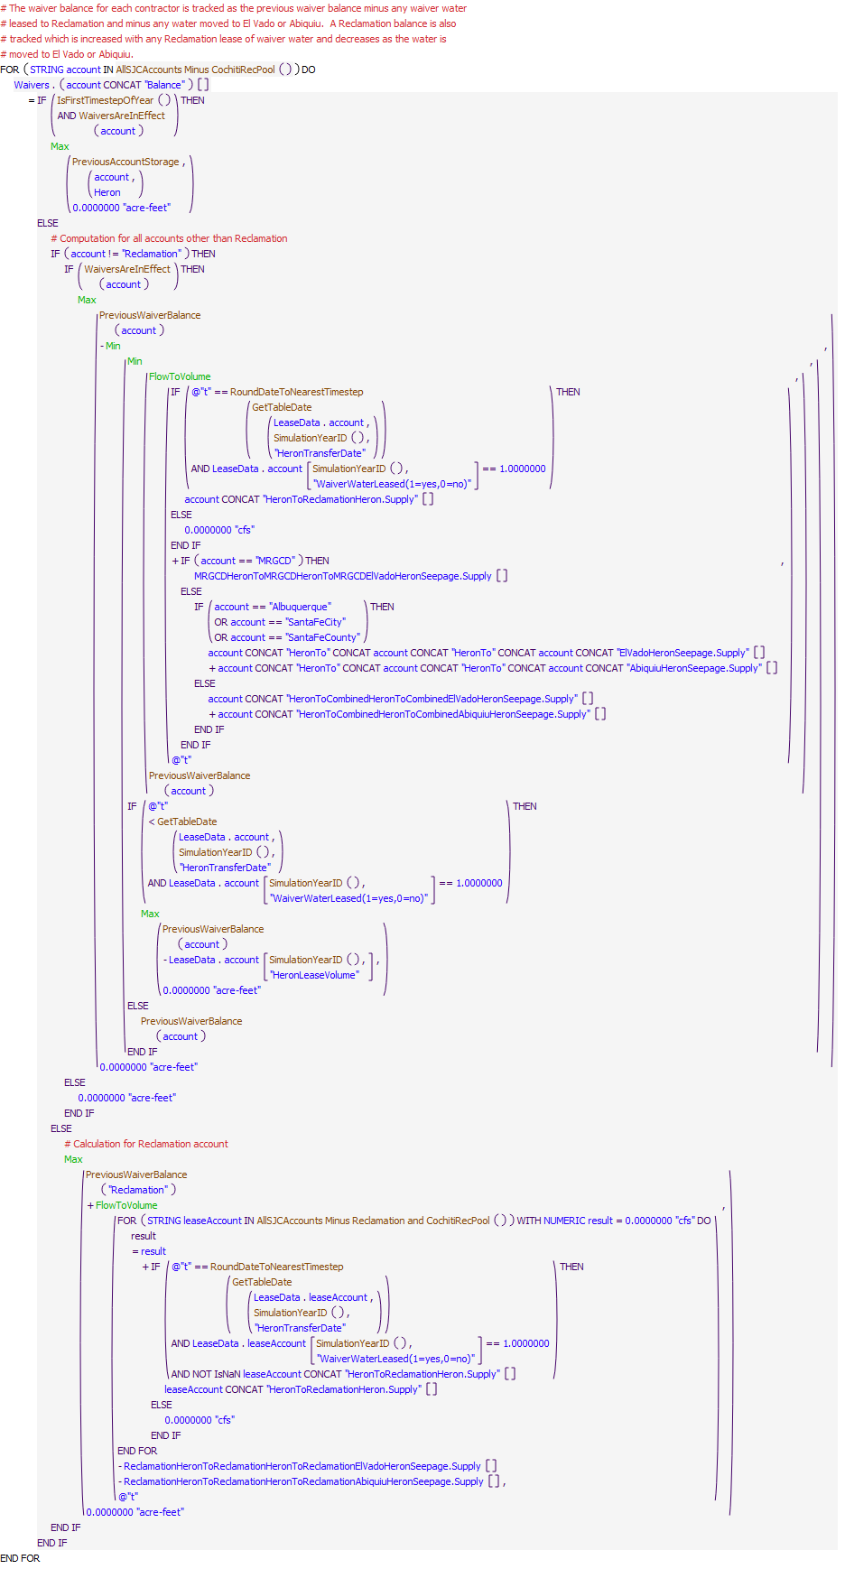
Execution Constraint
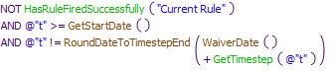
Referenced Functions
- PreviousWaiverBalance
- WaiversAreInEffect
- WaiverDate
- AllSJCAccounts Minus CochitiRecPool
- GetTableDate
- RoundDateToTimestepEnd
- IsFirstTimestepOfYear
- RoundDateToNearestTimestep
- Min
- Max
- GetTimestep
- FlowToVolume
- HasRuleFiredSuccessfully
- SimulationYearID
- AllSJCAccounts Minus Reclamation and CochitiRecPool
- GetStartDate
- PreviousAccountStorage

19.7 HeronRioGrandeEvaporationAdjustment
Rule Purpose:
This rule sets an end of year transfer of 350 acre-ft of Rio Grande water to the Federal pool at Heron Reservoir to pay back the San Juan-Chama Project pool for the impacts of storage of native water at Heron on evaporation losses of San Juan-Chama Project water and as use for recreation.
Rule Logic: Execution Constraint logic is at end of explanation.
The rule sets RioGrandeHeronToFederalSanJuanHeron.Supply for the previous timestep (last timestep of the previous year) to the flow necessary to move 350 AF in the given timestep using the predefined function VolumeToFlow.
This rule fires if the current timestep is greater than or equal to the beginning timestep for rulebased simulation as input by the model user to the RulebasedSimulationStartDate scalar slot in the ModelRunTypeTriggers data object and if the current timestep is the first timesteap of the year.
Model slots written by rule:
1. RioGrandeHeronToFederalSanJuanHeron.Supply
List of key model objects with slots read by the rule or child functions:
1. ModelRunTypeTriggers
Log of when and how the rule has been modified (newest changes at the top):
Date: Who. What
2/26/19: Jesse Roach. Added description field and updated notes field
11/10/17 JR: updated during timestep generalization of MRG rules.
Statements
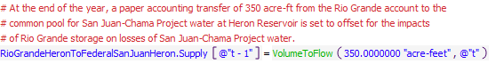
Execution Constraint
Referenced Functions
- IsFirstTimestepOfYear
- VolumeToFlow
- GetStartDate

20 El Vado SJC Deliveries
The rules in this policy group are used to compute deliveries of San Juan-Chama Project water from El Vado Reservoir and compute an initial total outflow of San Juan-Chama Project water from El Vado Reservoir.
Rules in the Group:
ComputeElVadoSJRelease
ComputeDeliveryForMRGCDPaybackToAlbuquerque
ComputeElVadoSJCDeliveriesToAbiquiu
Policy Group Change Log (newest changes at the top):
Date: Who. What

20.1 ComputeElVadoSJCDeliveriesToAbiquiu
Rule Purpose:
Any contractor water that may be temporarily stored at El Vado Reservoir is moved to Abiquiu Reservoir before a user input date that the water must be evacuated. MRGCD San Juan-Chama Project water at El Vado Reservoir is moved to maintain the operating pool at Abiquiu Reservoir used to meet the MRGCD demand at Cochiti AFTER native Rio Grande water or Emergency Drought water for MRGCD has been used. Storage may be allowed on passthrough accounts if operational constraints require storage, so initial passthroughs are recorded to passthrough the inflow to the passthrough accounts plus release any storage on the passthrough account as of the previous timestep.
Rule Logic: Execution Constraint logic is at end of explanation.
Twenty-six assignment statements are included in the rule to compute deliveries for San Juan-Chama Project water from El Vado Reservoir. For the first assignment statement, the MRGCDDeliveryElVadoToAbiquiu series slot in the ComputedDeliveries data object for the current timestep is set with the user-defined ComputeElVadoMRGCDSJRelease function. Within that function, if the MRGCD demand at Abiquiu as determined with the user-defined AbiquiuMRGCDDemand function is greater than 0.0 cfs or the current timestep is in the irrigation season and the available space at Abiquiu for MRGCD San Juan-Chama Project water as computed with the user-defined AvailableAccountStorage function is greater than half the allocated storage space for the MRGCD account and the previous storage in the Rio Grande and MRGCDDrought accounts is less than twice the MRGCD demand at Cochiti, MRGCD San Juan-Chama Project water is moved to Abiquiu. Otherwise, the delivery is set to 0.0 cfs. A delivery of MRGCD water to Abiquiu is set to fill the available space at Abiquiu plus meet the current MRGCD demand at El Vado with consideration for any contributions from the MRGCDDrought account and any release of RioGrande water from El Vado. The release is restricted to the available MRGCD storage at El Vado.
The next nineteen assignment statements set deliveries for moving contractor water to Abiquiu for contractors other than MRGCD using the user-defined SJCDeliveryFromElVadoToAbiquiu function. Within that function, if the account storage at El Vado is greater than zero and the current timestep is within the period to evacuate contractor water from El Vado based on the values input to the DateToFullyEvacuateTemporaryStorageAtElVado and DaysBeforeTargetDateToStartMovingWater columns for the corresponding account in the DeliverySettings table slot in the ComputedDeliveries data object, a delivery rate is set to the maximum of the same typical delivery rate used to move water out of Heron or the average rate to evacuate all the storage out of El Vado over the delivery period. The result is checked against the available space for the corresponding account at Abiquiu Reservoir with reference to the user-defined AvailableAccountStorage function.
The remaining six assignment statements set the passthrough amounts for water being moved from Heron to Abiquiu through El Vado Reservoir.
This rule fires if the current timestep is greater than or equal to the beginning timestep for rulebased simulation as input by the model user to the RulebasedSimulationStartDate scalar slot in the ModelRunTypeTriggers data object and if the rule has not fired yet as determined with a reference to the predefined HasRuleFiredSuccessfully function.
Model slots written by rule:
1. ComputedDeliveries.ACCOUNTDeliveryElVadoToAbiquiu where ACCOUNT is all SJC accounts except CochitiRecPool
2. ComputedDeliveries.ACCOUNTPassthroughAtElVado where ACCOUNT is Albuquerque, Combined, Reclamation, CochitiRecPool, SantaFeCity, or SantaFeCounty
List of key model objects with slots read by the rule or child functions:
1. ModelRunTypeTriggers
2. ElVado
3. Abiquiu
4. AbiquiuData
5. MRGCD
6. ComputedDeliveries
Log of when and how the rule has been modified (newest changes at the top):
Date: Who. What
2/26/19: Jesse Roach. Added description field and updated notes field
Statements
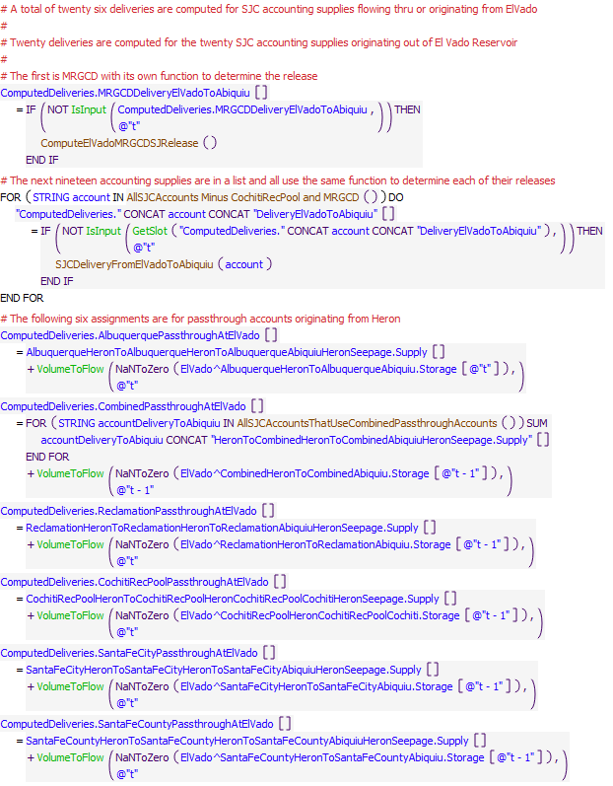
Execution Constraint
Referenced Functions
- SJCDeliveryFromElVadoToAbiquiu
- AllSJCAccounts Minus CochitiRecPool and MRGCD
- ComputeElVadoMRGCDSJRelease
- GetSlot
- VolumeToFlow
- IsInput
- HasRuleFiredSuccessfully
- GetStartDate
- AllSJCAccountsThatUseCombinedPassthroughAccounts

20.2 ComputeDeliveryForMRGCDPaybackToAlbuquerque
Rule Purpose:
Albuquerque historically loaned water to MRGCD that was not needed while waiting for the startup of the Albuquerque surface water diversion. This rule computes a delivery of MRGCD San Juan-Chama Project water from El Vado Reservoir to the Albuquerque account at Abiquiu based on inputs that reflect the debt for a past loan that occured prior to a model run period. The volume, dates for a payback, and a minimum release rate for the delivery from the MRGCD account at El Vado to the Albuquerque account at Abiquiu are input by the model user for each year of a simulatoin.
Rule Logic: Execution Constraint logic is at end of explanation.
If a value is not input as checked with reference to the predefined IsInput function, the value for the MRGCDPaybackToAlbuquerqueElVadoToAbiquiu series slot in the ComputedDeliveries data object for the current timestep is set with an IF THEN ELSE statement. If the current timestep is within the period between the dates input to the DeliveryStartDate and DeliveryEndDate columns of the PaybackScheduleForPastAlbuquerqueLoanToMRGCD table slot in the ComputedDeliveries data object, the delivery is set to the maximum of the rate input to the MinimumDeliveryRate column of the same table slot or the rate to deliver the amount in the VolumeForPayback column of that slot over the delivery period. The computed delivery is restricted to the amount of the remaining debt to be paid back and the available MRGCD water at El Vado Reservoir. 0 cfs is set if not within the delivery start and end dates or a negative value is the result of the calculation.
This rule fires if the current timestep is greater than or equal to the beginning timestep for rulebased simulation as input by the model user to the RulebasedSimulationStartDate scalar slot in the ModelRunTypeTriggers data object and if the rule has not fired yet as determined with a reference to the predefined HasRuleFiredSuccessfully function.
Model slots written by rule:
1. ComputedDeliveries.MRGCDPaybackToAlbuquerqueElVadoToAbiquiu
List of key model objects with slots read by the rule or child functions:
1. ModelRunTypeTriggers
2. ComputedDeliveries
3. ElVado
4. Abiquiu
Log of when and how the rule has been modified (newest changes at the top):
Date: Who. What
2/26/19: Jesse Roach. Added description field and updated notes field
Statements
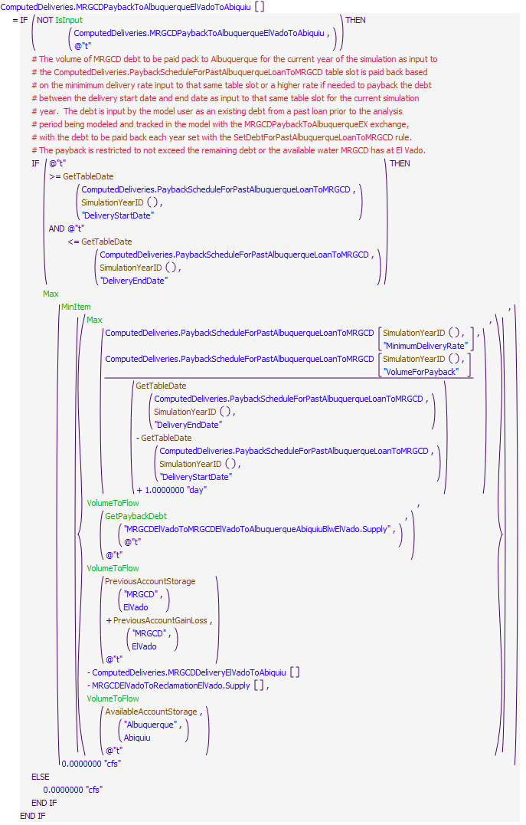
Execution Constraint
Referenced Functions
- AvailableAccountStorage
- GetTableDate
- MinItem
- Max
- GetPaybackDebt
- VolumeToFlow
- IsInput
- HasRuleFiredSuccessfully
- SimulationYearID
- PreviousAccountGainLoss
- GetStartDate
- PreviousAccountStorage

20.3 ComputeElVadoSJRelease
Rule Purpose:
A total release of San Juan-Chama Project water from El Vado Reservoir is computed as a sum of the individual deliveries for each San Juan-Chama contractor.
Rule Logic: Execution Constraint logic is at end of explanation.
The value for the SJOutflow series slot in the ElVadoData data object for the current timestep is computed as an addition of all the computed individual deliveries in the series slots in the ComputedDeliveries data object.
This rule fires if the current timestep is greater than or equal to the beginning timestep for rulebased simulation as input by the model user to the RulebasedSimulationStartDate scalar slot in the ModelRunTypeTriggers data object and if the value of the SJOutflow series slot in the ElVadoData data object for the current timestep is a NaN.
Model slots written by rule:
1. ElVadoData.SJOutflow
List of key model objects with slots read by the rule or child functions:
1. ModelRunTypeTriggers
2. ComputedDeliveries
Log of when and how the rule has been modified (newest changes at the top):
Date: Who. What
2/26/19: Jesse Roach. Added description field and updated notes field
Statements
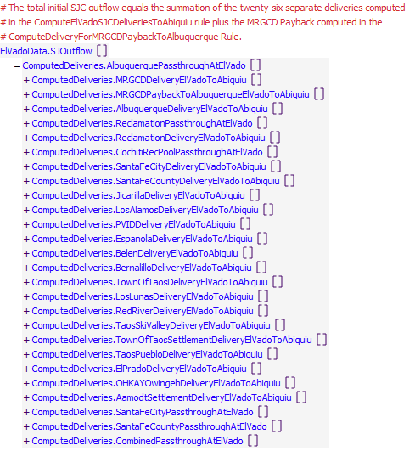
Execution Constraint
Referenced Functions
- GetStartDate

21 El Vado Reservoir Operations
The rules in this policy group are used to compute an initial total outflow from El Vado Reservoir and check the outflow against the maximum pool elevation and downstream channel capacity.
Rules in the Group:
ElVadoChannelCapacity
ElVadoFloodControl
ElVadoOutflow
Policy Group Change Log (newest changes at the top):
Date: Who. What

21.1 ElVadoOutflow
Rule Purpose:
Unless a total outflow for El Vado Dam has been input for the current timestep, the value is set to the sum of the predetermined outflows of Rio Grande and San Juan-Chama Project water, checked against the minimum outflow. That total release is checked to see if it is physically legitimate based on the El Vado Dam outlet works, and if not, the release is reset to reflect the restriction for the outlet works.
Rule Logic: Execution Constraint logic is at end of explanation.
This rule contains an IF THEN ELSE statement to see if the value in the TotalOutflowDirectlyInputToOverrideRules time series slot in the ElVadoData data object for the current timestep as referenced with the user-defined TotalOutflow function is a NaN. If not, the value for the Outflow time series slot in the ElVado storage reservoir object for the current timestep is set to that input TotalOutflowDirectlyInputToOverrideRules value. Otherwise, the Outflow is set using the user-defined CheckThisResPhysicalConstraints functionwith the sum of the RGOutflow and SJOutflow slot values in the ElVadoData data object the predetermined outflow, or the minimum outflow if it is larger as determined using the user-defined MinOutflow function.
This rule fires if the current timestep is greater than or equal to the beginning timestep for rulebased simulation as input by the model user to the RulebasedSimulationStartDate scalar slot in the ModelRunTypeTriggers data object and if the value for the Outflow time series slot in the ElVado storage reservoir object for the current timestep is a NaN.
Model slots written by rule:
1. ElVado.Outflow
List of key model objects with slots read by the rule or child functions:
1. ModelRunTypeTriggers
2. ElVado
3. ElVadoData
Log of when and how the rule has been modified (newest changes at the top):
Date: Who. What
2/26/19: Jesse Roach. Added description field and updated notes field
Statements
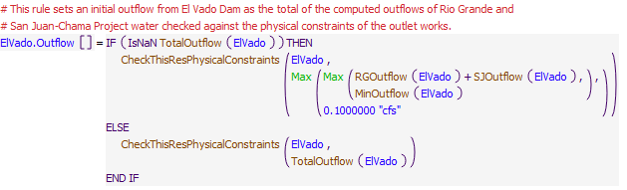
Execution Constraint
Referenced Functions
- CheckThisResPhysicalConstraints
- MinOutflow
- TotalOutflow
- RGOutflow
- Max
- SJOutflow
- GetStartDate

21.2 ElVadoFloodControl
Rule Purpose:
If the pool elevation at El Vado Reservoir is higher than the input maximum, the outflow is set to the release required to reduce the pool elevation to that maximum pool elevation or the maximum release from the outlet works if that outflow is lower. A check is also included to assure the minimum release is exceeded.
Rule Logic: Execution Constraint logic is at end of explanation.
The value for the Outflow time series slot in the ElVado storage reservoir object for the current timestep is set to the minimum of the result from the user-defined ComputeMaxOutflow function which references the predefined GetMaxOutflowGivenInflow function or the outflow required to reduce the pool elevation to the value in the MaxAllowableElevation periodic slot in the ElVadoData data object for the previous timestep as computed using the predefined SolveOutflow function. That result is checked to assure it exceeds the minimum outflow from El Vado Dam as determined with the user-defined MinOutflow function.
This rule fires if the current timestep is greater than or equal to the beginning timestep for rulebased simulation as input by the model user to the RulebasedSimulationStartDate scalar slot in the ModelRunTypeTriggers data object and if the value for the Pool Elevation time series slot in the ElVado storage reservoir object for the current timestep is greater than the value in the MaxAllowableElevation periodic slot in the ElVadoData data object for the previous timestep and if this rule has not already fired for the current timestep as checked against the predefined HasRuleFiredSuccessfully function.
Model slots written by rule:
1. ElVado.Outflow
List of key model objects with slots read by the rule or child functions:
1. ModelRunTypeTriggers
2. ElVado
3. ElVadoData
Log of when and how the rule has been modified (newest changes at the top):
Date: Who. What
2/26/19: Jesse Roach. Added description field and updated notes field
Statements
Execution Constraint
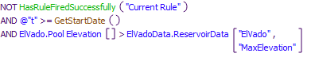
Referenced Functions
- ComputeElVadoFloodControl
- HasRuleFiredSuccessfully
- GetStartDate

21.3 ElVadoChannelCapacity
Rule Purpose:
This rule adjusts the outflow from El Vado Dam to comply with the input downstream channel capacity if the predetermined outflow exceeds that capacity.This rule fires after the ElVadoFloodControl rule, so the reservoir level will rise above the maximum pool elevation if required to keep downstream flows less than the channel capacity, however the rule for filling El Vado Reservoir is coded with buffers with a key goal being to prevent either the max pool elevation or downstream channel capacity from being a factor in operations.
Rule Logic: Execution Constraint logic is at end of explanation.
The value for the Outflow time series slot in the ElVado storage reservoir object is set to the maxRelease identified with the user-defined MaxOutflow function.
This rule fires if the current timestep is greater than or equal to the beginning timestep for rulebased simulation as input by the model user to the RulebasedSimulationStartDate scalar slot in the ModelRunTypeTriggers data object and if the current set value in the Outflow time series slot in the ElVado reservoir object for the current timestep is greater than the maxRelease in the ReservoirData table slot in the ElVadoData data object as referenced using the user-defined MaxOutflow function and if this rule has not already fired for the current timestep as checked with a reference against the predefined HasRuleFiredSuccessfully function.
Model slots written by rule:
1. ElVado.Outflow
List of key model objects with slots read by the rule or child functions:
1. ModelRunTypeTriggers
2. ElVadoData
Log of when and how the rule has been modified (newest changes at the top):
Date: Who. What
2/26/19: Jesse Roach. Added description field and updated notes field
Statements
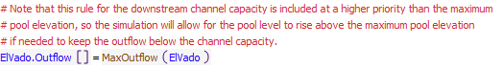
Execution Constraint
Referenced Functions
- MaxOutflow
- HasRuleFiredSuccessfully
- GetStartDate

22 El Vado Accounts
The rule SetAllRioGrandeAccountingSupplies is used to set the final accounting supplies for the outflow of Rio Grande water from El Vado Reservoir. The CheckElVadoRGOutflow rule stops the simulation if the Rio Grande outflow supply did not get set. The SetElVadoSJCAccountingSupplies rule is used to set the accounting supplies for the final deliveries of San Juan-Chama Project water from El Vado Reservoir, and the SetTransfersAtAbiquiuForDeliveriesViaCombinedAccount transfers water conveyed in the combined passthrough accounts back to individual contractor storage accounts at Abiquiu Reservoir.

Rules in the Group:
SetTransfersAtAbiquiuForDeliveriesViaCombinedAccount
SetElVadoSJCAccountingSupplies
CheckElVadoRGOutflow
SetAllRioGrandeAccountingSupplies
Policy Group Change Log (newest changes at the top):
Date: Who. What

22.1 SetAllRioGrandeAccountingSupplies
Rule Purpose:
Accounting supplies for the outflow of Rio Grande water from El Vado are set for the release from the CompactDebit, PandP, MRGCDoutofArticleVII, SupplementalESA, MRGCDDrought, and RioGrande accounts. The supplies are set one-by-one with consideration for the previously set supplies restricted to a total reconciled Rio Grande outflow. If initial computed deliveries cannot all be made with the final reconcile Rio Grande outflow, water is moved based in priority based on the order of the assignment statements. If a higher outflow is set due to flood control operations, the additional outflow will be included with the Rio Grande account outflow set last. If the reconciled outflow is different from the initial total Rio Grande outflow, deliveries are set to the initial computed values in the following priority: CompactDebit, PandP, MRGCDoutofArticleVII, SupplementalESA, MRGCDDrought, and RioGrande. It is very rare that the reconciled Rio Grande outflow would be different from the initial total Rio Grande outflow.
Rule Logic: Execution Constraint logic is at end of explanation.
Six assignment statements are used to set the six accounting supplies for the outflow of Rio Grande water from El Vado. The supply slot for the outflow from the CompactDebit account is set to the minimum of the initial corresponding computed delivery in the ComputedDeliveries data object and the reconciled Rio Grande outflow. The supply slot for the outflow from the PandP account is set to the minimum of the initial corresponding computed delivery in the ComputedDeliveries data object and the reconciled Rio Grande outflow minus the delivery from the CompactDebit account. The supply slot for the outflow from the MRGCDoutofArticleVII account is set to the minimum of the initial corresponding computed delivery in the ComputedDeliveries data object and the reconciled Rio Grande outflow minus the delivery from the CompactDebit and PandP accounts. The supply slot for the outflow from the SupplementalESA account is set to the minimum of the initial corresponding computed delivery in the ComputedDeliveries data object and the reconciled Rio Grande outflow minus the delivery from the CompactDebit, PandP, and MRGCDoutofArticleVII accounts. The supply slot for the outflow from the MRGCDDrought account is set to the minimum of the initial corresponding computed delivery in the ComputedDeliveries data object and the reconciled Rio Grande outflow minus the delivery from the CompactDebit, PandP, MRGCDoutofArticleVII, and SupplementalESA accounts. The supply slot for the outflow from the RioGrande account is set to the reconciled Rio Grande outflow minus the delivery from all other native accounts.
This rule fires if the current timestep is greater than or equal to the beginning timestep for rulebased simulation as input by the model user to the RulebasedSimulationStartDate scalar slot in the ModelRunTypeTriggers data object and if the value for the RioGrandeElVadoToRioGrandeBlwElVado.Supply slot for the current timestep is a NaN.
Comment:
This approach matches the approach used to set the numerous accounting supplies for deliveries of San Juan-Chama Project water from Rio Chama reservoirs, but since there are only six supplies for releases of native water from El Vado Reservoir, six separate assignment statements are used as opposed to a loop.
Model supplies written by rule:
1. ACCOUNTElVadoToRioGrandeBlwElVado.Supply where ACCOUNT is PandP, CompactDebit, SupplementalESA, MRGCDDrought, RioGrande, and MRGCDoutofARticleVII
List of key model objects with slots read by the rule or child functions:
1. ModelRunTypeTriggers
2. ComputedDeliveries
3. ElVado
Log of when and how the rule has been modified (newest changes at the top):
Date: Who. What
2/26/19: Jesse Roach. Rearranged order of assignments to match priority for readibility. Added description field and updated notes field
Statements
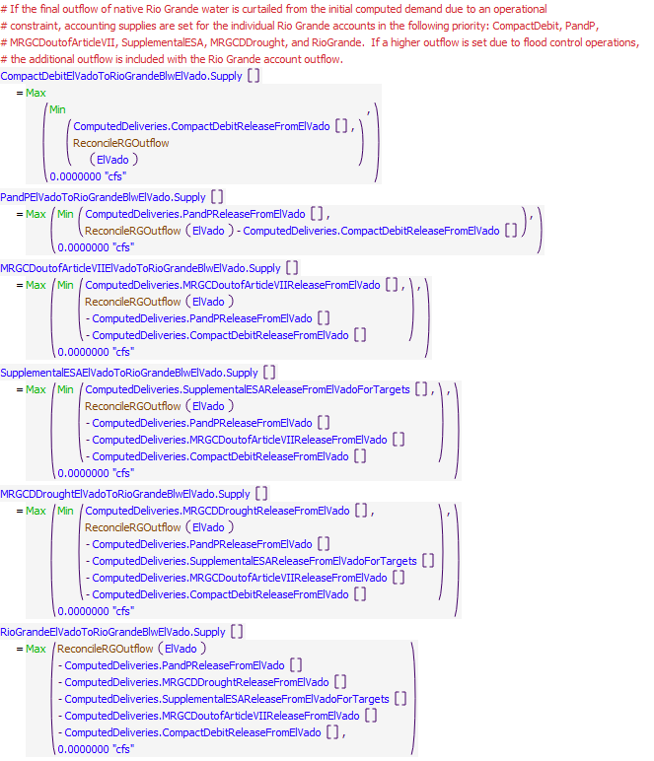
Execution Constraint
Referenced Functions
- ReconcileRGOutflow
- Min
- Max
- GetStartDate

22.2 CheckElVadoRGOutflow
Rule Purpose:
This rule is set up specifically to help with debugging and aborts the simulation if the accounting supply for the release of Rio Grande water from the account at El Vado Reservoir was not set. This is helpful because a simulation will stop if the Rio Grande supply was not set and the problem and any missing input can be identified by backtracking in the calculations from the point in the simulation that the run aborted. NOTE THAT the problem is likely not directly related to the computation of the Rio Grande outflow but most likely due to some earlier aspect of the rules solution. This rule just forces the run to go ahead and stop, so the problem can be fixed.
Rule Logic: Execution Constraint logic is at end of explanation.
If the value for the RioGrandeElVadoToRioGrandeBlwElVado.Supply is a NaN, the STOP_RUN command is used to stop the simulation, and the PRINT statement is used to print a comment to the Diagnostics Output window that the run stopped because the account slot value was not set.
This rule fires if the current timestep is greater than or equal to the beginning timestep for rulebased simulation as input by the model user to the RulebasedSimulationStartDate scalar slot in the ModelRunTypeTriggers data object.
Model supplies written by rule:
None
List of key model objects with slots read by the rule or child functions:
1. ModelRunTypeTriggers
Supply read by the rule or child functions:
RioGrandeElVadoToRioGrandeBlwElVado.Supply
Log of when and how the rule has been modified (newest changes at the top):
Date: Who. What
2/26/19: Jesse Roach. Added description field and updated notes field
Statements
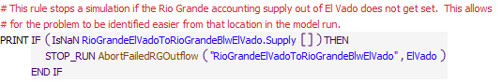
Execution Constraint
Referenced Functions
- AbortFailedRGOutflow
- GetStartDate

22.3 SetElVadoSJCAccountingSupplies
Rule Purpose:
This rule sets all the accounting supplies for deliveries of San Juan-Chama Project water from El Vado Reservoir. Values are set one-by-one based on the list of initial values and the companion list of supplies. Values are set in prioirity based on the matching order of the list of initial value and list of supplies. Deliveries may not be made for lower priority deliveries if some operational constraint restricted San Juan-Chama outflows from El Vado, but this is very rare in the simulations. Accounting supplies are also set for the transfers from contractor storage accounts to the MRGCD account for letter water deliveries completed as a payback to MRGCD.
Rule Logic: Execution Constraint logic is at end of explanation.
Eighteen assignment statements are first included for setting the accounting supplies for transfers from contractor storage accounts to the MRGCD account at El Vado based on the computed amounts in the corresponding series slots in the ComputedDeliveries data object.
An IF THEN statement is then used to identify if the final reconciled outflow of San Juan-Chama Project water determined with the user-defined ReconcileSJOutflow function is less than the previous determined outflow. If so, Print statements are used to print statements to the Diagnostics Output window that the full initial computed outflow could not be met, if Print statements are enabled in the Diagnostics Manager.
A FOR DO statement is then used in the rule to set all the accounting supplies from a list of all supply slot names, at index 0, and the final determined deliveries, at index 1, as created with the user-defined ElVadoPrioritizedSJCSuppliesAndValuesReconciliationCheck function. That function contains a list of all the accounting supplies from El Vado Reservoir for deliveries of San Juan-Chama Project water and a corresponding list of all the initial computed deliveries recorded to the ComputedDeliveries data object. A WHILE DO loop is then used in the function to loop through each supply in the order listed and set the deliveries while checking the cumulative release set so far within the function against the final total outflow of San Juan-Chama Project water. If the final total outflow of San Juan-Chama Project water, which is an input to the function, is less than the sum of the intial computed deliveries, deliveries included at the bottom of the listed supplies will be shorted in order from bottom up as needed.
This rule fires if the current timestep is greater than or equal to the beginning timestep for rulebased simulation as input by the model user to the RulebasedSimulationStartDate scalar slot in the ModelRunTypeTriggers data object and if the rule has not fired yet as determined with a reference to the predefined HasRuleFiredSuccessfully function.
Model supplies written by rule:
1. ACCOUNTElVadoToMRGCDElVado.Supply where ACCOUNT is all SJC accounts except MRGCD, Reclamation and CochitiRecPool
2. 27 additional supplies associated with pass throughs at El Vado, and deliveries from El Vado to Abiquiu
List of key model objects with slots read by the rule or child functions:
1. ModelRunTypeTriggers
2. ComputedLetterWater
3. ComputedDeliveries
Log of when and how the rule has been modified (newest changes at the top):
Date: Who. What
2/26/19: Jesse Roach.Added description field and updated notes field
Statements
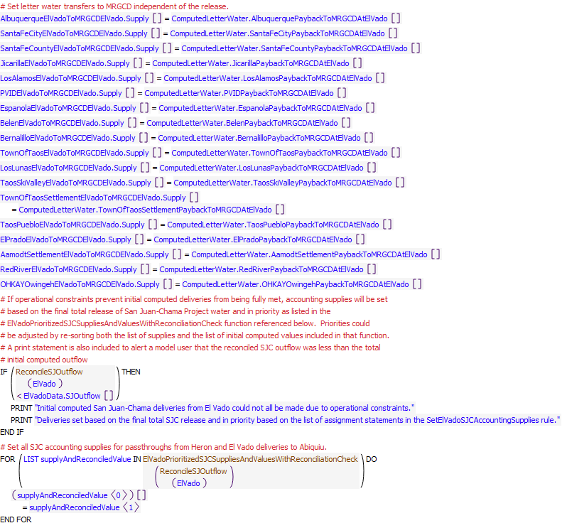
Execution Constraint
Referenced Functions
- ElVadoPrioritizedSJCSuppliesAndValuesWithReconciliationCheck
- HasRuleFiredSuccessfully
- ReconcileSJOutflow
- GetStartDate

22.4 SetTransfersAtAbiquiuForDeliveriesViaCombinedAccount
Rule Purpose:
This rule sets the accounting supplies to transfer water back out of the Combined storage account at Abiquiu for contractor water moved from Heron to Abiquiu and from El Vado to Abiquiu with the CombinedHeronToCombinedAbiquiu and CombinedElVadoToCombinedAbiquiu passthrough accounts, respectively. This approach is used for the fifteen contractors other than MRGCD, Albuquerque, Santa Fe City, Santa Fe County, and Cochiti Rec Pool.URGWOM is set up to move water for contractors for San Juan-Chama Project water (other than MRGCD, Reclamation, Albuquerque, Cochiti Rec Pool, Santa Fe City, and Santa Fe County) in a single chain of passthrough accounts. This configuration allows for fewer accounts and fewer slots to be used in URGWOM to reduce the model size and reduce memory requirements. Also, all these other contractors only use their allocated water for leases to Reclamation or for letter water deliveries. When their water is moved through the single thread of passthrough accounts, the water is moved back to storage accounts for each contractor at the downstream reservoirs (El Vado and Abiquiu).
Rule Logic: Execution Constraint logic is at end of explanation.
Fifteen assignment statements are included in this rule to set the accounting supplies for transfers from the Combined storage accout at Abiquiu to contractor storage accounts at Abiquiu based on any deliveries from Heron to Abiquiu and El Vado to Abiquiu for the corresponding contractor as moved in the combined passthrough accounts to Abiquiu. The assignments are set to the upstream accounting supplies for the deliveries at the previous timestep (per the one day travel time to Abiquiu) and adjusted for the San Juan-Chama loss rate from El Vado to Abiquiu as input to the Losses table slot in the SanJuanChamaRules data object and identified with the user-defined SJCLoss function.
This rule fires if the current timestep is greater than or equal to the beginning timestep for rulebased simulation as input by the model user to the RulebasedSimulationStartDate scalar slot in the ModelRunTypeTriggers data object andif the rule has not fired yet as determined with a reference to the predefined HasRuleFiredSuccessfully function.
Model supplies written by rule:
1. CombinedAbiquiuToACCOUNTAbiquiu.Supply where ACCOUNT is all SJC accounts except MRGCD, Reclamation, CochitiRecPool, Albuquerque, Santa Fe City, and Santa Fe County.
List of key model objects with slots read by the rule or child functions:
1. ModelRunTypeTriggers
Supply read by the rule or child functions:
ACCOUNTHeronToCombinedHeronToCombinedACCOUNTHeronSeepage.Supply
Log of when and how the rule has been modified (newest changes at the top):
Date: Who. What
2/26/19: Jesse Roach.Added description field and updated notes field
Statements
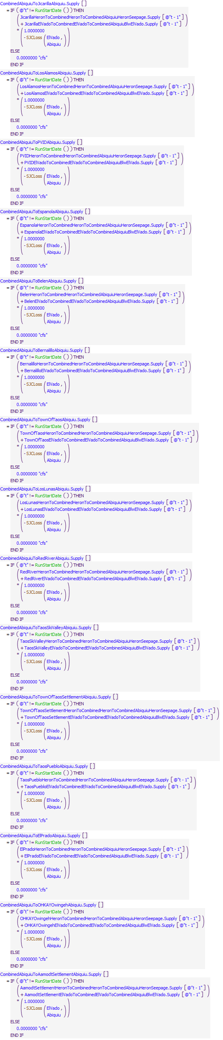
Execution Constraint
Referenced Functions
- RunStartDate
- HasRuleFiredSuccessfully
- SJCLoss
- GetStartDate

23 Abiquiu Passthroughs
The rules in this policy group are used to compute a potential inflow to conservation storage at Abiquiu Reservoir, and the outflow of Rio Grande water.
Rules in the Group:
ComputeAbiquiuPassthroughToCochitiRecPool
ComputeAbiquiuRGRelease
AbiquiuLockedIn
SetInflowToRGConservationStorageAtAbiquiu
Policy Group Change Log (newest changes at the top):
Date: Who. What
2/27/2019: Jesse Roach. Created group to distinguish pass through and target operations at Abiquiu.

23.1 SetInflowToRGConservationStorageAtAbiquiu
Rule Purpose:
If conservation storage at Abiquiu Reservoir is being modeled, this rule will set the storage to the available native inflow above the amount needed for the MRGCD demand at Cochiti and for targets in the Middle Valley.
Rule Logic: Execution Constraint logic is at end of explanation.
The RioGrandeAbiquiuToRioGrandeConservationAbiquiu.Supply slot for the current timestep is set to minimum of the result from the user-defined ComputeRGConsInflow function and the maximum inflow input to the MaxRGConservationInflow table slot in the AbiquiuData data object as identified with the user-defined MaxRGConservationInflow function. Within the ComputeRGConsInflow function, an IF THEN ELSE statement is used to check whether an inflow to conservation storage should be computed with the IsRGConservationAllowed function. If not, the function result is 0.0 cfs. If so, the inflow available for conservation storage is computed as the available native inflow determined with the user-defined RioGrandeInflowWithPreviousRGGainLoss function plus the value in the Incidental Content slot for the corresponding reservoir object at the previous timestep or any storage adjustment and determined carryover release amount for the reservoir minus a minimum reservoir outflow determined with the user-defined MinimumRioGrandeOutflowBeforeTransferToConservationStorage function which assures Middle Valley demands are met. The resulting inflow to conservation storage is restricted to the available space determined as the minimum of the results from the user-defined EasementSpaceAvailableAsFlow and RGConsSpaceAvailableAsFlow functions.
This rule fires if the current timestep is greater than or equal to the beginning timestep for rulebased simulation as input by the model user to the RulebasedSimulationStartDate scalar slot in the ModelRunTypeTriggers data object and if the value for the RioGrandeAbiquiuToRioGrandeConservationAbiquiu.Supply slot for the current timestep is a NaN.
Model supplies written by rule:
1. RioGrandeAbiquiuToRioGrandeConservationAbiquiu.Supply
List of key model objects with slots read by the rule or child functions:
1. ModelRunTypeTriggers
2. RioGrandeCompact
3. CochitiDeviations
4. Abiquiu
5. AbiquiuData
Log of when and how the rule has been modified (newest changes at the top):
Date: Who. What
2/26/19: Jesse Roach.Added description field and updated notes field
Statements
Execution Constraint
Referenced Functions
- ComputeRGConsInflow
- MaxRGConservationInflow
- Min
- GetStartDate

23.2 AbiquiuLockedIn
Rule Purpose:
This rule sets a trigger to indicate the flood control storage at Abiquiu Reservoir should be locked in storage until after the irrigation season. This policy effectively assures water stored during flood control operations is delivered to Elephant Butte Reservoir, as would have occurred during high flows. The storage is locked in if the flows after storage subsequently drop below a low threshold before all the water can be evacuated from Abiquiu Reservoir.
Rule Logic: Execution Constraint logic is at end of explanation.
This rule includes two assignment statements. First, the user-defined LockinCarryOverLookAhead function is used to set the value for the Locked In time series slot in the Abiquiu level power reservoir object if it is a NaN for the current timestep plus the number of timesteps input to the LookAhead table slot in the FloodCarryOverData data object as determined using the user-defined LookAhead function (hereinafter referred to as the look ahead timestep). The assignment serves as a trigger to identify whether storage should be locked in at Abiquiu Reservoir.
Within the LockinCarryOverLookAhead function, the user-defined IfLockinCarryOverLookAhead function is used to see if it is time to lock in storage. This function checks first to see if the look ahead date is between July and October (inclusive) as determined with the user-defined FloodCarryOverSeasonLookAhead function and if the value for the Local Inflow time series slot in the ElVadoLocalInflow reach object plus the value for the Gage Inflow time series slot in the Embudo stream gage object at the look ahead timestep as computed using the user-defined OtowiLookAhead function is less than the input value in the MinLockinFlow table slot in the FloodCarryOverData data object. Second, this function checks to see if the look ahead date is between July 3rd and the end of October (inclusive) and the value for the LockedIn time series slot for any day in this period is equal to 1.0.
An additional check is then included within the LockinCarryOverLookAhead function to see if the result from the user-defined EstimatedRGStorageLookAhead function is greater than the value for the MinRGCarryOverStorage table slot in the AbiquiuData data object as referenced using the user-defined MinRGCarryOverStorage function. The EstimatedRGStorageLookAhead function estimates the storage of Rio Grande water at the look ahead date based on the storage at the previous timestep referenced using the PreviousRGStorage function and the estimated inflow and outflow till the look ahead date as referenced using the user-defined EstimatedRGInflowLookAhead and the EstimatedRGOutflowLookAhead functions. The volume of outflow, till the look ahead date, is assumed to be equal to 3.5 times the Rio Grande outflow at the previous timestep. The estimated inflow is computed using the user-defined EstimatedAbiquiuInflowLookAhead function as the maximum of either the volume of the Rio Grande outflow from El Vado Dam plus the volume of the Local Inflow time series slot in the ElVadoToAbiquiuLocalInflow reach object or the volume of the Local Inflow time series slot in the ElVadoLocalInflow reach object plus the volume of the Local Inflow time series slot in the ElVadoToAbiquiuLocalInflow reach object till the look ahead dated. That estimated inflow volume is then multiplied by 0.95 and multiplied by the value for the PercentForecastError time series slot in the ForecastData data object for the end of the current month if it is not a NaN.
If those criteria are all satisfied, an interior IF THEN ELSE statement is included in the LockinCarryOverLookAhead function to see if the value for the Locked In time series slot for the timestep before the look ahead timestep is equal to 1.0. If so the function result is 1.0. Otherwise, if the result from the user-defined CochitiFloodSpaceAvailable function is greater than the value in the MinimumFloodSpaceForFloodCarryOver table slot in the CochitiData data object as determined with the user-defined IfCochitiFloodSpaceAvailable function, the function result is 1.0. Otherwise, the function result is 0.0.
A second assignment statement is included in the rule to set the value for the Locked In time series slot for the current timestep using the user-defined LockinCarryOver function. The logic in this function is the same as for the look ahead timestep except values for the current timestep are used instead of estimated values for the look ahead timestep and the check against the available flood space at Cochiti Lake is not included.
This rule fires if the current timestep is greater than or equal to the beginning timestep for rulebased simulation as input by the model user to the RulebasedSimulationStartDate scalar slot in the ModelRunTypeTriggers data object and if the rule has not fired yet as determined with a reference to the predefined HasRuleFiredSuccessfully function.
Model slots written by rule:
1. Abiquiu.Locked In
List of key model objects with slots read by the rule or child functions:
1. ModelRunTypeTriggers
2. Abiquiu
3. FloodCarryOverData
4. Embudo
5. Various others
Log of when and how the rule has been modified (newest changes at the top):
Date: Who. What
2/26/19: Jesse Roach.Added description field and updated notes field
Statements
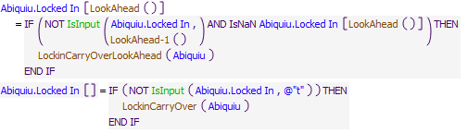
Execution Constraint
Referenced Functions
- LockinCarryOverLookAhead
- LookAhead
- LockinCarryOver
- LookAhead-1
- IsInput
- HasRuleFiredSuccessfully
- GetStartDate

23.3 ComputeAbiquiuRGRelease
Rule Purpose:
This rule sets the outflow of native Rio Grande water from Abiquiu Reservoir to bypass inflows but also includes consideration of inflows that may need to be stored for flood control operations or flood control storage that may need to be evacuated. Any potential releases of carryover storage are also considered. If conservation storage is being modeled, any inflows stored as conservation storage is considered.
Rule Logic: Execution Constraint logic is at end of explanation.
The value for the RGOutflow series slot in the AbiquiuData data object for the current timestep is set to the result of the user-defined AbiquiuMinRGOutflow function minus the RioGrandeAbiquiuToRioGrandeConservationAbiquiu.Supply slot value for the current timestep. The AbiquiuMinRGOutflow function computes the minimum outflow equal to the current Rio Grande inflow as determined with the user-defined CurrentRGInflow function plus the value for the Gain Loss for the Rio Grande Account at Abiquiu Reservoir for the previous timestep plus the result from the user-defined AbiquiuRGStorageAdjustment function plus the result from the RGCarryOverRelease function. The predefined Max function is used to restrict the result from this function to a minimum of the value of the MinRGOutflow function.
This rule fires if the current timestep is greater than or equal to the beginning timestep for rulebased simulation as input by the model user to the RulebasedSimulationStartDate scalar slot in the ModelRunTypeTriggers data object and if the value for the RGOutflow time series slot in the AbiquiuData data object for the current timestep is a NaN.
Comment:
Colored green because the majority of native flow out of Abiquiu will go to agricultural use.
Model slots written by rule:
1. AbiquiuData.RGOutflow
List of key model objects with slots read by the rule or child functions:
1. ModelRunTypeTriggers
2. Abiquiu
3. AbiquiuData
Log of when and how the rule has been modified (newest changes at the top):
Date: Who. What
2/26/19: Jesse Roach.Added description field and updated notes field
2/2017: Jesse Roach. Modified to limit outflows to available to release based on stepped release rules so that negative RG storage is avoided without violating step down constraints.
Statements
Execution Constraint
Referenced Functions
- AbiquiuMinRGOutflow
- MaxReleaseForSteppedReleasesOfAvailableWater
- Min
- GetStartDate

23.4 ComputeAbiquiuPassthroughToCochitiRecPool
Rule Purpose:
The passthrough of deliveries of Cochiti Rec Pool water from Heron Reservoir to Cochiti Lake including previous flows that may hae been held up in Abiquiu are recorded with this rule.
Rule Logic: Execution Constraint logic is at end of explanation.
If a value is not input as checked with reference to the predefined IsInput function, the CochitiRecPoolPassthroughAtAbiquiu series slot in the ComputedDeliveries data object for the current timestep is set to the accounting supply out of Heron Reservoir for the delivery of Cochiti Rec Pool water to Cochiti for the previous timestep (per the one day lag to Abiquiu) adjusted for the San Juan-Chama loss rate from El Vado to Abiquiu as input to the Losses table slot in the SanJuanChamaRules data object and as referenced with the user-defined SJCLoss function. The passthrough is also adjusted for any storage in the passthrough account at Abiquiu Reservoir.
This rule fires if the current timestep is greater than or equal to the beginning timestep for rulebased simulation as input by the model user to the RulebasedSimulationStartDate scalar slot in the ModelRunTypeTriggers data object and if the rule has not fired yet as determined with a reference to the predefined HasRuleFiredSuccessfully function.
Model slots written by rule:
1. ComputedDeliveries.CochitiRecPoolPassthroughAtAbiquiu
List of key model objects with slots read by the rule or child functions:
1. ModelRunTypeTriggers
2. Abiquiu
3. SanJuanChamaRules
Log of when and how the rule has been modified (newest changes at the top):
Date: Who. What
2/26/19: Jesse Roach.Added description field and updated notes field
12/21/17 JR: Generalized to timestep
Statements
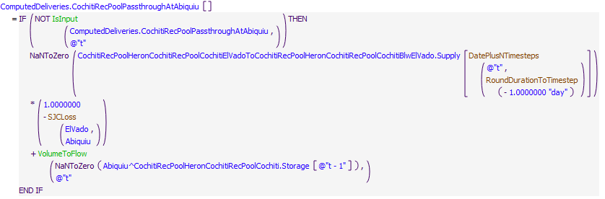
Execution Constraint
Referenced Functions
- DatePlusNTimesteps
- RoundDurationToTimestep
- VolumeToFlow
- IsInput
- HasRuleFiredSuccessfully
- SJCLoss
- GetStartDate

24 Abiquiu Deliveries
The rules in this policy group are used to compute deliveries of contractor San Juan-Chama Project water from Abiquiu Reservoir for MRGCD and targets. A total outflow of San Juan-Chama Project water from Abiquiu Reservoir is also computed.
Rules in the Group:
ComputeAbiquiuSJRelease
ComputeAbiquiuReleaseOfReclamationLeasedWater
ComputeAbiquiuRGConservationRelease
ComputeAbiquiuSJCEnvironmentalRelease
SetNeededSupplementalWaterReleaseFromAbiquiu
ComputeNeededSupplementalWaterFromAbiquiu
ComputeMRGCDSJCDeliveryToMiddleRioGrande
Policy Group Change Log (newest changes at the top):
Date: Who. What
2/27/2019: Jesse Roach. Removed 4 rules to leave target related operations at Abiquiu in this group.

24.1 ComputeMRGCDSJCDeliveryToMiddleRioGrande
Rule Purpose:
The delivery of MRGCD San Juan-Chama Project water is recorded based on the MRGCD demand at Abiquiu minus any Rio Grande outflow and minus the sum of all letter water deliveries to payback MRGCD.
Rule Logic: Execution Constraint logic is at end of explanation.
If a value is not input as checked with reference to the predefined IsInput function, the MRGCDSJCDeliveryToMiddleRioGrande series slot in the ComputedDeliveries data object for the current timestep is computed if the previous account storage for the RioGrande and MRGCDDrought accounts at El Vado is less than twice the MRGCD demand at Cochiti. The delivery is computed as the MRGCD demand at Abiquiu identified with reference to the AbiquiuMRGCDDemand function minus the Rio Grande outflow from Abiquiu and minus the sum of all the letter water deliveries from Abiquiu to payback MRGCD. The computed amount is restricted to the available MRGCD storage at Abiquiu Reservoir.
This rule fires if the current timestep is greater than or equal to the beginning timestep for rulebased simulation as input by the model user to the RulebasedSimulationStartDate scalar slot in the ModelRunTypeTriggers data object and if the rule has not fired yet as determined with a reference to the predefined HasRuleFiredSuccessfully function.
Model slots written by rule:
1. ComputedDeliveries.MRGCDSJCDeliveryToMiddleRioGrandeFromAbiquiu
List of key model objects with slots read by the rule or child functions:
1. ModelRunTypeTriggers
2. ElVado
3. MRGCD
4. AbiquiuData
5. SanJuanChamaRules
Log of when and how the rule has been modified (newest changes at the top):
Date: Who. What
2/26/19: Jesse Roach.Added description field and updated notes field
11/10/17 JR: updated during MRG timestep generalization.
Statements
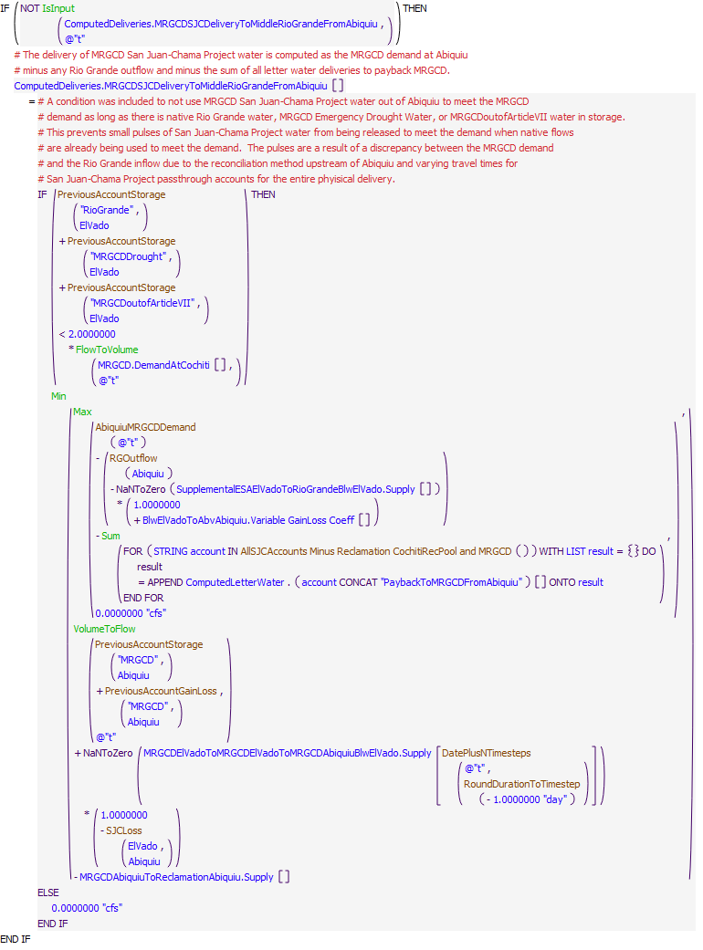
Execution Constraint
Referenced Functions
- DatePlusNTimesteps
- RoundDurationToTimestep
- AbiquiuMRGCDDemand
- RGOutflow
- Min
- Max
- Sum
- FlowToVolume
- VolumeToFlow
- IsInput
- HasRuleFiredSuccessfully
- SJCLoss
- AllSJCAccounts Minus Reclamation CochitiRecPool and MRGCD
- PreviousAccountGainLoss
- GetStartDate
- PreviousAccountStorage

24.2 ComputeNeededSupplementalWaterFromAbiquiu
Rule Purpose:
This rule records an exact amount (based on hypothetical simulation) of the supplemental water needed from Abiquiu Reservoir to meet the Middle Valley targets. The amount is recorded based on the total flow needed from Abiquiu for all downstream demands and the Middle Valley targets and subtracts off other contributions including the Rio Grande outflow from Abiqiuiu and letter water deliveries, deliveries to the Albuquerque surface water diversion, deliveries to the Buckman Direct Diversion, and deliveries of San Juan-Chama water to Elephant Butte.
Rule Logic: Execution Constraint logic is at end of explanation.
The value for the NeededSupplementalWaterFromAbiquiu series slot in the MiddleValleyTargets data object for the current timestep is set to the value for the TotalFlowNeededAtAbiquiuForTargets series slot for the current timestep minus the values in the AlbuquerqueDeliveryToSurfaceWaterDiversion, MRGCDSJCDeliveryToMiddleRioGrandeFromAbiquiu, SantaFeCityDeliveryToBuckmanDiversion, SantaFeCountyDeliveryToBuckman, AlbuquerqueDeliveryAbiquiuToElephantButte, and SantaFeCityDeliveryAbiquiuToElephantButte series slots in the ComputedDeliveries data object for the current timestep. All computed letter water deliveries to payback MRGCD and to payback the Compact are also subtracted. The need for supplemental water is reset to zero if there is Emergency Drought water available for ESA at El Vado or conservation storage at Cochiti or Jemez Reservoir.
This rule fires if the current timestep is greater than or equal to the beginning timestep for rulebased simulation as input by the model user to the RulebasedSimulationStartDate scalar slot in the ModelRunTypeTriggers data object and if the value for the NeededSupplementalWaterFromAbiquiu series slot in the MiddleValleyTargets data object for the current timestep is a NaN.
Model slots written by rule:
1. MiddleValleyTargets.NeededSupplementalWaterFromAbiquiu
List of key model objects with slots read by the rule or child functions:
1. MiddleValleyTargets
2. AbiquiuData
3. ComputedDeliveries
4. ComputedLetterWater
5. Cochiti
6. Jemez
Log of when and how the rule has been modified (newest changes at the top):
Date: Who. What
2/26/19: Jesse Roach.Added description field and updated notes field
Statements
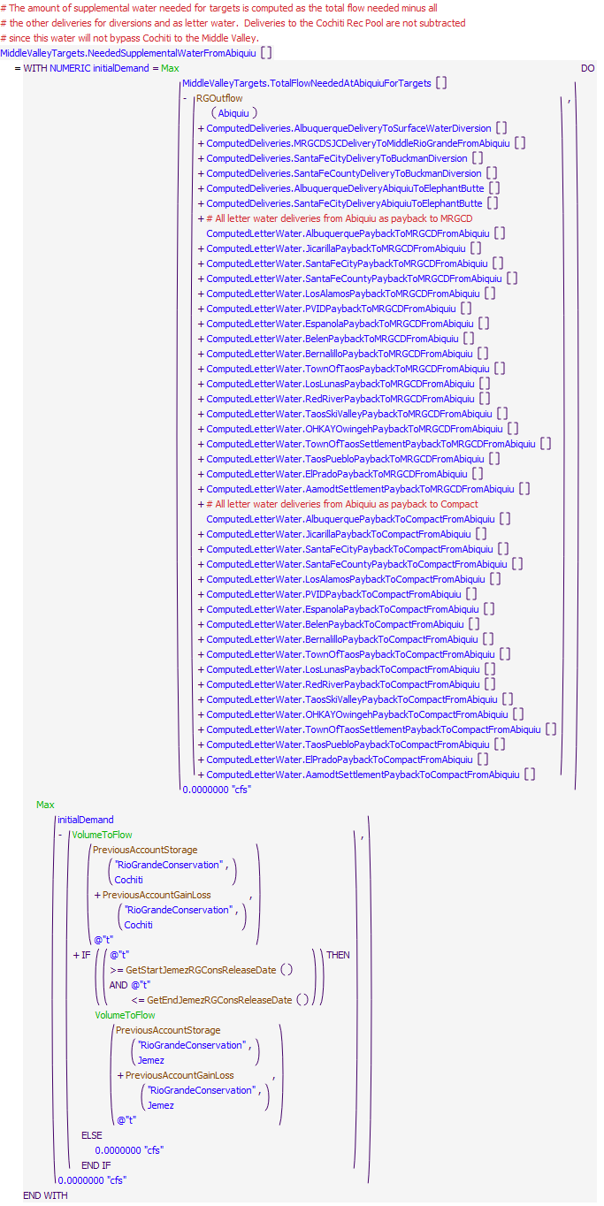
Execution Constraint
Referenced Functions
- GetEndJemezRGConsReleaseDate
- GetStartJemezRGConsReleaseDate
- RGOutflow
- Max
- VolumeToFlow
- PreviousAccountGainLoss
- GetStartDate
- PreviousAccountStorage

24.3 SetNeededSupplementalWaterReleaseFromAbiquiu
Rule Purpose:
This rule sets a final value for a needed release of supplemental water from Abiquiu Reservoir. Releases of Reclamation leased water from Abiquiu Reservoir for targets are set based on the determined exact need at Abiquiu but the final releases are rounded and also set to not adjust again until the need changes by an input threshold. The considerations result in a much more realistic modeled release of Reclamation leased water versus a release that fluctuates every day. However, depending on the purpose of the model run, the modeler may want to turn this rule off to have target releases be more exact.
Rule Logic: Execution Constraint logic is at end of explanation.
An IF THEN ELSE statement is included to first check if the current timestep is the start timestep for rulebased simulation. If so, the value for the NeededSupplementalWaterReleaseFromAbiquiu time series slot in the MiddleValleyTargets data object for the current timestep is set to the value in the NeededSupplementalWaterFromAbiquiu time series slot for the current timestep rounded to the nearest 10 cfs. A separate assignment is included to reset a counter for the number of days since an adjustment was made to the release of supplemental water.
Otherwise, another IF THEN ELSE statement is included to check if the previous counter value in the CountSinceSupplementalWaterReleaseAdjusted time series slot is greater than or equal to the value in the MinDaysBeforeSupplementalWaterReleaseAdjusted scalar slot in the MiddleValeyTargets data object and the average demand over that period minus the previous value for the NeededSupplementalWaterReleaseFromAbiquiu time series slot exceeds the value for the ChangeBeforeSupplementalWaterReleaseAdjusted scalar slot in the MiddleValleyTargets data object or the previous value in the CountSinceSupplementalWaterReleaseAdjusted time series slot in the MiddleValleyTargets data object is greater than or equal to the value in the MaxDaysWithNoSupplementalWaterReleaseAdjustment scalar slot. If the condition is satisfied, the value for the NeededSupplementalWaterReleaseFromAbiquiu slot is set to the average of the NeededSupplementalWaterReleaseFromAbiquiu slot values since the last adjustment was made. Otherwise, the previous value for the NeededSupplementalWaterReleaseFromAbiquiu slot is maintained. A counter is also set if the value in the NeededSupplementalWaterReleaseFromAbiquiu slot is adjusted.
This rule fires if the current timestep is greater than or equal to the beginning timestep for rulebased simulation as input by the model user to the RulebasedSimulationStartDate scalar slot in the ModelRunTypeTriggers data object and if the value for the NeededSupplementalWaterReleaseFromAbiquiu time series slot in the MiddleValleyTargets data object for the current timestep is a NaN.
Model slots written by rule:
1. MiddleValleyTargets.NeededSupplementalWaterReleaseFromAbiquiu
2. MiddleValleyTargets.CountSinceSupplementalWaterReleasenAdjusted
List of key model objects with slots read by the rule or child functions:
1. MiddleValleyTargets
Log of when and how the rule has been modified (newest changes at the top):
Date: Who. What
2/26/19: Jesse Roach.Added description field and updated notes field
11/10/17 JR: updated during timestep generalization of MRG rules.
Statements
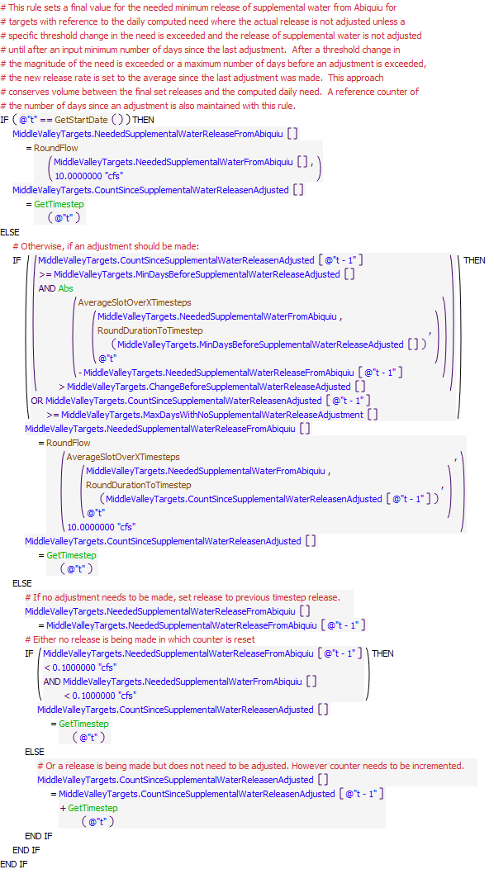
Execution Constraint
Referenced Functions
- RoundDurationToTimestep
- RoundFlow
- Abs
- GetTimestep
- AverageSlotOverXTimesteps
- GetStartDate

24.4 NeededSupplementalWaterReleaseFromAbiquiuBasedOnAgreement
Rule Purpose:
Sets the needed supplemental water release at Abiquiu if flows at target locations are lower than the flow target taking into account the Reclamation USBR agreement that while not in P&P Ops, 100% of ESA water released at Abiquiu will be diverted at the Isleta Diversion Dam and 50% of ESA water released at Abiquiu will be diverted at the San Acacia Diversion Dam. For the Central and San Marcial target, the rule will increase the supplemental water released by the difference between the target and the flow at the gage.
Rule Logic: Execution Constraint logic is at end of explanation.
If flows at Central and San Marcial gages are lower than the flow target set in MiddleValleyTargets.MinTargetFlows, then MiddleValleyTargets.NeededSupplementalWaterReleaseFrombAbiquiu is set to the previous day's NeededSupplementalWaterReleaseFrombAbiquiu plus the maximum of the Central target flow minus previous day's Central gage flow, or San Marcial flow minus previous day's San Marcial gage flow, or 0 cfs. If flows at Bosque Farms gage are lower than the flow target in MinTargetFlows, then NeededSupplementalWaterReleaseFrombAbiquiu is set to the Isleta MinTargetFlows times one divided by the MiddleValleyTargets.MRGCDandReclamationAgreementStreamflowCoefficient at Isleta (this coefficient dictates how much ESA water released at Abiquiu makes it past a specific diverision dam). If flows at San Acacia gage are lower than the flow target in MinTargetFlows, then NeededSupplementalWaterReleaseFrombAbiquiu is set to the San Acacia MinTargetFlows times one divided by the MiddleValleyTargets.MRGCDandReclamationAgreementStreamflowCoefficient at San Acacia.
This rule fires if the current timestep is greater than or equal to the beginning timestep for rulebased simulation as input by the model user to the RulebasedSimulationStartDate scalar slot in the ModelRunTypeTriggers data object, if the rule has not fired yet as determined with a reference to the predefined HasRuleFiredSuccessfully function, and if the MRGCDandReclamationAgreement switch is on (=1).
Statements
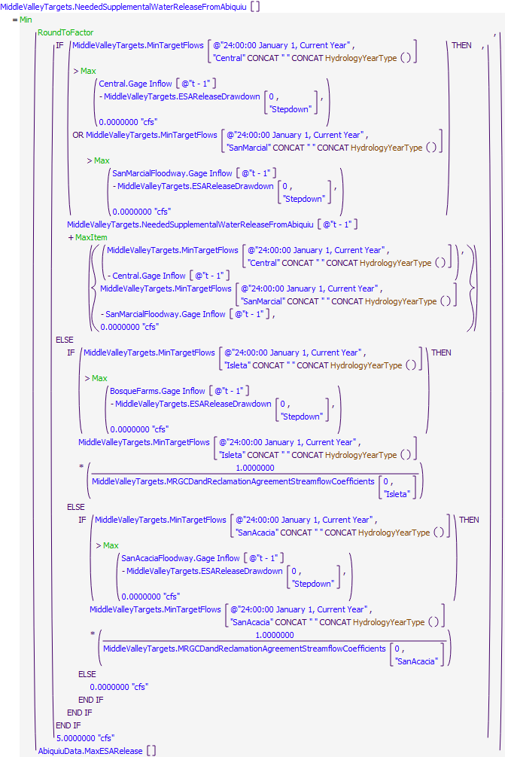
Execution Constraint
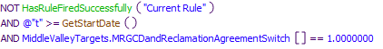
Referenced Functions
- HydrologyYearType
- Min
- Max
- RoundToFactor
- MaxItem
- HasRuleFiredSuccessfully
- GetStartDate

24.5 BeginESAReleaseWhenMRGDiversionsAreLimited
Rule Purpose:
Sets the needed supplemental water release at Abiquiu if outflows from the Angostura, Isleta, or San Acacia diversion dams fall below a certain threshold while dropping at a certain threshold (specified in MRGCD.DiversionLimiterCoefficients) to set off the rule that limits diversions at those diversion dams. This is done to reduce how fast the flow falls off in the river below those diversion dams the first time this rule is set off which should be during the tail end of the snowmelt period. After the first time, this rule will ensure that ESA flow is being released to assist in the drawdown if flows begin falling too fast after a pump up.
Rule Logic: Execution Constraint logic is at end of explanation.
If the sum of MRGCD.DiversionLimited from the beginning of the current year to two days before the current timestep is 0 and the DiversionLimited for the previous timestep is greater than 0, then MiddleValleyTargets.NeededSupplementalWaterReleaseFromAbiquiu equals MiddleValleyTargets.SlowTailSnowmeltWithESARelease. Otherwise, if just the previous timestep for DiversionLimited is greater than 0 and the NeededSupplementalWaterReleaseFromAbiquiu for the current timestep is calculated as less than the target flow at Isleta, then NeededSupplementalWaterReleaseFromAbiquiu is set to the target flow at Isleta times 1 over the Isleta agreement coefficient.
This rule fires if the current timestep is greater than or equal to the beginning timestep for rulebased simulation as input by the model user to the RulebasedSimulationStartDate scalar slot in the ModelRunTypeTriggers data object, if the rule has not fired yet as determined with a reference to the predefined HasRuleFiredSuccessfully function, if the current timestep is during irrigation season set by the IrrigationSeason function, and if the MRGCDandReclamationAgreement switch is on (=1).
Statements
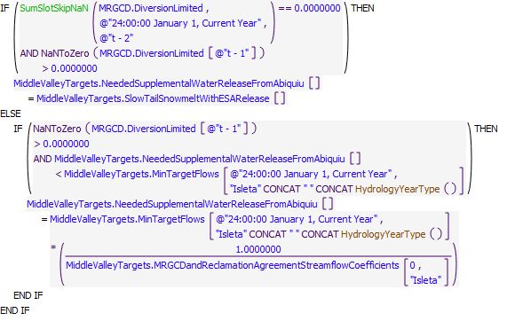
Execution Constraint
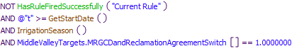
Referenced Functions
- IrrigationSeason
- HydrologyYearType
- SumSlotSkipNaN
- HasRuleFiredSuccessfully
- GetStartDate

24.6 SupplementalWaterReleaseStepDownFromAbiquiu
Rule Purpose:
Sets the needed supplemental water release at Abiquiu so that the supplemental releases step down a specified amount over a specified amount of time. This is to mimic operations so that supplemental flows will assist in gradual drying of a reach as opposed to a sudden drying of a reach.
Rule Logic: Execution Constraint logic is at end of explanation.
If the calculated MiddleValleyTargets.NeededSupplementalWaterReleaseFromAbiquiu up to this point in the rules is less than the previous days NeededSupplementalWaterReleaseFromAbiquiu then the following ifelse statement is triggered. If the previous timestep's NeededSupplementalWaterReleaseFromAbiquiu does not equal the rounded sum of NeededSupplementalWaterReleaseFromAbiquiu from t minus a specified number of days to two days before the current timestep divided by the total number of days being summed then NeededSupplementalWaterReleaseFromAbiquiu equals the rounded previous timestep's NeedSupplementalWaterReleaseFromAbiquiu. Else, the NeededSupplementalWaterReleaseFromAbiquiu equals the maximum of the rounded previous timestep's NeededSupplementalWaterReleaseFromAbiquiu minus a specified drawdown amount or 0 cfs.
This rule fires if the current timestep is greater than or equal to the beginning timestep for rulebased simulation as input by the model user to the RulebasedSimulationStartDate scalar slot in the ModelRunTypeTriggers data object, if the rule has not fired yet as determined with a reference to the predefined HasRuleFiredSuccessfully function, and if the MRGCDandReclamationAgreement switch is on (=1).
Statements
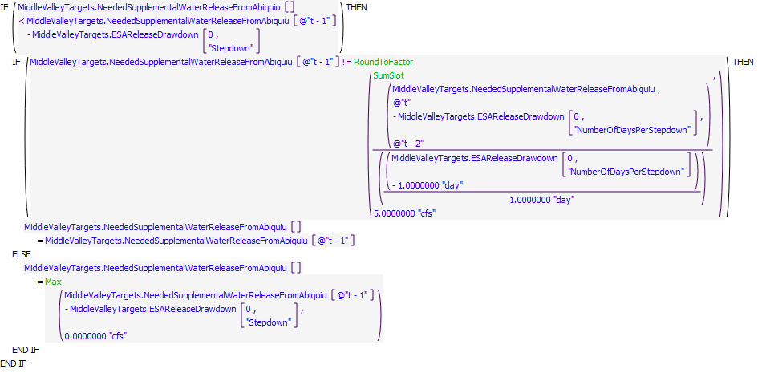
Execution Constraint
Referenced Functions
- SumSlot
- Max
- RoundToFactor
- HasRuleFiredSuccessfully
- GetStartDate

24.7 SupplementalWaterReleaseRestrictions
Rule Purpose:
Limits MiddleValleyTargets.NeededSupplementalWaterReleaseFromAbiquiu to the amount of water left in storage in the Reclamation account in Abiquiu
Rule Logic: Execution Constraint logic is at end of explanation.
If amount of water left in the Reclamation storage account in Abiquiu is less than the amount the is trying to be released from MiddleValleyTargets.NeededSupplementalWaterReleaseFromAbiquiu then the new release for NeededSupplementalWaterReleaseFromAbqiuiu equals that amount of water to deplete the Reclamation storage account in Abiquiu.
This rule fires if the current timestep is greater than or equal to the beginning timestep for rulebased simulation as input by the model user to the RulebasedSimulationStartDate scalar slot in the ModelRunTypeTriggers data object, if the rule has not fired yet as determined with a reference to the predefined HasRuleFiredSuccessfully function, and if the MRGCDandReclamationAgreement switch is on (=1).
Statements
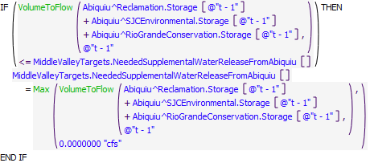
Execution Constraint
Referenced Functions
- Max
- VolumeToFlow
- HasRuleFiredSuccessfully
- GetStartDate

24.8 ComputeAbiquiuSJCEnvironmentalRelease
Rule Purpose:
A release from SJCEnvironmental storage is computed as the amount needed for Middle Valley targets, restricted to the available storage and a user input maximum release.
Rule Logic: Execution Constraint logic is at end of explanation.
An outer IF THEN loop is used to do nothing if the value for ComputedDeliveries.SJCEnvironmentalReleaseFromAbiquiu at the current timestep was set by user input. If this wasn't the case, ComputedDeliveries.SJCEnvironmentalReleaseFromAbiquiu at the current timestep is set equal to the smaller of a target release and available water. The outer Max function prevents the result from being negative.
This rule fires if it has not fired yet as determined with a reference to the predefined HasRuleFiredSuccessfully function, and the current timestep is greater than or equal to the beginning timestep for rulebased simulation as input by the model user to the RulebasedSimulationStartDate scalar slot in the ModelRunTypeTriggers data object.
Model slots written by rule:
1. ComputedDeliveries.SJCEnvironmentalReleaseFromAbiquiu
List of key model objects with slots read by the rule or child functions:
1. Abiquiu
2. AbiquiuData
3. MiddleValleyTargets
Log of when and how the rule has been modified (newest changes at the top):
Date: Who. What
2/27/19: Jesse Roach.Updated description and notes fields.
11/10/17 JR: updated during timestep generalization of MRG rules.
Statements
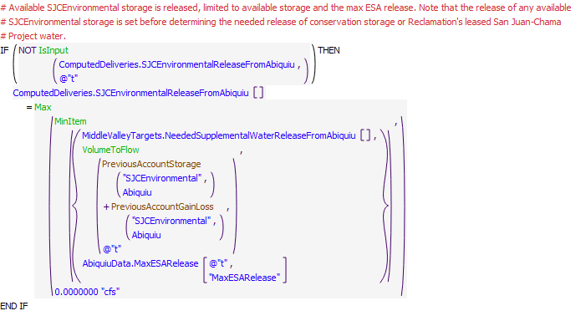
Execution Constraint
Referenced Functions
- MinItem
- Max
- VolumeToFlow
- IsInput
- HasRuleFiredSuccessfully
- PreviousAccountGainLoss
- GetStartDate
- PreviousAccountStorage

24.9 ComputeAbiquiuRGConservationRelease
Rule Purpose:
This rule computes a release of available conservation storage at Abiquiu to meet target flows. If the current timestep is within the period to make a release from conservation storage at Abiquiu, available conservation storage is released as the maximum of the amount needed for targets or an average flow to evacuate the water over an input delivery period. The release from conservation storage is computed based on the amount needed for Middle Valley targets, less what is already being released from the SJCEnvironmental account, or as a constant release if scheduled based on model user inputs.
Rule Logic: Execution Constraint logic is at end of explanation.
If a value is not input as checked with reference to the predefined IsInput function, the RGConservationReleaseFromAbiquiu series slot in the ComputedDeliveries data object for the current timestep is computed if the current timestep is within the period for a release based on the dates input to the RGConservationReleaseDays table slot in the AbiquiuData data object. For other periods, the release is set to 0.0 cfs. The computed release is set to the maximum of the value in the NeededSupplementalWaterReleaseFromAbiquiu series slot in the MiddleValleyTargets data object for the current timestep or the constant release to evacuate the storage over an input delivery period as computed with the user-defined ComputeConstantAbiquiuRGConservationRelease function. The computed release is restricted with the predefined MinItem function to the available conservation storage at Abiquiu Reservoir and the value in the MaxESARelease periodic slot in the AbiquiuData data object representing what is already being released from the SJCEnvironmental account.
This rule fires if the current timestep is greater than or equal to the beginning timestep for rulebased simulation as input by the model user to the RulebasedSimulationStartDate scalar slot in the ModelRunTypeTriggers data object and if the rule has not fired yet as determined with a reference to the predefined HasRuleFiredSuccessfully function.
Model slots written by rule:
1. ComputedDeliveries.RGConservationReleaseFromAbiquiu
List of key model objects with slots read by the rule or child functions:
1. Abiquiu
2. AbiquiuData
3. MiddleValleyTargets
4. ComputedDeliveries
Log of when and how the rule has been modified (newest changes at the top):
Date: Who. What
2/27/19: Jesse Roach.Updated description and notes fields.
Statements
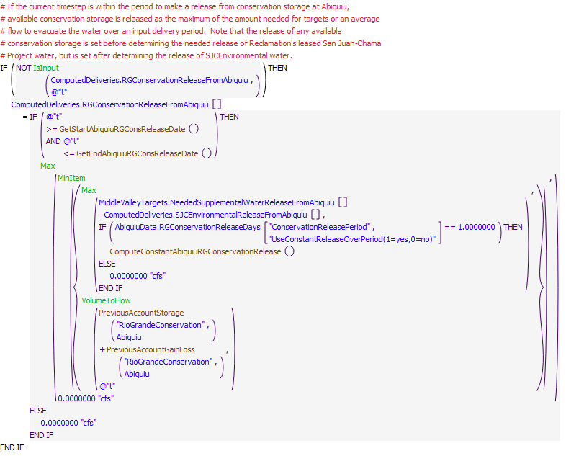
Execution Constraint
Referenced Functions
- ComputeConstantAbiquiuRGConservationRelease
- GetEndAbiquiuRGConsReleaseDate
- GetStartAbiquiuRGConsReleaseDate
- MinItem
- Max
- VolumeToFlow
- IsInput
- HasRuleFiredSuccessfully
- PreviousAccountGainLoss
- GetStartDate
- PreviousAccountStorage

24.10 ComputeAbiquiuReleaseOfReclamationLeasedWater
Rule Purpose:
This rule computes a release of leased San Juan-Chama Project water from Abiquiu Reservoir for targets based on the computed need for supplemental water minus any potential contribution from conservation storage releases.
Rule Logic: Execution Constraint logic is at end of explanation.
If a value is not input as checked with reference to the predefined IsInput function, the ReclamationReleaseFromAbiquiuForTargets series slot in the ComputedDeliveries data object for the current timestep is computed as the value in the NeededSupplementalWaterReleaseFromAbiquiu series slot in the MiddleValleyTargets data object for the current timestep minus the value for the RGConservationReleaseFromAbiquiu series slot in the ComputedDeliveries data object for the current timetep. The computed release is restricted with the predefined MinItem function to the storage in the Reclamation account at Abiquiu Reservoir and the value in the MaxESARelease periodic slot in the AbiquiuData data object.
This rule fires if the current timestep is greater than or equal to the beginning timestep for rulebased simulation as input by the model user to the RulebasedSimulationStartDate scalar slot in the ModelRunTypeTriggers data object and if the rule has not fired yet as determined with a reference to the predefined HasRuleFiredSuccessfully function.
Model slots written by rule:
1. ComputedDeliveries.ReclamationReleaseFromAbiquiuForTargets
List of key model objects with slots read by the rule or child functions:
1. ModelRunTypeTriggers
2. Abiquiu
3. AbiquiuData
4. MiddleValleyTargets
5. ComputedDeliveries
Log of when and how the rule has been modified (newest changes at the top):
Date: Who. What
2/27/19: Jesse Roach.Updated description and notes fields.
Statements
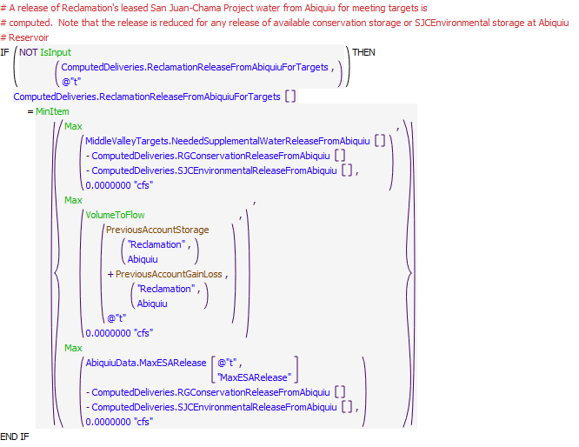
Execution Constraint
Referenced Functions
- MinItem
- Max
- VolumeToFlow
- IsInput
- HasRuleFiredSuccessfully
- PreviousAccountGainLoss
- GetStartDate
- PreviousAccountStorage

24.11 ComputeAbiquiuSJRelease
Rule Purpose:
A total release of San Juan-Chama Project water from Abiquiu Reservoir is computed as a summation of the individual deliveries for each San Juan-Chama contractor.
Rule Logic: Execution Constraint logic is at end of explanation.
The value for the SJOutflow series slot in the Abiquiu data object for the current timestep is computed as an addition of all the computed individual deliveries in the series slots in the ComputedDeliveries data object. The result is restricted to not exceed the value input to the MaximumSJOutflow periodic slot in the AbiquiuData data object.
This rule fires if the current timestep is greater than or equal to the beginning timestep for rulebased simulation as input by the model user to the RulebasedSimulationStartDate scalar slot in the ModelRunTypeTriggers data object and if the value for the SJOutflow series slot in the AbiquiuData data object for the current timestep is a NaN.
Model slots written by rule:
1. AbiquiuData.SJOutflow
List of key model objects with slots read by the rule or child functions:
1. ModelRunTypeTriggers
2. ComputedDeliveries
3. ComputedLetterWater
4. AbiquiuData
Log of when and how the rule has been modified (newest changes at the top):
Date: Who. What
2/27/19: Jesse Roach.Updated description and notes fields.
Statements
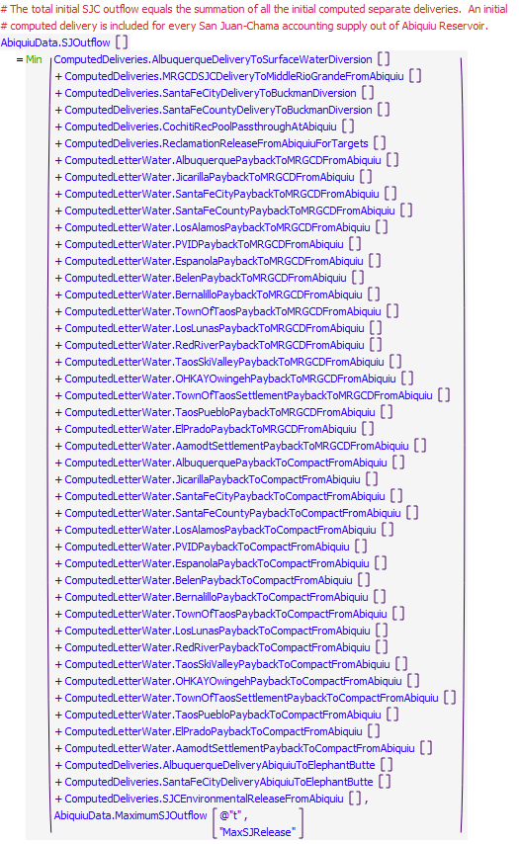
Execution Constraint
Referenced Functions
- Min
- GetStartDate

24.12 ComputeCompactDebitReleaseFromAbiquiu
Rule Purpose:
This rule empties the compact debit account in Abiquiu.
Rule Logic: Execution Constraint logic is at end of explanation.
If a value has not been input by the user, the account is emptied starting on a user-input StartDay, and continues until the user-input EndDay as specified in the RioGrandeCompact.CompactDebitReleaseSchedule slot, if there is any CompactDebit account water in Abiquiu, and the RioGrandeCompact.EnableCompactDebitStorageOnAbiquiu switch is set at 1.0. Water is emptied from this account at a constant rate based on the release schedule dates. On the final day of releases, all of the remaining water is emptied out of the account (the constant rate doesn't take into account minor fluctuations in gain-loss values on the account). If any one of the Boolean tests are FALSE, then the value is set to 0 cfs.
This rule fires if the current timestep is greater than or equal to the beginning timestep for rulebased simulation as input by the model user to the RulebasedSimulationStartDate scalar slot in the ModelRunTypeTriggers data object and the CompactDebitReleaseFromAbiquiu time series slot in the ComputedDeliveries data object for the current timestep is a NaN.
Model slots written by rule:
1. ComputedDeliveries.CompactDebitReleaseFromAbiquiu
List of key model objects with slots read by the rule or child functions:
1. ModelRunTypeTriggers
2. ComputedDeliveries
3. RioGrandeCompact
4. Abiquiu
Log of when and how the rule has been modified (newest changes at the top):
Date: Who. What
9/19/2022: Nick Mander - Hydros, created rule.
Statements
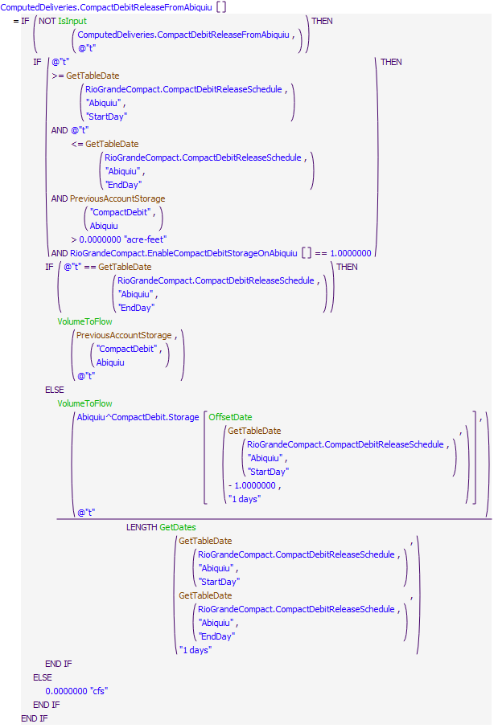
Execution Constraint
Referenced Functions
- GetTableDate
- OffsetDate
- GetDates
- VolumeToFlow
- IsInput
- GetStartDate
- PreviousAccountStorage

25 Abiquiu Reservoir Operations
The rules in this policy group are used to determine the total outflow from Abiquiu Dam with consideration for pre-evacuation releases, stepped release restrictions, downstream channel capacity restrictions, prescribed maintenance flows, flood contro, and carry over storagel operations.
Rules in the Group:
AbiquiuRGCarryOver
AbiquiuFloodControl
AbiquiuTemporaryFlowsForMaintenance
AbiquiuChannelCapacityRestrictions
AbiquiuSteppedRelease
AbiquiuPreEvacuation
AbiquiuOutflow
Policy Group Change Log (newest changes at the top):
Date: Who. What

25.1 AbiquiuOutflow
Rule Purpose:
Unless a total outflow for Abiquiu Dam has been input for the current timestep, the value for the outflow is set to the determined Rio Grande release plus the release of San Juan-Chama Project water. The resulting total release is checked to see if it is physically legitimate based on the outlet works, and if not, the release is reset to reflect the restriction of the outlet works.
Rule Logic: Execution Constraint logic is at end of explanation.
The user-defined InitialAbiquiuOutflow function is used to compute the total outflow from Abiquiu Dam. This function contains an exterior IF THEN ELSE statement to see if the value in the TotalOutflowDirectlyInputToOverrideRules time series slot in the AbiquiuData data object for the current timestep as referenced using the user-defined TotalOutflow function is a NaN. If not, the value for the Outflow time series slot in the Abiquiu level power reservoir object for the current timestep is set to that input TotalOutflowDirectlyInputToOverrideRules value. Otherwise, the result is set to the sum of the values for the SJOutflow and RGOutflow time series slots in the AbiquiuData data object for the current timestep as referenced with the user-defined SJOutflow and RGOutflow functions plus any release from conservation storage, with that sum restricted to the value in the MinRelease periodic slot in the AbiquiuData data object for the current timestep as referenced using the MinOutflow function. Within the rule, the result for the Outflow is checked against the physical restrictions of the outlet works using the user-defined CheckThisResPhysicalConstraints function.
This rule fires if the current timestep is greater than or equal to the beginning timestep for rulebased simulation as input by the model user to the RulebasedSimulationStartDate scalar slot in the ModelRunTypeTriggers data object and if the value for the Outflow time series slot in the Abiquiu level power reservoir object for the current timestep is a NaN.
Comment:
Note that the minimum flow needed for the Rio Chama acequias is set at El Vado Dam and would be bypassed at Abiquiu Dam. Separate minimum flows are also set by the user for Abiquiu Dam.
Model slots written by rule:
1. Abiquiu.Outflow
List of key model objects with slots read by the rule or child functions:
1. ModelRunTypeTriggers
2. AbiquiuData
3. Abiquiu
Log of when and how the rule has been modified (newest changes at the top):
Date: Who. What
2/28/19: Jesse Roach.Updated description and notes fields.
Statements
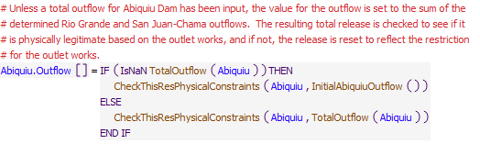
Execution Constraint
Referenced Functions
- CheckThisResPhysicalConstraints
- TotalOutflow
- InitialAbiquiuOutflow
- GetStartDate

25.2 AbiquiuPreEvacuation
Rule Purpose:
If water needs to be pre-evacuated at Abiquiu Reservoir in anticipation of forecasted inflows, the outflow from Abiquiu Dam is reset based on a computed pre-evacuation flow which includes consideration for the downstream channel capacity. It is very rare that criteria would be satisfied for such a pre-evacuation operation.
Rule Logic: Execution Constraint logic is at end of explanation.
If the execution constraints are satisfied, the value in the Outflow time series slot in the Abiquiu level power reservoir object for the current timestep is reset to the result from the user-defined DeterminePreEvacFlow function. The user-defined ComputePreEvacFlow function is referenced to compute the pre evacuation flow rate as the average flow required to evacuate the result from the AbiquiuRemainingForecastVolume function over the period from the current timestep to August 1. Within the DeterminePreEvacFlow function, the result is checked against the input downstream (D/S) value in the ChannelCapacities table slot and input value for the MaxThreshold, MaxStepFactor, and MaxThreshold in the SteppedReleaseData table slot in the AbiquiuData data object. The result from the DeterminePreEvacFlow function is checked against the physical restrictions of the outlet works using the user-defined CheckThisResPhysicalConstraints function. Only if pre evacuation (this is computed by the function ISPreEvacuationRequired which checks to see if it is pre evacuation season and that the remaining forecast volume is greater than the user input MinPreEvacStorage (on the AbiquiuData.PreEvacuationData table slot)) is required and the rule has not fired during the current timestep
This rule fires if the result from the user-defined IsPreEvacuationRequired function is TRUE AND the current timestep is greater than or equal to the beginning timestep for rulebased simulation as input by the model user to the RulebasedSimulationStartDate scalar slot in the ModelRunTypeTriggers data object and the rule has not fired as checked against the predefined HasRuleFiredSuccessfully function. The IsPreEvacuationRequired function checks to see if the current timestep is between December 31 plus the number of days entered to the PreEvacJulianDay column of the PreEvacuationData table slot in the AbiquiuData data object and April 30 (inclusive) as determined with the user-defined IsPreEvacuationSeason function. The IsPreEvacuationRequired function also checks to see if the forecasted volume of inflows to Abiquiu Reservoir minus the space remaining to the maximum elevation at El Vado Reservoir minus the space remaining to the AllowableStorageElevation entered to the PreEvacuationData table slot as computed with the user-defined AbiquiuRemainingForecastVolume function is greater than or equal to the input value in the MinPreEvacStorage column in the PreEvacuationData table slot.
Model slots written by rule:
1. Abiquiu.Outflow
List of key model objects with slots read by the rule or child functions:
1. ModelRunTypeTriggers
2. AbiquiuData
3. Abiquiu
4. ComputedDeliveries
Log of when and how the rule has been modified (newest changes at the top):
Date: Who. What
2/28/19: Jesse Roach.Updated description and notes fields.
Statements
Execution Constraint
Referenced Functions
- CheckThisResPhysicalConstraints
- IsPreEvacuationRequired
- DeterminePreEvacFlow
- MaximumAvailableToPreventNegativeRioGrandeStorage
- HasRuleFiredSuccessfully
- GetStartDate

25.3 AbiquiuSteppedRelease
Rule Purpose:
Releases from Abiquiu may be reset to step up the releases or step down the releases to prevent day to day changes to releases greater than a certain threshold. This rule determines whether a stepped release is required, and if so, computes the release based on a stepped release approach. The rule references a switch that may be set by the model user to prevent stepped release policy from causing the Rio Grande account storage to go negative. Rio Grande storage may go negative if there is not enough native water in storage to maintain higher releases for a step down in releases. For such cases, the negative Rio Grande storage effectively represents a debt by the Rio Grande account to all other accounts that is paid back when native Rio Grande storage is recaptured after stepped releases over.
Rule Logic: Execution Constraint logic is at end of explanation.
If the execution constraints are satisfied, the value in the Outflow time series slot in the Abiquiu level power reservoir object for the current timestep is reset using an IF THEN ELSE statement. If the model user has input a value of 1.0 to the RestrictSteppedReleasesToAvailableNativeSupply(1=Yes,0=No) column in the SteppedReleaseData table slot on the AbiquiuData data object and the result from the DetermineSteppedRelease function indicates a higher release than the value computed with the user-defined MaximumAvailableToPreventNegativeRioGrandeStorage function, the result from that latter MaximumAvailableToPreventNegativeRioGrandeStorage function is used. Otherwise, the release is reset to the result from the user-defined DetermineSteppedRelease function.
The DetermineSteppedRelease function includes an exterior IF THEN ELSE statement to see if the outflow from Abiquiu Dam is increasing as determined using the user-defined OutflowIsIncreasing function. If so, the outflow is calculated with the user-defined ComputeOutflowIncrSteppedRelease function. If not, the outflow is computed using the user-defined ComputeOutflowDecrSteppedRelease function unless it is determined that the release should be shutoff.
Within the rule, the result is checked against the physical restrictions of the outlet works using the user-defined CheckThisResPhysicalConstraints function
This rule fires if the rule has not fired as checked against the predefined HasRuleFiredSuccessfully function and if the current timestep is greater than or equal to the beginning timestep for rulebased simulation as input by the model user to the RulebasedSimulationStartDate scalar slot in the ModelRunTypeTriggers data object and if the result from the user-defined SteppedReleaseIsNeeded function is TRUE. The SteppedReleaseIsNeeded function includes three separate functions to check the change to the outflow as computed using the user-defined ComputeDeltaOutflow function against different criteria.
Model slots written by rule:
1. Abiquiu.Outflow
List of key model objects with slots read by the rule or child functions:
1. ModelRunTypeTriggers
2. AbiquiuData
3. Abiquiu
Log of when and how the rule has been modified (newest changes at the top):
Date: Who. What
2/28/19: Jesse Roach.Updated description and notes fields.
3/11/2021: Marc Sidlow. Added top If Else statement to assure at least the Minimum Release would be set. Prior to change some releases were being set to a value less than the Minimum Release.
Statements
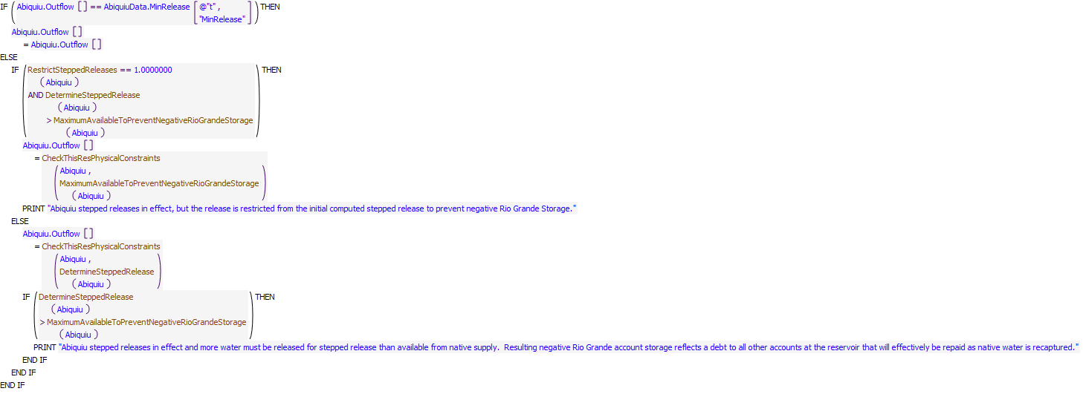
Execution Constraint
Referenced Functions
- CheckThisResPhysicalConstraints
- DetermineSteppedRelease
- SteppedReleaseIsNeeded
- MaximumAvailableToPreventNegativeRioGrandeStorage
- RestrictSteppedReleases
- HasRuleFiredSuccessfully
- GetStartDate

25.4 AbiquiuChannelCapacityRestrictions
Rule Purpose:
This rule resets the outflow from Abiquiu Dam if necessary maintain a downstream flow that is less than the downstream channel capacity restrictions below the dam (1800 cfs), at Chamita (3000 cfs), and at Otowi (10,000 cfs) with consideration for downstream local inflows. For such cases native Rio Grande water would be stored and evacuated later as possible within constraints of the downstream channel capacity, and rules that might lock that storage in until after the irrigation season.
Rule Logic: Execution Constraint logic is at end of explanation.
This rule includes an IF THEN ELSE statement to see if the value for the Outflow time series slot in the Abiquiu level power reservoir object for the current timestep is greater than the maximum release to comply with downstream channel capacities at Otowi and Chamita as determined with the user-defined AbiquiuReleaseForChannelCapacity function. This function references input values in the ChannelCapacities table slot in the AbiquiuData data object along with the flow at Otowi and local inflows between Embudo and Otowi and local inflows between Abiquiu Dam and Chamita to determine the maximum release. The value for the Outflow slot is reset if needed to comply with the downstream channel capacities. The result is checked against the physical restrictions of the outlet works using the user-defined CheckThisResPhysicalConstraints function. This rule resets the Abiquiu outflow to restrict the release for downstream channel capacities as needed. Outflows from Abiquiu Dam are often restricted during the snowmelt runoff for the currently official value of 1800 cfs channel capacity below the dam.
This rule fires if the current timestep is greater than or equal to the beginning timestep for rulebased simulation as input by the model user to the RulebasedSimulationStartDate scalar slot in the ModelRunTypeTriggers data object and if the rule has not fired as checked against the predefined HasRuleFiredSuccessfully function.
Model slots written by rule:
1. Abiquiu.Outflow
List of key model objects with slots read by the rule or child functions:
1. ModelRunTypeTriggers
2. AbiquiuData
3. Abiquiu
Log of when and how the rule has been modified (newest changes at the top):
Date: Who. What
2/28/19: Jesse Roach.Updated description and notes fields.
Statements
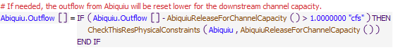
Execution Constraint
Referenced Functions
- CheckThisResPhysicalConstraints
- AbiquiuReleaseForChannelCapacity
- HasRuleFiredSuccessfully
- GetStartDate

25.5 AbiquiuFloodControl
Rule Purpose:
If the current Abiquiu outflow would cause an unregulated spill, and if the current outflow is less than channel capacity, this rule will increase the outflow from Abiquiu Dam up to the downstream channel capacity.
Rule Logic: Execution Constraint logic is at end of explanation.
If the execution constraints are satisfied, the value for the Outflow time series slot in the Abiquiu level power reservoir object for the current timestep is reset to the result from the AbiquiuFCOutflow function. This function includes an IF THEN ELSE statement to see if the result from the user-defined UnregulatedSpillWhenNoConduitFlow function, which references the predefined GetMinSpillGivenInflowRelease function, is less than the value for the downstream channel capacity in the ChannelCapacities table slot in the AbiquiuData data object. If so, the outflow is set to that input downstream channel capacity. If not, the release is set to the result from the UnregulatedSpillWhenNoConduitFlow function.
Within the rule, the result is checked against the physical restrictions of the outlet works using the user-defined CheckThisResPhysicalConstraints function. If Abiquiu Dam is spilling, the outflow will be set to represent the unregulated spill with no conduit flow unless the spill is less than what can be released for downstream channel capacities - in which case the release will be set to the ouflow for the channel capacity.
This rule fires if the current timestep is greater than or equal to the beginning timestep for rulebased simulation as input by the model user to the RulebasedSimulationStartDate scalar slot in the ModelRunTypeTriggers data object and if the rule has not fired as checked against the predefined HasRuleFiredSuccessfully function and the value for the Unregulated Spill time series slot in the Abiquiu level power reservoir object is greater than zero as determined with the user-defined ReservoirIsSpillingUnreg function.
Model slots written by rule:
1. Abiquiu.Outflow
List of key model objects with slots read by the rule or child functions:
1. ModelRunTypeTriggers
2. AbiquiuData
3. Abiquiu
Log of when and how the rule has been modified (newest changes at the top):
Date: Who. What
2/28/19: Jesse Roach.Updated description and notes fields.
Statements
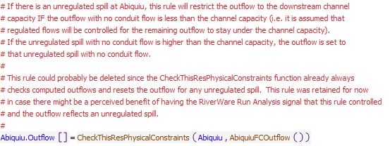
Execution Constraint
Referenced Functions
- CheckThisResPhysicalConstraints
- ReservoirIsSpillingUnreg
- AbiquiuFCOutflow
- HasRuleFiredSuccessfully
- GetStartDate

25.6 AbiquiuRGCarryOver
Rule Purpose:
If flood control storage was retained as carryover storage, a winter release of that carryover storage is recorded with this rule, if not input, to release the water at a constant rate before March. The amount of carryover storage remaining is also tracked.
Rule Logic: Execution Constraint logic is at end of explanation.
The rule includes an IF THEN ELSE statement to see if the current timestep is January 1 and if the result from the user-defined IsRGConservationAllowed function is TRUE. If not, the value for the RGCarryOverRelease time series slot in the AbiquiuData data object for the current timestep is set to the result from the user-defined RGCarryOverRelease function. If so, an interior IF THEN ELSE statement is used to see if the value for the RGCarryOverLeft time series slot in the AbiquiuData data object for the previous timestep is greater than the result from the user-defined ComputeAbiquiuRGConsInflow function converted to a volume using the predefined FlowToVolume function. If so, the value for the RGCarryOverRelease time series slot for the current timestep is set to the result from the user-defined RGCarryOverRelease function. If not, the value for the RGCarryOverRelease slot is set to 0.0 cfs.
This rule includes an additional assignment statement to set the value for the RGCarryOverLeft time series slot in the AbiquiuData data object for the current timestep to the result from the user-defined RGCarryOverLeft function.
This rule fires if the current timestep is greater than or equal to the beginning timestep for rulebased simulation as input by the model user to the RulebasedSimulationStartDate scalar slot in the ModelRunTypeTriggers data object and if the value for the RGCarryOverRelease time series slot in the AbiquiuData data object for the current timestep is a NaN and the current timestep is between November and March (inclusive) as determined with the user-defined FloodCarryOverReleaseSeason function.
Model slots written by rule:
1. AbiquiuData.RGCarryOverRelease
2. AbiquiuData.RGCarryOverLeft
List of key model objects with slots read by the rule or child functions:
1. ModelRunTypeTriggers
2. AbiquiuData
3. Abiquiu
Log of when and how the rule has been modified (newest changes at the top):
Date: Who. What
2/28/19: Jesse Roach.Updated description and notes fields.
Statements
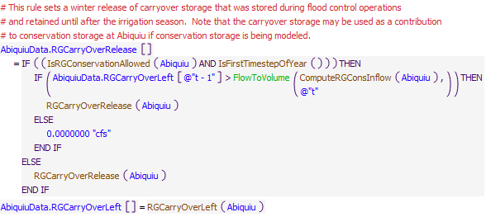
Execution Constraint
Referenced Functions
- ComputeRGConsInflow
- IsRGConservationAllowed
- IsFirstTimestepOfYear
- RGCarryOverLeft
- FloodCarryOverReleaseSeason
- RGCarryOverRelease
- FlowToVolume
- GetStartDate

25.7 AbiquiuTemporaryFlowsForMaintenance
Rule Purpose:
This rule resets the outflow from Abiquiu Dam to the input maintenance flow if the maintenance switch is set.
Rule Logic: Execution Constraint logic is at end of explanation.
If the execution constraints are satisfied, the value for the Outflow time series slot in the Abiquiu level power reservoir object for the current timestep is reset to the input value in the MaintenanceFlow table slot in the AbiquiuData data object as referenced with the user-defined MaintenanceFlow function.
This rule fires if the value for the MaintenanceSwitch periodic slot in the AbiquiuData data object is equal to 1.0 as determined with the user-defined IsMaintenanceSwitchOn function and if the current timestep is greater than or equal to the beginning timestep for rulebased simulation as input by the model user to the RulebasedSimulationStartDate scalar slot in the ModelRunTypeTriggers data object and if the rule has not fired as checked against the predefined HasRuleFiredSuccessfully function.
Model slots written by rule:
1. Abiquiu.Outflow
List of key model objects with slots read by the rule or child functions:
1. ModelRunTypeTriggers
2. AbiquiuData
Log of when and how the rule has been modified (newest changes at the top):
Date: Who. What
2/28/19: Jesse Roach.Updated description and notes fields.
Statements
Execution Constraint
Referenced Functions
- IsMaintenanceSwitchOn
- MaintenanceFlow
- HasRuleFiredSuccessfully
- GetStartDate

26 Abiquiu Accounts
The rules in this policy group are used to set the accounting supplies for the release from conservation storage, the Rio Grande outflow, and releases of San Juan-Chama Project water from Abiquiu Reservoir. The rule CheckAbiquiuRGOutflow aborts the run if the Rio Grande supply is for some reason not set. Finally, SetTransfersAtElephantButteForDeliveriesViaCombinedAccount pulls the water delivered to Elephant Butte via the combined account into individual accounts based on how those accounts were bundled at Abiquiu for conveyance.
Rules in the Group:
SetTransfersAtElephantButteForDeliveriesViaCombinedAccount
SetAbiquiuSJCAccountingSupplies
CheckAbiquiuRGOutflow
SetAbiquiuRioGrandeAccountingSupply
Policy Group Change Log (newest changes at the top):
Date: Who. What

26.1 SetAllAbiquiuRioGrandeAccountingSupplies
Rule Purpose:
Accounting supplies for the outflow of Rio Grande water from Abiquiu are set for the release from the RioGrandeConservation, CompactDebit, and RioGrande accounts. The supplies are set one-by-one with consideration for the previously set supplies restricted to a total reconciled Rio Grande outflow. If initial computed deliveries cannot all be made with the final reconcile Rio Grande outflow, water is moved based in priority based on the order of the assignment statements. If a higher outflow is set due to flood control operations, the additional outflow will be included with the Rio Grande account outflow set last. If the reconciled outflow is different from the initial total Rio Grande outflow, deliveries are set to the initial computed values in the following priority: RioGrandeConservation, CompactDebit, and RioGrande. It is very rare that the reconciled Rio Grande outflow would be different from the initial total Rio Grande outflow.
Rule Logic: Execution Constraint logic is at end of explanation.
Three assignment statements are used to set the three accounting supplies for the outflow of Rio Grande water from Abiquiu.
The value for the RioGrandeConservationAbiquiuToRioGrandeBlwAbiquiu.Supply slot for the current timstep is set to the minimum of the value in the RGConservationReleaseFromAbiquiu series slot in the ComputedDeliveries data object for the current timestep or the result from the user-defined ReconcileRGOutflow function.
The value for the CompactDebitAbiquiuToRioGrandeBlwAbiquiu.Supply slot for the current timstep is set to the minimum of the value in the CompactDebitReleaseFromAbiquiu series slot in the ComputedDeliveries data object for the current timestep or the result from the user-defined ReconcileRGOutflow function minus the delivery from the RioGrande conservation account. ComputedDeliveries data objec
The supply slot for the outflow from the RioGrande account is set to the reconciled Rio Grande outflow minus the delivery from all other native accounts.
This rule fires if the current timestep is greater than or equal to the beginning timestep for rulebased simulation as input by the model user to the RulebasedSimulationStartDate scalar slot in the ModelRunTypeTriggers data object and if the value for the RioGrandeAbiquiuToRioGrandeBlwAbiquiu.Supply slot for the current timestep is a NaN.
Model slots written by rule:
1. RioGrandeConservationAbiquiuToRioGrandeBlwAbiquiu.Supply
2. CompactDebitAbiquiuToRioGrandeBlwAbiquiu.Supply
2. RioGrandeAbiquiuToRioGrandeBlwAbiquiu.Supply
List of key model objects with slots read by the rule or child functions:
1. ModelRunTypeTriggers
2. Abiquiu
3. AbiquiuData
Log of when and how the rule has been modified (newest changes at the top):
Date: Who. What
9/19/22: Nick Mander. Re-combined RioGrande and RioGrandeConservation Account Supplies, and added new CompactDebit supply.
1/6/21: Marc Sidlow. Separated RioGrande and RioGrandeConservation Account Supplies. Created new general function AllRGConservationSuppliesFrom (used for Abiquiu and Jemez also).
2/28/19: Jesse Roach.Updated description and notes fields.
Statements
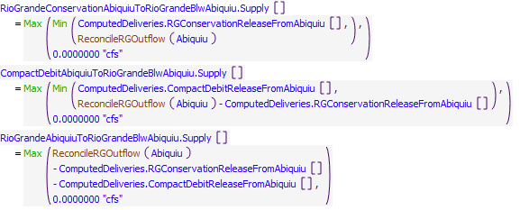
Execution Constraint
Referenced Functions
- ReconcileRGOutflow
- Min
- Max
- GetStartDate

26.2 CheckAbiquiuRGOutflow
Rule Purpose:
Aborts the simulation if the accounting supply for the release of Rio Grande water from the account at Abiquiu Reservoir was not set. This rule helps with debugging because a simulation will stop if the Rio Grande supply was not set and the problem and any missing input can be identified by backtracking in the calculations from the point in the simulation that the run aborted. NOTE THAT the problem is likely not directly related to the computation of the Rio Grande outflow but most likely due to some earlier aspect of the rules solution. This rule just forces the run to go ahead and stop, so the problem can be fixed.
Rule Logic: Execution Constraint logic is at end of explanation.
If the value for the RioGrandeAbiquiuToRioGrandeBlwAbiquiu.Supply is a NaN, the STOP_RUN command is used to stop the simulation, and the PRINT statement is used to print a comment to the Diagnostics Output window that the run stopped because the account slot value was not set.
This rule fires if the current timestep is greater than or equal to the beginning timestep for rulebased simulation as input by the model user to the RulebasedSimulationStartDate scalar slot in the ModelRunTypeTriggers data object.
Model slots written by rule:
None
List of key model objects with slots read by the rule or child functions:
1. ModelRunTypeTriggers
Log of when and how the rule has been modified (newest changes at the top):
Date: Who. What
2/28/19: Jesse Roach.Updated description and notes fields.
Statements
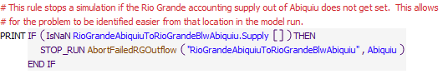
Execution Constraint
Referenced Functions
- AbortFailedRGOutflow
- GetStartDate

26.3 SetAbiquiuSJCAccountingSupplies
Rule Purpose:
This rule sets all the accounting supplies for deliveries of San Juan-Chama Project water from Abiquiu Reservoir. Values are set one-by-one based on the list of initial values and the companion list of supplies. Values are set in prioirity based on the matching order of the list of initial value and list of supplies. Deliveries may not be made for lower priority deliveries if some operational constraint restricted San Juan-Chama outflows from Abiqiuiu, but this is very rare in the simulations.
Rule Logic: Execution Constraint logic is at end of explanation.
An IF THEN statement is used first in the rule to identify if the final reconciled outflow of San Juan-Chama Project water determined with the user-defined ReconcileSJOutflow function is less than the previous determined outflow. If so, Print statements are used to print statements to the Diagnostics Output window that the full initial computed outflow could not be met, if Print statements are enabled in the Diagnostics Manager. A FOR DO statement is then used in the rule to set all the accounting supplies from a list of all supply slot names, at index 0, and the final determined deliveries, at index 1, as created with the user-defined AbiquiuPrioritizedSJCSuppliesAndValuesReconciliationCheck function. That function contains a list of all the accounting supplies from Abiquiu Reservoir for deliveries of San Juan-Chama Project water and a corresponding list of all the initial computed deliveries recorded to the ComputedDeliveries data object. A WHILE DO loop is then used in the function to loop through each supply in the order listed and set the deliveries while checking the cumulative release set so far within the function against the final total outflow of San Juan-Chama Project water. If the final total outflow of San Juan-Chama Project water, which is an input to the function, is less than the sum of the intial computed deliveries, deliveries included at the bottom of the listed supplies will be shorted in order from bottom up as needed.
This rule fires if the current timestep is greater than or equal to the beginning timestep for rulebased simulation as input by the model user to the RulebasedSimulationStartDate scalar slot in the ModelRunTypeTriggers data object and if the rule has not fired yet as determined with a reference to the predefined HasRuleFiredSuccessfully function.
Model slots written by rule:
45 supplies associated with SJC releases from Abiquiu
List of key model objects with slots read by the rule or child functions:
1. ModelRunTypeTriggers
2. Abiquiu
3. AbiquiuData
Log of when and how the rule has been modified (newest changes at the top):
Date: Who. What
2/28/19: Jesse Roach.Updated description and notes fields.
Statements
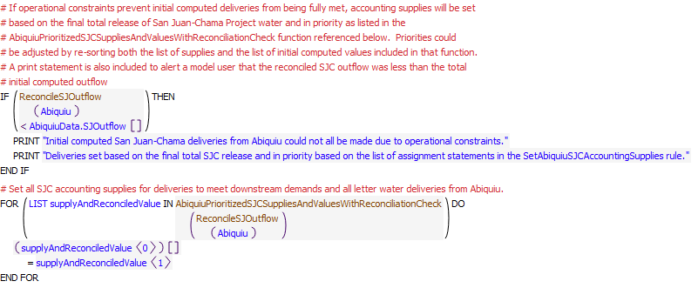
Execution Constraint
Referenced Functions
- AbiquiuPrioritizedSJCSuppliesAndValuesWithReconciliationCheck
- HasRuleFiredSuccessfully
- ReconcileSJOutflow
- GetStartDate

26.4 SetTransfersAtElephantButteForDeliveriesViaCombinedAccount
Rule Purpose:
URGWOM is set up to move water for contractors for San Juan-Chama Project water to Elephant Butte in a single chain of passthrough accounts (Currently, accounting supplies and rule are only set up for Albuquerque and Santa Fe City water to be moved to Elephant Butte, but other accounts could be set up in the same rule structure if ever needed). The configuration of using one set of passthrough accounts allows for fewer accounts and fewer slots to be used on the numerous objects along the mainstem of the Middle Rio Grande portion of URGWOM. This approach was used to reduce the model size and reduce memory requirements and simplify the model as possible. When water is moved through the single thread of passthrough accounts, the water is moved back to storage accounts for each contractor at Elephant Butte Reservoir with this rule. The transfer is set to the release minus San Juan-Chama losses between Abiquiu Dam and Elephant Butte Reservoir.
Rule Logic: Execution Constraint logic is at end of explanation.
Two assignment statements are included in this rule to set the CombinedElephantButteToAlbuquerqueElephantButte and CombinedElephantButteToSantaFeCityElephantButte transfer supplies to the value for the corresponding accounting supplies out of Abiquiu Reservoir for the Albuquerque and Santa Fe City deliveries to Elephant Butte multiplied by the San Juan-Chama loss rates. The user-defined SJCLoss function is used to identify the loss rate from Abiquiu to Cochiti. The loss rate for the delivery between Cochiti and Elephant Butte is actually computed with a user-defined accounting method, but the calculation is simplified here because the determined loss rate in the simulation, with consideration for the applied lags, can be referenced. The loss method for San Juan-Chama deliveries to Elephant Butte is applied on the SanFelipeToCentralSeepageArea2 reach object.
This rule fires if the current timestep is greater than or equal to the beginning timestep for rulebased simulation as input by the model user to the RulebasedSimulationStartDate scalar slot in the ModelRunTypeTriggers data object and if the rule has not fired yet as determined with a reference to the predefined HasRuleFiredSuccessfully function.
Model slots written by rule:
1. CombinedElephantButteToAlbuquerqueElephantButte.Supply
2. CombinedElephantButteToSantaFeCityElephantButte.Supply
List of key model objects with slots read by the rule or child functions:
1. ModelRunTypeTriggers
2. Abiquiu
3. AbiquiuData
Log of when and how the rule has been modified (newest changes at the top):
Date: Who. What
2/28/19: Jesse Roach.Updated description and notes fields.
Statements
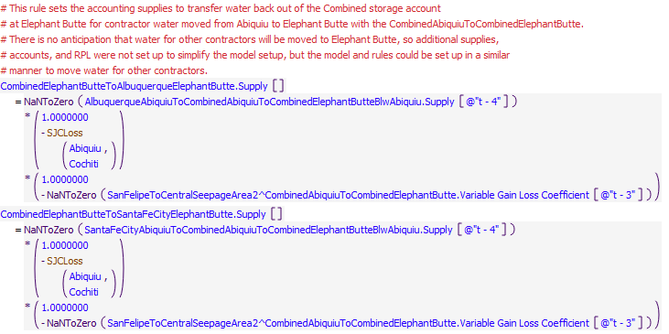
Execution Constraint
Referenced Functions
- HasRuleFiredSuccessfully
- SJCLoss
- GetStartDate

27 Cochiti and Jemez Deliveries
The rules in this policy group are used to determine whether storage at Cochiti Lake and Jemez Reservoir should be locked in as carryover storage per flood control operations, compute potential inflows to conservation storage, and compute the Rio Grande and San Juan releases from each reservoir.
Rules in the Group:
ComputeCochitiSJRelease
ComputeCochitiSJCPassthroughsToMRG
ComputeCochitiRGConservationRelease
ComputeJemezRGConservationRelease
SetJemezRGRelease
SetJemezRGConservationAccountInflow
SetJemezSJRelease
ComputeCochitiRGRelease
TallyCochitiConservationStorageInArticleVII
SetCochitiRGConservationAccountInflow
Cochiti and Jemez Locked In
Policy Group Change Log (newest changes at the top):
Date: Who. What

27.1 Cochiti and Jemez Locked In
Rule Purpose:
This rule sets a triggers to indicate the flood control storage at Cochiti Lake and Jemez Reservoir should be locked in storage until after the irrigation season. This policy effectively assures water stored during flood control operations is delivered to Elephant Butte Reservoir, as would have occurred during high flows. The storage is locked in if flows at Otowi drop below a low threshold before the stored flood control water can be evacuated.
Rule Logic: Execution Constraint logic is at end of explanation.
This rule includes three assignment statements. The functions referenced for these assignments are the same as those used for determining locked in storage at Abiquiu Reservoir. Refer to the discussion for the AbiquiuLockedIn rule for more information on the logic used in this rule. The LockedIn slot value for Jemez is set to 0.0 if a value is a NaN.
This rule fires if the current timestep is greater than or equal to the beginning timestep for rulebased simulation as input by the model user to the RulebasedSimulationStartDate scalar slot in the ModelRunTypeTriggers data object and if the rule has not fired yet as determined with a reference to the predefined HasRuleFiredSuccessfully function.
Model slots written by rule:
1. Cochiti.Locked In
2. Jemez.Locked In
List of key model objects with slots read by the rule or child functions:
1. ModelRunTypeTriggers
2. Cochiti
3. Jemez
4. Many model inflows
Log of when and how the rule has been modified (newest changes at the top):
Date: Who. What
2/28/19: Jesse Roach.Updated description and notes fields.
Statements
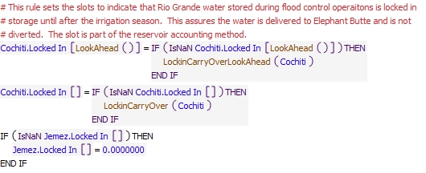
Execution Constraint
Referenced Functions
- LockinCarryOverLookAhead
- LookAhead
- LockinCarryOver
- HasRuleFiredSuccessfully
- GetStartDate

27.2 SetCochitiRGConservationAccountInflow
Rule Purpose:
If conservation storage at Cochiti Lake is being modeled, this rule sets the inflow to conservation storage. Conservation storage may be modeled as part of Cochiti Deviations or as a full time amount of space for conservation storage, if input, or BOTH. Native inflows are stored up to the designated amount of space for conservation storage as available above the amount needed for the MRGCD demand and for Middle Valley targets plus an additional amount of outflow input by the user before storage.
Rule Logic: Execution Constraint logic is at end of explanation.
The RioGrandeCochitiToRioGrandeConservationCochiti.Supply slot value for the current timestep is set with an IF THEN ELSE statement. If the value in the FullTimeRGConservationSpaceAvailableNotRelevantToDeviations table slot in the CochitiData data object is greater than zero or the value in the ComputedRGConservationSpaceAvailable slot for the current timestep is greater than zero and the current timestep is within the period for deviations storage, the value is set as the minimum of the result from the user-defined ComputeRGConsInflow function and the maximum inflow input to the MaxRGConservationInflow table slot in the AbiquiuData data object as identified with the user-defined MaxRGConservationInflow function. Within the ComputeRGConsInflow function, an IF THEN ELSE statement is used to check whether an inflow to conservation storage should be computed with the IsRGConservationAllowed function. If not, the function result is 0.0 cfs. If so, the inflow available for conservation storage is computed as the available native inflow determined with the user-defined RioGrandeInflowWithPreviousRGGainLoss function plus the value in the Incidental Content slot for the corresponding reservoir object at the previous timestep or any storage adjustment and determined carryover release amount for the reservoir minus a minimum reservoir outflow determined with the user-defined MinimumRioGrandeOutflowBeforeTransferToConservationStorage function which assures Middle Valley demands are met. The resulting inflow to conservation storage is restricted to the available space determined as the minimum of the results from the user-defined EasementSpaceAvailableAsFlow and RGConsSpaceAvailableAsFlow functions.
This rule fires if the current timestep is greater than or equal to the beginning timestep for rulebased simulation as input by the model user to the RulebasedSimulationStartDate scalar slot in the ModelRunTypeTriggers data object and if the RioGrandeCochitiToRioGrandeConservationCochiti.Supply slot value for the current timestep is a NaN.
Model slots written by rule:
1. RioGrandeCochitiToRioGrandeConservationCochiti.Supply
List of key model objects with slots read by the rule or child functions:
1. ModelRunTypeTriggers
2. CochitiData
3. CochitiDeviations
4. Cochiti
Log of when and how the rule has been modified (newest changes at the top):
Date: Who. What
2/28/19: Jesse Roach.Updated description and notes fields.
Statements
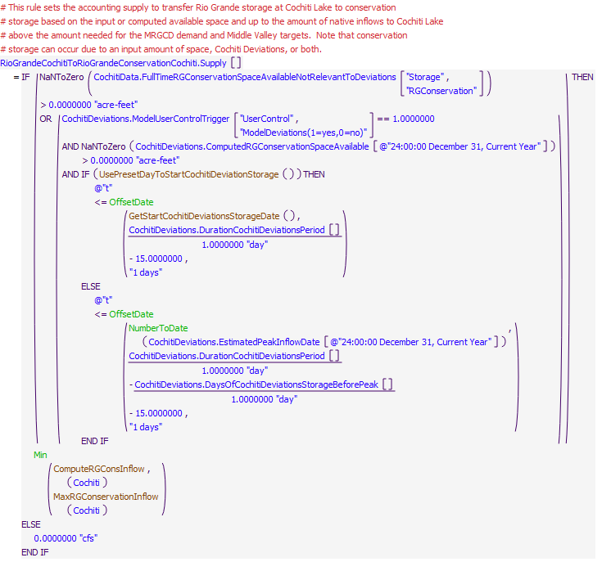
Execution Constraint
Referenced Functions
- GetStartCochitiDeviationsStorageDate
- ComputeRGConsInflow
- MaxRGConservationInflow
- UsePresetDayToStartCochitiDeviationStorage
- Min
- NumberToDate
- OffsetDate
- GetStartDate

27.3 TallyCochitiConservationStorageInArticleVII
Rule Purpose:
If water is stored as conservation storage at Cochiti Lake when Article VII is in effect, this water must be evacuated. Water stored for Cochiti Deviations is always evacuated after the Deviations operations is over, but if full time conservation storage is being modeled, water stored when Article VII was not in effect can be retained and used when needed for target flows. To model this aspect of operations, this rule tracks the amount of water stored while Article VII is in effect.
Rule Logic: Execution Constraint logic is at end of explanation.
The value for the SumConservationStorageWhileInArticleVII series slot for the current timestep is set to 0 if the current timestep is the start timestep or January 1. Otherwise, the value is set to the slot value at the previous timestep plus the value for the accounting supply for the transfer to the RioGrandeConservation account at Cochiti if the ArticleVII switch is equal to 1.0 and minus the value for the outflow from the RioGrandeConservation account at Cochiti.
This rule fires if it has not fired yet as determined with a reference to the predefined HasRuleFiredSuccessfully function.
Model slots written by rule:
1. CochitiDeviations.SumConservationStorageWhileInArticleVII
List of key model objects with slots read by the rule or child functions:
1. CochitiDeviations
2. RioGrandeCompact
Log of when and how the rule has been modified (newest changes at the top):
Date: Who. What
2/28/19: Jesse Roach.Updated description and notes fields.
Statements
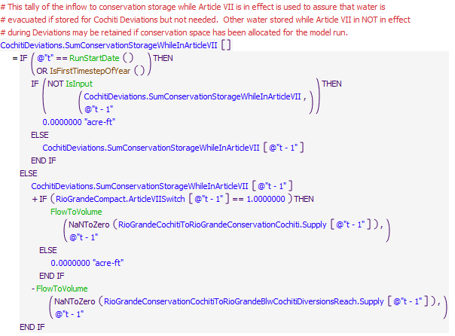
Execution Constraint
Referenced Functions
- IsFirstTimestepOfYear
- RunStartDate
- FlowToVolume
- IsInput
- HasRuleFiredSuccessfully

27.4 ComputeCochitiRGRelease
Rule Purpose:
This rule computes the preliminary value for the release of Rio Grande water at Cochiti Dam. The release is set to bypass inflows with any needed release from storage or adjustment from any potential storage during flood control operations and any potential non-irrigation season release of carrover storage from the irrigation season.
Rule Logic: Execution Constraint logic is at end of explanation.
The value for the RGOutflow time series slot in the CochitiData data object for the current timestep is set to the result from the user-defined CurrentRGInflow function plus the value for the Gain Loss for the Rio Grande account for the previous timestep as determined with the user-defined PreviousAccountGainLoss function plus the result from the user-defined CochitiRGStorageAdjustment function plus the result from the user-defined RGCarryOverRelease function and minus the value for the accounting supply for the current timestep for the transfer from the Rio Grande account into the RioGrandeConservation account. The result is restricted using the predefined Max function to assure it is at least equal to the input value in the MinRGOutflow periodic slot in the CochitiData data object as referenced with the user-defined MinRGOutflow function. The result is also checked against the physical restrictions of the outlet works using the user-defined CheckThisResPhysicalConstraints function.
The CurrentRGInflow function computes the Rio Grande inflow to Cochiti Lake as the value for the Inflow time series slot in the Cochiti storage reservoir object for the current timestep minus the sum of all the San Juan-Chama supplies into Cochiti as defined with the user-defined AllSJSuppliesIntoCochiti function. Within the RGCarryOverRelease function, if the criteria for a carry over release are NOT satisfied, the value is set to 0.0 cfs. Otherwise, the value in the RGCarryOverRelease time series slot in the CochitiData data object for the current timestep is referenced. If that value is a NaN, the function then references the user-defined ConstantRGCarryOverRelease function.
This rule fires if the current timestep is greater than or equal to the beginning timestep for rulebased simulation as input by the model user to the RulebasedSimulationStartDate scalar slot in the ModelRunTypeTriggers data object and if the value for the RGOutflow time series slot in the CochitiData data object for the current timestep is a NaN.
Model slots written by rule:
1. CochitiData.RGOutflow
List of key model objects with slots read by the rule or child functions:
1. ModelRunTypeTriggers
2. Cochiti
3. CochitiData
Log of when and how the rule has been modified (newest changes at the top):
Date: Who. What
2/28/19: Jesse Roach.Updated description and notes fields.
Statements
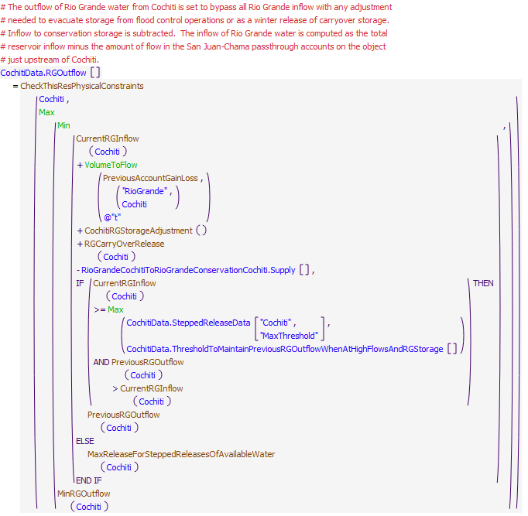
Execution Constraint
Referenced Functions
- CheckThisResPhysicalConstraints
- CochitiRGStorageAdjustment
- RGCarryOverRelease
- CurrentRGInflow
- MinRGOutflow
- PreviousRGOutflow
- MaxReleaseForSteppedReleasesOfAvailableWater
- Min
- Max
- VolumeToFlow
- PreviousAccountGainLoss
- GetStartDate

27.5 SetJemezSJRelease
Rule Purpose:
The San Juan release from Jemez is set to zero. URGWOM is not set up to model storage of San Juan-Chama Project water at Jemez Reservoir, but the rules structure is set up to potentially model storage and incorporate an exchange for storage of San Juan-Chama Project water at Jemez Reservoir. The release of San Juan-Chama water is now just set to zero.
Rule Logic: Execution Constraint logic is at end of explanation.
The value for the SJOutflow time series slot in the JemezData data object for the current timestep is set to 0.0 cfs.
This rule fires if the value for the SJOutflow time series slot in the JemezData data object for the current timestep is a NaN, the rule fires.
Model slots written by rule:
1. JemezData.SJOutflow
List of key model objects with slots read by the rule or child functions:
None
Log of when and how the rule has been modified (newest changes at the top):
Date: Who. What
2/28/19: Jesse Roach.Updated description and notes fields.
Statements
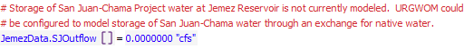
Execution Constraint

27.6 SetJemezRGConservationAccountInflow
Rule Purpose:
If conservation storage at Jemez Reservoir is being modeled, and inflows are available, this rule sets the inflow to conservation storage. Native inflows are stored up to the designated amount of space for conservation storage as available above the amount needed for the MRGCD demand and for Middle Valley targets plus an additional amount of outflow input by the user before storage. The amount needed from Jemez Reservoir for targets or the MRGCD demand is computed as the remaining amount needed for targets or the MRGCD demand out of Cochiti Lake that could not be met out of Cochiti.
Rule Logic: Execution Constraint logic is at end of explanation.
The RioGrandeJemezToRioGrandeConservationJemez.Supply slot for the current timestep is set to minimum of the result from the user-defined ComputeRGConsInflow function and the maximum inflow input to the MaxRGConservationInflow table slot in the JemezData data object as identified with the user-defined MaxRGConservationInflow function. Within the ComputeRGConsInflow function, an IF THEN ELSE statement is used to check whether an inflow to conservation storage should be computed with the IsRGConservationAllowed function. If not, the function result is 0.0 cfs. If so, the inflow available for conservation storage is computed as the available native inflow determined with the user-defined RioGrandeInflowWithPreviousRGGainLoss function plus the value in the Incidental Content slot for the corresponding reservoir object at the previous timestep minus a minimum reservoir outflow determined with the user-defined MinimumRioGrandeOutflowBeforeTransferToConservationStorage function which assures Middle Valley demands are met. The resulting inflow to conservation storage is restricted to the available space determined as the minimum of the results from the user-defined EasementSpaceAvailableAsFlow and RGConsSpaceAvailableAsFlow functions.
This rule fires if the current timestep is greater than or equal to the beginning timestep for rulebased simulation as input by the model user to the RulebasedSimulationStartDate scalar slot in the ModelRunTypeTriggers data object and if the value for the RioGrandeJemezToRioGrandeConservationJemez.Supply slot for the current timestep is a NaN.
Model slots written by rule:
1. RioGrandeJemezToRioGrandeConservationJemez.Supply
List of key model objects with slots read by the rule or child functions:
1. ModelRunTypeTriggers
2. Jemez
3. JemezData
Log of when and how the rule has been modified (newest changes at the top):
Date: Who. What
2/28/19: Jesse Roach.Updated description and notes fields.
Statements
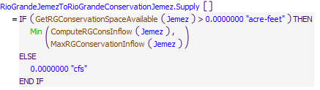
Execution Constraint
Referenced Functions
- GetRGConservationSpaceAvailable
- ComputeRGConsInflow
- MaxRGConservationInflow
- Min
- GetStartDate

27.7 SetJemezRGRelease
Rule Purpose:
This rule computes an initial value for the release of Rio Grande water at Jemez Canyon Dam as the sum of the inflow to the reservoir plus the amount of water in the Rio Grande storage account at Jemez Reservoir. If the amount of water in the storage account is negative, the outflow is set to the inflow multiplied by an input percentage such that the Rio Grande storage will return toward zero. The bypassed inflow is reduced for any transfer to conservation storage at Jemez Reservoir. The reference to storage includes consideration for modeled sedimentation.
Rule Logic: Execution Constraint logic is at end of explanation.
The value for the RGOutflow time series slot in the JemezData data object for the current timestep is set to the result from the user-defined JemezRGOutflow function minus the value for the accounting supply for any transfer to conservation storage at Jemez Reservoir. An IF THEN ELSE statement in the JemezRGOutflow function is used to see if the value for the inflow is less than or equal to zero and if the value for the previous account storage is less than or equal to zero. If so, the function result is set to 0.0 cfs. Otherwise, a second IF THEN ELSE statement is used to see if the current inflow is greater than zero and the previous account storage is less than zero. If so, the result is set to the value for the inflow multiplied by the value in the PercentRGReleaseWhenNegRGStorage table slot in the JemezData data object. Otherwise, the result is set to the inflow plus the previous account storage. The references to the previou storage are adjusted for modeled sedimentation.
This rule fires if the current timestep is greater than or equal to the beginning timestep for rulebased simulation as input by the model user to the RulebasedSimulationStartDate scalar slot in the ModelRunTypeTriggers data object and if the value for the RGOutflow time series slot in the JemezData data object for the current timestep is a NaN.
Model slots written by rule:
1. JemezData.RGOutflow
List of key model objects with slots read by the rule or child functions:
1. ModelRunTypeTriggers
2. Jemez
Log of when and how the rule has been modified (newest changes at the top):
Date: Who. What
2/28/19: Jesse Roach.Updated description and notes fields.
Statements
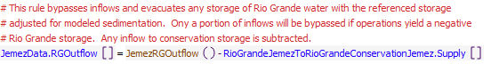
Execution Constraint
Referenced Functions
- JemezRGOutflow
- GetStartDate

27.8 ComputeJemezRGConservationRelease
Rule Purpose:
If conservation storage at Jemez Reservoir is being modeled, water is released from conservation storage as needed for targets and based on the magnitude of additional flow needed at Cochiti after considering all contributions out of Cochiti Lake. Water is only released from conservation storage at Jemez Reservoir within a user input season for conservation storage releases. The release is checked against a maximum release rate and against the available supply of conservation storage.
Rule Logic: Execution Constraint logic is at end of explanation.
If a value is not input as checked with reference to the predefined IsInput function, the RGConservationReleaseFromJemez series slot in the ComputedDeliveries data object for the current timestep is computed if the current timestep is within the period for a release based on the dates input to the RGConservationReleaseDays table slot in the JemezData data object. For other periods, the release is set to 0.0 cfs. The computed release is set to zero if the previous storage in the RioGrandeConservation account at Cochiti is greater than 10 acre-ft or otherwise the value is set to the MinReleaseNeededAtCochiti minus the bypassed inflow at Cochiti. The predefined Max function is used to increase the release to the constant release to evacuate the storage over the input delivery period, if that release rate is higher, as computed with the user-defined ComputeConstantAbiquiuRGConservationRelease function. The computed release is restricted with the predefined MinItem function to the available conservation storage at Jemez Reservoir and the value in the MaxESARelease periodic slot in the JemezData data object.
This rule fires if the current timestep is greater than or equal to the beginning timestep for rulebased simulation as input by the model user to the RulebasedSimulationStartDate scalar slot in the ModelRunTypeTriggers data object and if the value for the RGConservationReleaseFromJemez series slot in the JemezData data object for the current timestep is a NaN.
Model slots written by rule:
1. ComputedDeliveries.RGConservationReleaseFromJemez
List of key model objects with slots read by the rule or child functions:
1. MiddleValleyTargets
2. JemezData
3. Jemez
4. ComputedDeliveries
Log of when and how the rule has been modified (newest changes at the top):
Date: Who. What
2/28/19: Jesse Roach.Updated description and notes fields.
Statements
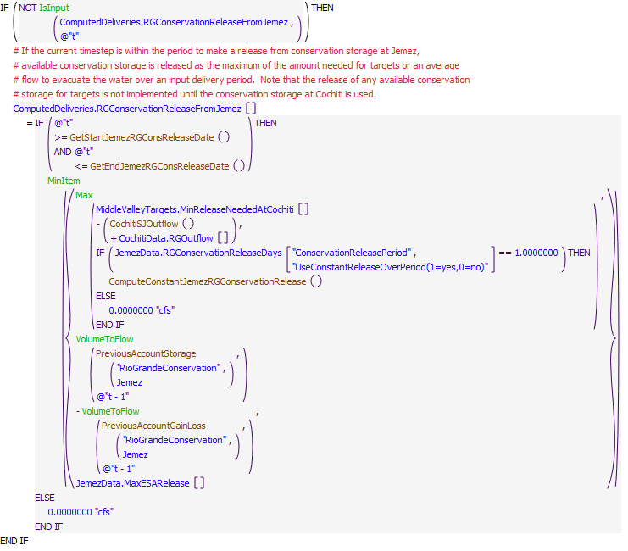
Execution Constraint
Referenced Functions
- GetEndJemezRGConsReleaseDate
- GetStartJemezRGConsReleaseDate
- ComputeConstantJemezRGConservationRelease
- CochitiSJOutflow
- MinItem
- Max
- VolumeToFlow
- IsInput
- PreviousAccountGainLoss
- GetStartDate
- PreviousAccountStorage

27.9 ComputeCochitiRGConservationRelease
Rule Purpose:
If conservation storage at Cochiti is being modeled as part of Cochiti Deviations or as full time conservation storage or BOTH, a release from conservation storage is computed to release the amount needed for Middle Valley targets or as a constant release to evacuate conservation storage if scheduled based on model user inputs. The release is restricted to the available supply of conservation storage. For Deviations, releases are set to provide recruitment or overbank flows depending on which operation is targeted based on established criteria. Releases are set to provide a peak release at the same time as the peak inflow. Releases may also be set to assure water is evacuated from conservation storage by the end of an input Deviations period. Any water that may be stored based on an input amount of conservation storage space will be released as needed for targets before water from upstream sources is used (e.g. Emergency Drought water for ESA or Reclamation leased San Juan-Chama Project water). Water stored for Deviations not needed for targets is evacuated at the end of the deviations period down to an input amount of regular conservation space or if it was stored while Article VII was in effect.
Rule Logic: Execution Constraint logic is at end of explanation.
A preliminary release from conservation storage at Cochiti Lake is computed using a WITH DO statement as the value in the MinReleaseNeededAtCochiti series slot in the MiddleValleyTargets data object for the current timestep minus the bypassed inflow at the current timestep estimated as the outflow of San Juan-Chama Project water plus the value in the RGOutflow series slot in the CochitiData data object for the current timestep. That release is also restricted to the available storage in the RioGrandeConservation account at Cochiti and the input value in the MaxESARelease periodic slot in the CochitiDeviations table slot. An IF THEN ELSE statement is used to also determine if conservation storage should be evacuated. If the previous storage in the RioGrandeConservation account is greater than the input value to the FullTimeRGConservationSpaceAvailableNotRelevantToDeviations table slot or the value in the SumConservationStorageWhileInArticleVII series slot for the current timestep and the current timestep is within 15 days of the end of the Cochiti Deviations period, the release is then set to the maximum of the preliminary value computed as needed for targets or the amount needed to evacuate the excess water by the end of the deviations period as computed with the user-defined ReleaseToEvacuateDeviationsRGConservationStorage function. Otherwise, the release is set to the amount needed for targets not to be less than 0.0.
This rule fires if the current timestep is greater than or equal to the beginning timestep for rulebased simulation as input by the model user to the RulebasedSimulationStartDate scalar slot in the ModelRunTypeTriggers data object and if the value for the RGConservationRelease time series slot for the current timestep is a NaN.
Model slots written by rule:
1. CochitiDeviations.RGConservationRelease
List of key model objects with slots read by the rule or child functions:
1. MiddleValleyTargets
2. ComputedDeliveries
3. CochitiData
4. Cochiti
5. CochitiDeviations
6. Jemez
Log of when and how the rule has been modified (newest changes at the top):
Date: Who. What
2/28/19: Jesse Roach.Updated description and notes fields.
11/10/17 JR: MRG timestep generalization work in 2015 that mostly didn't get into ruleset appears to have gotten in here as the check for timestep <= 1 day already here.
Statements
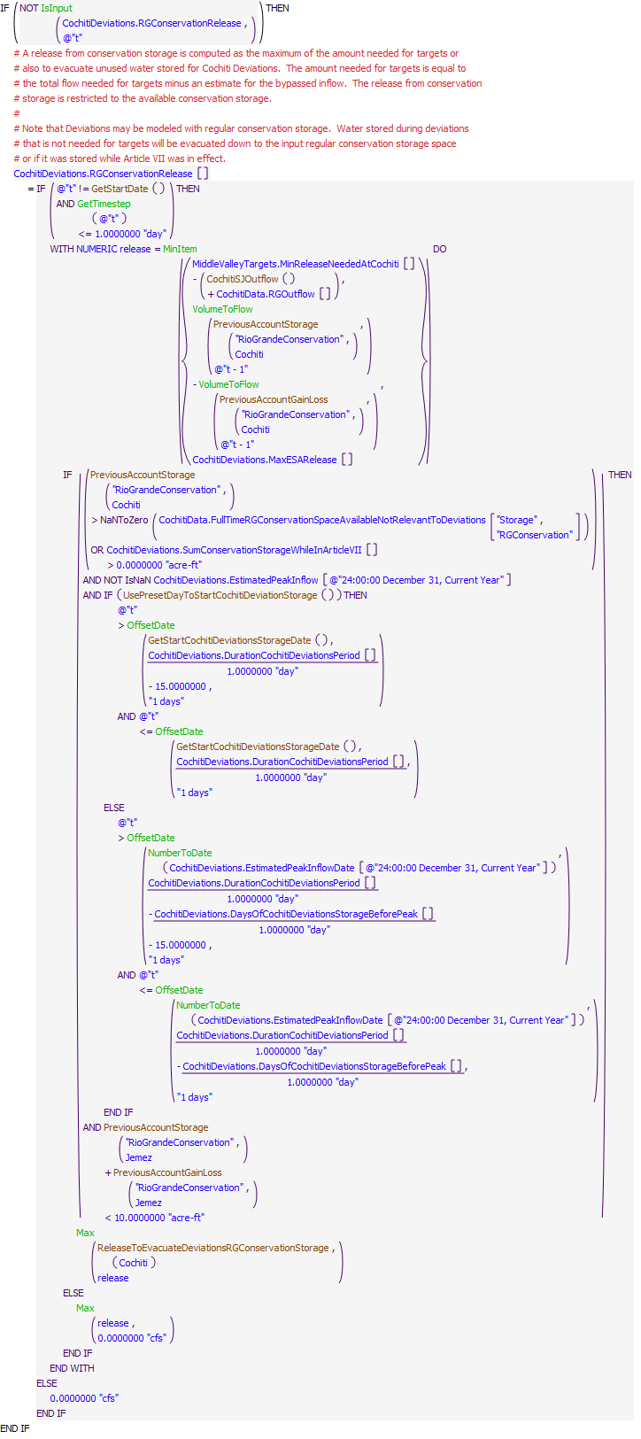
Execution Constraint
Referenced Functions
- GetStartCochitiDeviationsStorageDate
- ReleaseToEvacuateDeviationsRGConservationStorage
- UsePresetDayToStartCochitiDeviationStorage
- CochitiSJOutflow
- MinItem
- Max
- NumberToDate
- GetTimestep
- OffsetDate
- VolumeToFlow
- IsInput
- PreviousAccountGainLoss
- GetStartDate
- PreviousAccountStorage

27.10 ComputeCochitiSJCPassthroughsToMRG
Rule Purpose:
This rule computes the passthroughs at Cochiti Lake for San Juan-Chama Project water being delivered to the Albuquerque surface water diversion, MRGCD diversions, Reclamation leased San Juan-Chama Project water for targets, or contractor deliveries to Elephant Butte. Thesei passthroughs of SJC water are calculated based on Abiquiu releases and losses between Abiquiu Dam and Cochiti Lake. Temporary storage may occur on passthrough accounts at Cochiti Lake due to operational constraints, so this rule also releases any water that remains "trapped" in storage frome previous timestep(s).
Rule Logic: Execution Constraint logic is at end of explanation.
Four assignment statements are included in this rule for computing the Cochiti passthroughs for the corresponding series slots on the ComputedDeliveries data object. If values are not input as checked with the predefined IsInput function, values for each passthrough delivery are set to the corresponding accounting supply out of Abiquiu at the previous timestep (per the one day lag from Abiquiu to Cochiti) adjusted for the San Juan-Chama loss rate from Abiquiu to Cochiti as input to the Losses table slot in the SanJuanChamaRules data object and identified with the user-defined SJCLoss function. The computed deliveries are adjusted for any potential storage on the passthrough accounts at Cochiti.
This rule fires if the current timestep is greater than or equal to the beginning timestep for rulebased simulation as input by the model user to the RulebasedSimulationStartDate scalar slot in the ModelRunTypeTriggers data object and if the rule has not fired yet as determined with a reference to the predefined HasRuleFiredSuccessfully function.
Model slots written by rule:
1. ComputedDeliveries.AlbuquerqueDeliveryToSurfaceWaterDiversionPassthroughAtCochiti
2. ComputedDeliveries.MRGCDSJCDeliveryToMiddleRioGrandePassthroughAtCochiti
3. ComputedDeliveries.ReclamationPassthroughAtCochiti
4. ComputedDeliveries.CombinedPassthroughAtCochiti
List of key model objects with slots read by the rule or child functions:
1. ModelRunTypeTriggers
2. SanJuanChamaRules
3. Cochiti
Log of when and how the rule has been modified (newest changes at the top):
Date: Who. What
3/1/19: Jesse Roach.Updated description and notes fields.
11/10/17 JR: updated during MRG timestep generalization. Where t-1 implies days (flows), generalized. Where t-1 implies timesteps (storage), unchanged.
Statements
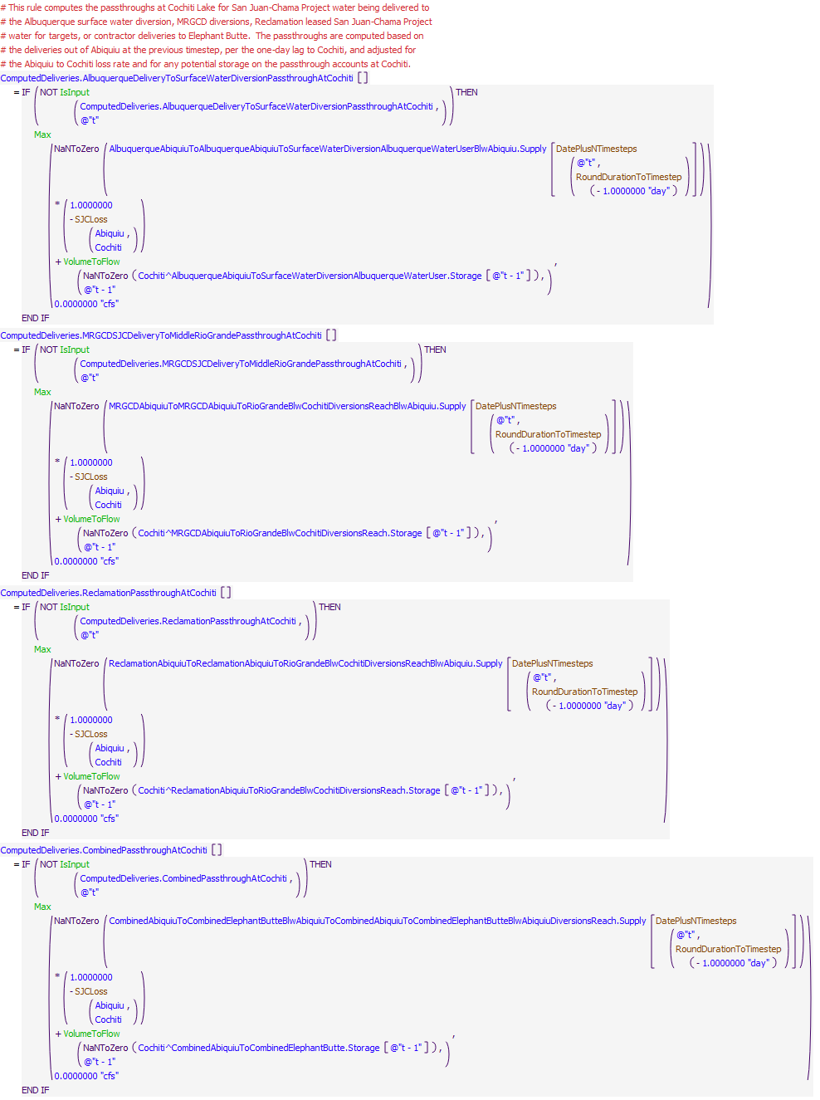
Execution Constraint
Referenced Functions
- DatePlusNTimesteps
- RoundDurationToTimestep
- Max
- VolumeToFlow
- IsInput
- HasRuleFiredSuccessfully
- SJCLoss
- GetStartDate

27.11 ComputeCochitiSJRelease
Rule Purpose:
A total release of San Juan-Chama Project water from Cochiti Lake is computed as a summation of the individual deliveries for each San Juan-Chama contractor. The delivery at Cochiti consists entirely of a passthrough of deliveries to Elephant Butte, the Albuquerque diversion, MRGCD diversionsr, or for Reclamation water for targets. All San Juan-Chama inflows to Cochiti except for Rec Pool water is bypassed.
Rule Logic: Execution Constraint logic is at end of explanation.
The value for the SJOutflow time series slot on the CochitiData data object for the current timestep is computed as an addition of all the computed individual deliveries out of Cochiti in the corresponding series slots in the ComputedDeliveries data object.
This rule fires if the current timestep is greater than or equal to the beginning timestep for rulebased simulation as input by the model user to the RulebasedSimulationStartDate scalar slot in the ModelRunTypeTriggers data object and if the value for the SJOutflow time series slot in the CochitiData data object for the current timestep is a NaN.
Model slots written by rule:
1. CochitiData.SJOutflow
List of key model objects with slots read by the rule or child functions:
1. ModelRunTypeTriggers
2. ComputedDeliveries
Log of when and how the rule has been modified (newest changes at the top):
Date: Who. What
3/1/19: Jesse Roach.Updated description and notes fields.
Statements
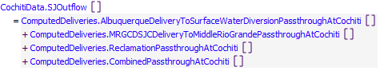
Execution Constraint
Referenced Functions
- GetStartDate

28 Cochiti and Jemez Reservoir Operations
The rules in this policy group are used to determine the total outflow from Cochiti Dam and Jemez Canyon Dam with consideration for downstream target flows, downstream channel capacities, stepped release restrictions, and flood control operations. Policy for balanced operations between Cochiti Dam and Jemez Canyon Dam for flood control operations is also checked.
Rules in the Group:
ComputeRGCarryOver
CochitiFloodControl
CochitiWCMBalancedRelease
JemezSteppedRelease
CochitiSteppedRelease
CochitiChannelCapacityRestrictions
JemezSanMarcialChannelCapacity
SanMarcialChannelCapacityRule
CentralChannelCapacityRule
JemezOutflow
CochitiOutflow
Policy Group Change Log (newest changes at the top):
Date: Who. What

28.1 CochitiOutflow
Rule Purpose:
Unless a total outflow for Cochiti Dam has been input for the current timestep, the value is set to bypass all inflows except Cochiti Rec Pool deliveries and potential transfers to conservation storage. Adjustments for incidental content and any winter release of carryover storage is also added, and the outflow is checked against the physical constraints of the outlet works.
Rule Logic: Execution Constraint logic is at end of explanation.
This rule contains an IF THEN ELSE statement to see if the value in the TotalOutflowDirectlyInputToOverrideRules time series slot in the CochitiData data object for the current timestep as referenced using the user-defined TotalOutflow function is a NaN. If not, the value for the Outflow time series slot in the Cochiti storage reservoir object for the current timestep is set to that input TotalOutflowDirectlyInputToOverrideRules value. Otherwise, the value for the Outflow slot is set to the result from the user-defined InitialCochitiOutflow function which sets the outflow to the sum of the computed Rio Grande outflow in the RGOutflow series slot on the CochitiData data object and the total San Juan-Chama outflow in the SJOutflow series slot on the CochitiData data object plus the computed release from conservation storage in the RGConservationRelease series slot in the CochitiDeviations data object. The predefined Max function is used to assure the minimum Rio Grande outflow is maintatined.
Within the rule, the result for the Outflow is checked against the physical restrictions of the outlet works using the user-defined CheckThisResPhysicalConstraints function.
This rule fires if the current timestep is greater than or equal to the beginning timestep for rulebased simulation as input by the model user to the RulebasedSimulationStartDate scalar slot in the ModelRunTypeTriggers data object and if the value for the Outflow time series slot in the Cochiti storage reservoir object for the current timestep is a NaN.
Model slots written by rule:
1. Cochiti.Outflow
List of key model objects with slots read by the rule or child functions:
1. ModelRunTypeTriggers
2. Cochiti
3. CochitiData
4. CochitiDeviations
Log of when and how the rule has been modified (newest changes at the top):
Date: Who. What
3/1/19: Jesse Roach.Updated description and notes fields.
Statements
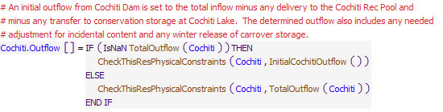
Execution Constraint
Referenced Functions
- CheckThisResPhysicalConstraints
- TotalOutflow
- InitialCochitiOutflow
- GetStartDate

28.2 JemezOutflow
Rule Purpose:
Unless a total outflow for Jemez Canyon Dam has been input for the current timestep, the value is set to the sum of the predetermined Rio Grande and San Juan-Chama outflows and including any release from conservation storagte. The resulting total release is checked to see if it is physically legitimate based on the outlet works, and if not, the release is reset to reflect the restriction for the given outlet works.
Rule Logic: Execution Constraint logic is at end of explanation.
This rule contains an exterior IF THEN ELSE statement to see if the value in the TotalOutflowDirectlyInputToOverrideRules time series slot in the JemezData data object for the current timestep as referenced with the user-defined TotalOutflow function is a NaN. If not, the value for the Outflow time series slot in the Jemez storage reservoir object for the current timestep is set to that input TotalOutflowDirectlyInputToOverrideRules value. Otherwise, the outflow is set to the value in the RGOutflow series slot on the JemezData data object for the current timestep plus the value in the SJOutflow series slot on the same data object for the current timestep plus the value for the RGConservationReleaseFromJemez series slot on the ComputedDeliveries data object for the current timestep.
Within the rule, the result for the Outflow is checked against the physical restrictions of the outlet works using the user-defined CheckThisResPhysicalConstraints function.
This rule fires if the current timestep is greater than or equal to the beginning timestep for rulebased simulation as input by the model user to the RulebasedSimulationStartDate scalar slot in the ModelRunTypeTriggers data object and if the value for the Outflow time series slot in the Jemez storage reservoir object for the current timestep is a NaN.
Model slots written by rule:
1. Jemez.Outflow
List of key model objects with slots read by the rule or child functions:
1. ModelRunTypeTriggers
2. Jemez
3. JemezData
4. ComputedDeliveries
Log of when and how the rule has been modified (newest changes at the top):
Date: Who. What
3/1/19: Jesse Roach.Updated description and notes fields.
Statements
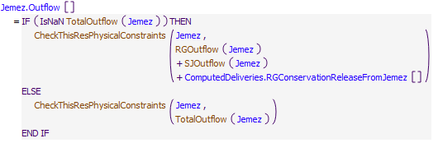
Execution Constraint
Referenced Functions
- CheckThisResPhysicalConstraints
- TotalOutflow
- RGOutflow
- SJOutflow
- GetStartDate

28.3 CentralChannelCapacityRule
Rule Purpose:
The maximum outflow from Cochiti Dam to maintain flows at Central below the channel capacity at Central is determined and recorded with this rule.
Rule Logic: Execution Constraint logic is at end of explanation.
The value for the MaxReleaseForCentralChannelCap time series slot in the CochitiData data object for the current timestep is set to the result from the user-defined CochitiReleaseForCentralChannelCapacity function. This function uses the predefined HypTargetSimWithStatus function to determine the required outflow from Cochiti Dam (or the value for the Inflow time series slot for the BlwCochitiDiversionsReach reach object) to yield the channel capacity at Central (or the Gage Inflow time series slot in the Central stream gage object) at the next timestep equal to the input value in the CentralChannelCapacity periodic slot in the CochitiData data object. The function completes the hypothetical simulation for all the objects in the BlwCochitiToCentralTarget subbasin, and for the input bounds for the hypothetical simulation, the lower bound is set to the channel capacity minus 1000 cfs or the minimum outflow and the upper bound is set to the maximum outflow from Cochiti Dam as input to the maxRelease column of the ReservoirData table slot in the CochitiData data object. The tolerance is input to the CentralChannelCapacity periodic slot in the CochitiData data object. The release from Jemez Canyon Dam (or the value for the Gage Inflow time series slot in the BlwJemez stream gage object) is assumed to equal the Inflow to Jemez as identified with the user-defined JemezInflowInputs function.
This rule fires if the current timestep is greater than or equal to the beginning timestep for rulebased simulation as input by the model user to the RulebasedSimulationStartDate scalar slot in the ModelRunTypeTriggers data object and if the value for the MaxReleaseForCentralChannelCap time series slot in the CochitiData data object for the current timestep is a NaN and if the EstimatedCochitiInflowAvailableForMiddleValley slot value is greater than half of either the channel capacity at Central or at San Marcial.
Model slots written by rule:
1. CochitiData.MaxReleaseForCentralChannelCap
List of key model objects with slots read by the rule or child functions:
1. ModelRunTypeTriggers
2. CochitiData
3. MRGCD
4. Cochiti
5. All objects between Cochiti and Central for hypothetical simulation
Log of when and how the rule has been modified (newest changes at the top):
Date: Who. What
3/1/19: Jesse Roach.Updated description and notes fields.
Statements
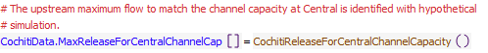
Execution Constraint
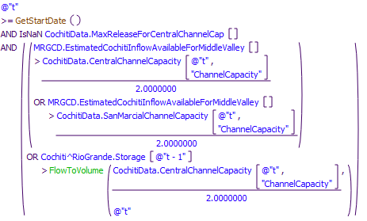
Referenced Functions
- CochitiReleaseForCentralChannelCapacity
- FlowToVolume
- GetStartDate

28.4 SanMarcialChannelCapacityRule
Rule Purpose:
This rule uses hypothetical simulation to determine the maximum release from Cochiti Dam possible without exceeding either the channel capacity at San Marcial or the maximum computed inflow to Elephant Butte to prevent an Elephant Butte release greater than the channel capacity below Elephant Butte.
Rule Logic: Execution Constraint logic is at end of explanation.
The value for the MaxReleaseForSanMarcialChannelCap time series slot in the CochitiData data object for the current timestep is set to the result from the user-defined CochitiReleaseForSanMarcialChannelCapacity function. This function uses the predefined HypTargetSimWithStatus function to determine the required outflow from Cochiti Dam (or the value for the Inflow time series slot for the BlwCochitiDiversionsReach reach object) to yield the minimum of the channel capacity at San Marcial (or the Gage Inflow time series slot in the SanMarcialFloodway stream gage object) at the timestep after the next timestep equal to the input value in the SanMarcialChannelCapacity periodic slot in the CochitiData data object or the inflow to Elephant Butte to keep the Elephant Butte outflow below the channel capacity below Elephant Butte as identified with the predefined SolveInflow function. The CochitiReleaseForSanMarcialChannelCapacity function completes the hypothetical simulation for all the objects in the BlwCochitiToSanMarcialTarget subbasin, and for the input bounds for the hypothetical simulation, the lower bound is set to the channel capacity minus 1000 cfs or the minimum outflow and the upper bound is set to the maximum outflow from Cochiti Dam as input to the maxRelease column of the ReservoirData table slot in the CochitiData data object. The tolerance is input to the SanMarcialChannelCapacity periodic slot in the CochitiData data object. The release from Jemez Canyon Dam (or the value for the Gage Inflow time series slot in the BlwJemez stream gage object) is assumed to equal the Inflow to Jemez as identified with the user-defined JemezInflowInputs function.
This rule fires if the current timestep is greater than or equal to the beginning timestep for rulebased simulation as input by the model user to the RulebasedSimulationStartDate scalar slot in the ModelRunTypeTriggers data object and if the value for the MaxReleaseForSanMarcialChannelCap time series slot in the CochitiData data object for the current timestep is a NaN and if the EstimatedCochitiInflowAvailableForMiddleValley slot value is greater than half of either the channel capacity at Central or at San Marcial.
Model slots written by rule:
1. CochitiData.MaxReleaseForSanMarcialChannelCap
List of key model objects with slots read by the rule or child functions:
1. ModelRunTypeTriggers
2. CochitiData
3. MRGCD
4. Cochiti
5. All objects between Cochiti and SanMarcial for hypothetical simulation
Log of when and how the rule has been modified (newest changes at the top):
Date: Who. What
3/1/19: Jesse Roach.Updated description and notes fields.
Statements
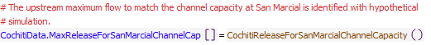
Execution Constraint
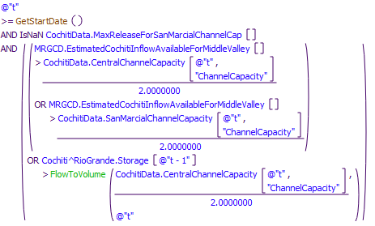
Referenced Functions
- CochitiReleaseForSanMarcialChannelCapacity
- FlowToVolume
- GetStartDate

28.5 JemezSanMarcialChannelCapacity
Rule Purpose:
This rule sets the maximum release possible from Jemez without exceeding either the channel capacity at San Marcial or the maximum computed inflow to Elephant Butte to prevent an Elephant Butte release greater than the channel capacity below Elephant Butte.
Rule Logic: Execution Constraint logic is at end of explanation.
When the rule fires, the value for the MaxReleaseForSanMarcialChannelCap time series slot in the JemezData data object for the current timestep is simply set equal to the value in the MaxReleaseForSanMarcialChannelCap time series slot in the CochitiData data object for the same timestep.
This rule fires if the current timestep is greater than or equal to the beginning timestep for rulebased simulation as input by the model user to the RulebasedSimulationStartDate scalar slot in the ModelRunTypeTriggers data object and if the value for the MaxReleaseForSanMarcialChannelCap time series slot in the JemezData data object for the current timestep is a NaN and if the EstimatedCochitiInflowAvailableForMiddleValley slot value is greater than half of either the channel capacity at Central or at San Marcial.
Comment:
The maximum release from Jemez and Cochiti for the San Marcial and Elephant Butte constraints are the same. This information is combined in subsequent flood control rules to set the release from both reservoirs in combination.
Model slots written by rule:
1. JemezData.MaxReleaseForSanMarcialChannelCap
List of key model objects with slots read by the rule or child functions:
1. ModelRunTypeTriggers
2. JemezData
3. CochitiData
4. MRGCD
Log of when and how the rule has been modified (newest changes at the top):
Date: Who. What
3/1/19: Jesse Roach.Updated description and notes fields.
Statements
Execution Constraint
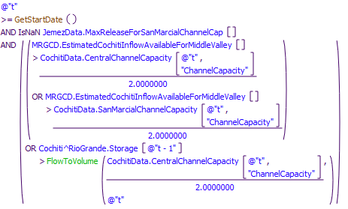
Referenced Functions
- FlowToVolume
- GetStartDate

28.6 CochitiChannelCapacityRestrictions
Rule Purpose:
This rule resets the outflow from Cochiti Dam and Jemez Canyon Dam to comply with the downstream channel capacities at Central and San Marcial if necessary. An indicator slot value is also set to identify for the model user which downstream channel capacity is controlling the release: 1 Central, 2 San Marcial, 3 below Elephant Butte.
Rule Logic: Execution Constraint logic is at end of explanation.
If the execution constraints are satisfied, three assignments are made in this rule. The value for the Outflow time series slot in the Cochiti storage reservoir object is set to the minimum of the values for the MaxReleaseForCentralChannelCap and MaxReleaseForSanMarcialChannelCap time series slots in the CochitiData data object as determined with the user-defined CochitiReleaseForChannelCapacity function minus the result for the user-defined JemezFloodRelease function.
For the second assignment, the value for the Outflow time series slot in the Jemez storage reservoir object is set to the result for the user-defined JemezFloodRelease function. This function sets the Jemez release equal to the result from the user-defined CochitiReleaseForChannelCapacity function multiplied by the storage space at Jemez Reservoir as determined with the user-defined AvailableStorage function divided by the total storage space at both Jemez Reservoir and Cochiti Lake. The predefined Min function is used to assure the release is no greater than the value in the Inflow time series slot at Jemez Reservoir plus the storage in the Rio Grande account at Jemez Reservoir at the previous timestep as determined with the user-defined PreviousAccountStorage function and converted to a flow using the predefined VolumeToFlow function.
For both of the previous assignments, the result for the Outflow is checked against the physical restrictions of the outlet works for the corresponding dam using the user-defined CheckThisResPhysicalConstraints function (Refer to Section B.27.2.1).
For the third assignment statement, the value in the ChannelCapacityOpsFlag series slot in the CochitiData data object is set to 1.0 if the max release for Central is less than the max release for San Marcial, and 2.0 if channel capacity at San Marcial is less than the inflow to Elephant Butte to keep the Elephant Butte outflow below the channel capacity below Elephant Butte. Otherwise, the value is set to 3.0.
This rule fires if the current timestep is greater than or equal to the beginning timestep for rulebased simulation as input by the model user to the RulebasedSimulationStartDate scalar slot in the ModelRunTypeTriggers data object and if the rule has not already fired for the current timestep as checked with reference to the predefined HasRuleFiredSuccessfully function and if the EstimatedCochitiInflowAvailableForMiddleValley slot value is greater than half of either the channel capacity at Central or at San Marcial and if the sum of the values in the Outflow time series slots in the Cochiti and Jemez storage reservoir objects is greater than the minimum of the values for the MaxReleaseForCentralChannelCap and MaxReleaseForSanMarcialChannelCap time series slots in the CochitiData data object as determined with the user-defined CochitiReleaseForChannelCapacity function.
Model slots written by rule:
1. Cochiti.Outflow
2. Jemez.Outflow
3. CochitiData.ChannelCapacityOpsFlag
List of key model objects with slots read by the rule or child functions:
1. ModelRunTypeTriggers
2. JemezData
3. CochitiData
4. Cochiti
5. Jemez
Log of when and how the rule has been modified (newest changes at the top):
Date: Who. What
3/1/19: Jesse Roach.Updated description and notes fields.
Statements
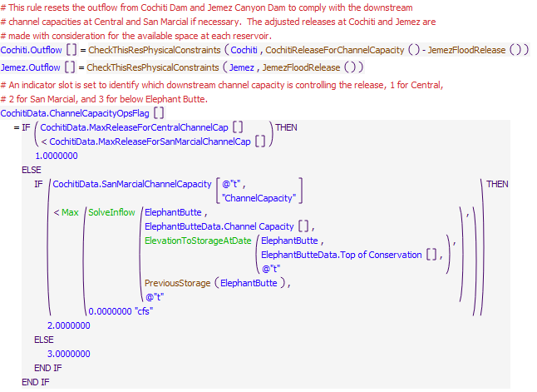
Execution Constraint
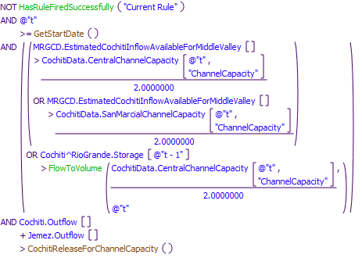
Referenced Functions
- CheckThisResPhysicalConstraints
- CochitiReleaseForChannelCapacity
- JemezFloodRelease
- Max
- SolveInflow
- ElevationToStorageAtDate
- FlowToVolume
- HasRuleFiredSuccessfully
- GetStartDate
- PreviousStorage

28.7 CochitiSteppedRelease
Rule Purpose:
The outflow from Cochiti Dam may be reset to assure increasing or decreasing releases are stepped if needed. This rule determines whether stepped releases are required, and if so, computes the release from Cochiti. Note that the stepped release policy is not implemented if the target flow at Central is increasing such that stepped releases do not conflict with Cochiti Deviations. Stepped release policy may result in negative Rio Grande account storage if there is not enough native water in storage to maintain higher releases for a step down. For such cases, the resulting negative Rio Grande account storage effectively represents a debt by the Rio Grande account to all other accounts. That debt is effectively paid back when Rio Grande water is recaptured after stepped releases are over to return the Rio Grande account storage to zero. A switch can also be set by the model user to restrict stepped release rates from causing the Rio Grande account storage from going negative.
Rule Logic: Execution Constraint logic is at end of explanation.
If the execution constraints are satisfied, the value in the Outflow time series slot in the Cochiti storage reservoir object for the current timestep is reset using an IF THEN ELSE statement. If the model user has input a value of 1.0 to the RestrictSteppedReleasesToAvailableNativeSupply(1=Yes,0=No) column in the SteppedReleaseData table slot on the CochitiData data object and the result from the DetermineSteppedRelease function indicates a higher release than the value computed with the user-defined MaximumAvailableToPreventNegativeRioGrandeStorage function, the result from that latter MaximumAvailableToPreventNegativeRioGrandeStorage function is used. Otherwise, the release is reset to the result from the user-defined DetermineSteppedRelease function.
The DetermineSteppedRelease function includes an exterior IF THEN ELSE statement to see if the outflow from Cochiti Dam is increasing as determined using the user-defined OutflowIsIncreasing function. If so, the outflow is calculated with the user-defined ComputeOutflowIncrSteppedRelease function. If not, the outflow is computed using the user-defined ComputeOutflowDecrSteppedRelease function unless it is determined that the release should be shutoff.
The resulting outflow is checked against the physical restrictions of the outlet works using the user-defined CheckThisResPhysicalConstraints function.
This rule fires if the rule has not fired as checked against the predefined HasRuleFiredSuccessfully function and if the current timestep is greater than the beginning timestep for rulebased simulation as input by the model user to the RulebasedSimulationStartDate scalar slot in the ModelRunTypeTriggers data object and if the result from the user-defined SteppedReleaseIsNeeded function is TRUE. The SteppedReleaseIsNeeded function includes three separate functions to check the change to the outflow as computed using the user-defined ComputeDeltaOutflow function against different criteria. Also, the rule only fires when the Central target flow is not increasing to assure stepped release policy does not conflict with operations for Cochiti Deviations.
Model slots written by rule:
1. Cochiti.Outflow
List of key model objects with slots read by the rule or child functions:
1. ModelRunTypeTriggers
2. CochitiData
3. Cochiti
Log of when and how the rule has been modified (newest changes at the top):
Date: Who. What
3/1/19: Jesse Roach.Updated description and notes fields.
Statements
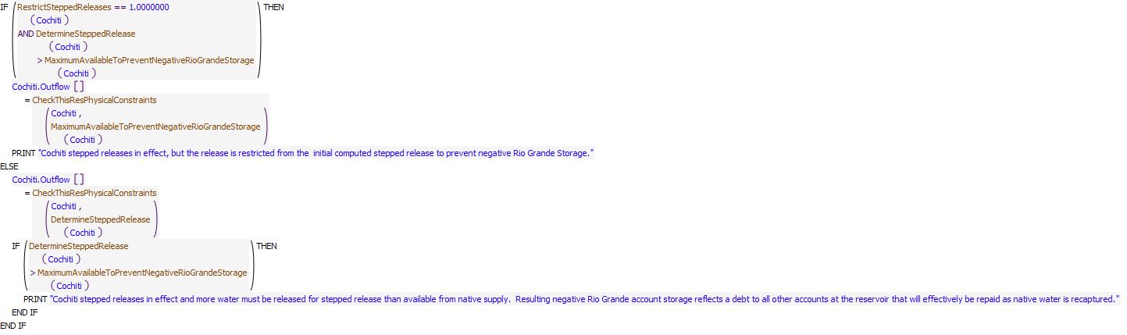
Execution Constraint
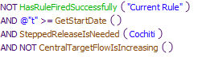
Referenced Functions
- CheckThisResPhysicalConstraints
- CentralTargetFlowIsIncreasing
- DetermineSteppedRelease
- SteppedReleaseIsNeeded
- MaximumAvailableToPreventNegativeRioGrandeStorage
- RestrictSteppedReleases
- HasRuleFiredSuccessfully
- GetStartDate

28.8 JemezSteppedRelease
Rule Purpose:
The outflow from Jemez Canyon Dam may be reset to assure increasing or decreasing releases are stepped if needed. This rule determines whether stepped releases are required, and if so, computes the release for Jemez. Stepped release policy may result in negative Rio Grande account storage if there is not enough native water in storage to maintain higher releases for a step down. For such cases, if there is other wate in th reservoir to use for stepping down releases, the resulting negative Rio Grande account storage effectively represents a debt by the Rio Grande account to all other accounts. That debt is effectively paid back when Rio Grande water is recaptured after stepped releases are over to return the Rio Grande account storage to zero. A switch can also be set by the model user to restrict stepped release rates from causing the Rio Grande account storage from going negative.
Rule Logic: Execution Constraint logic is at end of explanation.
The value in the Outflow time series slot in the Jemez storage reservoir object for the current timestep is reset using an IF THEN ELSE statement. If the model user has input a value of 1.0 to the RestrictSteppedReleasesToAvailableNativeSupply(1=Yes,0=No) column in the SteppedReleaseData table slot on the JemezData data object and the result from the DetermineSteppedRelease function indicates a higher release than the value computed with the user-defined MaximumAvailableToPreventNegativeRioGrandeStorage function, the result from that latter MaximumAvailableToPreventNegativeRioGrandeStorage function is used. Otherwise, the release is reset to the result from the user-defined DetermineSteppedRelease function.
The DetermineSteppedRelease function includes an exterior IF THEN ELSE statement to see if the outflow from Jemez Canyon Dam is increasing as determined using the user-defined OutflowIsIncreasing function. If so, the outflow is calculated with the user-defined ComputeOutflowIncrSteppedRelease function. If not, the outflow is computed using the user-defined ComputeOutflowDecrSteppedRelease function unless it is determined that the release should be shutoff.
The resulting outflow is checked against the physical restrictions of the outlet works using the user-defined CheckThisResPhysicalConstraints function.
This rule fires if the rule has not fired as checked against the predefined HasRuleFiredSuccessfully function and if the current timestep is greater than the beginning timestep for rulebased simulation as input by the model user to the RulebasedSimulationStartDate scalar slot in the ModelRunTypeTriggers data object and if the result from the user-defined SteppedReleaseIsNeeded function is TRUE. The SteppedReleaseIsNeeded function includes three separate functions to check the change to the outflow as computed using the user-defined ComputeDeltaOutflow function against different criteria.
If the execution constraints are satisfied,
Model slots written by rule:
1. Jemez.Outflow
List of key model objects with slots read by the rule or child functions:
1. ModelRunTypeTriggers
2. JemezData
3. Jemez
Log of when and how the rule has been modified (newest changes at the top):
Date: Who. What
3/1/19: Jesse Roach.Updated description and notes fields.
Statements
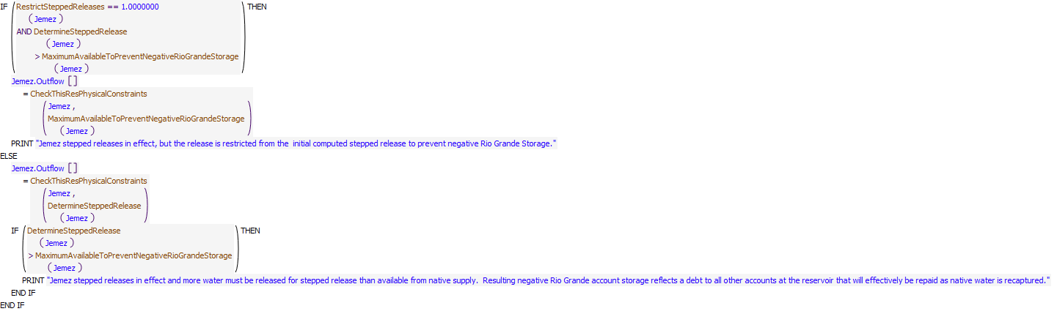
Execution Constraint
Referenced Functions
- CheckThisResPhysicalConstraints
- DetermineSteppedRelease
- SteppedReleaseIsNeeded
- MaximumAvailableToPreventNegativeRioGrandeStorage
- RestrictSteppedReleases
- HasRuleFiredSuccessfully
- GetStartDate

28.9 CochitiWCMBalancedRelease
Rule Purpose:
The rule looks to see if there is flood storage in both Cochiti Lake and Jemez Canyon Reservoir, if there is flood storage then the remaining flood space and release is balanced by this rule. The CheckThisPhysicalConstraints function tests to see if the resulting outflow can be physically released from the reservoirs. If not the amount of outflow is set to the amount that can be physically released. It resets the outflow from Cochiti Dam and Jemez Canyon Dam as necessary to balance operations and the available flood storage space at each reservoir as stipulated in the water control manuals for each dam. This balancing is constrained by thel outlet works of each dam.
Rule Logic: Execution Constraint logic is at end of explanation.
If the execution constraints are satisfied, two assignments are completed with this rule. The value for the Outflow time series slot in the Cochiti storage reservoir object is set to the result from the user-defined CochitiBalancedOperation function. Within this function, an IF THEN ELSE statement is used to see if the result from the user-defined CochitiJemezStorageDifferentialRatio function is less than zero. The result from this function is the ratio of the currently available flood storage space to the total available flood storage space at Cochiti Lake minus the ratio of the currently available flood storage space to the total available flood storage space at Jemez Reservoir. So, if that value is less than zero (the ratio at Cochiti Lake is less than the ratio at Jemez Reservoir), the outflow is increased using that ratio. Otherwise, the outflow is decreased based on the adjustment made to the release from Jemez Canyon Dam. For the second assignment, the user-defined JemezBalanceOperation function is used to set the value for the Outflow time series slot in the Jemez storage reservoir object. The same ratio is checked again, and the outflow is adjusted similarly.
For both of the previous assignments, the result for the Outflow is checked against the physical restrictions of the outlet works for the corresponding dam using the user-defined CheckThisResPhysicalConstraints function
This rule fires if the rule has not already fired for the current timestep as checked with reference to the predefined HasRuleFiredSuccessfully function and and if the current timestep is greater than or equal to the beginning timestep for rulebased simulation as input by the model user to the RulebasedSimulationStartDate scalar slot in the ModelRunTypeTriggers data object and if the value in the Outflow time series slots in the Cochiti storage reservoir object minus the result from the user-defined CochitiBalancedOperation function is greater than 10 cfs or if the value in the Outflow time series slots in the Jemez storage reservoir object minus the result from the user-defined JemezBalancedOperation function is greater than 10 cfs and if the result from the user-defined IfCochitiJemezBalancedOperation function is TRUE.
Model slots written by rule:
1. Cochiti.Outflow
2. Jemez.Outflow
List of key model objects with slots read by the rule or child functions:
1. ModelRunTypeTriggers
2. CochitiData
3. Cochiti
4. JemezData
5. Jemez
Log of when and how the rule has been modified (newest changes at the top):
Date: Who. What
3/1/19: Jesse Roach.Updated description and notes fields.
Statements
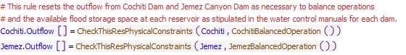
Execution Constraint
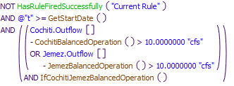
Referenced Functions
- CheckThisResPhysicalConstraints
- CochitiBalancedOperation
- IfCochitiJemezBalancedOperation
- JemezBalancedOperation
- HasRuleFiredSuccessfully
- GetStartDate

28.10 CochitiFloodControl
Rule Purpose:
If there is an unregulated spill, per flood control operations, this rule resets the outflow from Cochiti Dam to match the channel capacity at Central if necessary and as possible while maintaining the unregulated spill portion of the outflow.
Rule Logic: Execution Constraint logic is at end of explanation.
If the execution constraints are satisfied, the value for the Outflow time series slot in the Cochiti storage reservoir object for the current timestep is reset to the result from the CochitiFCOutflow function. This function includes an IF THEN ELSE statement to see if the value for the Unregulated Spill time series slot in the Cochiti storage reservoir object for the current timestep is less than the channel capacity at Cochiti as input in the ChannelCapacities table slot in the CochitiData data object and referenced with the user-defined ChannelCapacity function. If not, the function result is set equal to the value in the Outflow time series slot in the Cochiti storage reservoir object for the current timestep (i.e. the outflow is not changed). If so, the function result is then computed using the user-defined CochitiFlowToMatchCentralChannelCapacity function.
The CochitiFlowToMatchCentralChannelCapacity function computes the outflow to match the input channel capacity, if necessary, based on the value in the Gage Inflow time series slot in the Central stream gage object for the current timestep. An exterior IF THEN ELSE statement is used to see if the value in the Gage Inflow time series slot is greater than the channel capacity. If not, the outflow at the current timestep is adjusted based on that difference to match the channel capacity. If so, a second IF THEN ELSE statement is used to see if the computed release to match the channel capacity is less than zero as identified with the user-defined IsReleaseToMatchChannelCapacity<0 function. If so, the release is set to the value input to the Minimum column in the ChannelCapacities table slot in the CochitiData data object as referenced using the user-defined ChannelCapacity function. Otherwise, a third IF THEN ELSE statement is used to see if the computed release to match the channel capacity is greater than zero as identified with the IsReleaseToMatchChannelCapacity>0 function. If so, the outflow is set to the Outflow time series slot in the Cochiti storage reservoir object for the current timestep (i.e. the outflow is not changed). The last IF THEN ELSE statement identifies whether the outflow from just Jemez Canyon Dam to match the target is less than zero, and then the outflow from Cochiti Dam is adjusted accordingly.
Within the rule, the result is checked against the physical restrictions of the outlet works using the user-defined CheckThisResPhysicalConstraints function.
This rule fires if the rule has not already fired for the current timestep as checked with reference to the predefined HasRuleFiredSuccessfully function and and if the current timestep is greater than or equal to the beginning timestep for rulebased simulation as input by the model user to the RulebasedSimulationStartDate scalar slot in the ModelRunTypeTriggers data object and if the value for the Unregulated Spill time series slot in the Cochiti storage reservoir object is greater than zero as determined with the user-defined ReservoirIsSpillingUnreg function.
Model slots written by rule:
1. Cochiti.Outflow
List of key model objects with slots read by the rule or child functions:
1. ModelRunTypeTriggers
2. CochitiData
3. Cochiti
4. Central
Log of when and how the rule has been modified (newest changes at the top):
Date: Who. What
3/1/19: Jesse Roach.Updated description and notes fields.
Statements
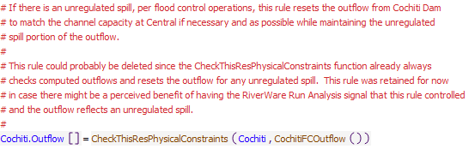
Execution Constraint
Referenced Functions
- CheckThisResPhysicalConstraints
- ReservoirIsSpillingUnreg
- CochitiFCOutflow
- HasRuleFiredSuccessfully
- GetStartDate

28.11 CochitiRGCarryOver
Rule Purpose:
If flood control storage was retained as carryover storage at Cochiti Lake, this rule sets a value for the winter release of that storage and records the remaining carry over content. Flood water may be carried over until after the irrigation season.
Rule Logic: Execution Constraint logic is at end of explanation.
The value for the RGCarryOverRelease time series slot in the CochitiData data object for the current timestep is set to the result from the user-defined RGCarryOverRelease function. This function includes an exterior IF THEN ELSE statement to see if it is the carry over release season (November through March) as determined using the user-defined FloodCarryOverReleaseSeason function and if the value for the Storage in the Rio Grande account is greater than zero and if the value for the Locked In time series slot in the Cochiti storage reservoir object is equal to zero. If not, the carry over release is set to 0.0 cfs. If so, a second IF THEN ELSE statement is used to see if the result from the user-defined IfRGCarryOverRelease function is true. This function checks to see if the value for the RGCarryOverLeft time series slot in the CochitiData data object is greater than zero or the value for the Storage in the Rio Grande account at Cochiti Lake is greater than the value in the MinRGCarryOverStorage table slot in the CochitiData data object or the value in the Carryover Content time series slot in the Cochiti storage reservoir object for October 31 of the current year is greater than zero. If not, the carry over release is set to 0.0 cfs. If so, the carry over release is set to the value in the RGCarryOverRelease time series slot in the CochitiData data object for the current timestep unless it is a NaN. Then, the value is set to the result from the user-defined ConstantRGCarryOverRelease function.
The rule includes a second assignment statement to set the value for the RGCarryOverLeft time series slot in the CochitiData data object for the current timestep to the result from the user-defined RGCarryOverLeft function. Within this function, an exterior IF THEN ELSE statement is used to see if the results from the RGCarryOverIsNaNBoolean function and the user-defined ConstantCOReleaseBoolean function are true. The former checks to see if the result from the FloodCarryOverReleaseSeason function is true and if the Storage in the Rio Grande account at the previous timestep is greater than zero and if the result from the IfRGCarryOverRelease function is true and if the value for the RGCarryOverRelease time series slot in the CochitiData data object for the current timestep is a NaN. The latter checks some of the same criteria and also to see if the value for the Locked In time series slot in the Abiquiu level power reservoir object is equal to 0.0. If those criteria are satisfied, a second IF THEN ELSE statement checks again to see if the Storage in the Rio Grande account at the previous timestep is greater than zero. If not, the function result is 0.0 acre-ft. A third IF THEN ELSE statement is then used to see if the value for the RGCarryOverLeft time series slot in the CochitiData data object for the previous timestep is greater than zero. If not, the carry over left is set to the previous Storage in the Rio Grande account minus the volume of the RGCarryOverRelease. A fourth IF THEN ELSE statement is used to see if the result from the user-defined IsRGConservationAllowed function is true. If not, the carry over left is the value in the RGCarryOverLeft time series slot in the CochitiData data object for the previous timestep minus the RGCarryOverRelease. If so, the result is the value for the RGCarryOverLeft minus the result from the user-defined ComputeAbiquiuRGConsInflow function minus the RGCarryOverRelease. If the exterior IF THEN ELSE is NOT satisfied, a second IF THEN ELSE statement is used to see if the results from the RGCarryOverNOTNaNBoolean function and the ConstantCOReleaseBoolean functions are true. If so, the Storage in the Rio Grande account is checked again to see if it is greater than zero and then, the result is the previous Storage in the Rio Grande account minus the RGCarryOverRelease. If not, an IF THEN ELSE statement is used to see if the value for the RGCarryOverRelease is a NaN. If so, the result from the user-defined ComputeIsNaNRGCarryOverLeft function is checked to see if it is less than or equal to zero or the RGCarryOverRelease is equal to zero. If so, the result is 0.0 acre-ft. If not, the function result is the result from the user-defined ComputeIsNaNRGCarryOverLeft function. Otherwise, a last IF THEN ELSE statement is used to see if the ComputeNOTIsNaNRGCarryOverLeft function is less than or equal to zero or the RGCarryOverRelease is greater than or equal to the Storage in the Rio Grande account. If so, the result is 0.0 acre-ft. If not, the carry over left is set to the result from the user-defined ComputeNOTIsNaNRGCarryOverLeft function.
This rule fires if the current timestep is greater than or equal to the beginning timestep for rulebased simulation as input by the model user to the RulebasedSimulationStartDate scalar slot in the ModelRunTypeTriggers data object and if the value for the RGCarryOverRelease time series slot in the CochitiData data object for the current timestep is a NaN.
Model slots written by rule:
1. CochitiData.RGCarryOverRelease
2. CochitiData.RGCarryOverLeft
List of key model objects with slots read by the rule or child functions:
1. ModelRunTypeTriggers
2. CochitiData
3. Cochiti
Log of when and how the rule has been modified (newest changes at the top):
Date: Who. What
3/1/19: Jesse Roach.Updated description and notes fields.
Statements
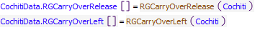
Execution Constraint
Referenced Functions
- RGCarryOverLeft
- RGCarryOverRelease
- GetStartDate

29 Cochiti and Jemez Accounts
The rules in this policy group are used to set the accounting supplies for the final outflow of Rio Grande water from Cochiti and Jemez Dams and for the deliveries of San Juan-Chamna Project water through Cochiti Dam.
Rules in the Group:
ReconciledRGandSJReleases
CheckJemezRGOutflow
SetJemezRGAccountingSupply
SetCochitiSJCAccountingSupplies
CheckCochitiRGOutflow
SetCochitiRGAccount
Policy Group Change Log (newest changes at the top):
Date: Who. What

29.1 SetCochitiRGConservationAccountSupply
Rule Purpose:
This rule sets the accounting supplies for the release from conservation storage at Cochiti Lake and for the final outflow of Rio Grande water from Cochiti Dam. The outflow of Rio Grande water is set to the total outflow minus the outflow of San Juan-Chama Project water and minus the release from conservation storage. The outflow of Rio Grande water is checked against the mimimum outflow.
Rule Logic: Execution Constraint logic is at end of explanation.
The value for the RioGrandeConservationCochitiToRioGrandeBlwCochitiDiversionsReach accounting supply for the current timestep is set to the minimum of the value in the RGConservationRelease series slot in the CochitiDeviations data object for the current timestep or the result from the user-defined ReconcileRGOutflow function. For Cochiti Lake, the ReconcileRGOutflow function result is set equal to the value in the Outflow time series slot in the Cochiti storage reservoir object for the current timestep minus the value in the SJOutflow time series slot in the CochitiData data object for the current timestep as identified with the user-defined SJOutflow function. The predefined Max function is used to restrict the result to be no less than the value in the MinRGOutflow periodic slot in the CochitiData data object as referenced with the user-defined MinRGOutflow function. A second assignment statement is used to set the RioGrandeCochitiToRioGrandeBlwCochitiDiversionsReach.Supply slot for the current timestep equal to the result from the ReconcileRGOutflow function minus the value in the RGConservationRelease series slot.
This rule fires if the current timestep is greater than or equal to the beginning timestep for rulebased simulation as input by the model user to the RulebasedSimulationStartDate scalar slot in the ModelRunTypeTriggers data object and if the value for the RioGrandeCochitiToRioGrandeBlwCochitiDiversionsReach accounting supply for the current timestep is a NaN.
Model Slots written by rule:
1. RioGrandeConservationCochitiToRioGrandeBlwCochitiDiversionsReach.Supply
2. NO LONGER SETS THIS SUPPLY IN THIS RULE: RioGrandeCochitiToRioGrandeBlwCochitiDiversionsReach.Supply
List of key model objects with slots read by the rule or child functions:
1. ModelRunTypeTriggers
2. CochitiDeviations
3. CochitiData
4. Cochiti
Log of when and how the rule has been modified (newest changes at the top):
Date: Who. What
1/6/21: Marc Sidlow. Separated RioGrande and RioGrandeConservation Account Supplies that were in rule SetCochitiRGAccount - now rule is labeled SetCochitiRGAccountSupply. This is a new rule that runs before rule SetCochitiRGAccountSupply
3/1/19: Jesse Roach.Updated description and notes fields.
Statements
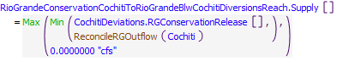
Execution Constraint
Referenced Functions
- ReconcileRGOutflow
- Min
- Max
- GetStartDate

29.2 SetCochitiRGAccountSupply
Rule Purpose:
This rule sets the accounting supplies for the release from conservation storage at Cochiti Lake and for the final outflow of Rio Grande water from Cochiti Dam. The outflow of Rio Grande water is set to the total outflow minus the outflow of San Juan-Chama Project water and minus the release from conservation storage. The outflow of Rio Grande water is checked against the mimimum outflow.
Rule Logic: Execution Constraint logic is at end of explanation.
The value for the RioGrandeConservationCochitiToRioGrandeBlwCochitiDiversionsReach accounting supply for the current timestep is set to the minimum of the value in the RGConservationRelease series slot in the CochitiDeviations data object for the current timestep or the result from the user-defined ReconcileRGOutflow function. For Cochiti Lake, the ReconcileRGOutflow function result is set equal to the value in the Outflow time series slot in the Cochiti storage reservoir object for the current timestep minus the value in the SJOutflow time series slot in the CochitiData data object for the current timestep as identified with the user-defined SJOutflow function. The predefined Max function is used to restrict the result to be no less than the value in the MinRGOutflow periodic slot in the CochitiData data object as referenced with the user-defined MinRGOutflow function. A second assignment statement is used to set the RioGrandeCochitiToRioGrandeBlwCochitiDiversionsReach.Supply slot for the current timestep equal to the result from the ReconcileRGOutflow function minus the value in the RGConservationRelease series slot.
This rule fires if the current timestep is greater than or equal to the beginning timestep for rulebased simulation as input by the model user to the RulebasedSimulationStartDate scalar slot in the ModelRunTypeTriggers data object and if the value for the RioGrandeCochitiToRioGrandeBlwCochitiDiversionsReach accounting supply for the current timestep is a NaN.
Model Slots written by rule:
1. NO LONGER SETS THIS SUPPLY IN THIS RULE: RioGrandeConservationCochitiToRioGrandeBlwCochitiDiversionsReach.Supply
2. RioGrandeCochitiToRioGrandeBlwCochitiDiversionsReach.Supply
List of key model objects with slots read by the rule or child functions:
1. ModelRunTypeTriggers
2. CochitiDeviations
3. CochitiData
4. Cochiti
Log of when and how the rule has been modified (newest changes at the top):
Date: Who. What
1/6/21: Marc Sidlow. Separated RioGrande and RioGrandeConservation Account Supplies that were in rule SetCochitiRGAccount - now rule is labeled SetCochitiRGAccountSupply. Cretaed new general function AllRGConservationSuppliesFrom (used for Abiquiu and Jemez also).
3/1/19: Jesse Roach.Updated description and notes fields.
Statements
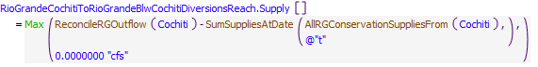
Execution Constraint
Referenced Functions
- ReconcileRGOutflow
- AllRGConservationSuppliesFrom
- Max
- GetStartDate
- SumSuppliesAtDate

29.3 CheckCochitiRGOutflow
Rule Purpose:
This rule aborts the simulation if the supply for the release of Rio Grande water from the Rio Grande account at Cochiti Lake was not set. This rule helps with debugging because a simulation will stop if the Rio Grande supply was not set and the problem and any missing input can be identified by backtracking in the calculations from the point in the simulation that the run aborted. NOTE THAT the problem is likely not directly related to the computation of the Rio Grande outflow but most likely due to some earlier aspect of the rules solution. This rule just forces the run to go ahead and stop, so the problem can be fixed.
Rule Logic: Execution Constraint logic is at end of explanation.
If the value for the RioGrandeCochitiToRioGrandeBlwCochitiDiversionsReach.Supply slot for the current timestep is is a NaN, the STOP_RUN command is used to stop the simulation, and the PRINT statement is used to print a comment to the Diagnostics Output window that the run stopped because the account slot value was not set.
This rule fires if the current timestep is greater than or equal to the beginning timestep for rulebased simulation as input by the model user to the RulebasedSimulationStartDate scalar slot in the ModelRunTypeTriggers data object.
Model supplies written by rule:
None
List of key model objects with slots read by the rule or child functions:
1. ModelRunTypeTriggers
Model supply read by the rule or child functions:
RioGrandeCochitiToRioGrandeBlwCochitiDiversionsReach.Supply
Log of when and how the rule has been modified (newest changes at the top):
Date: Who. What
3/1/19: Jesse Roach.Updated description and notes fields.
Statements
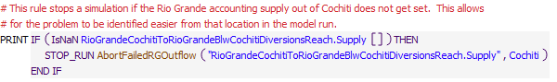
Execution Constraint
Referenced Functions
- AbortFailedRGOutflow
- GetStartDate

29.4 SetCochitiSJCAccountingSupplies
Rule Purpose:
Final accounting supplies for all San Juan-Chama deliveries from El Vado Reservoir are set with this rule to the initial computed values for each. Values are set one-by-one based on the list of initial values and the companion list of supplies. Values are set in prioirity based on the matching order of the list of initial value and list of supplies. Deliveries may not be made for lower priority deliveries if some operational constraint restricted San Juan-Chama outflows from Cochiti, but this is very rare in the simulations.
Rule Logic: Execution Constraint logic is at end of explanation.
An IF THEN statement is used first in the rule to identify if the final reconciled outflow of San Juan-Chama Project water determined with the user-defined ReconcileSJOutflow function is less than the previous determined outflow. If so, Print statements are used to print statements to the Diagnostics Output window that the full initial computed outflow could not be met, if Print statements are enable in the Diagnostics Manager. A FOR DO statement is then used in the rule to set all the accounting supplies from a list of all supply slot names, at index 0, and the final determined deliveries, at index 1, as created with the user-defined CochitiPrioritizedSJCSuppliesAndValuesReconciliationCheck function. That function contains a list of all the accounting supplies from Cochiti Lake for deliveries of San Juan-Chama Project water and a corresponding list of all the initial computed deliveries recorded to the ComputedDeliveries data object. A WHILE DO loop is then used in the function to loop through each supply in the order listed and set the deliveries while checking the cumulative release set so far within the function against the final total outflow of San Juan-Chama Project water. If the final total outflow of San Juan-Chama Project water, which is an input to the function, is less than the sum of the intial computed deliveries, deliveries included at the bottom of the listed supplies will be shorted in order from bottom up as needed.
This rule fires if the current timestep is greater than or equal to the beginning timestep for rulebased simulation as input by the model user to the RulebasedSimulationStartDate scalar slot in the ModelRunTypeTriggers data object and if the rule has not fired yet as determined with a reference to the predefined HasRuleFiredSuccessfully function.
Model supplies written by rule:
1. AlbuquerqueAbiquiuToSurfaceWaterDiversionAlbuquerqueWaterUserCochitiToAlbuquerqueAbiquiuToSurfaceWaterDiversionAlbuquerqueWaterUserBlwCochitiDiversionsReach.Supply
2. MRGCDAbiquiuToRioGrandeBlwCochitiDiversionsReachCochitiToRioGrandeBlwCochitiDiversionsReach.Supply
3. ReclamationAbiquiuToRioGrandeBlwCochitiDiversionsReachCochitiToRioGrandeBlwCochitiDiversionsReach.Supply
4. CombinedAbiquiuToCombinedElephantButteCochitiToCombinedAbiquiuToCombinedElephantButteBlwCochitiDiversionsReach.Supply
List of key model objects with slots read by the rule or child functions:
1. ModelRunTypeTriggers
2. ComputedDeliveries
Log of when and how the rule has been modified (newest changes at the top):
Date: Who. What
3/1/19: Jesse Roach.Updated description and notes fields.
Statements
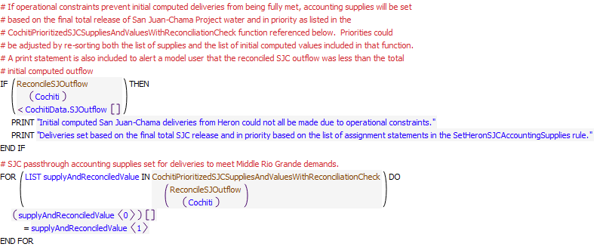
Execution Constraint
Referenced Functions
- CochitiPrioritizedSJCSuppliesAndValuesWithReconciliationCheck
- HasRuleFiredSuccessfully
- ReconcileSJOutflow
- GetStartDate

29.5 SetJemezRGConservationAccountingSupply
Rule Purpose:
This rule sets the accounting supplies for the release from conservation storage at Jemez Reservoir and for the final outflow of Rio Grande water from Jemez Canyon Dam. The supply for release from conservation storage is set to the initial computed value restricted to the reconciled total Rio Grande outflow from Jemez Reservoir. The supply for the release of Rio Grande water is set as the total Rio Grande outflow minus the release from conservation storage.
Rule Logic: Execution Constraint logic is at end of explanation.
The value for the RioGrandeConservationJemezToRioGrandeBlwJemez accounting supply for the current timestep is set to the minimum of the value in the RGConservationReleaseFromJemez series slot in the ComputedDeliveries data object for the current timestep or the result from the user-defined ReconcileRGOutflow function. A second assignment statement is used to set the RioGrandeJemezToRioGrandeBlwJemez.Supply slot for the current timestep equal to the result from the ReconcileRGOutflow function minus the value in the RGConservationReleaseFromJemez series slot.
This rule fires if the current timestep is greater than or equal to the beginning timestep for rulebased simulation as input by the model user to the RulebasedSimulationStartDate scalar slot in the ModelRunTypeTriggers data object and if the value for the RioGrandeJemezToRioGrandeBlwJemez accounting supply for the current timestep is a NaN.
Model supplies written by rule:
2. RioGrandeConservationJemezToRioGrandeBlwJemez.Supply
3. NO LONGER SETS THIS SUPPLY IN THIS RULE: RioGrandeJemezToRioGrandeBlwJemez.Supply
List of key model objects with slots read by the rule or child functions:
1. ModelRunTypeTriggers
2. ComputedDeliveries
Log of when and how the rule has been modified (newest changes at the top):
Date: Who. What
1/6/21: Marc Sidlow. Separated RioGrande and RioGrandeConservation Account Supplies that were in rule SetJemezRGAccountingSupply. This is a new rule and runs before rule SetAbiquiuRioGrandeAccountingSupply.
3/1/19: Jesse Roach.Updated description and notes fields.
Statements
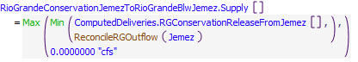
Execution Constraint
Referenced Functions
- ReconcileRGOutflow
- Min
- Max
- GetStartDate

29.6 SetJemezRGAccountingSupply
Rule Purpose:
This rule sets the accounting supplies for the release from conservation storage at Jemez Reservoir and for the final outflow of Rio Grande water from Jemez Canyon Dam. The supply for release from conservation storage is set to the initial computed value restricted to the reconciled total Rio Grande outflow from Jemez Reservoir. The supply for the release of Rio Grande water is set as the total Rio Grande outflow minus the release from conservation storage.
Rule Logic: Execution Constraint logic is at end of explanation.
The value for the RioGrandeConservationJemezToRioGrandeBlwJemez accounting supply for the current timestep is set to the minimum of the value in the RGConservationReleaseFromJemez series slot in the ComputedDeliveries data object for the current timestep or the result from the user-defined ReconcileRGOutflow function. A second assignment statement is used to set the RioGrandeJemezToRioGrandeBlwJemez.Supply slot for the current timestep equal to the result from the ReconcileRGOutflow function minus the value in the RGConservationReleaseFromJemez series slot.
This rule fires if the current timestep is greater than or equal to the beginning timestep for rulebased simulation as input by the model user to the RulebasedSimulationStartDate scalar slot in the ModelRunTypeTriggers data object and if the value for the RioGrandeJemezToRioGrandeBlwJemez accounting supply for the current timestep is a NaN.
Model supplies written by rule:
1. NO LONGER SETS THIS SUPPLY IN THIS RULE:RioGrandeConservationJemezToRioGrandeBlwJemez.Supply
2. RioGrandeJemezToRioGrandeBlwJemez.Supply
List of key model objects with slots read by the rule or child functions:
1. ModelRunTypeTriggers
2. ComputedDeliveries
Log of when and how the rule has been modified (newest changes at the top):
Date: Who. What
1/6/21: Marc Sidlow. Separated RioGrande and RioGrandeConservation Account Supplies. Cretaed new general function AllRGConservationSuppliesFrom (used for Abiquiu and Cochiti also).
3/1/19: Jesse Roach.Updated description and notes fields.
Statements
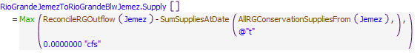
Execution Constraint
Referenced Functions
- ReconcileRGOutflow
- AllRGConservationSuppliesFrom
- Max
- GetStartDate
- SumSuppliesAtDate

29.7 CheckJemezRGOutflow
Rule Purpose:
This rule aborts the simulation if the supply for the release of Rio Grande water from the Rio Grande account at Jemez Reservoir was not set. This rule helps with debugging because a simulation will stop if the Rio Grande supply was not set and the problem and any missing inputs can be identified by backtracking in the calculations from the point in the simulation that the run aborted.
Rule Logic: Execution Constraint logic is at end of explanation.
If the value for the RioGrandeJemezToRioGrandeBlwJemez.Supply slot for the current timestep is a NaN, the STOP_RUN command is used to stop the simulation, and the PRINT statement is used to print a comment to the Diagnostics Output window that the run stopped because the account slot value was not set.
This rule fires if the current timestep is greater than or equal to the beginning timestep for rulebased simulation as input by the model user to the RulebasedSimulationStartDate scalar slot in the ModelRunTypeTriggers data object.
Model supplies written by rule:
None
List of key model objects with slots read by the rule or child functions:
1. ModelRunTypeTriggers
Model supply read by the rule or child functions:
RioGrandeJemezToRioGrandeBlwJemez.Supply
Log of when and how the rule has been modified (newest changes at the top):
Date: Who. What
3/1/19: Jesse Roach.Updated description and notes fields.
Statements
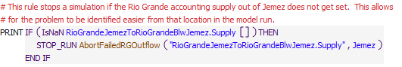
Execution Constraint
Referenced Functions
- AbortFailedRGOutflow
- GetStartDate

29.8 ReconciledRGandSJReleases
Rule Purpose:
Final reconciled Rio Grande outflows and San Juan-Chama outflows from Heron, El Vado, Abiquiu, and Cochiti are recorded for model user reference.
Rule Logic: Execution Constraint logic is at end of explanation.
Two FOR DO statements are used to set the ReconciledRGOutflow series slots and the ReconciledSJOutflow series slots in the HeronData, ElVadoData, AbiquiuData, and CochitiData data objects for the current timestep. The values are computed with the user-defined ReconcileRGOutflow and ReconcileSJOutflow functions. Different equations are used in the ReconcileRGOutflow function depending on the reservoir. For the user-defined ReconcileSJOutflow function, the result is the value for the Outflow time series slot in the corresponding reservoir object for the current timestep minus the result from the ReconcileRGOutflow function for the corresponding reservoir object.
This rule fires if the current timestep is greater than or equal to the beginning timestep for rulebased simulation as input by the model user to the RulebasedSimulationStartDate scalar slot in the ModelRunTypeTriggers data object and if the value for the ReconciledRGOutflow time series slot in the AbiquiuData data object for the current timestep is a NaN.
Model slots written by rule:
1. RESERVOIRData.ReconciledRGOutflow where RESERVOIR is Heron, ElVado, Abiquiu, and Cochiti
2. RESERVOIRData.ReconciledSJOutflow where RESERVOIR is Heron, ElVado, Abiquiu, and Cochiti
List of key model objects with slots read by the rule or child functions:
1. ModelRunTypeTriggers
2. RESERVOIRData where RESERVOIR is Heron, ElVado, Abiquiu, and Cochiti
3. RESERVOIR where RESERVOIR is Heron, ElVado, Abiquiu, and Cochiti
4. RioGrandeCompact
Log of when and how the rule has been modified (newest changes at the top):
Date: Who. What
3/1/19: Jesse Roach.Updated description and notes fields.
Statements
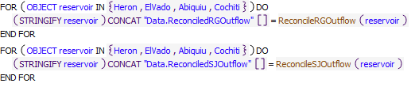
Execution Constraint
Referenced Functions
- ReconcileRGOutflow
- ReconcileSJOutflow
- GetStartDate

30 MRG Diversions

30.1 LimitMRGCDDiversionsToPercentOfCochitiNativeFlow
Rule Purpose:
This rule limits the MRGCD diversions to be no more than a user-defined percentage of the native flow below Cochiti. The diversions are curtailed pro-rata if they exceed this threshold. This logic no longer applies if the river has gone dry at any of the gages in the Middle Valley.
Rule Logic: Execution Constraint logic is at end of explanation.
A WITH statement creates a list of the MRGCD diversions is created, by combining the MiddleRioGrandeDiversions subbasin with the SanAcaciaDiversions:CanalDiv object.
A WITH statement creates a list of the Middle Valley River Gages is created, based on the MRG River Gages subbasin.
A WITH statement sums the MRGCD diversions at the current timestep.
IF this sum is larger than a percentage (defined by the MRGCD.PercentOfBlwCochitiNativeWaterAvailableToDivert scalar slot) of the BlwCochitiDiversionsReach^RioGrande.Inflow, AND IF the minimum of the Gage Inflow values in the list of the Middle Valley River Gages is more than 5 cfs, AND IF the date is less than the MRGCD.DateToEndPercentOfBlwCochitiNativeWaterRule, then a reduction fraction is determined based on the percentage of the BlwCochitiDiversionsReach^RioGrande.Inflow divided by the sum of the MRGCD diversions. This reduction fraction is applied to all of the MRGCD diversions.
This rule fires if the rule has not fired successfully for the current timestep as determined with reference to the predefined HasRuleFiredSuccessfully function, if the current timestep is greater than or equal to the beginning timestep for rulebased simulation as input by the model user to the RulebasedSimulationStartDate scalar slot in the ModelRunTypeTriggers data object, and if the MRGCD.LimitMRGCDDiversionsToPercentOfCochitiNativeFlowSwitch is set equal to 1.
Model slots written by rule:
1. BlwCochitiDiversions:EastSideMain.Diversion Requested
2. BlwCochitiDiversions:SiliCanal.Diversion Requested
3. BlwIsletaDiversions:BelenHLC.Diversion Requested
4. BlwIsletaDiversions:CaciqueAcequia.Diversion Requested
5. BlwIsletaDiversions:ChicalAcequia.Diversion Requested
6. BlwIsletaDiversions:ChicalLateral.Diversion Requested
7. BlwIsletaDiversions:Peralta.Diversion Requested
8. BlwSanFelipeDiversions:AlbMainCanal.Diversion Requested
9. BlwSanFelipeDiversions:AtriscoFeeder.Diversion Requested
10. SanAcaciaDiversions:CanalDiv.Diversion Requested
11. SanAcaciaDiversions:LowFlowDiv.Diversion Requested

List of key model objects with slots read by the rule or child functions:
1. ModelRunTypeTriggers
2. MRGCD
3. BlwCochitiDiversionsReach
4. Model objects in subbasin "MiddleRioGrandeDiversions"
5. SanAcaciaDiversions:CanalDiv
6. Model objects in subbasin "MRG River Gages"
Log of when and how the rule has been modified (newest changes at the top):
Date: Who. What
2/18/22: Nick Mander: Created rule and added description and notes fields
Statements
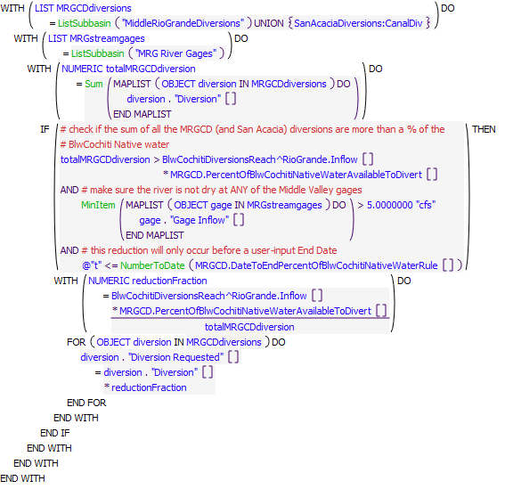
Execution Constraint
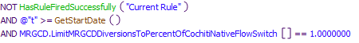
Referenced Functions
- MinItem
- Sum
- NumberToDate
- ListSubbasin
- HasRuleFiredSuccessfully
- GetStartDate

30.2 SupplementalWaterBypassAtCentral
Rule Purpose:
Ensures that a specified percentage of supplemental water being released out of Abiquiu is bypassed down the river at Angostura Diversion Dam.
Rule Logic: Execution Constraint logic is at end of explanation.
If amount of flow coming into the Angostura Diversion Dam (SanFelipeToCentralSeepageArea1.Inflow) minus the amount asked to divert at the dam (BlwSanFelipeDiversions.Total Diversion Requested) is less than MiddleValleyTargets.NeededSupplementalWaterReleaseFromAbiquiu multiplied by a specified coefficient for Central (MiddleValleyTargets.MRGCDandReclamationAgreementStreamflowCoefficients) then the amount that is allowed to be diverted at the dam (SanFelipeToCentralSeepageArea1.Available For Diversion) is set equal to the maximum of the inflow into Angostura Diversion Dam minus the NeededSupplementalWaterReleaseFromAbiquiu multiplied by the specified coefficient for Central and 0 cfs.
This rule fires if the current timestep is greater than or equal to the beginning timestep for rulebased simulation as input by the model user to the RulebasedSimulationStartDate scalar slot in the ModelRunTypeTriggers data object, if the rule has not fired yet as determined with a reference to the predefined HasRuleFiredSuccessfully function, MiddleValleyTargets.NeededSupplemetalWaterReleaseFromAbiquiu is greater than 0 cfs, and if the MRGCDandReclamationAgreement switch is on (=1).
Model slots written by rule:
1. SanFelipeToCentralSeepageArea1.Available For Diversion
List of key model objects with slots read by the rule or child functions:
1. SanFelipeToCentralSeepageArea1
2. BlwSanFelipeDiversions
3. MiddleValleyTargets
Log of when and how the rule has been modified (newest changes at the top):
Date: Who. What
11/8/22: Lucas Barrett. Created Rule.
Statements
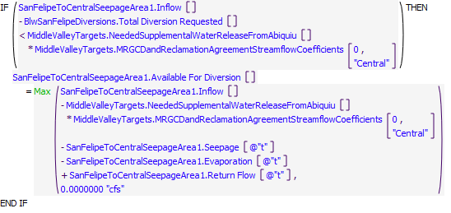
Execution Constraint
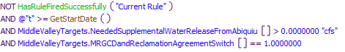
Referenced Functions
- Max
- HasRuleFiredSuccessfully
- GetStartDate

30.3 AngosturaDiversionLimiter
Rule Purpose:
Restricts large drops in bypass from Angostura Diversion Dam by restricting how much can be diverted into MRGCD canals when bypass is below a specified flow.
Rule Logic: Execution Constraint logic is at end of explanation.
If the previous day's bypass from Angostura Diversion Dam (SanFelipeToCentralSeepageArea.Outflow) minus the current bypasss from Angostura Diversion Dam is greater than a specified stepdown (MRGCD.DiversionLimiterCoefficients) and the current bypass from Angostura Diversion Dam is less than a specified flow (MRGCD.DiversionLimiterCoefficients) then the amount available to divert at the Angostura Diversion Dam (SanFelipeToCentralSeepageArea1.Available For Diversion) equals the following. If the previous bypass from Angostura Diversion Dam minus the specified stepdown is greater than the specified flow to begin the stepdown then the amount available for diversion equals the inflow into the Angostura Diversion Dam (SanFelipeToCentralSeepageArea1.Inflow) minus the specified flow to begin the stepdown minus seepage minus evaporation plus return flow. Else, the amount available for diversion equals the maximum of inflow into Angostura Diversion Dam minus the previous step's bypass plus the specified stepdown amount minus seepage minus evaporation plus return flow and 0 cfs. If the first if statement triggers it will also set MRGCD.DiversionLimited equal to 1.
This rule fires if the current timestep is greater than or equal to the beginning timestep for rulebased simulation as input by the model user to the RulebasedSimulationStartDate scalar slot in the ModelRunTypeTriggers data object, if the rule has not fired yet as determined with a reference to the predefined HasRuleFiredSuccessfully function, and if the MRGCDandReclamationAgreement switch is on (=1).
Model slots written by rule:
1. SanFelipeToCentralSeepageArea1.Available For Diversion
2. MRGCD.DiversionLimited
List of key model objects with slots read by the rule or child functions:
1. SanFelipeToCentralSeepageArea1
2. MRGCD
Log of when and how the rule has been modified (newest changes at the top):
Date: Who. What
11/8/22: Lucas Barrett. Created Rule.
Statements
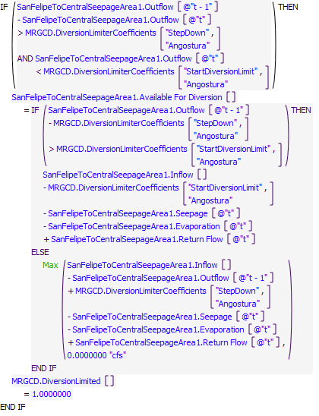
Execution Constraint
Referenced Functions
- Max
- HasRuleFiredSuccessfully
- GetStartDate

30.4 SupplementalWaterBypassAtIsletaFromAgreement
Rule Purpose:
Ensures that a specified percentage of supplemental water being released out of Abiquiu is bypassed down the river at Isleta Diversion Dam.
Rule Logic: Execution Constraint logic is at end of explanation.
If amount of flow coming into the Isleta Diversion Dam (IsletaDiversionDam.Inflow) minus the amount asked to divert at the dam (BlwIsletaDiversions.Total Diversion Requested) is less than MiddleValleyTargets.NeededSupplementalWaterReleaseFromAbiquiu multiplied by a specified coefficient for Isleta (MiddleValleyTargets.MRGCDandReclamationAgreementStreamflowCoefficients) then the amount that is allowed to be diverted at the dam (IsletaDiversionDam.Available For Diversion) is set equal to the maximum of the inflow into Isleta Diversion Dam minus the NeededSupplementalWaterReleaseFromAbiquiu multiplied by the specified coefficient for Isleta and 0 cfs.
This rule fires if the current timestep is greater than or equal to the beginning timestep for rulebased simulation as input by the model user to the RulebasedSimulationStartDate scalar slot in the ModelRunTypeTriggers data object, if the rule has not fired yet as determined with a reference to the predefined HasRuleFiredSuccessfully function, MiddleValleyTargets.NeededSupplemetalWaterReleaseFromAbiquiu is greater than 0 cfs, and if the MRGCDandReclamationAgreement switch is on (=1).
Model slots written by rule:
1. IsletaDiversionDam.Available For Diversion
List of key model objects with slots read by the rule or child functions:
1. IsletaDiversionDam
2. Central
3. MiddleValleyTargets
4. BlwIsletaDiversions
Log of when and how the rule has been modified (newest changes at the top):
Date: Who. What
11/8/22: Lucas Barrett. Created Rule.
Statements
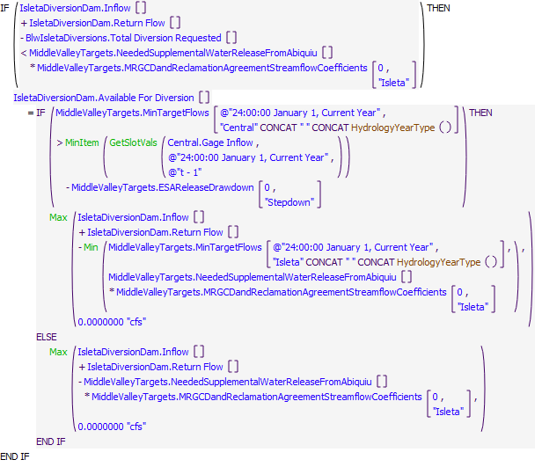
Execution Constraint
Referenced Functions
- HydrologyYearType
- Min
- MinItem
- Max
- GetSlotVals
- HasRuleFiredSuccessfully
- GetStartDate

30.5 IsletaDiversionLimiter
Rule Purpose:
Restricts large drops in bypass from Isleta Diversion Dam by restricting how much can be diverted into MRGCD canals when bypass is below a specified flow.
Rule Logic: Execution Constraint logic is at end of explanation.
If the previous day's bypass from Isleta Diversion Dam (IsletaDiversionDam.Outflow) minus the current bypasss from Isleta Diversion Dam is greater than a specified stepdown (MRGCD.DiversionLimiterCoefficients) and the current bypass from Isleta Diversion Dam is less than a specified flow (MRGCD.DiversionLimiterCoefficients) then the amount available to divert at the Isleta Diversion Dam (IsletaDiversionDam.Available For Diversion) equals the following. If the previous bypass from Isleta Diversion Dam is greater than the specified flow to begin the stepdown then the amount available for diversion equals the inflow into the Isleta Diversion Dam (IsletaDiversionDam.Inflow) minus the specified flow to begin the stepdown. Else, the amount available for diversion equals the maximum of inflow into Angostura Diversion Dam minus the previous step's bypass plus the specified stepdown amount and 0 cfs. If the first if statement triggers it will also set MRGCD.DiversionLimited equal to 2.
This rule fires if the current timestep is greater than or equal to the beginning timestep for rulebased simulation as input by the model user to the RulebasedSimulationStartDate scalar slot in the ModelRunTypeTriggers data object, if the rule has not fired yet as determined with a reference to the predefined HasRuleFiredSuccessfully function, and if the MRGCDandReclamationAgreement switch is on (=1).
Model slots written by rule:
1. IsletaDiversionDam.Available For Diversion
2. MRGCD.DiversionLimited
List of key model objects with slots read by the rule or child functions:
1. IsletaDiversionDam
2. MRGCD
Log of when and how the rule has been modified (newest changes at the top):
Date: Who. What
11/8/22: Lucas Barrett. Created Rule.
Statements
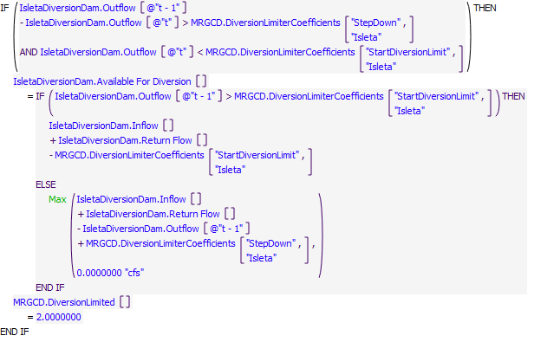
Execution Constraint
Referenced Functions
- Max
- HasRuleFiredSuccessfully
- GetStartDate

30.6 SupplementalWaterBypassAtSanAcaciaFromAgreement
Rule Purpose:
Ensures that a specified percentage of supplemental water being released out of Abiquiu is bypassed down the river at San Acacia Diversion Dam.
Rule Logic: Execution Constraint logic is at end of explanation.
If amount of flow coming into the San Acacia Diversion Dam (SanAcaciaDiversionReach.Inflow) minus the amount asked to divert at the dam (SanAcaciaDiversions.Total Diversion Requested) is less than MiddleValleyTargets.NeededSupplementalWaterReleaseFromAbiquiu multiplied by a specified coefficient for San Acacia (MiddleValleyTargets.MRGCDandReclamationAgreementStreamflowCoefficients) then the amount that is allowed to be diverted at the dam (SanAcaciaDiversionReach.Available For Diversion) is set equal to the maximum of the inflow into San Acacia Diversion Dam minus the NeededSupplementalWaterReleaseFromAbiquiu multiplied by the specified coefficient for San Acacia and 0 cfs.
This rule fires if the current timestep is greater than or equal to the beginning timestep for rulebased simulation as input by the model user to the RulebasedSimulationStartDate scalar slot in the ModelRunTypeTriggers data object, if the rule has not fired yet as determined with a reference to the predefined HasRuleFiredSuccessfully function, MiddleValleyTargets.NeededSupplemetalWaterReleaseFromAbiquiu is greater than 0 cfs, and if the MRGCDandReclamationAgreement switch is on (=1).
Model slots written by rule:
1. SanAcaciaDiversionReach.Available For Diversion
List of key model objects with slots read by the rule or child functions:
1. SanAcaciaDiversionReach
2. Central
3. MiddleValleyTargets
Log of when and how the rule has been modified (newest changes at the top):
Date: Who. What
11/8/22: Lucas Barrett. Created Rule.
Statements
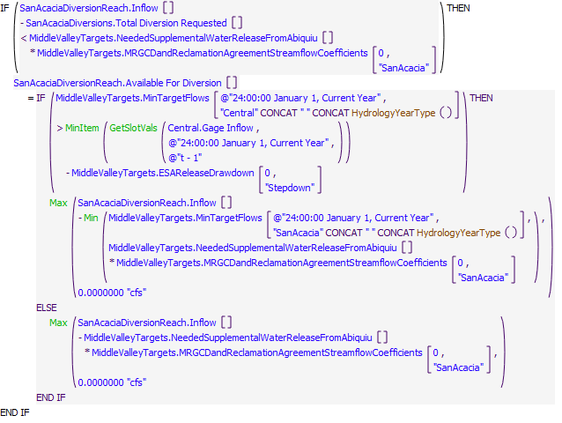
Execution Constraint
Referenced Functions
- HydrologyYearType
- Min
- MinItem
- Max
- GetSlotVals
- HasRuleFiredSuccessfully
- GetStartDate

30.7 SanAcaciaDiversionLimiter
Rule Purpose:
Restricts large drops in bypass from San Acacia Diversion Dam by restricting how much can be diverted into MRGCD canals when bypass is below a specified flow.
Rule Logic: Execution Constraint logic is at end of explanation.
If the previous day's bypass from San Acacia Diversion Dam (SanAcaciaDiversionReach.Outflow) minus the current bypasss from San Acacia Diversion Dam is greater than a specified stepdown (MRGCD.DiversionLimiterCoefficients) and the current bypass from San Acacia Diversion Dam is less than a specified flow (MRGCD.DiversionLimiterCoefficients) then the amount available to divert at the San Acacia Dam (SanAcaciaDiversionReach.Available For Diversion) equals the following. If the previous bypass from San Acacia Diversion Dam is greater than the specified flow to begin the stepdown then the amount available for diversion equals the inflow into the San Acacia Diversion Dam (SanAcaciaDiversionReach.Inflow) minus the specified flow to begin the stepdown. Else, the amount available for diversion equals the maximum of inflow into San Acacia Diversion Dam minus the previous step's bypass plus the specified stepdown amount and 0 cfs. If the first if statement triggers it will also set MRGCD.DiversionLimited equal to 3.
This rule fires if the current timestep is greater than or equal to the beginning timestep for rulebased simulation as input by the model user to the RulebasedSimulationStartDate scalar slot in the ModelRunTypeTriggers data object, if the rule has not fired yet as determined with a reference to the predefined HasRuleFiredSuccessfully function, and if the MRGCDandReclamationAgreementSwitch switch is on (=1).
Model slots written by rule:
1. SanAcaciaDiversionReach.Available For Diversion
2. MRGCD.DiversionLimited
List of key model objects with slots read by the rule or child functions:
1. SanAcaciaDiversionReach
2. MRGCD
Log of when and how the rule has been modified (newest changes at the top):
Date: Who. What
11/8/22: Lucas Barrett. Created Rule.
Statements
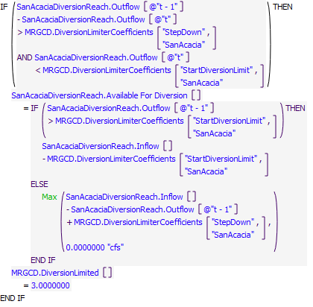
Execution Constraint
Referenced Functions
- Max
- HasRuleFiredSuccessfully
- GetStartDate

31 Nambe
A Nambe reservoir object is included for rulebased simulations in the single URGWOM file used for all applications because the object is needed for Accounting Model runs. The object is not linked and is thus irrelevant for rulebased simulations but the object must contain inputs for the simulation to complete. The rule in this policy group sets Nambe releases such that the rulebased simulations will complete.
Rules in the Group:
MaintainConstantNambePoolElevation
Policy Group Change Log (newest changes at the top):
Date: Who. What

31.1 MaintainConstantNambePoolElevation
Rule Purpose:
The Nambe object is not linked in URGWOM and is thus irrelevant for rulebased simulations, but the object must be included in the single URGWOM model file for Accounting Model runs. Inputs on the Nambe object are needed for rulebased simulations to continue, so this rule simply sets a bypass of inflows such that the object will dispatch and the rulebased simulation will continue.
Rule Logic: Execution Constraint logic is at end of explanation.
The rule maintains Nambe storage by using the predefined function SolveOutflow to get the outflow necessary so that the storage at the end of the timestep matches that to start the timestep.
This rule fires if the rule has not already fired for the current timestep as checked with reference to the predefined HasRuleFiredSuccessfully function and and if the current timestep is greater than or equal to the beginning timestep for rulebased simulation as input by the model user to the RulebasedSimulationStartDate scalar slot in the ModelRunTypeTriggers data object.
Model slots written by rule:
1. Nambe.Outflow
List of key model objects with slots read by the rule or child functions:
1. ModelRunTypeTriggers
2. Nambe
Log of when and how the rule has been modified (newest changes at the top):
Date: Who. What
3/1/19: Jesse Roach.Updated description and notes fields.
Statements
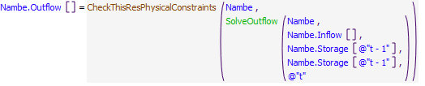
Execution Constraint
Referenced Functions
- CheckThisResPhysicalConstraints
- SolveOutflow
- HasRuleFiredSuccessfully
- GetStartDate

